Introduction

* 1. Purpose

MyCar is an android application that help customer rent vehicle from a dealership. This document is a document of requirements that downplays the process of developing this android application. The document’s purpose is to keep tack and help during the developing.

* 1. Scope

MyCar is an application for customer to rent vehicle from dealerships. MyCar will allow customers to search and select the type of vehicle they want to rent directly from dealership. They can choose the amount of time (days) that they want to rent the car for. Customer can make reservation for the vehicle they want to rent for the date they want to rent on. MyCar is intended to make it easier for customer to rent car.

With MyCar, dealers can add their vehicle to be rented to customer. They can set the price, availability and details (color, features, history…) of the vehicle. The dealers can also cancel the reservation of customers and send a message to the customer about the cancel.

* 1. Overview

This document will go over the MyCar and its functions. In the second section, the document will go over the functionality of the application. It will tell of the design that the application will take and how it works. The third section, will further explains the functions of the application and list the non-functional requirements.

2. Description

2.1 Product Component

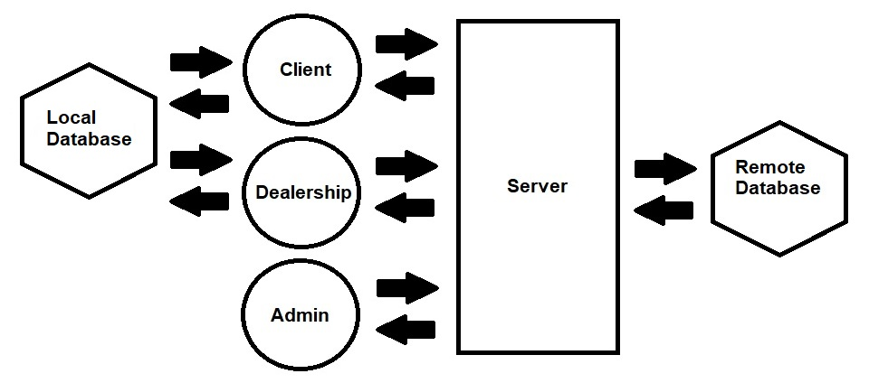

2.1.1 Client, Dealership, Admin

The client, dealership, and admin are the users that interact with the server. Interacting with the server will be how the user get most of the information and data.

2.1.2 Client

The client interfaces with the server, which in turn hosts the database holding the data that the client interacts with. Personal details such as name, email, address, and password are stored using encrypted techniques. The client also searches for vehicles using a local database, and features are able to be filtered and isolated to finalize a choice for an order.

2.1.3 Dealership

The Dealership has its own type of login separate from the client, personal details of the business can be stored using encrypted methods. Individual vehicles from the dealership's inventory to be rented by the client are stored in a local database.

2.1.4 App Admin

The administrator has its own type of login separate from the client or the dealership types, and is strictly for maintaining the list of users (both client and dealership) with the capability of account deletion.

2.1.5 Server

The server is driven by Google, and all authentication read/write traffic utilizes it through the means of their Firebase platform.

2.1.6 Remote Database

This project uses Google's Firebase database, which is a platform designed for mobile applications such as MyCar using an Android OS and is classified as a BaaS (Backend-as-a-Service).

2.1.7 Local Database

MyCar utilizes a local database for reading and writing data for the vehicle information. The local database stores data in the form of strings and integers, and is accessed by both the client and dealership login types.

3. Requirements

3.1 External Interface Requirements

3.1.1 User Interfaces

3.2 Functional Requirements

3.2.0 FR0

ID: FR0 – Home

DESC: The home page for the application. Allow user to go to login page. User can go to customer, dealer or admin login page.

RAT: For user to go to login page.

DEP: None

3.2.1 FR1

ID: FR1 – User Login

DESC: The login page for user to login into their account.

Rat: For user to login into the app.

DEP: FR0

3.2.2 FR2

ID: FR2 – User Registration

DESC: The user can access the register through the login page. The user provides the email and password to be register.

RAT: For the user to register on the application

DEP: FR1

3.2.3 FR3

ID:FR3 – Dashboard

DESC: After the user login, they will go to the dashboard. The dashboard will have option such as search, profile, setting, reservation and more for the user the navigate.

RAT: For the user to navigate to other functions

DEP: FR1

3.2.4 FR4

ID: FR4 – Profile

DESC: In the Dashboard, user can go to profile. Profile allows user to view the info they set.

RAT: For user to view self-info

DEP:FR3

3.2.5 FR5

ID: FR5 – Edit Profile

DESC: User can change and update their profile. Can be access through profile.

RAT: For user to change and update profile

DEP: FR4

3.2.6 FR6

ID: FR6 – Search

DESC: Search can be access through dashboard. Search allow the user to search for the vehicle they want to rent. User can spinner search for the type of feature that want such as touch screen, camera and more.

RAT: For user to search vehicle

DEP: FR3

3.2.7 FR7

ID: FR7 – Customer Reservation

DESC: After choosing the vehicle to rent, user will go to the reservation page. User can choose the dates to reserve the vehicle for.

RAT: For user the reserve vehicle.

DEP: FR6

3.2.8 FR8

ID: FR8 – Order Confirmation

DESC: After reserving the vehicle, the user will be notified rather they successfully reserve the vehicle or not. The confirmation will popup in the confirmation page.

RAT: For confirming the user reservation.

DEP: FR7

3.2.9 FR9

ID: FR9 – Calendar

DESC: Calendar can be access through dashboard and reservation. Calendar allow user to view their reservations.

RAT: For user to view reservations.

DEP: FR3, FR7

3.2.10 FR10

ID: FR10 – Dealer Login

DESC: Login page for the dealer to login into the application.

RAT: Login for dealer.

DEP: FR0

3.2.11 FR11

ID: FR11 – Dealer Registration

DESC: Through the login page, dealer can access the registration page. Dealer provide the email and password to be register.

RAT: For dealer to register and account.

DEP: FR10

3.2.12 FR12

ID: FR12 – Dealer Dashboard

DESC: After login, dealer will go to dashboard. Dashboard allow dealer to access option such as inventory, search, profile and more.

RAT: For dealer to access other functions.

DEP:FR10

3.2.13 FR13

ID: FR13 – Inventory

DESC: Dealer can view their inventory list. They can also delete and add to the inventory.

RAT: For dealer to view and update inventory.

DEP:FR12

3.2.14 FR14

ID: FR14 – Search

DESC: Search allow dealer to search for their customers. Through search dealer to access customers’ reservation.

RAT: For dealer to view customer list and reservations.

DEP: FR12

3.2.15 FR15

ID: FR15 – Dealer Reservation

DESC: Dealer can view the list of vehicles that the customer has reserve. They can click on the vehicle to see more details.

RAT: For dealer to view the reserve vehicle list.

DEP:FR12, FR13

3.2.16 FR16

ID: FR16 – Cancel Reservation

DESC: Allow dealer to cancel the reservation of customers. Customer can allow cancel their own reservations. Dealer can access this page from search and reservation, while customer can access through the calendar.

RAT: Allow dealer and customer to cancel reservation.

DEP: FR9, FR14, FR15

3.3 Non-Functional Requirements

3.3.1 NFR1

ID: Performance

DESC: When the Android application starts on the emulator, it shouldn’t take less than 3 seconds to load the home screen for users to access.

3.3.2 NFR 2

ID: User Login Error

DESC: If the user type in wrong login information 3 times, account is locked.

3.3.3 NFR 3

ID: Ability to Adapt to Different Screen Sizes on Android

DESC: When the Android Application is displayed on Android, it should be able to adapt to any Android’s different screen sizes.

4 Security Requirements

On the mobile app for login information, the user/dealer/admin will have 3 attempts to login into their accounts. If they are unsuccessful, then they will be locked out of their accounts for the purpose of protecting their accounts from hackers.

5 Prioritization

