Software Requirements Specification
for
Bar-Pop
Version 1.0 approved
Prepared by Evan Bonsignori
CSCI 3321
10/3/2017
Table of Contents
Table of Contents ii
Revision History ii
1. Introduction 1
1.1 Purpose 1
1.2 Document Conventions 1
1.3 Intended Audience and Reading Suggestions 1
1.4 Product Scope 1
2. Overall Description 2
2.1 Product Perspective 2
2.2 Product Functions 2
2.3 User Classes and Characteristics 3
2.4 Use Cases 3
2.5 Operating Environment 6
2.6 Design and Implementation Constraints 6
2.7 User Documentation 6
2.8 Assumptions and Dependencies 7
3. External Interface Requirements 7
3.1 User Interfaces 7
3.2 Hardware Interfaces 9
3.3 Software Interfaces 9
3.4 Communications Interfaces 9
4. System Features 10
4.1 Population Count 10
4.2 Map View 10
4.3 Venue Info 10
4.4 Login 11
4.5 Registration 11
4.6 Other Features 11
5. Other Nonfunctional Requirements 12
5.1 Performance Requirements 12
5.2 Safety Requirements 12
5.3 Security Requirements 12
5.4 Software Quality Attributes 12
5.5 Business Rules 12

Revision History
Name | Date | Reason for Changes | Version
Evan Bonsignori | 10/7/17 | Addition of Use Case UML Diagram in 2.3 | .8
Evan Bonsignori | 10/12 | Modify Use Case Diagram and Add Use Case Documents for Certain Use Cases | 1.0

Introduction

Purpose
The goal of Bar-Pop is a mobile application that provides population metrics, event, and location data to customers looking for nightlife venues in Savannah GA. Additionally, Bar-pop seeks to provide a mobile application interface for nightlife venue staff that provides population metrics and the ability to edit event data for their venue.

Document Conventions
The term Venue-Hopper will include any customer seeking out a nightlight location regardless of if it’s a bar, club, or other venue. Venue-Hopper does not necessarily mean that customers are actively switching between venues, since they could be using the app to locate their first and only venue. The term Venue-Owner will refer to anyone on a nightlife venue’s staff that needs to know the number of people in a venue’s location. We will call the number of people on a specific venue’s property population. Finally, when the word potentially is used in reference to a feature, that means that the feature has less priority and may not be implemented in the initial version if time constraints aren’t meant.

Abbreviations:
- AWS = Amazon Web Services
- GPS = Global Positioning System
- API = Application programming interface
- FAQ = Frequently Asked Questions
- OS = Operating System
- TBD = To Be Decided

Intended Audience and Reading Suggestions
This majority of the requirements document is written in natural language and should be comprehensible to anyone who has attended nightlife venues and owns a smartphone. There are sections towards the end of the document that require some moderate technical knowledge about remote servers and databases.

Product Scope
Bar-Pop uses laser hardware installed at each venue to count the number of people entering and exiting. The number of people are stored in a database that the mobile application can access and report to a user through an intuitive maps interface like Google Maps. Locations of each venue are represented by pins of varying color depending on the ratio of people at each supported location. Upon pressing a pin, users can view further information such as events and potentially walking distance and reviews.

Overall Description

Product Perspective
Figure 1 shows the three systems: server, sensors, and mobile application, and how they interact with each other. The mobile application will be developed using Xamarin.Forms, a framework that allow shared code between IOS and Android. Both platform’s Maps and GPS features will be implemented using existing APIs native to the respective platform. The mobile application and sensors will both require internet access. Additionally, the mobile application will require GPS connections. Population data for each venue will be stored on a remote database located on a web-server. The sensors will each use a Raspberry pi with internet access and two lasers will be required to detect a person’s entrance and exit for each venue they are placed in.
Figure 1 – Systems Overview
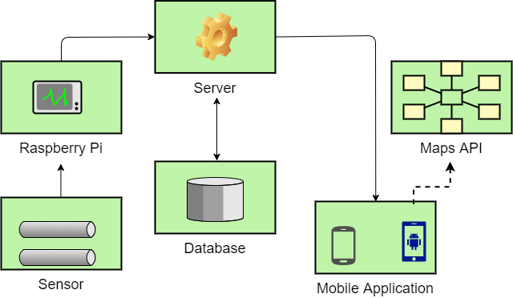

Product Functions
- Users will initially log in and consecutively start at map screen
- First time users are shown a tutorial and can review it in a help screen
- The map screen contains venues as pins relative to current location that can be clicked on
- Clicking on a pin provides population and (potentially) event, review, and directions
- Sensor located at doors of venue count the people entering and entering
- Venue-owners can potentially add events to their venue

User Classes and Characteristics
- Venue-Hopper:
Bar-Pop’s primary customer. Includes any person searching for a venue to attend with the mobile application. Customer may be located at an existing venue and wish to change venues based on data provided by Bar-Pop. Likely intoxicated and without technical expertise. Will only have the default map interface. Sensor will detect entrance or exit in venue as seen in Figure 2.

- Venue-Owner:
Owner of a bar, club, or other nightlife venue. Extension of Venue-Hopper, but with a potential additional interface for adding events to their bar. A professional, but without technical expertise. A customer of importance that is also responsible for approving hardware sensors to be placed at his/her door.
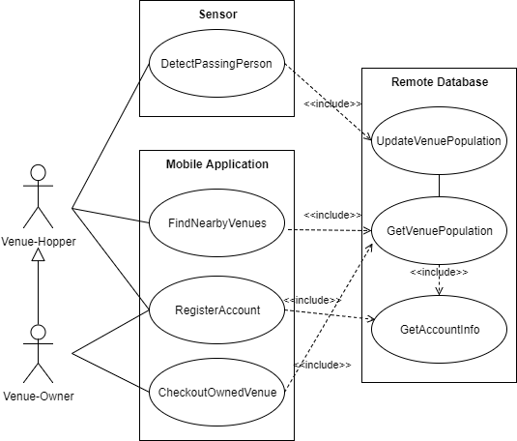

Figure 2 – Use Case Diagram

Use Cases
This section includes the four use cases from Figure 2 that the Venue-Hopper or Venue-Owner interact with. Each letter contains a use cases and the system associated with them. Each contains a table that shows the preconditions that must be met before the actor can initiate the main flow of events, and the postconditions that are established assuming that all conditions were met (main flow). The actors are always a Venue-Hopper, except for the use case, CheckoutOuwnedVenue, which has the actor Venue-Owner.

- Sensor: DetectPassingPerson
Precondition: The sensors two lasers are working and the sensor is on

Actor actions  1. Venue-Hopper enters or exits a venue where sensor is located  3. Another Venue-Hopper enters or exits | System Responses  2. Sensor connects to the remote database and updates the appropriate in or out count  4. Repeat updating the database with venue’s population until sensor is turned off
Postcondition: Database contains result that was reported by sensor and Venue-Hopper is in or out of the venue

- Mobile Application: RegisterAccount

Precondition – User doesn’t have a preexisting account and has mobile app installed.

Actor actions  1. User Indicates the need to register  3. User provides information. May request owner permissions  5. Confirmation message and user is brought to Map View (Figure 5) with Tutorial Overlay | System Responses  2. System asks for information such as name, e-mail, password, etc. to register.  4. System validates the information, checking for duplicates, then updates database with user information and privileges
Postcondition: The user has access to the application features depending on privilege level

- Remote Database: FindNearbyVenues

Precondition: Phone’s GPS is enabled for mobile app and user has a registered account.
Phone is within (TBD) radius of a venue with a sensor.

Actor actions:  1. Logged in user enters the Map View and application requests locations in city  3. App finds and displays the venues that are within radius of user’s current GPS location.  User clicks on a nearby venue to view venue information  5. User views the information | System Responses:  2. Database verifies user account info and establishes session. Database returns locations in current user’s city.  4. Database returns information for clicked on venue
Postcondition: User has established a connection with database and can view nearby venues and information about them

- Mobile Application: CheckOutOwnedVenue

Precondition: User has account with Venue-Owner privileges
Actor actions  1. Venue-Owner sends their login information to database  3. Request information for owned venue from the database  5. View venue information | System Responses  2. Validate login information  4. Send venue information corresponding to owner account
Postconditions: Database connection established and venue information is available for duration of user login

Operating Environment
The mobile application will be developed for recent IOS models and for Android models that support GPS and Maps API. Ideally, any hardware running one of these platforms from the past three years should function without error. Quantitively, that translates to any operating system within 2 versions of the most recent OS. (i.e. IOS 9 support when IOS 11 is the current release). Sensors will be built using Raspberry Pi models that support WIFI connectivity (for relaying enter/exits to a database) and the web server will run Ubuntu Server LTS. Initially, AWS’s free year-long hosting will be used for hosting until fiscal options are further evaluated at the end of the trail period. The database will be created in MySQL’s most recent version and will be updated regularly alongside Ubuntu (to the most stable LTS release) to maintain a secure system.

Design and Implementation Constraints
- Sensor’s people-counting accuracy using lasers
The sensor system will be far from perfect under our current budget and time constraints. Correctly identifying if a person enters or exits is imprecise and prone to error. For example, if a group of people walking side-by-side pass the lasers, then only one person may be counted as entering/exiting. However, other more expensive methods of people count exist (such as camera face detection), and may be considered in later versions.
- Server Stress and Scaling
With no concrete plans of scaling, our current free-tier server provided by AWS may not handle a high load of users. Methods of caching populations or changing the intervals that populations are fetched from the database may be employed to provide a temporary solution.
- Securing Population Information
Bar-Pop will refrain from revealing exact numbers in each venue, instead opting to show a description based on a ratio of population/total venue capacity. However, calculations for the ratio will happen on the mobile application side, meaning that the data fetched from the database includes the exact number of people at any venue, which could be dangerous information. Development will consider encryption methods for preventing malicious access.
- Population Accuracy
The population relay to the database from the sensor to the mobile application from the database will not happen in real time. This can create noticeable population inconsistencies when a large group enters or exits a venue in a short period of time. This is problematic when venue-hoppers move to a venue because they valued the venue’s low population. Once they arrive, it could be the case that the venue became overpopulated because of other venue-hoppers with similar small-crowd preferences that switched venues based on time delayed population data provided in Bar-Pop.

User Documentation
An FAQ and Help screen will be provided in the app and will include an overview of how the app works and how to interface with it. Potentially, new users will be shown a tutorial in the form of tooltips when they first log in. However, due to the simplicity of the app (i.e. only three or four different views) expansive end-user documentation will not be provided. Instead, a simple pop-up screen with a tutorial should be sufficient for all user use cases.

Assumptions and Dependencies
- Permission to place sensors in each venue
Since permission must be granted by a venue-owner, sensor placement isn’t guaranteed. Heuristics for population counting in these unapproved venues may be considered in later versions. Such heuristics include fetching the number of people using GPS from mobile users to estimate the number of people in the unapproved bar. The number of people not using the app, but located in the bar, could be estimated using statistics.
- Venue WIFI
For a sensor to relay population information to the database, the sensor must be connected to WIFI. If the venue doesn’t have WIFI or has WIFI errors, then the sensor is inhibited.
- Xamarin.Forms Libraries
Since the app is built entirely in Xamarin.Forms, if Xamarin discontinues its product, then our app will not be updateable for future releases.
- Amazon Web Services (AWS) performance
- GPS being enabled on a user’s phone

External Interface Requirements

User Interfaces
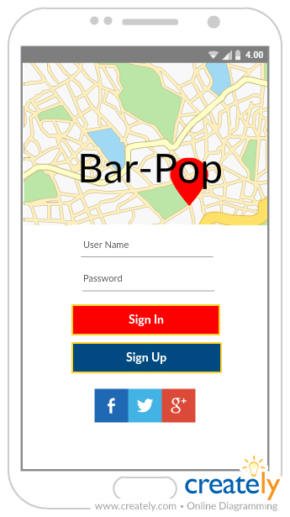
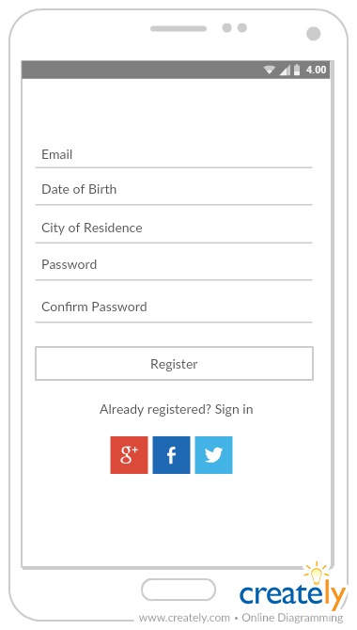

Figure 4 – Register View
Figure 3 – Login View

- First Time Use:
- Login and Registration Views
First-time users will be brought to the Login View (Figure 3). Users can potentially login using Facebook, Google, Twitter, or email and password forms. Under these forms is a “Sign In” button followed by a “Sign Up” button. The Registration View (Figure 4) is opened by pressing the “Sign Up” button. Registration View consists of email, password, date of birth, and city of residence input forms. Once logged in, users will automatically stay logged in for future application openings, unless specifically choosing to log out in the Help View (Figure 5).
- Tutorial Overlay
Upon logging in, a notification window will pop up that gives a tutorial of Bar-Pop and its features. There will be a button used to exit the tutorial. The tutorial can potentially be in the form of cycled through tooltips with “Next” buttons that can be pressed until and a “Finish” button is reached.

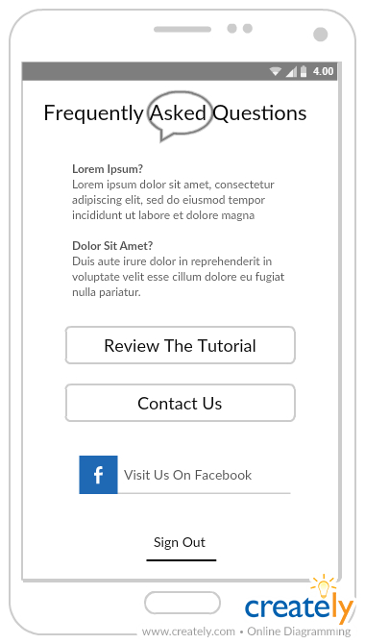
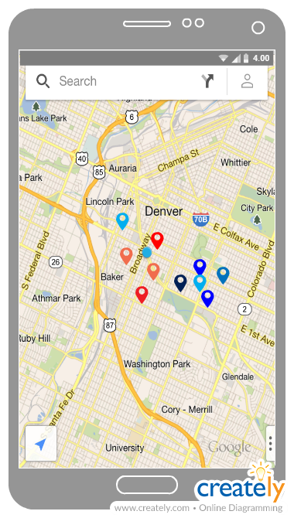

Figure 4 – Map View
Figure 5 – Help View

- Consecutive Application Openings
- Map View
After completing the Tutorial Overlay, logged in users will first see a map centered on their location (Figure 4), with a radius (size TBD) surrounding them. If any supported venues are within this radius, they will appear as pins on the map and may be clicked on. In the top left of the map view will be a small menu button (Where the search icon is in Figure 4).
- Map Pins
Map Pins will be colored according to population ratio. If a venue is mostly full, then it will be a darker shade of red than a venue that is less full. Less full venues will be a lighter shade of blue than moderately full venues. Potential customization options could include user notifications for certain types of locations. More popular locations could be labelled “hot” and less frequented locations as “chill.”
- Venue Info View
Upon pressing a pin an overlay will appear, called the Venue Info View (GUI TBD). This view contains population information, and potentially additional information such as reviews, events, and a button with the distance to on it that opens the default maps application for navigation.
- Menu View
The menu view is reached from pressing the top left button in the Map View (search icon in Figure 4) and at the bottom gives an option to log out and be brought back to the Login View. The top of the Menu View shows the name of the user logged in and a “Help” button (GUI TBD).
- Help View
The Help View (Figure 5), contains FAQ, an option to review the tutorial, and a “Contact Us” button which opens the default mail app linked to our email (email TBD). We will potentially have a Facebook page for which a “Visit Us on Facebook” button will link to. The last option in the Help View is to sign out of the logged in account.

Hardware Interfaces
- Sensors - People counting with lasers
The hardware used to gain populations from each venue is a Raspberry Pi attached to two lasers. These lasers detect the direction of the object -hopefully person- passing them. This object should be a person entering or exiting a venue. At an interval that can be sustained by the remote database, the Raspberry Pi will connect to the remote server using a built in WIFI chip and update the database located on that server with its population count. The Raspberry Pi holds the current count in its onboard memory and potentially resets the count to zero after closing hours of a venue. Sensors will potentially allow remote access for maintenance.
- Phones – iPhones and Android OS enabled phones
The hardware required from the phone is that which is required to run the mobile application, in addition to providing GPS location data.
- Server - Remote Hosting
The hardware for the remote hosting is in a black-box to the developers, thus we only interact with the server itself, which will be running Ubuntu Server LTS OS. This will be accessed through SSH and web calls.

Software Interfaces
- Xaramin.Forms for Mobile Application
  - Mobile Application uses native APIs for maps and GPS data
  - Mobile Application will potentially fetch data from Facebook, Google, and/or Twitter for log ins, events, and reviews
- AWS for hosting an Ubuntu Server LTS OS
- MySQL installed and running on the Ubuntu Server
- Raspberry Pi running Python to send SQL queries for updating the MySQL database

Communications Interfaces
The mobile application and Raspberry Pi will connect to the remote MySQL database using TCP/IP protocols.

System Features

Population Count
4.1.1 Description and Priority
- Highest Priority [10/10]
- Base functionality of the application. Uses sensors to count the number of people in any venue and that number can be viewed from Map View (4.2) in the application.
4.1.2 Stimulus/Response Sequences
- Count is updated when a person enters or exists a room with a sensor in it
- Count is accessed from the database when the application asks the database to retrieve it
- Count is sent to database at a set (TBD) interval
4.1.3 Functional Requirements

REQ-1: To Access: User is logged in
REQ-2: To update: During business hours and sensor is connected to WIFI

Map View
4.2.1 Description and Priority
- Very High Priority [9/10]
- Basis for user interaction with Population Count (4.1). Uses a map display with pins as venues. Clicking on a pin will shows Population Count and TBD features.
4.2.2 Stimulus/Response Sequences
- User opens mobile application and logs in
4.2.3 Functional Requirements

REQ-1: To Access: User is logged in
REQ-2: User has GPS enabled
REQ-3: User is within a certain distance (TBD) of a supported venue

Venue Info
4.2.1 Description and Priority
- Very High Priority (equal to and in coherence with Map View) [9/10]
- When clicking on a map pin, the venue info is displayed
- Includes:
  - Population Count [Priority 9/10]
- May Include:
  - Events [Priority 5/10]
  - Reviews [Priority 4/10]
  - Distance [Priority 4/10]
  - Directions [Priority 3/10]
4.2.2 Stimulus/Response Sequences
- User presses on a pin in Map View

4.2.3 Functional Requirements

REQ-1: Population Count exists for clicked on venue
REQ-2: GPS signal

Login
4.2.1 Description and Priority
- Very Important [8/10]
- Allows user to interact with Map View
4.2.2 Stimulus/Response Sequences
- User opens mobile application and fills in login forms
4.2.3 Functional Requirements

REQ-1: User has installed the application and has a supported OS
REQ-2: User has an account (See 4.5, Registration)

Registration
4.2.1 Description and Priority
- Equal Priority (and dependent) to Login [8/10]
- Allows user to create an account for Login
- Provides developers with customer information
4.2.2 Stimulus/Response Sequences
- User opens mobile application and selects “Sign Up”
- User enters the following information:
  - Email
  - Password
  - DOB
  - City of Residence

4.2.3 Functional Requirements

REQ-1: User has installed the application
REQ-2: User has an email

Other Features
Are described throughout the document and are prefixed with “potentially.” These features are largely TBD and may not make it into the features of version 1.0. Examples include:
- Venue-Owners adding events to Venue Info (4.3)
- Distance button that opens directions in native maps application in Venue Info (4.3)
- Tutorial overlay for the first time opening Map View (4.2)

Other Nonfunctional Requirements

Performance Requirements
Speed requirements should be fast enough to provide users with accurate population information, but not to the speed that the remote server slows down. Implementation will require adjusting the interval that population data is fetched from the hardware to the database until stable speeds are reached.

Safety Requirements
As a mobile application that will potentially be used when walking around late at night, users should be warry of not looking up from their phone to avoid any harm. There is also the matter of intoxication and underage drinking. However, the app will not have a causal relationship with drinking. Periodic warning popups to look at one’s surroundings and not to drink and drive might be a good caution measure to prevent harm and lawsuits that may follow (though this seems highly unlikely).

Security Requirements
User email and city of residence location must be secure from malicious attacks. Additionally, population information could be used for nefarious purposes. Thus, exact population numbers will not be displayed for any venue. Additionally, this information must be secured to prevent malicious access.

Software Quality Attributes
Bar-Pop will be easy to use due to its minimalistic nature of having only one main view (Map View). The software will be free and available for Android in the Google Play Store and for IOS in the App Store. Thus, the app will be available to nearly every venue-hopper since both major operating systems are supported and use isn’t barred by income level.
In its initial stages, the application may not provide accurate and reliable data. However, if dedication is given to maintaining the project over time, then the robustness of the application will increase with updates and further development.

Business Rules
In the scenario that the mobile application ends up supporting venue events, then adding events will only be accessible to venue owners. Otherwise, anyone can use the mobile application and see created events.

