**Testing of Fuzzywuzzy**

Team: The Darkness

Members: Wyatt Morris, Juan Crispi, Chance Leaird

Fault Injection

* Our faults involve arithmetic changes when calculating the ratio
* Some constants were altered to demonstrate how the values would change
* Also shows how only certain strings were affected because our string inputs were simple

Testing

* Decided on testing simple strings and fringe cases
* Wanted to ensure that empty strings could be handled
* Used a consistent string to ensure testing integrity within each method

What is fuzzywuzzy?

* String comparison module
* Uses python standard difflib to calculate differences between strings
* Can tokenize strings to ensure testing integrity

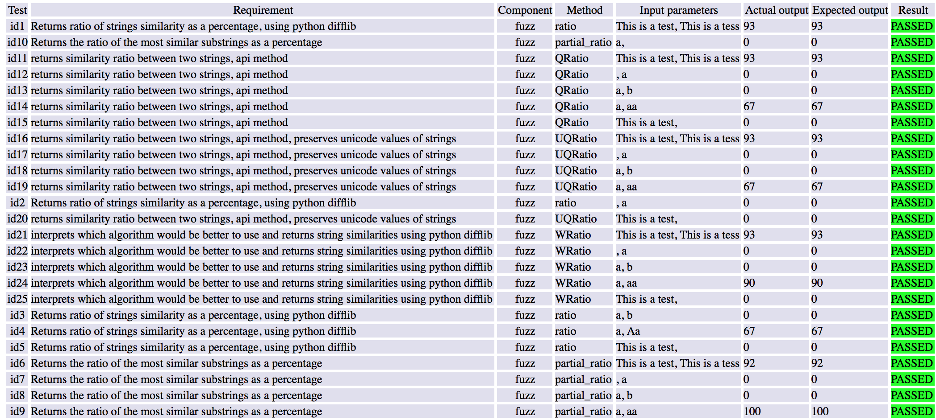

Testing without faults

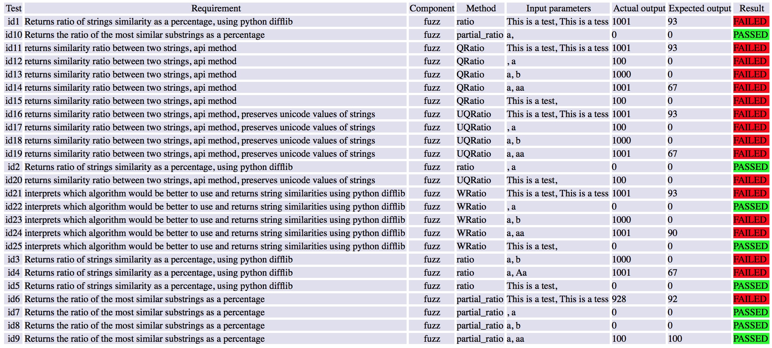

Testing with faults