Team Name: Team Perseus

Build Running Locally:
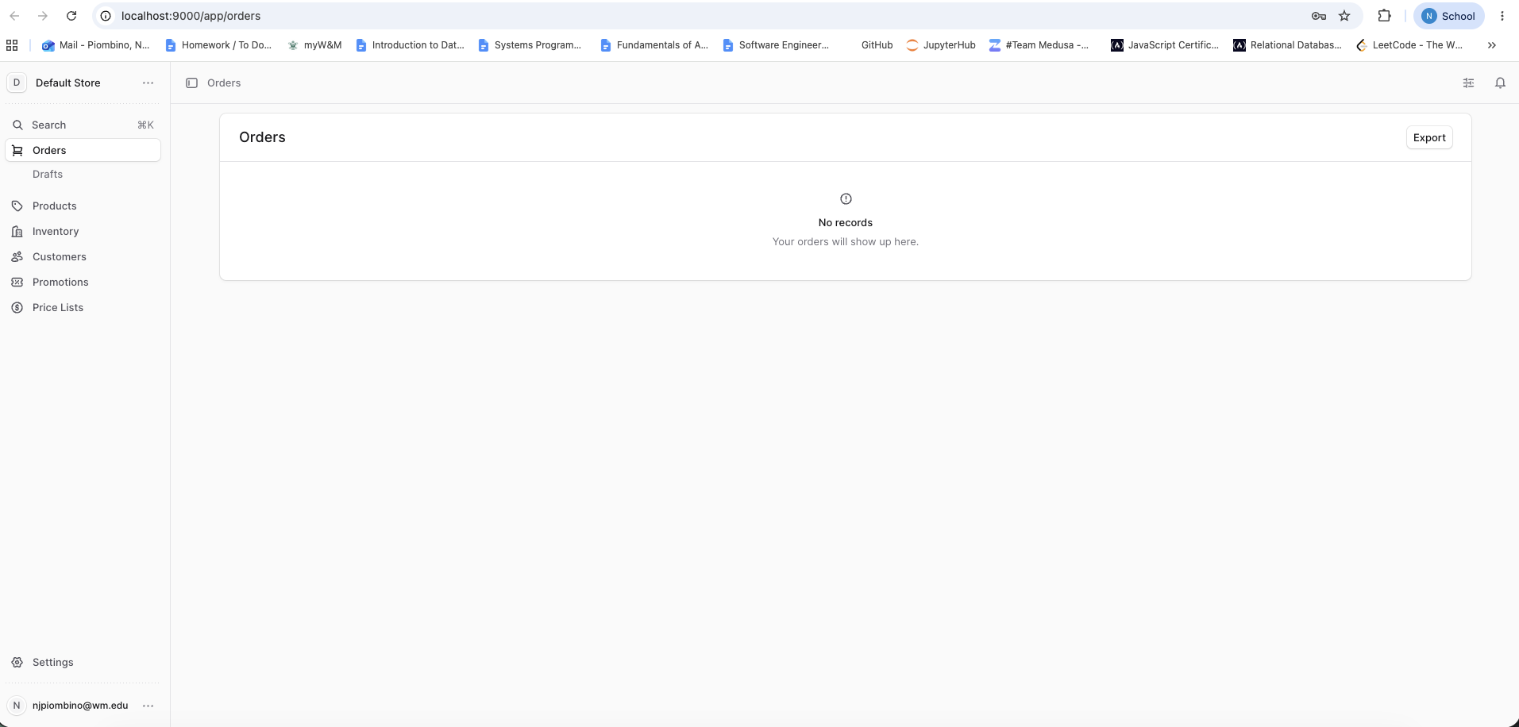

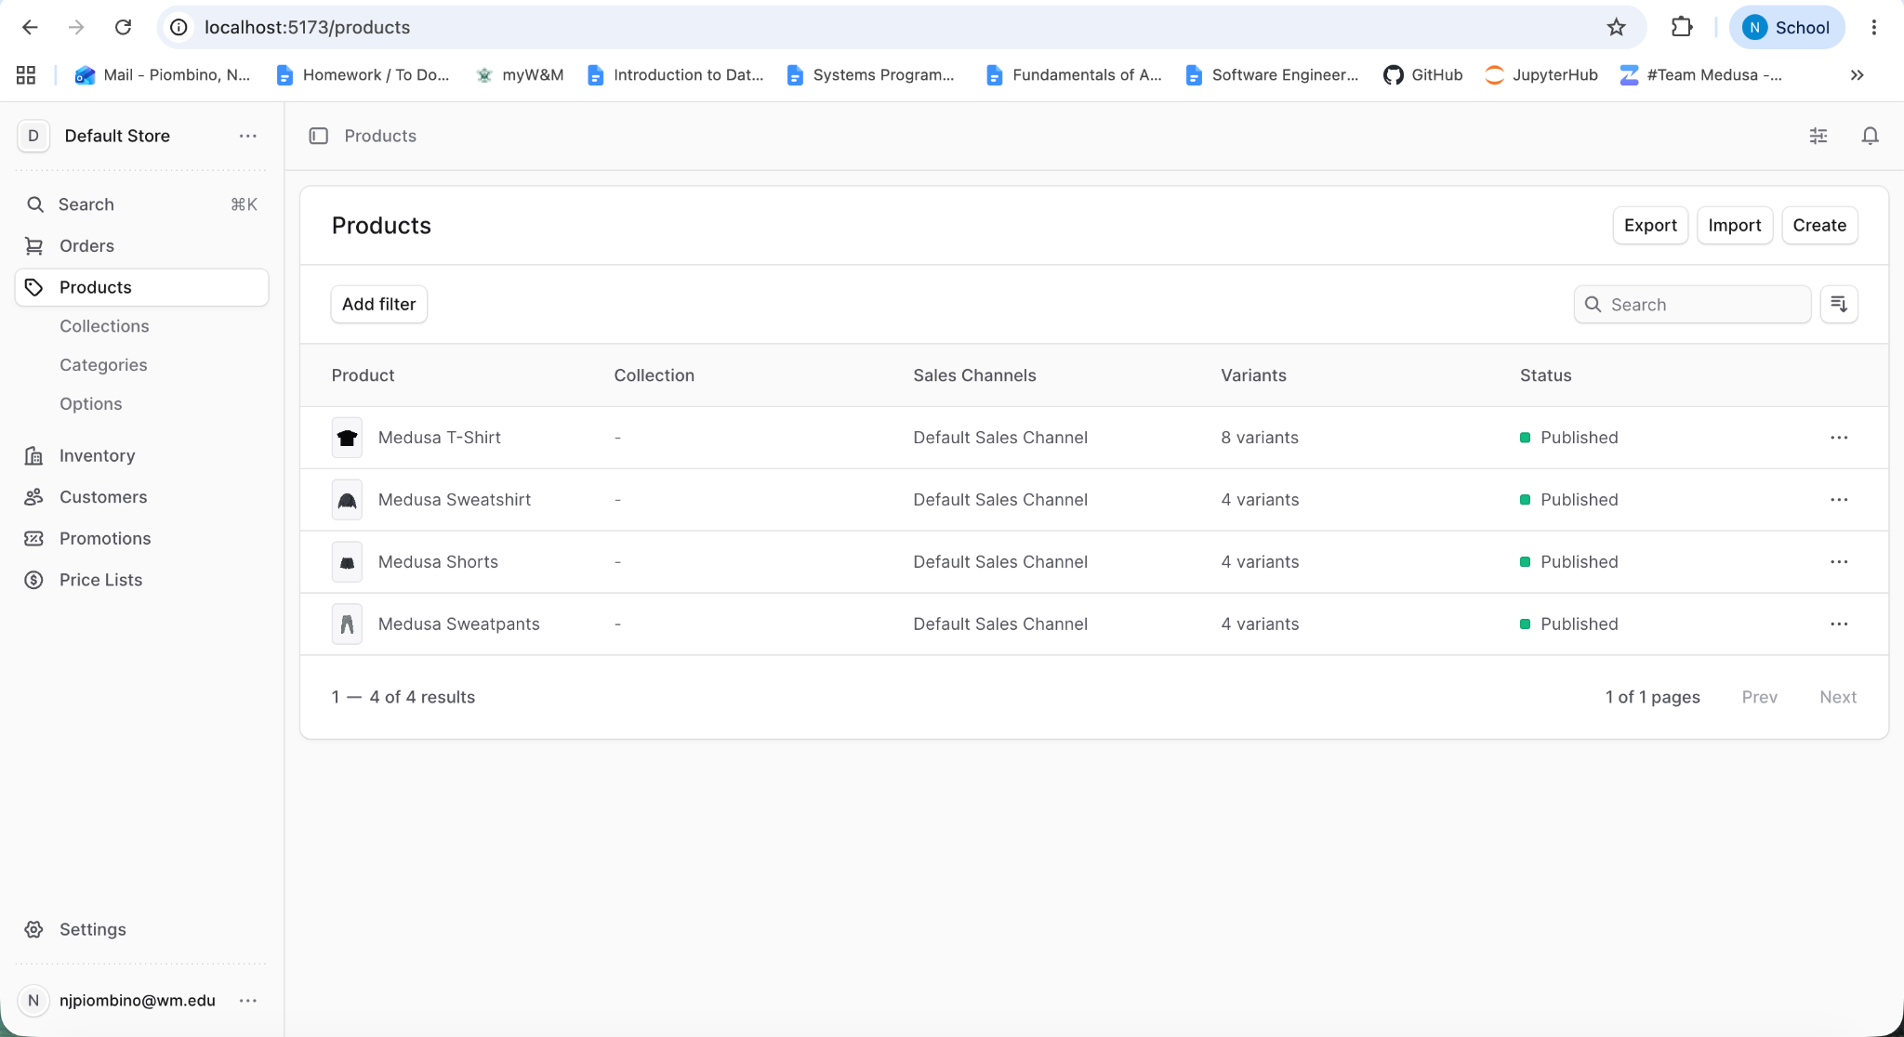
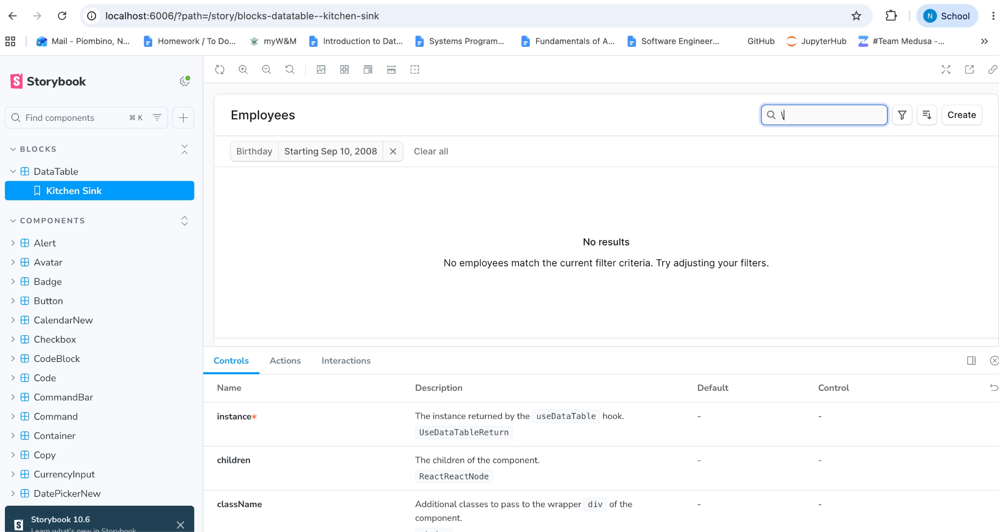

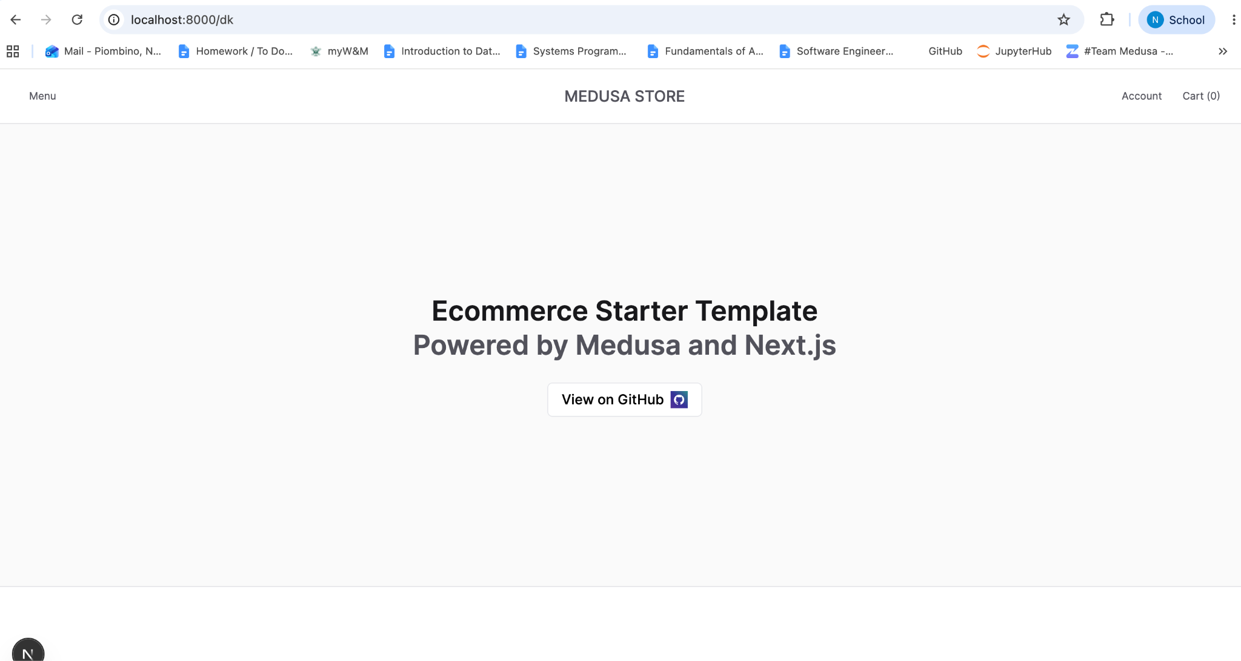

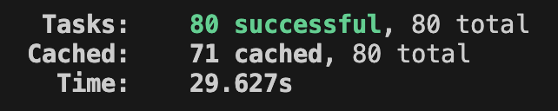
- yarn build
Test Suite Passing:
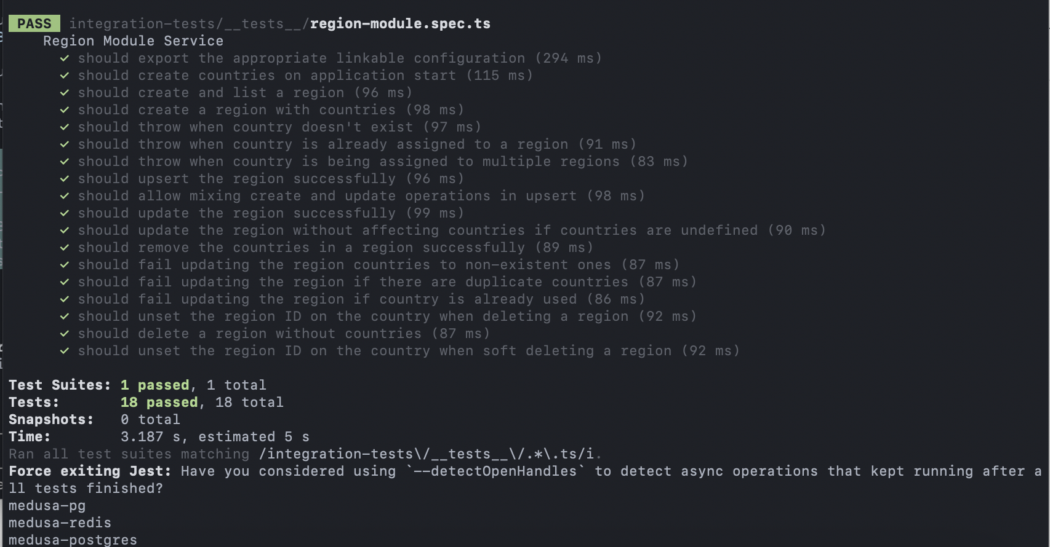
(integration-region)
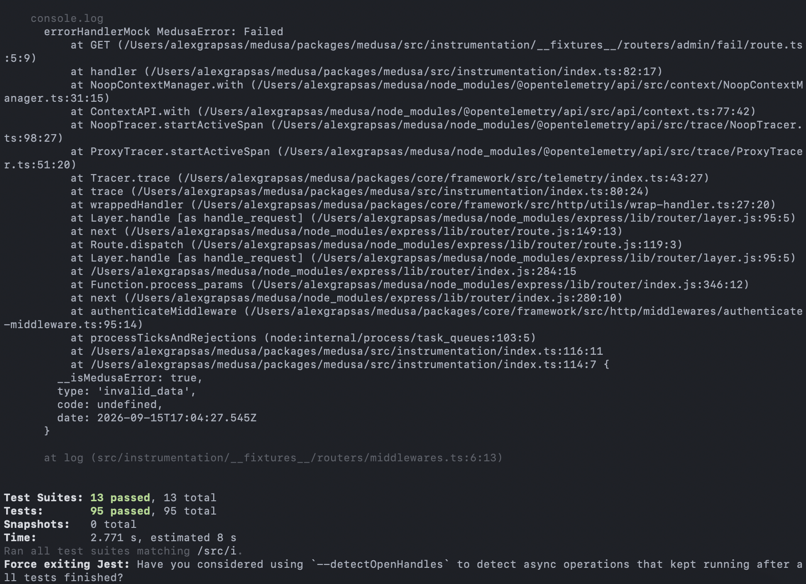
(jest medusa)
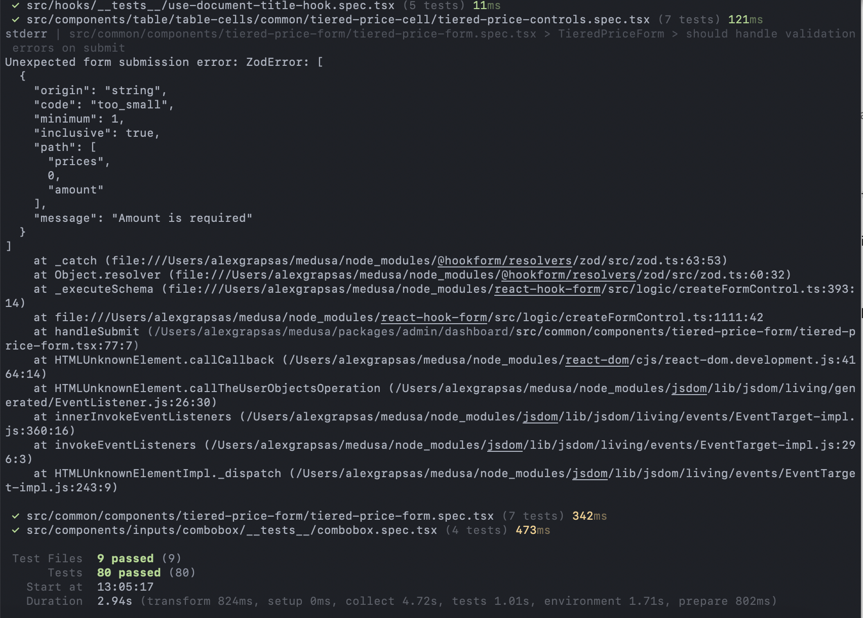
(vitest-dashboard)

Project Overview:
- What does the system do? Who are its users? What are its main features?
  - Medusa is an e-commerce platform with a framework to build custom features. It has 3 main tools: a suite of commerce models, a framework for building custom features, and a customizable dashboard. Users are essentially anyone who wants a commerce platform that is super customizable.
- What are the main components and how do they interact?
  - 4 layers: API routes as the entry point, workflows that hold the business logic, modules for specific tasks used by the workflows, and a data store that has an SQL database. Everything is connected through the Medusa container and module links.
- What are the major technologies, frameworks, and external services?
  - The database is PostgreSQL; Redis is used for caching, events, locking, and workflow engine; The backend is written with Node.js; pnpn is the package manager; SWC is the compilation tool; React is used to build the admin dashboard UI; Next.js is used to build the storefront.
- How is the code organized (directory structure, key packages/modules)?
  - The code had docs for getting started, cloud, product, build, tools, and a user guide. For the actual repo, there’s a single folder that contains everything. Inside the folder, some of the most important sub-folders include the core, medusa as the main server, modules for the infrastructure modules, and plugins for the official plugins.
- How do developers typically contribute? What is the PR and code review workflow? What are the standards for issue reporting, triage, and management?
  - Developers contribute bug fixes, new features, and tooling improvements. One of the primary rules is issues before pull requests, so issues aren’t fixed when they aren’t really a problem. Every time a change is made, the packages need to be built again with yarn build. There are two branches, develop (for Medusa 2.0) and v1.x (for Medusa v1.x). Commits should be small and isolated, and in pull requests you need to follow the structure “what, why, how, and testing.” Every change should include testing for those changes, and comments in code should complement the changes.

Feature Backlog Summary:
14 total issues were created, with 6 being resolved in sprint 0. Our top themes are making things easier for the store owner, and fixing some small issues that weren’t exactly bugs but could lead to some problems if left unresolved. The top issues the team wants to pursue in future sprints include: #6 Add Product Subscriptions, #11 Add bulk order import via CSV file, and #23 Add workflow lifecycle controls to the admin API and dashboard.

Link to the issues: https://github.com/CSCI-435-SE/medusa/issues

Standards Document Summary:
Branch-based workflow. Keep commits small. All PRs should include tests for the changes that are included and should be reviewed by at least one other team member.
Replace the @medusajs/* dependencies and devDependencies in your test project's package.json to point to the corresponding local packages in your forked Medusa repository. You will also need to add the Medusa packages in the resolutions section of the package.json, so that every dependency is resolved locally. Every time you make a change in your Medusa repository, you need to build the packages where the modifications took place with yarn build.
There are currently two base branches: develop - development of Medusa 2.0, and v1.x - development of Medusa v1.x. All changes should be part of a branch and submitted as a pull request - your branches should be prefixed with one of: fix/ for bug fixes, feat/ for features, or docs/ for documentation changes.
Formatting (Prettier): no semicolons, double quotes, 2 space indentation, ES5 trailing commas, always use parentheses in arrow functions.
Naming convention:
  - Files: kebab-case (define-config.ts)
  - Types/Interfaces/Classes: PascalCase
  - Functions/Variables: camelCase
  - Constants: SCREAMING_SNAKE_CASE
  - DB fields: snake_case

Link to standards.md: https://github.com/CSCI-435-SE/medusa/blob/develop/docs/sprint0/standards.md

Completed PRs:
https://github.com/CSCI-435-SE/medusa/pulls?q=is%3Apr+state%3Aclosed

PR title | Issue link | Author | Reviewer(s) | Status (merged / open) | Brief description of the change
Implement payment status tooltip | #12 - Closes #3 | Nicholas Piombino | Logan Fecko | Merged | Payment status labels in the orders table are displayed as a small colored badge with a short text label. When the label is truncated due to column width, there is no tooltip showing the full status text. A tooltip should appear on hover so that users can read the full status without widening the column.
Implement product title length limit | #13 - Closes #2 | Logan Fecko | Nicholas Piobino | Merged | When creating or editing a product, the description field does not show how many characters have been entered. The app should display a live character counter below the description field so that users can easily track the length of their product descriptions while writing.
Implement description character count | #14&15 - closes #5 | Nicholas Piobino | Logan Fecko | Merged | The description field had no way to see how long the text was. Adds a live character counter below the product description field, shown while creating or editing a product, so users can track description length as they type.
Implement order count and total spent | #19 - Closes #9 | Logan Fecko | Nicholas Piobino | Merged | No way to see a customer's total order count and lifetime spend on their profile page. Adds a count of total orders and amount spent (split by currency) onto the customer page. Now store owners can more quickly assess a customer’s value to their store.
Add delete action to the customers list row menu | #20 - Closes #10 | Alex Grapsas | Logan Fecko | Merged | The customers list only had an Edit action, so deleting a customer meant opening their detail page first. Adds a Delete action to the row menu, reusing the same confirmation prompt the detail page uses.
Require a handle when creating a product | #21 - Closes #4 | Alex Grapsas | Logan Fecko | Merged | The handle field on the product create form was optional. Makes it required and removes the tooltip text saying a handle would be generated from the title.

AI Tool Usage:
We are using Claude/Claude Code. Claude.md gives a full overview of coding conventions that should be followed. Everything generated by an ai agent or chatbot should be fully examined and understood before including it in a PR.

Logan’s Usage: 6 logs.
https://github.com/CSCI-435-SE/medusa/tree/develop/ai-logs/sprint0/lefecko
  - Claude code helped me find the files in the file tree, recommended code that I could modify/accept, and helped give me terminal commands for things such as running the test cases. I mostly used the manual mode so I could understand everything and no big changes were made at one time.

Nicholas’ usage: 2 logs. https://github.com/CSCI-435-SE/medusa/tree/develop/ai-logs/sprint0/njpiombino
  - Claude helped me with setting up the project, while Claude Code helped me with running, testing, implementing, and debugging.

Alex’s Usage: 4 logs.
https://github.com/CSCI-435-SE/medusa/tree/develop/ai-logs/sprint0/angrapsas
  - Claude Code helped set up the local environment and track down why the admin dashboard dev server rendered a blank page.
  - Used it to explore the codebase and research feature ideas before writing the issues.
  - Helped implement and test both PRs.

Release:
v2.17.2-csci435-s0
https://github.com/CSCI-435-SE/medusa/releases/tag/v2.17.2-csci435-s0

Risks & Challenges:
Setting up the environment and running the initial tests provided some challenges for our team. A number of us had issues with the local app, and we all had a few tests that failed (ui and icon tests), which we decided was an issue with the test cases rather than our setup. Getting our team running smoothly was another challenge. It wasn’t until just a few days before everything was due that our team started writing consistently in Zulip, meaning that everything was a bit rushed at the end. Risks for sprint one include other work / classwork that might slow us down. We know we need to meet and begin working earlier in the sprint but we might have difficulties in satisfying everyone’s schedule, especially when other classes can assign work unpredictably.

Sprint 1 Ideas:
Our primary goals for sprint 1 include fixing the test cases that don’t run when you initially set up the Medusa system and setting up a meeting time(s) for the group to work/communicate any ideas, concerns, or comments so that it doesn’t feel rushed. Beyond that, we plan to work on making Medusa more user-friendly and easy to use by implementing direct edit access for user and product fields. In addition, our ideas include CSV import/export updates, at minimum adding an export for a customer list (#17) and a bulk order import (#11) (when switching order tracking to Medusa), attempting to make the store owners more money by implementing features such as product subscriptions (#6) and checkout upsells (#7), and implementing a status tracker for store owners to follow growth/customer activity.

