- This is an important step as it will allow (among other things) to save automatically your annotations as they are done. When you receive the invitation to the Drive Folder, please accept and create a shortcut to your main drive, by right-clicking on the shared folder and then going to “Organise” > “Add shortcut”:
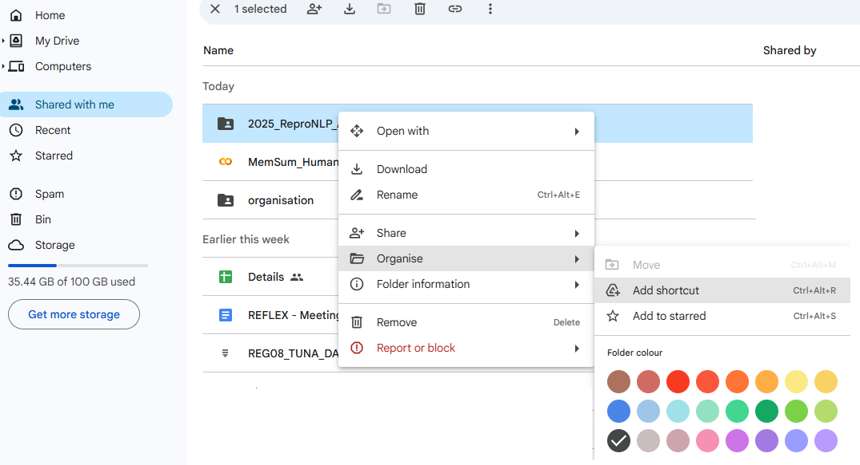

Then click on All location, and select “My Drive”, then click on “Add” on the right:
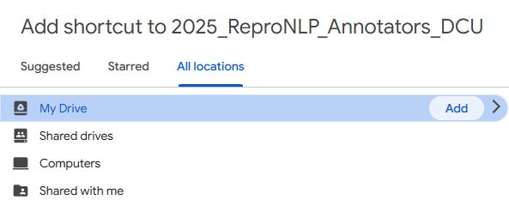

There should now be a shortcut in your Drive! You can of course remove this shortcut as soon as you are done with the evaluation.

- Now go and click the link to the Notebook that is assigned to your email address in the Annotators_notebook_assignments spreadsheet of the shared drive. Make sure the ID at the end of your notebook name (red circle below) matches the ID in the spreadsheet:
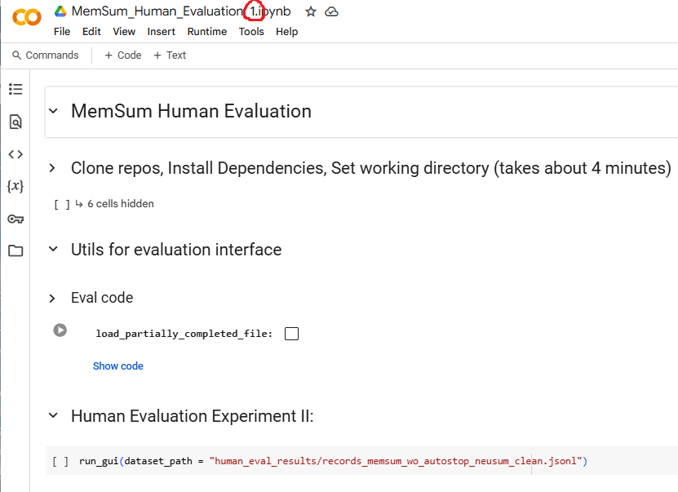

- Click on the first “Play” button (red circle below), and then on “Run anyway” in the pop-up window (this runs the 6 hidden cells in a row):
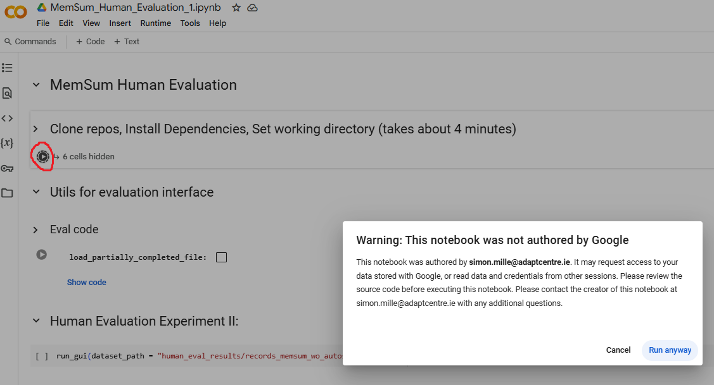
- You will then be prompted to allow access to Google Drive, click on “Connect to Google Drive” in the pop-up window (red circle below), and then choose the email account you provided to the team that carries out the experiment. At least allow Drive to modify files/folders, and proceed with logging in, until the pop-up window disappears. Once you are done, it will take about 4 minutes for the resources to be loaded, during which the “Play” button becomes a “Stop” button. When the button is back to being “Play”, you can move to the next step.
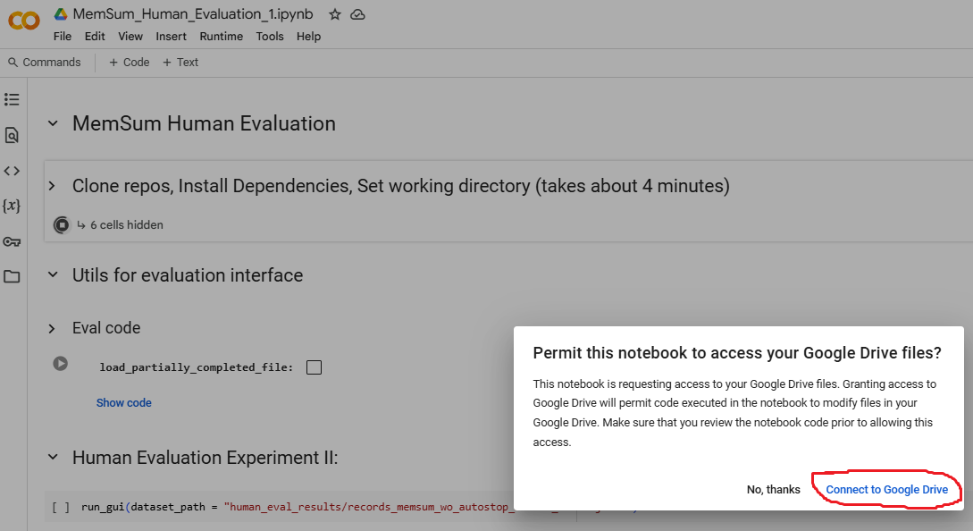
- Now click on the second “Play” button, in the “Eval code” cell (red circle below). This takes only a few seconds. The first time you use this interface, leave the “load_partially_completed_file” unticked. But if for any reason you stop before finishing all 63 evaluations, and pick the task at a later time after restarting the Notebook runtime, ticking this box (orange circle below) will load your existing file. If you don’t tick that box, your existing file will be erased and you will have to start over.
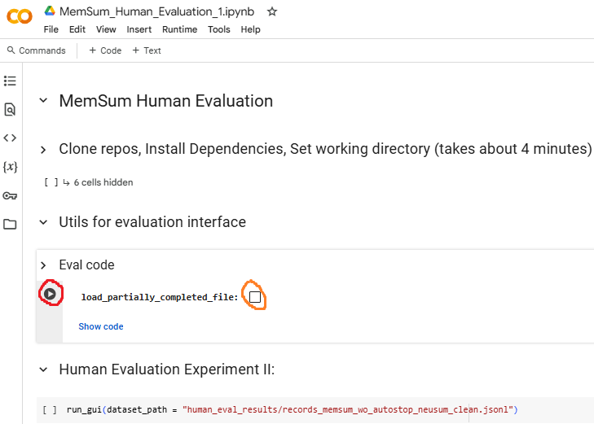

- Finally, click on the third and last “Play” button (red circle below):
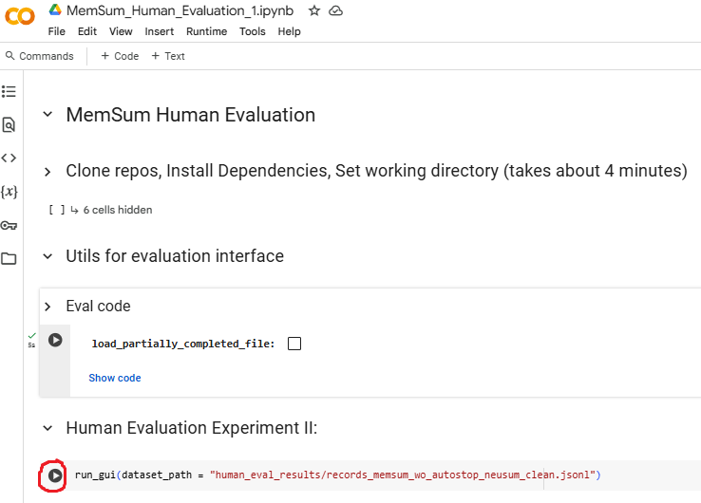
- This will immediately launch the annotation interface, which looks like the figure below. You then have to follow the annotation instructions provided to you separately.
