Software Requirements Specification
for
FriendSync
Version 1.0

Prepared by
Group Name: B6
PANG Jia | 1155240620 | 1155240620@link.cuhk.edu.hk
WU Xuanwei | 1155211209 | 1155211209@link.cuhk.edu.hk
Wong Cheuk Lam | 1155227159 | 1155227159@link.cuhk.edu.hk
ZHU Kevin | 1155240676 | 1155240676@link.cuhk.edu.hk

Instructor: | Tak-Kei Lam
Course: | CSCI3100
Teaching Assistant: | <place your TA’s name here>
Date: | 2025.2.9
Contents
Revisions iii
1 Introduction 1
1.1 Product Scope 1
1.2 Definitions, Acronyms and Abbreviations 1
1.3 References and Acknowledgments 1
2 Assumptions and Dependencies 2
3 High-Level System Architecture 2
4 Functional Requirements 2
4.1 Functional Requirements 2
4.1.1 User Authentication and Management 2
4.1.2 User Search and Tagging 2
4.1.3 Room and Team Creation 3
4.1.4 Recommendations and Suggestions 3
4.1.5 Social Interaction Features 3
4.2 Use Cases 3
4.2.1 Sign up 3
4.2.2 Log in 3
4.2.3 Update personal profile 4
4.2.4 User searching 4
4.2.5 Room or team creation 4
4.2.6 Room or team deleting 4
4.2.7 Join room or team 4
4.2.8 User leave a Room or Team 5
4.2.9 User recommendation 5
4.2.10 Social Interaction 5
4.3 Flowchart 6
4.3.1 Sign up 6
4.3.2 Login 6
4.3.3 Update Profile 6
4.3.4 Search Users 7
4.3.5 Create Rooms 7
4.3.6 Create Teams 7
4.3.7 Delete Rooms or Teams 8
4.3.8 Join Rooms or Teams(Teams as an example) 8
4.3.9 Leave Rooms or Teams 8
4.3.10 Recommend Similar Users 9
4.3.11 Communicate with Users 9
5 Non-functional Requirements 9
5.1 Performance Requirements 9
5.2 Safety and Security Requirements 9
5.3 Software Quality Attributes 10
5.3.1 Usability 10
5.3.2 Robustness 10

Revisions
Version | Primary Author(s) | Description of Version | Date Completed
0.1 | PANG Jia | Draft the project's specification document to clarify the underlying functionality, software architecture, and technology stack. Part 1 introduction and Part 2 overall description are finished. | 2025/02/07
0.2 | WU Xuanwei | Part 3 and Part 4 are partly finished. | 2025/02/07
0.3 | WU Xuanwei | Reconstruct the document structure. Add more use cases. | 2025/02/09
0.4 | Wong Cheuk Lam | Reconstruct the document structure secondly, some typos are corrected. Draw use cases diagrams. | 2025/02/09
1. 0 | PANG Jia | Refinement of User cases and redrawing. Preliminary completion of the first part. | 2025/02/10

Introduction
FriendSync is a mobile H5 website (APP style), which is based on Spring Boot back-end + Vue3 front-end. As a full-stack project, the FriendSync including user login, update personal information, search for users by tag, build a room and team, recommend similar users and other functions.

Product Scope
The " FriendSync" mobile H5 website is a platform designed to help users find like-minded individuals to collaborate with based on shared interests and learning goals. The system will allow users to create and update profiles, search for other users by specific tags (such as learning topics, skills, or interests), build virtual rooms and teams, and receive recommendations for similar users.

The product aims to foster learning collaborations and social networking among users, with a primary focus on students, professionals, and anyone seeking to connect with others in an educational or personal development context. By leveraging user tags and profile details, the system will enable personalized recommendations, thereby enhancing user engagement and satisfaction. The system will be built with modern web technologies, making it easily accessible via mobile browsers, providing flexibility for users to access the platform anywhere.

Definitions, Acronyms and Abbreviations
API: Application Programming Interface
CRUD: Create, Read, Update, Delete
H5: HTML5 (used for mobile web applications)
UI: User Interface
Vue3: The JavaScript framework used for the front-end development
Spring Boot: A Java-based framework for back-end development
SRS: Software Requirements Specification

References and Acknowledgments
SO/IEC/IEEE International Standard - Systems and software engineering -- Life cycle processes -- Requirements engineering: https://ieeexplore.ieee.org/document/8559686/
Spring Boot documentation: https://spring.io/projects/spring-boot/
Vue.js official documentation: https://vuejs.org/

Assumptions and Dependencies
The following assumptions are made during the development of the FriendSync application:
- User Availability and Engagement
It is assumed that users will be actively engaged with the platform and maintain their profiles and tags.
- Internet Access
The system assumes that users will have access to a stable internet connection, as the platform is web-based and requires online connectivity for many of its features.
- Tagging System
Tags used to categorize users, and their learning interests will be consistently applied by users to ensure accurate search and recommendation functionalities.
- External Integrations
The system may depend on future integrations with other educational or social platforms (such as Learning Management Systems) that could affect the functionality and user experience.
- Third-Party Authentication Services
The system will rely on OAuth or similar third-party authentication services for user login. Changes to the OAuth API or services could affect the functionality of the authentication system.

High-Level System Architecture
FriendSync application adapts the Client-server architecture. The client and server communicate by web API provides by server. The server can operate the SQL database directly.
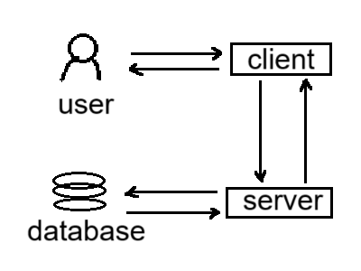

Functional Requirements

Functional Requirements

User Authentication and Management
- Users can register, log in, and log out using their credentials.
- Users can update their personal profiles, including interests and tags.

User Search and Tagging
- Users can search for other users based on tags and interests.

Room and Team Creation
- Users can create learning rooms or teams where they can collaborate on specific topics or projects.
- Each room can be dedicated to a specific topic or interest, and users can join based on their interests.

Recommendations and Suggestions
- The system will recommend similar users based on tags, shared interests, and learning goals.

Social Interaction Features
- Users can interact within teams, exchange messages, and collaborate in shared rooms.

Use Cases

Sign up
Initiator: Any user
Description: This allows new users to register new accounts.

Basic Flow of Events
This use case begins when a new user attempts to register a new account through entering his/her email address and password. The system verifies that the password is strong [E-1] and email address is not used [E-2], then the system allows the user to create a new account and writes to the database.

Exceptional Flow of Events
[E-1]: Week password
The user should be asked to re-enter the password.
[E-2]: Used e-mail
The user should be asked to re-enter the email address.

Log in
Initiator: Any user
Description: This allows users to log in existing accounts.

Basic Flow of Events
This use case begins when a user attempts to log in an existing account through entering his/her e-mail address and password. The system verifies that the account exists[E-1] and the password is valid [E-2], then the system allows the user to log in the account and writes to the database.

Exceptional Flow of Events
[E-1]: Account doesn’t exist
Ask the user to re-enter the e-mail address.
[E-2]: Wrong password
The user should be asked to re-enter the password.

Update personal profile
Initiator: Any user
Description: This allows users to update their personal profiles.
Preconditions:
- The user has logged in his/her account.
Basic Flow of Events
This use case begins when a user attempts to change his/her profile. After editing, the user submits it to the server.

User searching
Initiator: Any user
Description: This allows users to search other users by name and tags.
Preconditions:
- The user has logged in his/her account.
Basic Flow of Events
This use case begins when a user attempts to search other users by name and tags. The system returns the result user list to the user.

Room or team creation
Initiator: Any user
Description: This allows users to create new learning rooms.
Preconditions:
- User has logged in the system.
Basic Flow of Events
This use case begins when a user attempts to create a new learning room or team through enter the room or team name and the tags.

Room or team deleting
Initiator: The user that created the room or team
Description: This allows users to delete learning rooms.
Preconditions:
- User has logged in the system.
- User is the creator.
Basic Flow of Events
This use case begins when a user attempts to delete a learning room or team.

Join room or team
Initiator: The user that not in it
Description: This allows users to join a room or team.
Preconditions:
- User has logged in the system.
- User is not in it.
Basic Flow of Events
This use case begins when a user attempts to join a team or room. If the user wants to join a team, the user should provide valid team licence [E-1].
Exceptions
- Invalid license
Refuse the join request.

Leave a room or team
Initiator: The user in a room or team.
Description: This allows users to leave a room or team.
Preconditions:
- User has logged in the system.
- User is in a room or team.
Basic Flow of Events
This use case begins when a user attempts to leave a team or room. If the user wants to leave a team or room, the system will check whether the user is the administrator or not. If there is only another one person left in the room of team after the user leaves, the room or team will be dismissed.
- If the user is administrator, the Administrator privileges will be transferred and then the user can leave.
- If the user is not administrator, the user can leave directly.
- If only one person will be in the room or team, the room or team will be dismissed.

User recommendation
Initiator: Any user
Description: Recommend other users that the user may be interested in to the user.
Preconditions:
- User has logged in the system.
Basic Flow of Events
Server searches the database, returns the user list to the user.

Social Interaction
Initiator: Any user
Description: Send message to other users or in a team or room.
Preconditions:
- User has logged in the system.
- If the user wants to send the message in a team or room. The user must be in the team or the room.
Basic Flow of Events
The user enters the message and submit it.

Flowchart

Sign up
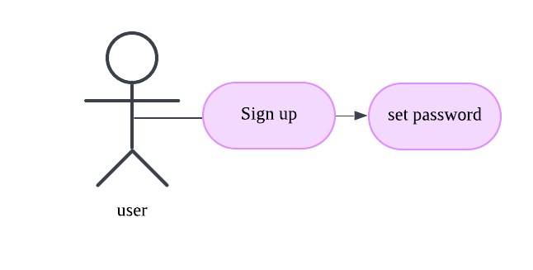

Login
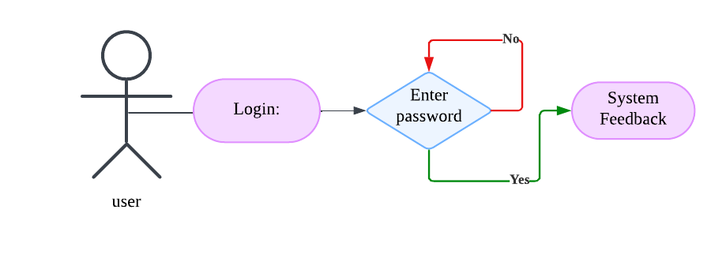

Update Profile
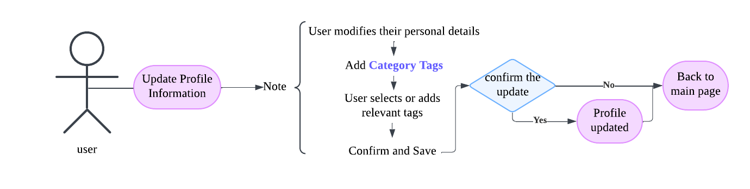

Search Users
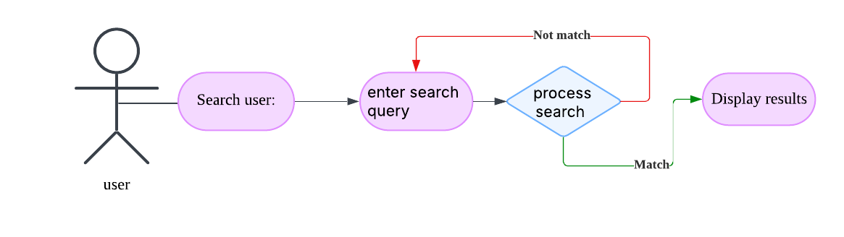

Create Rooms
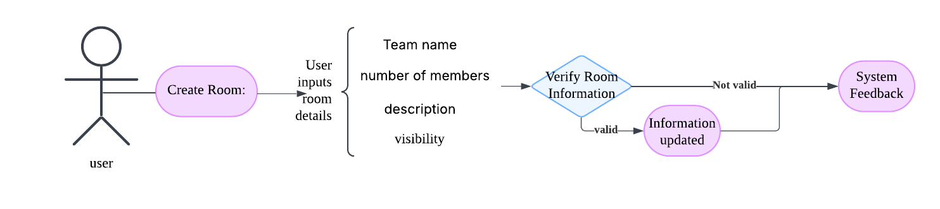

Create Teams
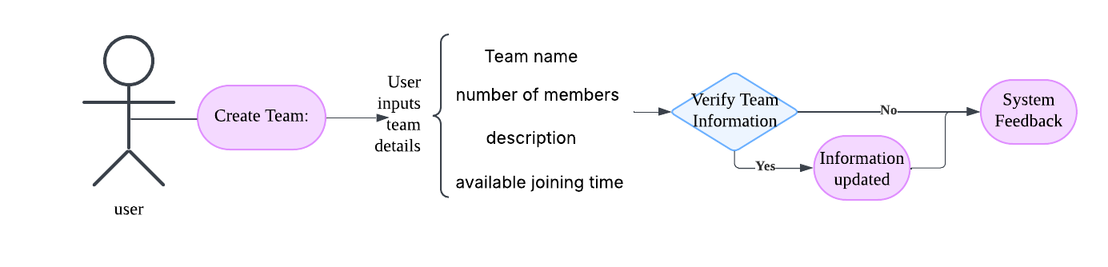

Delete Rooms or Teams
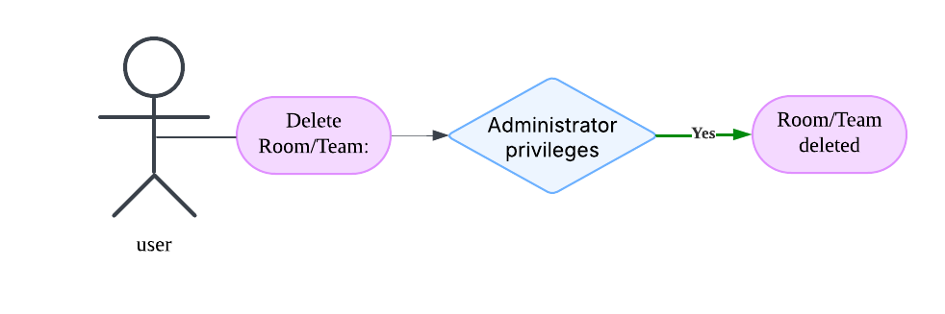

Join Rooms or Teams(Teams as an example)
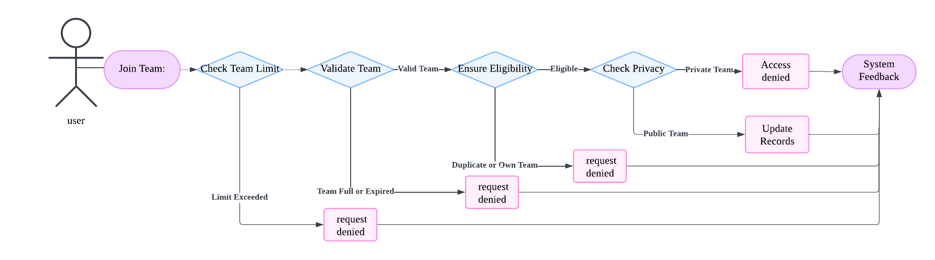

Leave Rooms or Teams
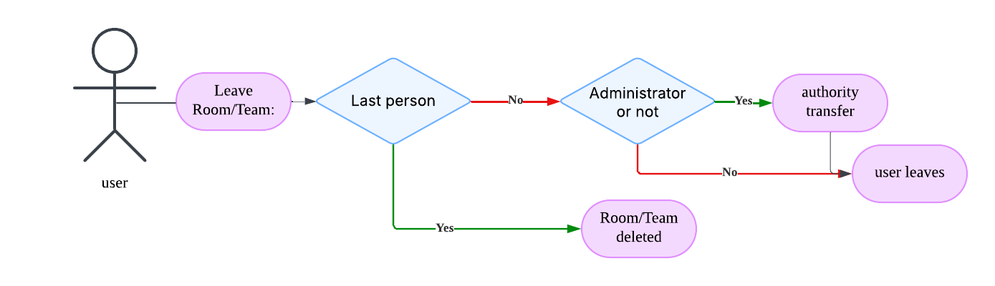

Recommend Similar Users
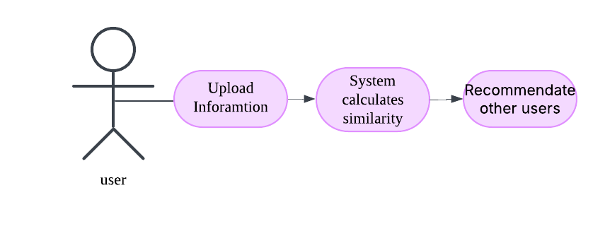

Communicate with Users
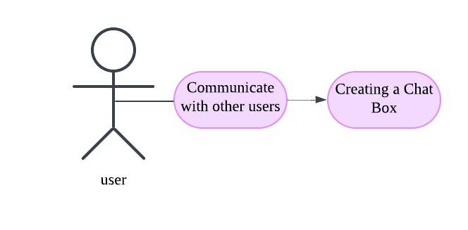

Non-functional Requirements

Performance Requirements
The server and client are required to respond within 2 seconds after a single user operation.

Safety and Security Requirements
- Authentication will rely on OAuth for third-party authentication.
- Encryption techniques for essential user data and communication.

Software Quality Attributes

Usability
The client must be usable on major decent browsers, including Firefox and Chrome.

Robustness
The server should be fault tolerant and have error handling methods.

