**Team**: Paul Boschert, Teresa Creech

**Title**: Tardis-box

**Project Summary**:

Tardis-box is a no-charge media distribution system. It will allow a guest to view and sort the available media and, if desired, create a member account using a valid email address. The member may delete this account, if all borrowed media has been checked in.

A member may view and sort the media with the option to check-out an item. If the requested media is unavailable, the request can be waitlisted to be checked out to the user as soon as it is available. The member may check-in media.

An administrator may view and sort the media. Only an admin can add and delete media. An administrator can delete a member account, if necessary and can handle overdue items.

**Project Requirements:**

|  |  |  |  |  |
| --- | --- | --- | --- | --- |
| Business Requirements | | | | |
| ID | **Requirement** | **Topic Area** | **User** | **Priority** |
| BR-01 | Member usernames must be a valid e-mail address. | Accounts | Member | Medium |
| BR-02 | Only admin can add/delete media items. | Database | Admin | Medium |
| BR-03 | Guests can view available media without having to create an account or login. | Database | Guest | Critical |

|  |  |  |  |  |
| --- | --- | --- | --- | --- |
| User Requirements | | | | |
| ID | **Requirement** | **Topic Area** | **User** | **Priority** |
| UR-01 | Guest can request and create their own account | Accounts | Guest | Critical |
|  |  |  |  |  |
| (Help Page)UR-02 | Any user can view media list | Database | All | Critical |
| UR-03 | A member can remove their account if certain conditions are met (e.g. no overdue items). | Accounts | Member | Medium |
| UR-04 | A member can make a request to checkout media. | Database | Member | Critical |
| UR-05 | A member can check-in media. | Database | Member | Critical |
| UR-06 | An admin can delete an account | Accounts | Admin | Medium |
| UR-07 | An admin can handle overdue items | Accounts | Admin | Medium |

|  |  |  |  |  |
| --- | --- | --- | --- | --- |
| Functional Requirements | | | | |
| ID | **Requirement** | **Topic Area** | **User** | **Priority** |
| FR-01 | There must be a display of the media that shows the title and an associated picture. | Database | All | Critical |
| FR-02 | There must be a way to view details of a particular media item (besides just a picture and title) that shows a short description and possibly other details e.g. IMDB data). | Database | All | Medium |
| FR-03 | There must be a way to sort the media for display to the user. | Database | All | Medium |
| FR-04 | There must be a way to put media on a waitlist, if necessary. | Accounts | Admin | Medium |
| FR-05 | There must be a way to remove item from waitlist (and check it out to a requestor) |  | Admin | Medium |

|  |  |  |  |  |
| --- | --- | --- | --- | --- |
| Non-Functional Requirements | | | | |
| ID | **Requirement** | **Topic Area** | **User** | **Priority** |
| NR-01 | Time to cycle from one page media titles to the next must be reasonable. | User Interface | All | Medium |
| NR-02 | Member credentials must be encrypted. | Accounts | Member | Low |
| NR-03 | Web pages need to be clearly worded and easy to navigate. | User Interface | All | Medium |

**Users and Tasks:**

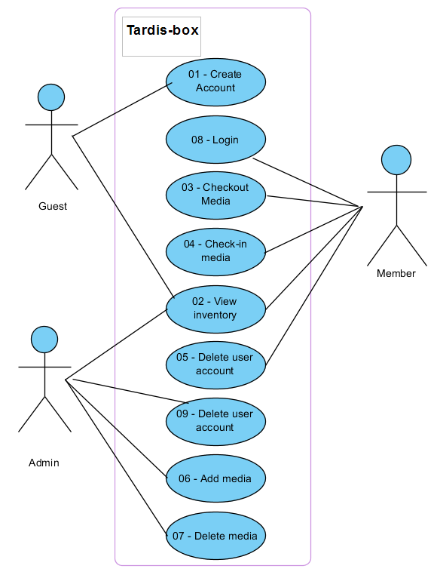

|  |  |  |  |
| --- | --- | --- | --- |
| Use Case ID: | UC-01 | | |
| Use Case Name: | Create Account | | |
| Description: | Allow a guest to create a member account, which will allow member access to the database of items to check out. | | |
|  | | | |
| Actor: | Guest | | |
| Pre-conditions: | Member database must exist | | |
| Post-conditions: | Guest becomes a Member | | |
| Frequency of Use: | Unknown, potentially 100% of guests | | |
| Flow of Events: |  | **Actor Action** | **System Response** |
| 1. | Guest visits homepage and clicks on “create account” button | Accesses the create account page |
| 2. | Guest enters first and last names, a valid email-id, enters a password, then presses “ok” | System verifies that the email is valid, creates entry in the member database containing this information. System issues an “account created” message |
| Variations: | Guest enters an invalid email-id. System issues error message then clears the create account page. Guest omits email-id and/or password – error message issued screen cleared. | | |
| Notes & Issues: |  | | |
| Developer Notes: |  | | |

|  |  |  |  |
| --- | --- | --- | --- |
| Use Case ID: | UC-02 | | |
| Use Case Name: | View Inventory | | |
| Description: | Allow a guest or member to access the item database. This will allow them to scroll through and sort (by item number, name, or description) | | |
|  | | | |
| Actor: | All | | |
| Pre-conditions: | Database exists with ability to sort and scroll, Guest/Member has accessed the View Media page | | |
| Post-conditions: | Database is scrolled and/or sorted | | |
| Frequency of Use: | Arbitrary, depends on guest/member needs | | |
| Flow of Events: |  | **Actor Action** | **System Response** |
| 1. | Uses scroll bar | Moves list up or down, depending on the direction user is moving scroll bar |
| 2. | Sort by clicking one of the column headers (once for ascending order, twice for descending order) | Sorts the list using the selected column, either in ascending or descending order as indicated by the number of clicks. |
| 3. | Double click item | Displays additional information |
| Variations: |  | | |
| Notes & Issues: | The check-in/out buttons will be grayed out when page is accessed from the home page instead of the sign in page. | | |
| Developer Notes: |  | | |

|  |  |  |  |
| --- | --- | --- | --- |
| Use Case ID: | UC-03 | | |
| Use Case Name: | Check-out Media | | |
| Description: | Member may borrow an item if it is available (not already checked-out). | | |
|  | | | |
| Actor: | Member | | |
| Pre-conditions: | Member is signed in and has accessed the View Media page | | |
| Post-conditions: | Item is either checked-out to the member or has been placed on a waitlist for the member. | | |
| Frequency of Use: | Arbitrary, estimated at least once per member login. | | |
| Flow of Events: |  | **Actor Action** | **System Response** |
| 1. | Enters an item number into the check-out field, Clicks OK button | Checks to see if the item is available. If it is, the item is checked-out to the member.  If not available, system issues message asking member if he wishes to add the item to the waitlist. |
| 2. | Selects yes | Item is added to waitlist and system issues confirmation message. |
| 3. | Selects no | System removes message |
| 4. |  |  |
| 5. |  |  |
| Variations: | Issue error message if the item number is invalid. | | |
| Notes & Issues: |  | | |
| Developer Notes: |  | | |

|  |  |  |  |
| --- | --- | --- | --- |
| Use Case ID: | UC-04 | | |
| Use Case Name: | Checkin Media | | |
| Description: | Member returns an item which had been borrowed | | |
|  | | | |
| Actor: | Member | | |
| Pre-conditions: | The item must already be checked-out to the member, member is logged in and has accessed the view items page | | |
| Post-conditions: | The item is available for check-out | | |
| Frequency of Use: | Done for up to 100% of items borrowed, estimate many times daily | | |
| Flow of Events: |  | **Actor Action** | **System Response** |
| 1. | Enters item number in the check-in field | System makes item available for check-out, updates item list, and removes it from the member’s account. Issues a “check-in successful” message. |
| 2. |  |  |
| 3. |  |  |
| 4. |  |  |
| 5. |  |  |
| Variations: | Members enters an invalid item number (either already available in the database or the item does not exist. An appropriate error message is displayed and the check-in field is cleared. | | |
| Notes & Issues: |  | | |
| Developer Notes: |  | | |

|  |  |  |  |
| --- | --- | --- | --- |
| Use Case ID: | UC-05 | | |
| Use Case Name: | Delete Account (Member) | | |
| Description: | Member may delete account as long as all items have been checked-in | | |
|  | | | |
| Actor: | Member | | |
| Pre-conditions: | Must be on login page | | |
| Post-conditions: | Account no longer exists | | |
| Frequency of Use: |  | | |
| Flow of Events: |  | **Actor Action** | **System Response** |
| 1. | Enters email-id and password | Verifies information |
| 2. | Clicks on Delete button | Verifies that no items are checked-out, removes account and issues confirmation email |
| 3. |  |  |
| 4. |  |  |
| 5. |  |  |
| Variations: | Email-id and/or Password invalid – system issues error message and clears screen  Items checked out – system issues message instructing Member to return items before account can be deleted | | |
| Notes & Issues: |  | | |
| Developer Notes: |  | | |

|  |  |  |  |
| --- | --- | --- | --- |
| Use Case ID: | UC-06 | | |
| Use Case Name: | Add media | | |
| Description: | A new media item can be added to the system. | | |
|  | | | |
| Actor: | Admin | | |
| Pre-conditions: | The media item must not already exist. | | |
| Post-conditions: | The new media item was added and is available for checkout. | | |
| Frequency of Use: | Arbitrary, anytime an admin needs to add media. Est: weekly | | |
| Flow of Events: |  | **Actor Action** | **System Response** |
| 1. | Log in to Tardis-box | User credentials are verified |
| 2. | Click on administrator panel | Administrative options are displayed |
| 3. | Click on media sub-panel | A list of media actions is displayed |
| 4. | Click on add media | The media entry form is displayed |
| 5. | Enter media details; click submit | The new media item is added |
| Variations: |  | | |
| Notes & Issues: |  | | |
| Developer Notes: |  | | |

|  |  |  |  |
| --- | --- | --- | --- |
| Use Case ID: | UC-07 | | |
| Use Case Name: | Delete media | | |
| Description: | A media item needs to be removed from the system. | | |
|  | | | |
| Actor: | Admin | | |
| Pre-conditions: | The media item must exist. | | |
| Post-conditions: | The media item deleted no longer exists in the system. | | |
| Frequency of Use: | Arbitrary, anytime an admin needs to delete media. Est: weekly | | |
| Flow of Events: |  | **Actor Action** | **System Response** |
| 1. | Log into Tardis-box | User credentials are verified |
| 2. | Click on administrator panel | Administrative options are displayed |
| 3. | Click on media sub-panel | A list of media actions is displayed |
| 4. | Click on delete media | A list of available media items is displayed |
| 5. | Select the media item; click delete | The media item is deleted |
| Variations: |  | | |
| Notes & Issues: |  | | |
| Developer Notes: |  | | |

|  |  |  |  |
| --- | --- | --- | --- |
| Use Case ID: | UC-08 | | |
| Use Case Name: | Login Member | | |
| Description: | A member may login to account | | |
|  | | | |
| Actor: | Member | | |
| Pre-conditions: | Member is on login page | | |
| Post-conditions: | Member is logged in | | |
| Frequency of Use: |  | | |
| Flow of Events: |  | **Actor Action** | **System Response** |
| 1. | Enter email-id and password, clicks on Login button | Verifies information, if account is an admin account, the system will go to the admin page.  Members are logged in and sent to view items page |
| 2. |  | If waitlisted item is now available, system displays message indicating that the item is available for check-out and will be deleted from the waitlist (checkout is in different UC table) |
| Variations: | Email-id and/or Password invalid – system issues error message and clears screen | | |
| Notes & Issues: |  | | |
| Developer Notes: |  | | |

|  |  |  |  |
| --- | --- | --- | --- |
| Use Case ID: | UC-09 | | |
| Use Case Name: | Delete account (Admin) | | |
| Description: | Administrators can remove user accounts | | |
|  | | | |
| Actor: | Admin | | |
| Pre-conditions: | The user that needs to be deleted exists. | | |
| Post-conditions: | The deleted user no longer exists. | | |
| Frequency of Use: | Arbitrary, anytime a user needs to be removed by an administrator. Est: monthly. | | |
| Flow of Events: |  | **Actor Action** | **System Response** |
| 1. | Log in to Tardis-box | User credentials are verified |
| 2. | Click on administrator panel | Administrative options are displayed |
| 3. | Click on user sub-panel | A list of users is displayed |
| 4. | Select a user | The user is highlighted |
| 5. | Click the remove icon | The user is removed |
| Variations: |  | | |
| Notes & Issues: |  | | |
| Developer Notes: |  | | |

**Activity Diagram:**

**TODO**

**Data Storage:**

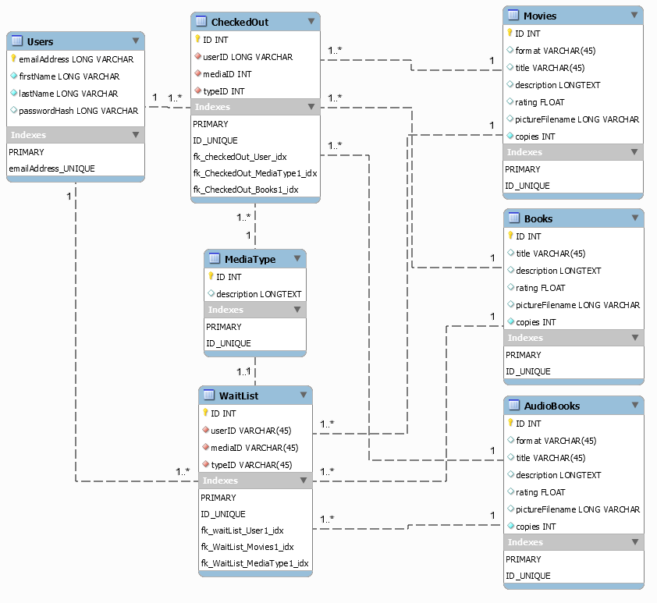

**UI Mockups:**

*In separate document, will be merged later*

**User Interactions:**

**TODO**

**Class Diagram:**

**TODO**