# Life Cycle Plan (LCP)

**Populic**

**Team No.4**

Chengyu Shen (Product Manager)

Shiji Zhou (Designer/Prototyper)

Yufei Hong (Feasibility Analyst)

Guanghe Cao (Software Architecture)

Yang Wei (Operational Concept Engineer)

Lin Xia (Life Cycle Planner)

William Goishi (Quality Focal Point)

# Version History

| Date | Author | Version | Changes made | Rationale |
| --- | --- | --- | --- | --- |
| 10/08/17 | Lin | 1.0 | Original template for use with Populic v1.0 | Initial draft for use with Populic v1.0 |
| 10/11/17 | Lin | 1.1 | Add COCOMO Estimation | Add scale factor according to COCOMO II |
| 11/22/17 | Lin | 1.2 | Add test result and Iteration Plan | Add test result detail of all the function. |

# Table of Contents

Life Cycle Plan (LCP) i

Version History ii

Table of Contents iii

1.Introduction 1

1.1 Purpose of the LCP 1

1.2 Status of the LCP 1

1.3 Assumptions 1

2.Milestones and Products 2

2.1 Overall Strategy 2

2.2 Project Deliverables 3

3.Responsibilities 6

3.1 Project-specific stakeholder’s responsibilities 6

3.2 Responsibilities by Phase 6

3.3 Skills 7

4.Approach 10

4.1 Monitoring and Control 10

4.2 Methods, Tools and Facilities 10

5. Resources 12

6. Iteration Plan 17

6.1 Plan 17

6.1.1 Capabilities to be implemented 17

6.1.2 Capabilities to be tested 18

6.1.3 Capabilities not to be tested 19

6.1.4 CCD Preparation Plans 19

6.2 Iteration Assessment 19

6.3 Adherence to Plan 21

Introduction

#### Purpose of the LCP

The Life Cycle Plan(LCP) document acts as a primary management tool to satisfy Populic’s Project Requirement. The document includes all the artifacts of each phase, the team members’ contribution at each stage and the milestone of five phases.

The Objectives of the Life Cycle Plan:

1. Aids in the construction and transitioning of the project.
2. Helps in maximizing the utility of people and resources throughout the life cycle of the project.
3. Will manage and control the progress of the project and ensure timely execution of each of the phases.
4. Ensure quality of project and feasibility through business-case analysis and resources available.

#### Status of the LCP

The status of the LCP is currently at version 1.1. The latest version that will be delivered to the client.

#### Assumptions

* + The duration of the project is 16 weeks which is entire 2017 Fall Semester.

Milestones and Products

#### Overall Strategy

The Populic project is following Architected Agile process because there is no Non-Development Item or Web service that would fit to most of the core capabilities.

**Exploration phase**

**Duration:** 09/12/2017-09/22/2017

**Concept:** identify initial scope of the product through the analysis of previous version. Understand the application architecture and life-cycle plan through client meetings and win-win negotiation. Based on capability of each member decide the team roles.

**Deliverables**: Valuation Report and Team Website, Client Interaction Report, Project Plan, Progress Report

**Milestone**: Valuation Commitment Review

**Strategy**: One Incremental Commitment Cycle

**Valuation phase**

**Duration:** 09/22/2017-10/2/2017

**Concept:** Negotiate with client to plan the final function and requirement. Seek the potential COTS which could be used in the later development phase according to the determined requirement. Identify all the risks and rank them. Attempt to implement the high risk prototype and discus the method to mitigate those risks.

**Deliverables**: Win-Condition Report, High Risk Prototype, Project Plan, Progress Report.

**Milestone**: Foundation Commitment Review

**Strategy**: One Incremental Commitment Cycle

**Foundation phase**

**Duration:** 10/02/2017- 10/18/2017

**Concept:** According to determined COTS and requirement, finish the whole High risks function prototype. Discuss with client and improve the prototype. Select the NDI and finish the life-cycle plan and architecture.

**Deliverables**: Development Commitment Package, Risk and Defect Report, Project Plan, Progress Report.

**Milestone**: Development Commitment Review

**Strategy**: One Incremental Commitment Cycle

**Development phase**

**Duration:** 10/19/2017- 11/15/2017

**Concept:** Each team member implements their individual part according to the prototype and test each subsystem and function. After finishing the peer code review, Have the team member who is charge of IV&V and client review the whole system and function to check all the functions which are discussed in previous phase

**Deliverables**: Core Capability Drive-Through Report, Risk and Defect Report, Progress Report, Technical Debt Report

**Milestone**: Transition Readiness Review, Core Capability Drive-Through

**Strategy**: One Incremental Commitment Cycle

#### Project Deliverables

##### Exploration Phase

Table : Artifacts Deliverables in Exploration Phase

|  |  |  |  |
| --- | --- | --- | --- |
| **Artifact** | **Due date** | **Format** | **Medium** |
| Client Interaction Report | 9/17/2017 | .doc, .pdf | Soft copy |
| Evaluation of Valuation Commitment Package | 09/27/2017 | .xls | Soft copy |
| Project Effort | Every Sunday | Text | ER system |
| Project Plan | Every other Sunday | .mpp, .pdf | Soft copy |
| Progress Report | Every other Sunday | .xls | Soft copy |
| Jira | Every Friday | Text/ticket | Jira Website |

##### Valuation Phase

Table 2: Artifact deliverable in Valuation Phase

|  |  |  |  |
| --- | --- | --- | --- |
| **Artifact** | **Due date** | **Format** | **Medium** |
| Win-Condition Report | 09/27/2017 | .pdf | soft copy |
| High Risk Prototype | 09/27/2017 | .pdf | soft copy |
| Progress Report | Every other Sunday | .pdf | soft copy |
| Jira | Every Friday | Text/ticket | Jira Website |
| Project Plan | Every other Sunday | .pdf | soft copy |

##### Foundations Phase

Table : Artifact deliverable in Foundations Phase

|  |  |  |  |
| --- | --- | --- | --- |
| **Artifact** | **Due date** | **Format** | **Medium** |
| Project Plan | Every other Sunday | .pdf | soft copy |
| Risk and Defect Report | Every other Sunday | .xls | soft copy |
| Jira | Every Friday | Text/ticket | Jira Website |
| Progress Report | Every other Sunday | .pdf | soft copy |
| FC Package   * Feasibility Evidence Description(FED) * Operational Concept Description(OCD) * Life Cycle Plan(LCP) * Prototype Report * System and Software Architecture Description (SSAD) | 10/15/2017 | .doc,.pdf | soft copy |
| On-Campus Technical Debt Report | Every other Friday | .xls | soft copy |
| QFP Technical Debt Report | Every other Friday | .xls | soft copy |

##### Development Phase

Table : Artifact deliverable in Development Phase

|  |  |  |  |
| --- | --- | --- | --- |
| **Artifact** | **Due date** | **Format** | **Medium** |
| Progress Report | Every other Sunday | .xls | soft copy |
| Risk and Defect Report | Every other Sunday | .xls | soft copy |
| Project Plan | Every other Sunday | .mpp ,.pdf | soft copy |
| Jira | Every Friday | text | Jira Website |
| DC Package | 12/05/2017 | .doc,.pdf | soft copy |
| Project Archive | 12/05/2017 | .doc,.pdf | soft copy |
| Individual Critique | 12/05/2017 | .doc,.pdf | soft copy |
| On-Campus Technical Debt Report | Every other Friday | .xls | soft copy |
| QFP Technical Debt Report | Every other Friday | .xls | soft copy |

Responsibilities

#### Project-specific stakeholder’s responsibilities

this project doesn’t have any project-specific stakeholder.

#### Responsibilities by Phase

The following table is a template for stakeholder’s responsibilities in each phase.

Table : Stakeholder's Responsibilities in each phase

|  |  |  |  |  |  |
| --- | --- | --- | --- | --- | --- |
| **Team Member / Role** | **Primary / Secondary Responsibility** | | | | |
| **Exploration** | **Valuation** | **Foundations** | **Development-** Construction Iteration | **Development-** Transition Iteration |
| **Name:**  Villi Vaananen  (Client) | **Primary Responsibility**  Give the overview and description of the application | **Primary Responsibility**  Negotiate the requirements and team responsibility with team members | **Primary Responsibility**  Review the project progress | **Primary Responsibility**  Check the prototype and project schedule and support the feedback | **Primary Responsibility**  Negotiate with the all team member for transition of the project |
| **Name:**  chengyu Shen (Product Manager) | **Primary Responsibility**  Learn the project and negotiate with client. Finish the project reports. Organize the team meeting  **Secondary Responsibility**  Develop Website | **Primary Responsibility**  Negotiate with client to decide the requirement  **Secondary Responsibility**  Maintain the website | **Primary Responsibility**  Design application prototype  Organize the team meeting. Report the project schedule  **Secondary Responsibility**  Develop Website | **Primary Responsibility**  Finish the development assignment  Keep a track of the progress schedule | **Primary Responsibility**  Help client finish transition job. |
| **Name:**  Shiji Zhou (Designer/Prototyper) | **Primary Responsibility**  Learn the project.  Participate in win-win negotiation | **Primary Responsibility**  Analysis the COTS and risk, identify the high risk part of project.  Reports | **Primary Responsibility**  Finish the prototype design and live demo  **Secondary Responsibility**  Create OCD document | **Primary Responsibility**  Develop the challenge display function. | **Primary Responsibility**  Submit relative document and help with transition of the project |
| **Name:**  Yufei Hong  (Requirements Engineer) | **Primary Responsibility**  Learn the project.  Participate in win-win negotiation | **Primary Responsibility**  Negotiate with client identify the accurate requirements better | **Primary Responsibility**  Finish related documents. | **Primary Responsibility**  Develop the daily challenge part of the application. | **Primary Responsibility**  Submit relative document and help with transition of the project |
| **Name:**  Guanghe Cao (Software Architecture) | **Primary Responsibility**  Learn the project.  Participate in win-win negotiation | **Primary Responsibility**  Analysis the COTS and design the software architecture | **Primary Responsibility**  Work on SSAD document and development | **Primary Responsibility**  Develop camera function of the application | **Primary Responsibility**  Submit relative document and help with transition of the project |
| **Name:**  Yang Wei  (Software Developer) | **Primary Responsibility**  Learn the project.  Participate in win-win negotiation | **Primary Responsibility**  Analysis the potential COTS and divide the whole system into sub part according to functionality | **Primary Responsibility**  Work on OCD document and set up system integration | **Primary Responsibility**  Develop the contact list page and invite function | **Primary Responsibility**  Submit relative document and help with transition of the project |
| **Name:**  Lin Xia  (Software Developer) | **Primary Responsibility**  Learn the project.  Participate in win-win negotiation  **Secondary Responsibility**  Develop team Website | **Primary Responsibility**  Analysis the potential COTS and divide the whole system into sub part according to functionality | **Primary Responsibility**  Work on LCP document and set up system integration | **Primary Responsibility**  Develop the daily challenge UI page and design API to get data from the server. | **Primary Responsibility**  Submit relative document and help with transition of the project |
| **Name:**  William Goishi (Quality Focal Point) | **Primary Responsibility**  Learn the project.  Participate in win-win negotiation | **Primary Responsibility**  Analyze risk and rationality of requirement and offer some solutions mitigate the risk | **Primary Responsibility**  Work on FED document | **Primary Responsibility**  Design the usage case and test cases for testing | **Primary Responsibility**  Submit relative document and help with transition of the project |

#### Skills

|  |  |  |
| --- | --- | --- |
| **Team members** | **Role** | **Skills** |
| Chengyu Shen | Product Manager | Current skills: Designing Prototype, UML Diagram, Web Development, IOS application development  Required skills: react native developing ,Management |
| Shiji Zhou | Designer/Prototyper | Current skills: Designing Prototype, Web Development, IOS application development  Required skills: react native developing ,Management |
| Name:  Yufei Hong  (Requirements Engineer) | Requirements Engineer | Current skills: UML Diagram, Web Development, IOS application development  Required skills: react native developing ,Management |
| Name:  Guanghe Cao (Software Architecture) | Software Architecture | Current skills: Designing Prototype, UML Diagram, Web Development, IOS application development  Required skills: react native developing ,Management |
| Name:  Yang Wei  (Software Developer) | Software Developer | Current skills: Designing Prototype, UML Diagram, Web Development, IOS application development  Required skills: react native developing |
| Name:  Lin Xia  (Software Developer) | Software Developer | Current skills: Designing Prototype, UML Diagram, Web Development, Android application development  Required skills: react native developing ,negotiation skill |
| Name:  William Goishi (Quality Focal Point) | Quality Focal Point | Current skills: Designing Prototype, UML Diagram, Web Development, IOS/ Android application development  Required skills: negotiation skill |

Approach

#### Monitoring and Control

We use five methods to monitor and control the project.

1. Progress Reports are used to keep a track of the project schedule and project plan which made in last week
2. Project Plan is used to record the deadline of each document and development schedules
3. Weekly Team Meetings are for discussion progress detail with all the team members
4. Slack is used to communicate with client and their engineer.
5. Communication outside of team meetings is done using a group chat on Wechat

##### Closed Loop Feedback Control

Our teams take following steps to get and provide feedback:

1. Each team member is in the Wechat group if they have any problem they can directly ask for help
2. We use team website to share all the documents created by any team member
3. We use Github to record and review the code and check the development schedules.
4. Email is used to send reminder about the meetings and deadline of submitting document

##### Reviews

Each task and function is finished, we will have code review and arrange all the related documents. After that, we will clarify all the development process and discussion if there are some parts we can improve upon. All the module based functions will undergo individual testing and then integration testing in which will provide feedback on whether another review is required or not.

#### Methods, Tools and Facilities

|  |  |  |
| --- | --- | --- |
| **Tools** | **Usage** | **Provider** |
| Xcode | Used to develop react native development | Apple |
| Webstorm | Used to develop react native development | [JetBrains](https://www.jetbrains.com/webstorm/) |
| Github | Used to record the version control. | Github |
| Wechat | Used for source code management | Tencent |
| Microsoft Office Visio | Used to design and draw UML and workflow | Microsoft |

### 5. Resources

Identify the following information in order to estimate the software cost:

* Estimated CSCI577a Effort : 7 team members at 15 hrs/week for 12 weeks
* Total estimated effort:1307 hours
* Budget information: $0
* Project duration: 12 weeks
* Component modules in your development project: Invitation Module, Challenge Module, Score Module.
* Programming language used: JavaScript node.js

Table : COCOMOII Scale Driver

|  |  |  |
| --- | --- | --- |
| **Scale Driver** | **Value** | **Rationale** |
| PREC | LOW | The team has no experience in developing application base on the |
| FLEX | HIGH | The client is flexible about the requirements |
| RESL | LOW | Team don’t have much knowledge and experience to identify the COTS and risk |
| TEAM | HIGH | Less interaction and collaboration among team members |
| PMAT | LOW | SEI CMM process maturity |
| Total Scale Factor = 18.97 | | |

Table : COCOMOII Challenge Cost Driver

|  |  |  |
| --- | --- | --- |
| **Cost Driver** | **Value** | **Rationale** |
| TOOL | VHI | We just use Xcode to development |
| RELY | NOM | This is separate function and don’t have much dependency |
| PCON | NOM | The developers are continuity, all of them will work on this project until the end of this semester |
| APEX | LOW | None of the developers have react native development experience |
| LTEX | LOW | Some developers have no JavaScript development experience |
| DOCU | LOW | The react native is new technic, there are few document which we can use |
| ACAP | HIGH | On one in this team has experience about designing pop box UI |
| DATA | HIGH | There is no any API which we can fetch data from server |
| SITE | NOM | The client’s developers are not in American， so they can not give much help. |
| CPLX | HIGH | The logic flow between different users is easy to design, but it still need do much effort on it |
| RUSE | LOW | The client didn’t offer any previous code about the challenge display |
| PCAP | NOM | The programmer needs more programming experience about the react native. |
| PVOL | LOW | React native framework updates at irregular intervals. |
| SCED | LOW | This project needs to be finished in 12 weeks |
| TIME | NOM | This module does not have huge impact on execution time |
| STOR | NOM | The client doesn’t offer any place to store the challenge content data |
| PLEX | NOM | The team members don’t have any develop experience on react native. |

Table 9: COCOMOII Score Cost Driver

|  |  |  |
| --- | --- | --- |
| **Cost Driver** | **Value** | **Rationale** |
| TOOL | VHI | We just use Xcode to development |
| RELY | NOM | This is separate function and don’t have much dependency |
| PCON | NOM | The developers are continuity, all of them will work on this project until the end of this semester |
| APEX | LOW | None of the developers have react native development experience |
| DATA | LOW | The is no API we can access the users information |
| RUSE | LOW | The client didn’t offer any previous code about the online shop |
| LTEX | LOW | Some developers have no JavaScript development experience |
| DOCU | LOW | The react native is new technic, but there are a lot documents which we can use |
| SITE | NOM | The client’s developers are not in American， so they can not give much help. |
| ACAP | HIGH | On one in this team has experience about designing online shop. |
| DATA | HIGH | There is no any API which we can fetch data from server |
| STOR | NOM | The client doesn’t offer any place to store the online shop data. |
| CPLX | NOM | The logic flow between different users is not easy to design |
| PLEX | NOM | The team members don’t have any develop experience on react native, but we can learn it quickly |
| PCAP | HIGH | Some of team members are not graduate students with Computer Science background |
| TIME | NOM | This module does not have much requirement on execution time |
| PVOL | NOM | React native framework updates at irregular intervals. |
| SCED | LOW | This project needs to be finished in 12 weeks |

Table 10: COCOMOII Invitation Cost Driver

|  |  |  |
| --- | --- | --- |
| **Cost Driver** | **Value** | **Rationale** |
| TOOL | VHI | We just use Xcode to development |
| RELY | NOM | This is separate function and don’t have much dependency |
| PCON | NOM | The developers are continuity, all of them will work on this project until the end of this semester |
| APEX | LOW | None of the developers have no react native development experience |
| **RUSE** | LOW | The client didn’t offer any previous code about the invitation function |
| LTEX | LOW | Some developers have no JavaScript development experience |
| **PCAP** | HIGH | The programmer needs more programming experience about the react native. |
| **TIME** | NOM | This module does not have huge impact on execution time |
| DOCU | LOW | The react native is new technic, but there are a lot document which we can use |
| **PLEX** | NOM | The team members don’t have any develop experience on react native, but it’s not very difficult to learn. |
| SITE | NOM | The client’s developers are not in American， so they can not give much help and communication. |
| **ACAP** | NOM | On one in this team has experience about using Listview component |
| DATA | HIGH | The IOS don’t allow application get users all contact information |
| PVOL | NOM | React native framework updates at irregular intervals. |
| STOR | NOM | The client doesn’t offer any place to store contact list |
| SCED | LOW | This project needs to be finished in 12 weeks |
| **CPLX** | NOM | The function can display all the contact list of user offer check book which users can check and send messages to their friends to invite them, this logic is not work flow to design |

**Overall COINCOMO Result**

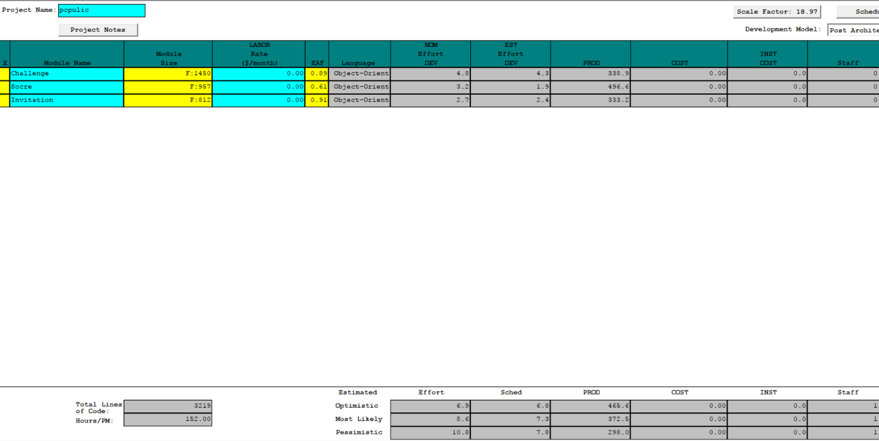

Estimation:

Number of SLOC: 3,219

Effort needed (Most Likely): 8.6 Person-Month

Each Member Works: 15 hrs/week for 12 weeks

Time Spent by Members:

Monthly Efforts: 15 hrs/week × 7 members × 4 weeks = 420 hrs/month

Total Efforts: 15 hrs/week x 7 members x 12 weeks = 1,260 total hours

Time Needed:

Monthly Efforts: (10.3 person-month x 152 hrs/person-month) ÷ 560 = 3.11 months

Total Efforts: (10.3 person-month × 152 hrs/person-month) = 1,307.2 total hours

Result: According to the above estimation, the project will take 3.1 months to complete. The team has 12 weeks which is within the estimated time to complete the project

**COINCOMO Cost Driver**

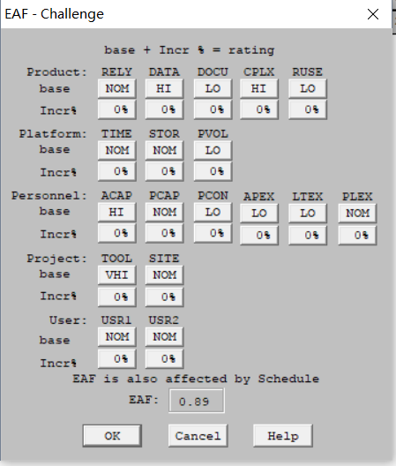 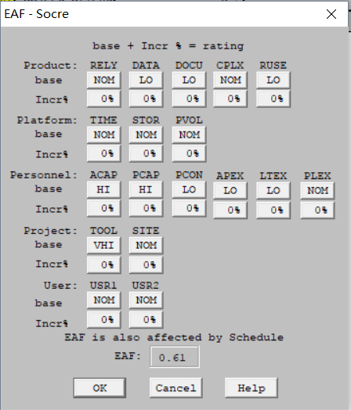

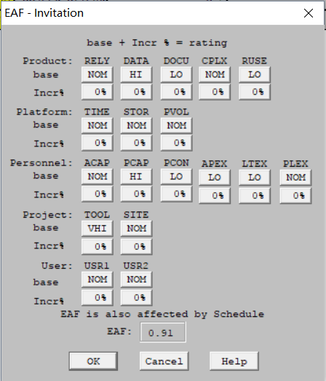

# 6. Iteration Plan

## 6.1 Plan

We plan use two cycles to finish the development phase. The first cycles will aim at finishing all the frontend part including all page’s UI, UX and the API of getting the data. And we will ensure all the front-end part can work well for the Core Capability Drive. During this phase, we need do some improvement according to client’s feedback and test result. This feedback would be very helpful for our next stage.

The second cycle will focus on back end. We will learn to use node.js to write API of support data to front-end and test the full functionality of the application. We will also help the client fix other functional bugs and improve our development schedule according the previous stage’s feedback.

After the development phase, our team members will focus on transitioning the system smoothly, finishing all the relative documents and list all the key point which the following development should be noticed.

#### 6.1.1 Capabilities to be implemented

Table : Construction iteration capabilities to be implemented

|  |  |  |  |  |
| --- | --- | --- | --- | --- |
| **ID** | **Capability** | **Description** | **Priority** | **Iteration** |
| 1 | Challenge Photos and Videos Post | The user can post challenge photos and videos on communities | High | 1 |
| 2 | Challenge Complete Competition | The user can choose one friend to compete the time of finishing daily challenge | High | 1 |
| 3 | Challenge Game Suggestion | The user can send their feedback and challenge ideas to client | Medium | 2 |
| 4 | upcoming 4 Days Daily Challenge Post | The system will post further 4 days daily challenge. | High | 1 |
| 5 | View, Approve or Decline Challenge: | The users are capable of viewing, approve or decline their friends challenge post. | High | 1 |
| 6 | Challenge Game Pop Screen | The user will touch the pop screen to get all daily challenge information | High | 1 |
| 7 | Offline & Online Notification | The user will get notification from populic. | High | 1 |
| 8 | Competition Reward | The user will get reward points from challenge competition | Medium | 1 |

#### 6.1.2 Capabilities to be tested

Table : Construction iteration capabilities to be tested

|  |  |  |  |  |
| --- | --- | --- | --- | --- |
| **ID** | **Capability** | **Description** | **Priority** | **Iteration** |
| 1 | Challenge Photos and Videos Post | The user can post challenge photos and videos on communities | High | 2 |
| 2 | Challenge Complete Competition | The user can choose one friend to compete the time of finishing daily challenge | High | 2 |
| 3 | Challenge Game Suggestion | The user can send their feedback and challenge ideas to client | Medium | 2 |
| 4 | upcoming 4 Days Daily Challenge Post | The system will post further 4 days daily challenge. | High | 2 |
| 5 | View, Approve or Decline Challenge | The users are capable of viewing, approve or decline their friends challenge post. | High | 2 |
| 6 | Challenge Game Pop Screen | The user will touch the pop screen to get all daily challenge information | High | 2 |
| 7 | Offline & Online Notification | The user will get notification from populic. | High | 2 |
| 8 | Competition Reward | The user will get reward points from challenge competition | Medium | 2 |

#### 6.1.3 Capabilities not to be tested

All the capabilities were test to ensure the application work well in any situation.

#### 6.1.4 CCD Preparation Plans

CCD is scheduled around November 15th to 18th. The client and his development team member will take part in. The clients will test all the challenge functions and give the feedback. And we will plan our next iteration according to that feedback. The client and his team members will act as a user and follow the instruction to run all the relative function to challenge each other.

Given below are our team member preparation plan for Core Capability Drive through session:

1. Make sure that the challenge content which fetch from server is correct and display perfectly.

2. Make sure that we can upload all the user’s challenge information and the data passing to the database is clear and conforming to the specification

3. Make sure that the server and database are up

4. Make sure all the pages are responsive.

5. Make sure that we have done a dry run with the whole team before the actual CCD session.

6. Ensure all of the client’s requirements have been implemented and tested.

## 6.2 Iteration Assessment

##### 6.2.1 Capabilities Implemented, Tested, and Results

The table below specifies the capabilities that were implemented, the test cases that were performed on it and the results obtained for each of them.

###### Table 22: Capabilities implemented, tested, and results

|  |  |  |  |  |
| --- | --- | --- | --- | --- |
| **ID** | **Capability** | **Test Case** | **Test Results** | **If fail, why?** |
| TC-1 | Navigation | TC-01-01 | Pass |  |
| TC-01-02 | Pass |  |
| TC-01-03 | Pass |  |
| TC-01-04 | Pass |  |
| TC-01-05 | Pass |  |
| TC-01-06 | Pass |  |
| TC-01-07 | Pass |  |
| TC-01-08 | Pass |  |
| TC-2 | Notification | TC-02-01 | Pass |  |
| TC-02-02 | Pass |  |
| TC-02-03 | Pass |  |
| TC-02-04 | Pass |  |
| TC-02-05 | Pass |  |
| TC-02-06 | Pass |  |
| TC-3 | Pick a competitor | TC-03-01 | Pass |  |
| TC-03-02 | Pass |  |
| TC-03-03 | Pass |  |
| TC-03-04 | Pass |  |
| TC-03-05 | Pass |  |
| TC-03-06 | Pass |  |
| TC-03-07 | Pass |  |
| TC-4 | Challenge page | TC-04-01 | Pass |  |
| TC-04-02 | Pass |  |
| TC-04-03 | Pass |  |
| TC-04-04 | Pass |  |
| TC-5 | Verification and score | TC-05-01 | Pass |  |
| TC-05-02 | Pass |  |
| TC-05-03 | Pass |  |
| TC-05-04 | Pass |  |
| TC-05-05 | Pass |  |
| TC-05-06 | Pass |  |
| TC-05-07 | Pass |  |
| TC-05-08 | Pass |  |
| TC-6 | Challenge others page | TC-06-01 | Pass |  |
| TC-06-02 | Pass |  |
| TC-06-03 | Pass |  |
| TC-06-04 | Pass |  |
| TC-06-05 | Pass |  |
| TC-7 | Post | TC-07-01 | Pass |  |
| TC-07-02 | Pass |  |
| TC-07-03 | Pass |  |
| TC-07-04 | Pass |  |

##### 

##### 6.2.2 Core Capabilities Drive-Through Results

Positive Feedback:

1. The response time of information change is pretty quick.
2. The work flow is clear and same as the requirement document.
3. All the notification message is accurate and in time.

Improvements Needed/Suggested:

1. The time remaining should not display the seconds
2. Add more detail about the user and opponent of the challenge
3. The application should navigate to the challenge page when user click the banner of notification.
4. There should be some Red spot for counting the notification numbers.

Risks:

1. Currently, the challenge is just for a pair of friends, it’s not easy to scale it to multiply players.

#### 6.3 Adherence to Plan

All our development plans are finished before the deadline. Every Friday team would have meeting to check if there are some team members meeting some problem, other team members would help them to avoid delay. One thing we could improve is that we don't have much knowledge and experience about the Git. So the version control is a big deal for us. We always meet some conflict and unknown problem. Because of that, we waste a lot of time. But finally we solve them by rolling back. Except that, our plan was carried perfectly.