System and Software Architecture Description (SSAD)

**<Populic>**

**<Team 4>**

**<Team members and roles>**

Chengyu Shen Project manager, Tester

Shiji Zhou Prototype

Yufei Hong Feasibility Analyst

Guanghe Cao Software Architect, UML modeler

Yang Wei Operational Concept Developer

Lin Xia Life Cycle Planner

William Goishi IIV&V, Quality Focal Point, Tester

**<12/04/2017>**

Version History

| Date | Author | Version | Changes made | Rationale |
| --- | --- | --- | --- | --- |
| 10/07/2017 | Guanghe Cao | 1.0 | * The Introduction and system   analysis part of the report | * Initial draft for the whole project |
| 10/11/2017 | Guanghe Cao | 1.1 | * Add the technology-specific model   and the frameworks | * Second version for the project |
| 11/29/2017 | Guanghe Cao | 2.0 | * Change the Process Realization Diagram and the class diagram | * Initial draft for the As-Built Package |
| 12/04/2017 | Guanghe Cao | 2.1 | * Fixed the mistake in the 1.1 version. | * Final draft for the As-Built Package |

Table of Contents

System and Software Architecture Description (SSAD) 1

Version History iv

Table of Contents vi

Table of Tables vii

Table of Figures viii

* + 1. Introduction ix
       1. Purpose of the SSAD ix
       2. Status of the SSAD ix
    2. System Analysis xi
       1. System Analysis Overview xi
       2. System Analysis Rationale xxi
    3. Technology-Independent Model xxiii
    4. Technology-Specific System Design xxiv
       1. Design Overview xxiv
       2. Design Rationale xxix
    5. Architectural Styles, Patterns and Frameworks xxxi

Table of Tables

Table 1: Actors Summary 8

Table 2: Artifacts and Information Summary 8

Table 3: Process Description 9

Table 4: Typical Course of Action 10

Table 5: Process Description 10

Table 6: Typical Course of Action 10

Table 7: Process Description 10

Table 8: Typical Course of Action 10

Table 9: Process Description 11

Table 10: Typical Course of Action 11

Table 11: Process Description 11

Table 12: Typical Course of Action 11

Table 13: Process Description 12

Table 14: Typical Course of Action 12

Table 15: Alternate Course of Action 12

Table 16: Process Description 12

Table 17: Typical Course of Action 13

Table 18: Process Description 13

Table 19: Typical Course of Action 13

Table 20: Alternate Course of Action 13

Table 21: Process Description 14

Table 22: Typical Course of Action 14

Table 23: Process Description 14

Table 24: Typical Course of Action 14

Table 29: Hardware Component Description 18

Table 30: Software Component Description 18

Table 32: Design Class Description 19

Table 33: Architectural Styles, Patterns, and Frameworks 23

Table of Figures

Figure 1: System Context Diagram 7

Figure 2: Artifacts and Information Diagram 8

Figure 3: Process Diagram 9

Figure 4: Conceptual Domain Diagram 9

Figure 5: Hardware Component Class Diagram………………………………………………...……17

Figure 6: Software Component Class Diagram.…………………………………………………….…18

Figure 7: Design Class Diagram……………………………………………………………………...…19

Figure 8: Process Realization Diagram………………………………………………………………...20

* + 1. Introduction
       1. Purpose of the SSAD

This document is going to elaborate the system analysis, system design and it model, and architectural style, pattern and framework. The main part in this document is using system context diagram and use case to show the key properties of the system.

* + - 1. Status of the SSAD

This document is the final version. It contains the first two chapter, which is the introduction and the system analysis.

* + 1. System Analysis
       1. System Analysis Overview

The purpose of the challenge system is to appeal more user join in our app. In the original Map interface, we add a button to guide user open the ‘Challenge’ page, and take part in to the daily challenge, which is posted by us. The users have to challenge their friend to make a pair to compete with each other who can finish the challenge game first. Any user who can finish the challenge will have some point based on the time they spend. Also, user could invite their friend using contact list, which could make more people download the app.

* + - * 1. System Context

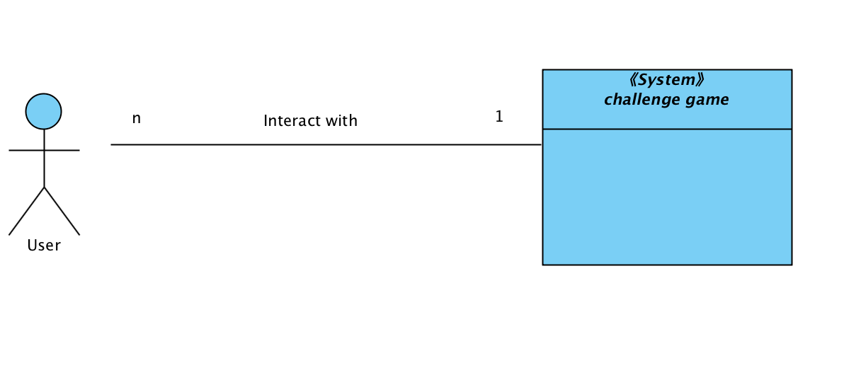

Figure 1: System Context Diagram

Table 1: Actors Summary

| **Actor** | **Description** | **Responsibilities** |
| --- | --- | --- |
| User | General user taking part in the challenge game. (We only have one kinds of user) | · Challenge other users.  · Accept other user’s challenge.  · Confirm or decline other challenge result.  · Post their challenge result.  · Submit their idea of challenge. |

* + - * 1. Artifacts & Information

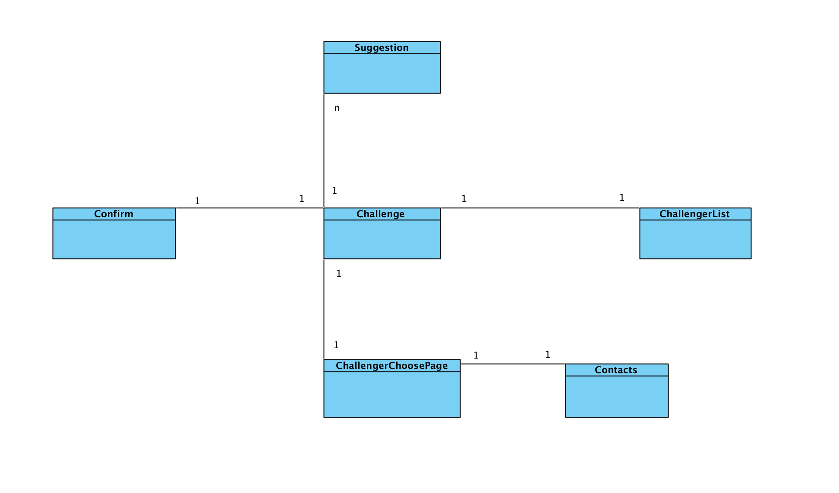

Figure 2: Artifacts and Information Diagram

Table 2: Artifacts and Information Summary

|  |  |
| --- | --- |
| **Artifact** | **Purpose** |
| Challenge | To help users know what’s the daily challenge and upcoming challenge, and guide user to other pages. |
| ChallengerChooserPage | To help users choose a friend from friend list. |
| Contact | To help user contact the friend who never download this app before. |
| ChallengerList | To help user choose one of other users who have challenge this user. |
| Confirm | To help user inspect whether their opponent have finish the challenge or not. |
| Suggestion | To help us get more suggestion of the challenge idea from the users. |

* + - * 1. Behavior

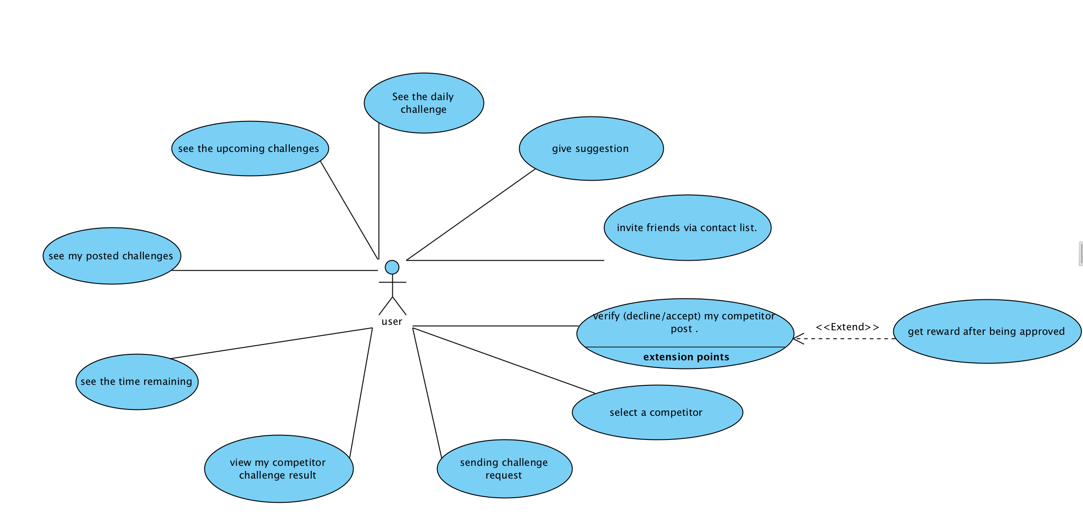

Figure 3: Process Diagram

**Capability** view

Process daily challenge

Table 3: Process Description

|  |  |
| --- | --- |
| **Identifier** | UC-1: seeing the daily challenge |
| **Purpose** | Make user interested in taking part in challenge. |
| **Requirements** |  |
| **Development Risks** | None |
| **Pre-conditions** | User click the challenge button. |
| **Post-conditions** | User is able to see the content of daily challenge. |

Table 4: Typical Course of Action

|  |  |  |
| --- | --- | --- |
| **Seq#** | **Actor’s Action** | **System’s Response** |
| **1** | Open challenge page |  |
| **2** |  | Show the daily challenge |

Process upcoming challenge

Table 5: Process Description

|  |  |
| --- | --- |
| **Identifier** | UC-2: See the upcoming challenge |
| **Purpose** | Make user more interested in this challenge game. |
| **Requirements** |  |
| **Development Risks** | None |
| **Pre-conditions** | User click the challenge button. |
| **Post-conditions** | User is able to see the content of upcoming challenge. |

Table 6: Typical Course of Action

|  |  |  |
| --- | --- | --- |
| **Seq#** | **Actor’s Action** | **System’s Response** |
| **1** | Open challenge page |  |
| **2** |  | Show the upcoming challenge. |

Process time remaining

Table 7: Process Description

|  |  |
| --- | --- |
| **Identifier** | UC-3: See the time remaining of the challenge |
| **Purpose** | Make user more urgent to finish the challenge. |
| **Requirements** |  |
| **Development Risks** | None |
| **Pre-conditions** | User click the challenge button. |
| **Post-conditions** | User is able to see the time remaining of the challenge. |

Table 8: Typical Course of Action

|  |  |  |
| --- | --- | --- |
| **Seq#** | **Actor’s Action** | **System’s Response** |
| **1** | Open challenge page |  |
| **2** |  | Show the time remaining of the challenge. |

Process challenge result

Table 9: Process Description

|  |  |
| --- | --- |
| **Identifier** | UC-4: See own post challenge result. |
| **Purpose** | Make users make sure what they have done. |
| **Requirements** |  |
| **Development Risks** | None |
| **Pre-conditions** | User click the own challenge list button. |
| **Post-conditions** | User is able to see own challenge result. |

Table 10: Typical Course of Action

|  |  |  |
| --- | --- | --- |
| **Seq#** | **Actor’s Action** | **System’s Response** |
| **1** | click the own challenge list button |  |
| **2** |  | Show own challenge result. |

Process y

Table 11: Process Description

|  |  |
| --- | --- |
| **Identifier** | UC-5: See opponent challenge result. |
| **Purpose** | Make users see what their opponent have done. |
| **Requirements** |  |
| **Development Risks** | None |
| **Pre-conditions** | User click opponent’s challenge list button. |
| **Post-conditions** | User is able to see opponent challenge result. |

Table 12: Typical Course of Action

|  |  |  |
| --- | --- | --- |
| **Seq#** | **Actor’s Action** | **System’s Response** |
| **1** | click opponent’s challenge list button. |  |
| **2** |  | Show opponent challenge result. |

**Capability** challenging

**Process** sending challenge

Table 13: Process Description

|  |  |
| --- | --- |
| **Identifier** | UC-6: Send challenge request |
| **Purpose** | Make more users take part in the challenge game. |
| **Requirements** | User has friends in the app. |
| **Development Risks** | None |
| **Pre-conditions** | User click the challenge button. |
| **Post-conditions** | User is able to see the content of daily challenge. |

Table 14: Typical Course of Action

|  |  |  |
| --- | --- | --- |
| **Seq#** | **Actor’s Action** | **System’s Response** |
| **1** | User clicks the challenge button. |  |
| **2** |  | Showing friends list |
| **3** | User clicks the friends that he/she want to challenge |  |
| **4** |  | Sending the challenge require to other users. |

Table 15: Alternate Course of Action

|  |  |  |
| --- | --- | --- |
| **Seq#** | **Actor’s Action** | **System’s Response** |
| **1** | User clicks the challenge button. |  |
| **2** |  | Showing friends list |
| **3** | User clicks ‘go back’ |  |
| **4** |  | Return to the former page |

**Process** select a competitor

Table 16: Process Description

|  |  |
| --- | --- |
| **Identifier** | UC-7: Select a competitor from the challenger list |
| **Purpose** | Make a pair that compete with each other |
| **Requirements** | User has friends who challenge him/her. |
| **Development Risks** | None |
| **Pre-conditions** | User click the challenger list button. |
| **Post-conditions** | User is able to have a competitor to compete about the challenge. |

Table 17: Typical Course of Action

|  |  |  |
| --- | --- | --- |
| **Seq#** | **Actor’s Action** | **System’s Response** |
| **1** | User clicks the challenge list button. |  |
| **2** |  | Showing challengerlist |
| **3** | User clicks the friends that he/she want to challenge |  |
| **4** |  | Make a pair successfully. |

**Process** daily challenge

Table 18: Process Description

|  |  |
| --- | --- |
| **Identifier** | UC-8: Verify competitor challenger result. |
| **Purpose** | Make sure that the user finish the challenge. |
| **Requirements** | User has posted the challenge result. |
| **Development Risks** | None |
| **Pre-conditions** | User click opponent challenger list button. |
| **Post-conditions** | User is able to approve or decline their opponent’s challenge result. |

Table 19: Typical Course of Action

|  |  |  |
| --- | --- | --- |
| **Seq#** | **Actor’s Action** | **System’s Response** |
| **1** | User clicks the opponent challenge list button. |  |
| **2** |  | Showing result of opponent’s result |
| **3** | User clicks approve button |  |
| **4** |  | Opponent get the reward. |

Table 20: Alternate Course of Action

|  |  |  |
| --- | --- | --- |
| **Seq#** | **Actor’s Action** | **System’s Response** |
| **1** | User clicks the opponent challenge list button. |  |
| **2** |  | Showing result of opponent’s result |
| **3** | User clicks decline button |  |
| **n** |  | Opponent’s result cancel and have to redo the challenge. |

**Process** invite

Table 21: Process Description

|  |  |
| --- | --- |
| **Identifier** | UC-9: Invite friend from contact list. |
| **Purpose** | Make more users download the app. |
| **Requirements** | User want to challenge the friend who do not have the app |
| **Development Risks** | None |
| **Pre-conditions** | User click contact list button. |
| **Post-conditions** | User is able to send a challenge message to friend. |

Table 22: Typical Course of Action

|  |  |  |
| --- | --- | --- |
| **Seq#** | **Actor’s Action** | **System’s Response** |
| **1** | User clicks contact list button. |  |
| **2** |  | Showing result of contact list |
| **3** | User clicks the person he/she wants to challenge. |  |
| **4** |  | Challenge invitation is sent. |

Capability suggestion

Table 23: Process Description

|  |  |
| --- | --- |
| **Identifier** | UC-10: Giving suggestion. |
| **Purpose** | To get more idea of the challenge topic. |
| **Requirements** | User have a new idea about the topic of the challenge |
| **Development Risks** | None |
| **Pre-conditions** | User click the suggestion button. |
| **Post-conditions** | We can get the idea of the challenge topic |

Table 24: Typical Course of Action

|  |  |  |
| --- | --- | --- |
| **Seq#** | **Actor’s Action** | **System’s Response** |
| **1** | User clicks suggestion button. |  |
| **2** |  | Showing suggestion page. |
| **3** | User write ideas and submit |  |
| **4** |  | Getting suggestion. |

* + - * 1. Modes of Operation

We don’t have more than one modes of operation in our system, so we will not contain any modes in this part.

* + - 1. System Analysis Rationale

In our team, there is no one who can design a good interface for the whole challenge process. And the interface is a little bit complicated and ugly. Given the user want to take part into the challenge game but without any impetus to figure out how to play the challenge game, it will be very dangerous for the app because the user would go away from the challenge game. Thus, our purpose is not accomplished because non-technology staff. The above mention is the aspects of analysis that are deemed by the team.

* + 1. Technology-Independent Model

This section is blank because our project is technology-specific model. So you can refer to the next chapter for the who content as required in the template.

* + 1. Technology-Specific System Design
       1. Design Overview
          1. System Structure

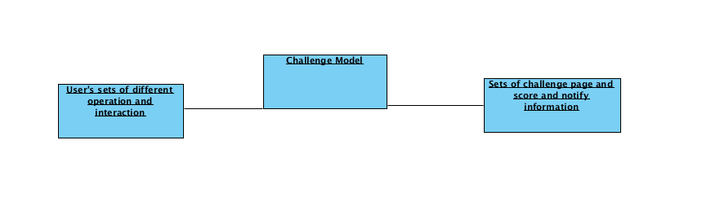

Figure 4: Conceptual Domain Diagram

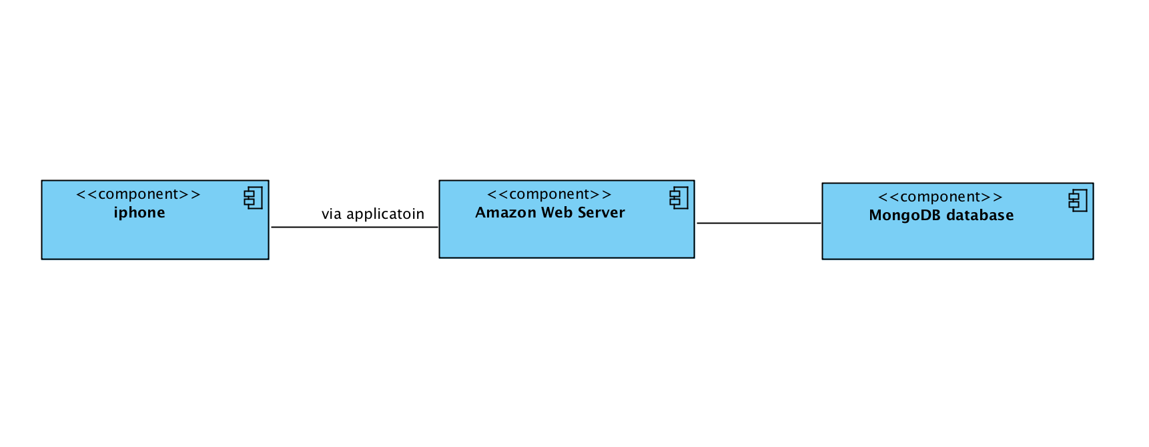

Figure 5: Hardware Component Class Diagram

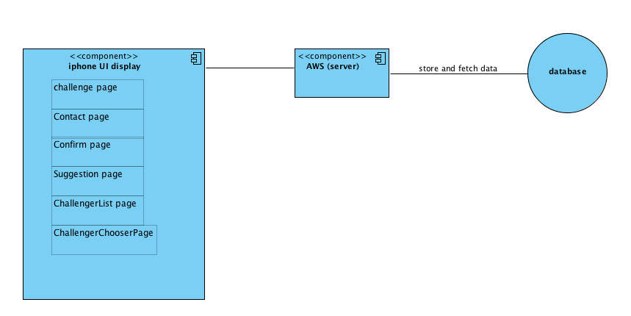

Figure 6: Software Component Class Diagram

Table 25: Hardware Component Description

|  |  |
| --- | --- |
| **Hardware Component** | **Description** |
| Iphone | Any iphone that download populic application |
| Amazon Web Service | A web server that could provide the service for the whole app |
| MongoDB database | A NoSQL database that store users’ profile, post and game info |

Table 26: Software Component Description

|  |  |
| --- | --- |
| **Software Component** | **Description** |
| Challenge | The challenge that every user could get when joining in the challenge game part. |
| ChallengerList | A list that the user has for choosing a challenger to challenge with. |
| Contact | A contact list that user has for inviting other users who have not download this app. |
| Suggestion | A suggestion part that could help users give more suggestion for the idea of the challenge topic |
| Confirm | A component that could help user go confirm opponent’s challenge result |
| ChallengerChooserPage | A page that could helper users choose one of the challenger |
| AWS (server) | For we use Amazon Web Server, we do not have to worry about the maintain of the server, so it could help us maintain the app very vell |
| DataBase | It could help us store the data of the user and challenge. |

* + - * 1. Design Classes

<User Classe>

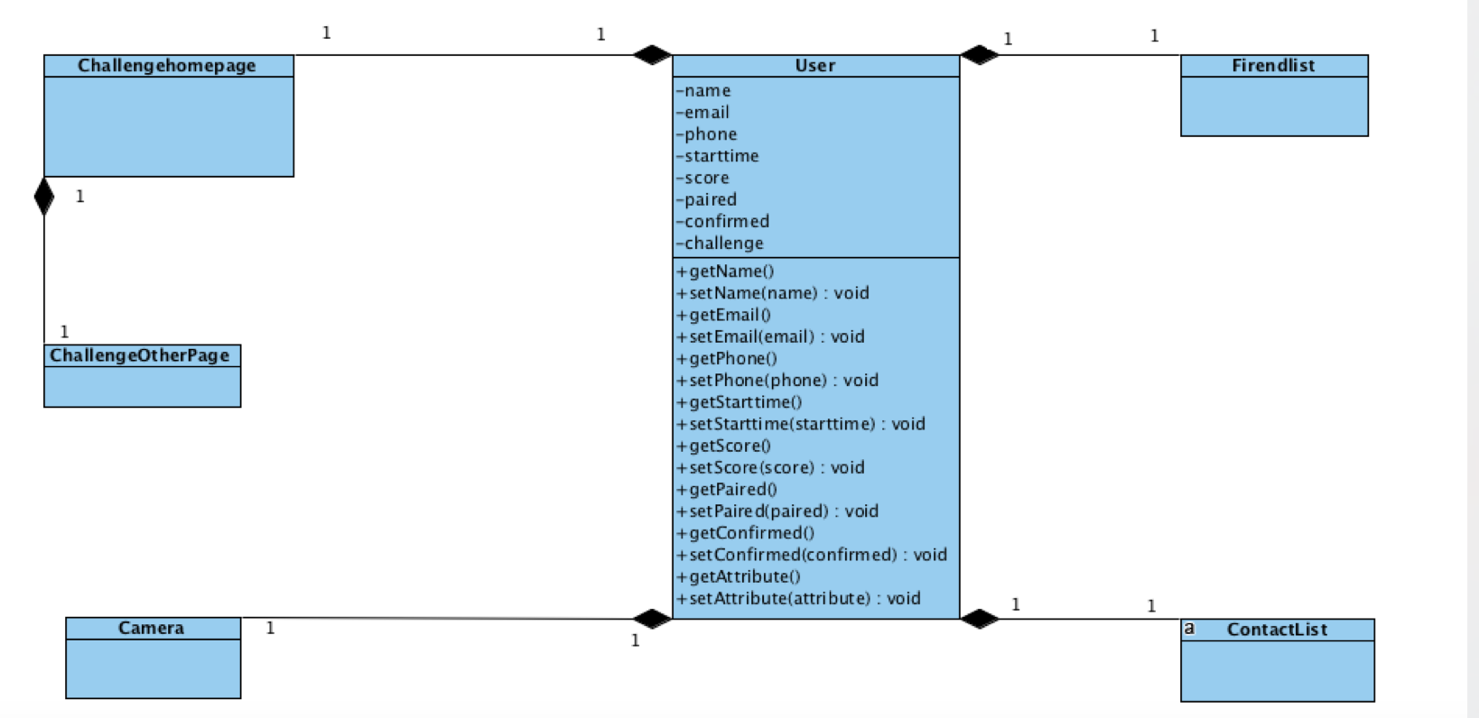

Figure 7: Design Class Diagram

Table 27: Design Class Description

|  |  |  |
| --- | --- | --- |
| **Class** | **Type** | **Description** |
| Challenghomepage | Controller | This implement the challenge function(Challenghomepage) |
| User | Controller | This is the user for the who app |
| FriendList | Entity | This is the list of friend for user to send challenge. |
| ContactList | Entity | This is the list of contact for user to send challenge. |
| ChallengeOtherPage | boundary | This is the page for challenge other |
| Camera | boundary | This is a tool for user to do the challenge |

* + - * 1. Process Realization

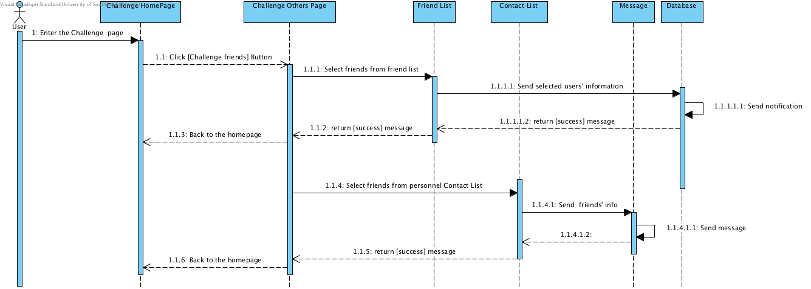

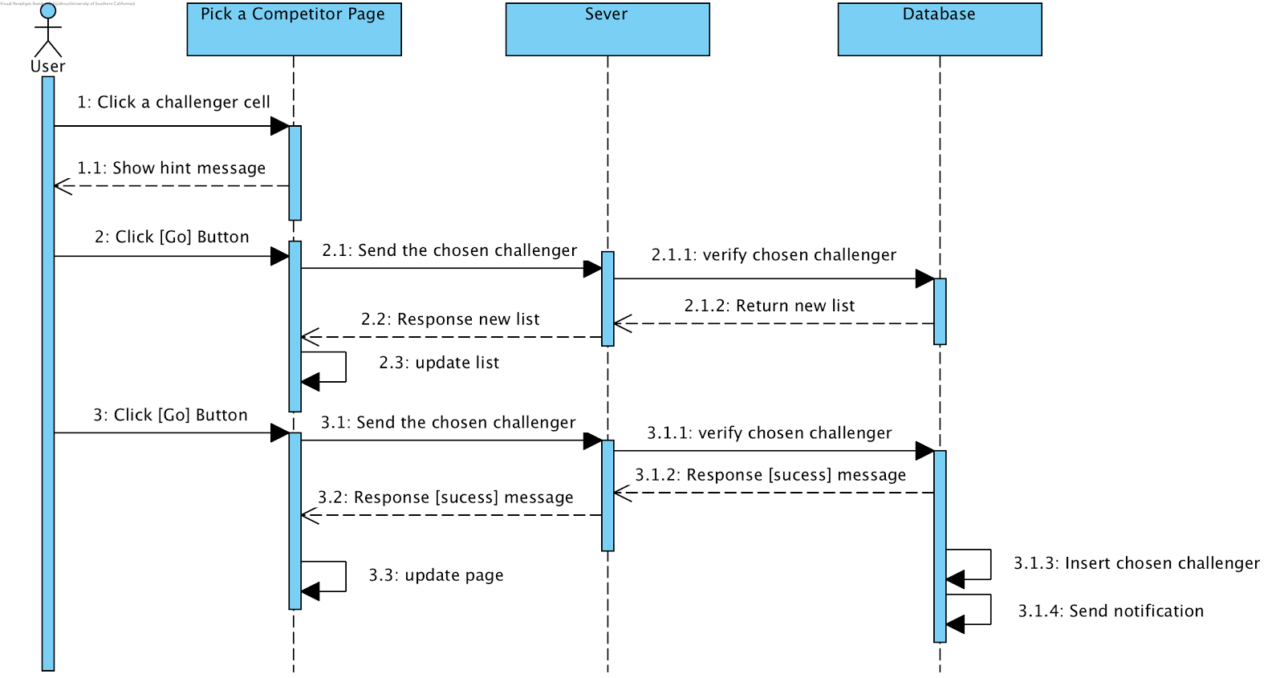

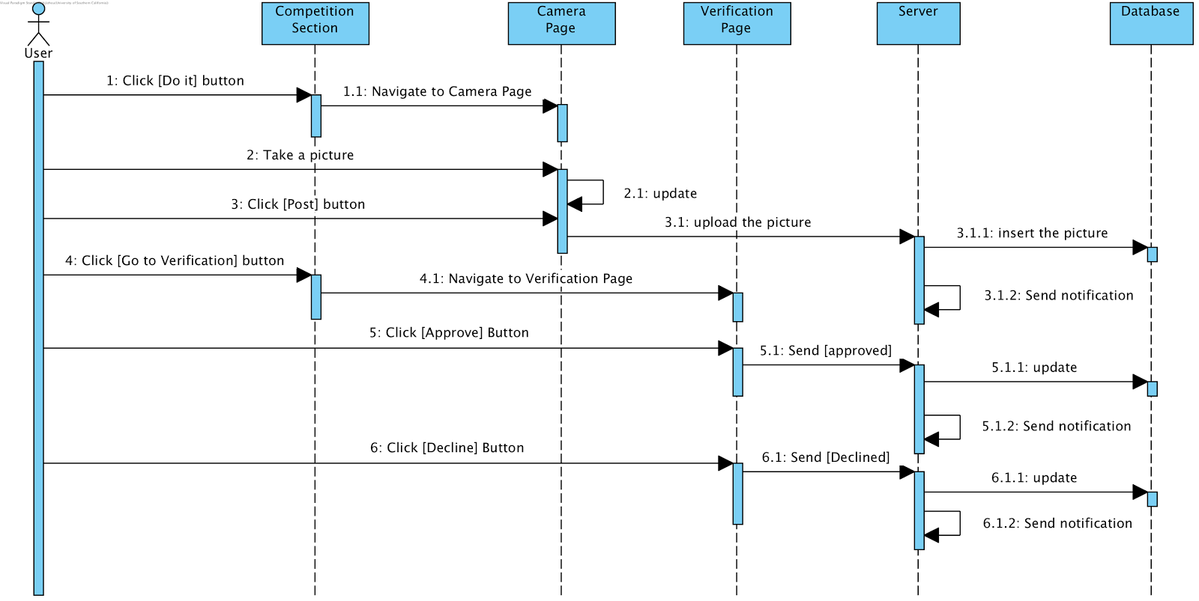

Figure 8: Process Realization Diagram

* + - 1. Design Rationale

The challenge game part we are designing is one of the functions that should be added in the current map. Thus, in the map, there is a button, which guides us to the page of challenge game part. When user enter into the challenge game part, there is a sign for us to challenge our friends. When we enter the page that we choose a friend to challenge with, there is two types of list we can choose. One is the friend list that we have in this app, the other is the contact that we get from user’s phone. When user send the invitation, the user who get the invitation could see a button that guide us to the page we choose one of the challenger who have sent the invitation. Then when the user make a pair and finish the challenge by posting the result, the challenge will have a confirm button for user to confirm. Then user could confirm opponent’s result, and then opponent will get the points after that.

For the who architecture, it is a three-tier architecture pattern.

1. UI display(iPhone)
2. Logic of the whole challenge game(AWS)
3. Database(MongoDB)

The UI display could show basic page connection of the challenge part without the logic of the game. In the server part, which is Amazon Web Server, we add the logic of the challenge game part, so that we could help users page turn correctly. And also, we need connect the database, which is MongoDB, with the server, so to store the user’s profile, post and game information.

* + 1. Architectural Styles, Patterns and Frameworks

Table 28: Architectural Styles, Patterns, and Frameworks

|  |  |  |
| --- | --- | --- |
| **Name** | **Description** | **Benefits, Costs, and Limitations** |
| Three-tire architecture | This is a architecture style that contain what I mention before, which are UI display, Amazon Web Service, MongoDB. They can not work without any other part in our project. UI display do not have any logic of the challenge game, and it also does not have any data (e.g. post, profile, game information) that store in UI display. It has to connect with the server, which is AWS (Amazon Web Service), and this kind of backend could help the user guide into the correct page, or connect the MongoDB to get the data from it to return it back to the UI display, so these parts is a three-tire architecture for the project. | Benefit: it could help the who project maintain very well because the server side could provide a very stable service for the project. Also, the who architecture could handle many case in the project, like one of the three lays can not work, it could not have much more damage for the other layer  Cost: Free  Limitation: We need to change all the layer’s code if we want to change a feature. |
| Client-server | For our project, Amazon Web Service is the server that provide the function for the project, and the client could run the app by the service provided by AWS. It is also a part of the three-tire architecture. | Benefit: separate the frontend and the backend.  Cost: free  Limitation: can not maintain as many as users. |