**User Manual**

**Populic**

**Team 04**

|  |  |  |
| --- | --- | --- |
| **Name** | **First Role** | **Second Role** |
| Guanghe Cao | Software Architect | Developer, Tester |
| Yang Wei | Operational Concept Engineer | Developer, Tester |
| Chengyu Shen | Project Manager | Developer, Tester |
| William Goishi | IIV & V | Developer, Tester |
| Lin Xia | Life Cycle Plan | Developer, Tester |
| Yufei Hong | Feasibility Analyst | Developer, Tester |
| Shiji Zhou | Prototyper | Developer, Tester |

**12/02/2016**

# Version History

| Date | Author | Version | Changes made | Rationale |
| --- | --- | --- | --- | --- |
| 12/02/17 | William | 1.0 | Original template for use with Populic v1.0 | Initial draft for use with Populic v1.0 |
|  |  |  |  |  |

**Table of Contents**

Version History ii

Table of Tables IIi

1. Introduction 1

1.1 Background 1

1.2 Populic Game Home Page 1

2. Populic Game 2

2.1 Background Information 2

2.2 Challenging Users 2

2.3 Picking a Competitor 3

3. Competition 4

3.1 Competition Page 5

### Introduction

#### Background

Our application is Populic and the focus of this is upon the game portion associated with the application. The purpose of populic’s game feature is to formulate an activity that can allow users to observe and interact amongst other players around in their region. This feature allows people to take part in activities and associate with the community to meet and get to know other people.

Populic’s game feature allows people to challenge one and another to accomplish tasks and post them via photos or videos which will be confirmed through confirmation reviews. Individuals are awarded points based on certain criteria when they accomplish the game challenge. The game itself consists of daily challenges while also allowing users to create challenges, in which they can challenge users and friends to take part in the challenge.

#### Populic Game Home Page

The game feature begins at the home page user interface where the page shows the daily challenge, offers the ability to challenge users, and offers other miscellaneous info that can help in accomplish game tasks.

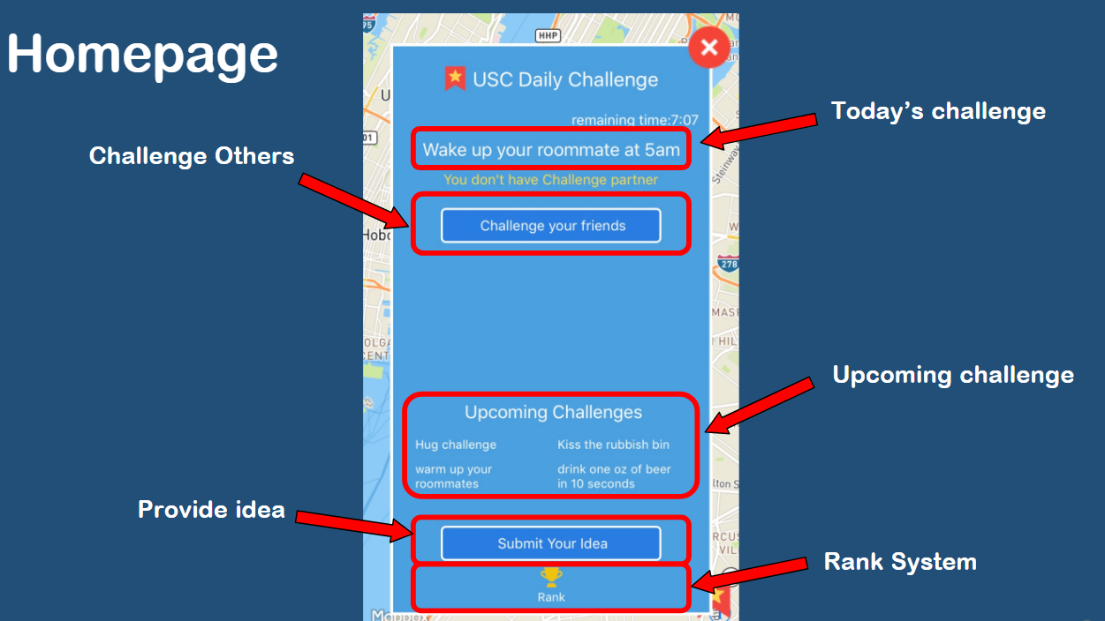

### Populic Game

#### Background Information

The challenge game main page offers many different functionalities and displays data for some of these functionalities. Some the data displayed is upcoming challenges, whether you are already in a challenge or not and with whom as well as a timer to track the time left on a challenge.

* Challenge your Friends
* Submit an Idea
* View Ranking to see user’s score as well as competitors

#### Challenging Users

The below image shows the methods of adding people to challenge whether it be from your friend list or from the contact list. Within the game feature, users are given the ability to challenge and invite friends from their contact list who do not have the app installed.

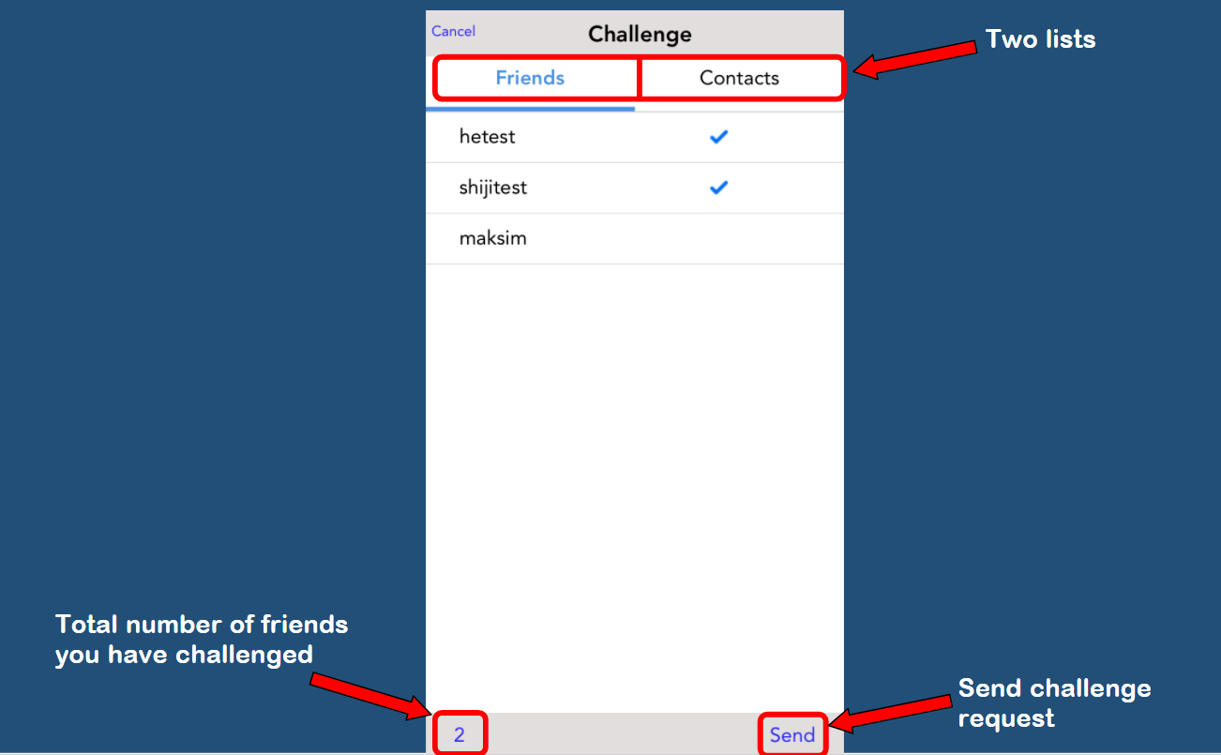

#### Picking a Competitor

Within the application when a user interacts with the challenge feature they are prompted to pick a competitor from the challenger list. If a user that is selected is in a challenge already, then an error message will be prompted notifying the user that, that specific user is already in a challenge for the day. By pressing the GO button users will be given either the error message or they will receive a game is one page that will provide details of the challenge relationship as well as sending a notification.

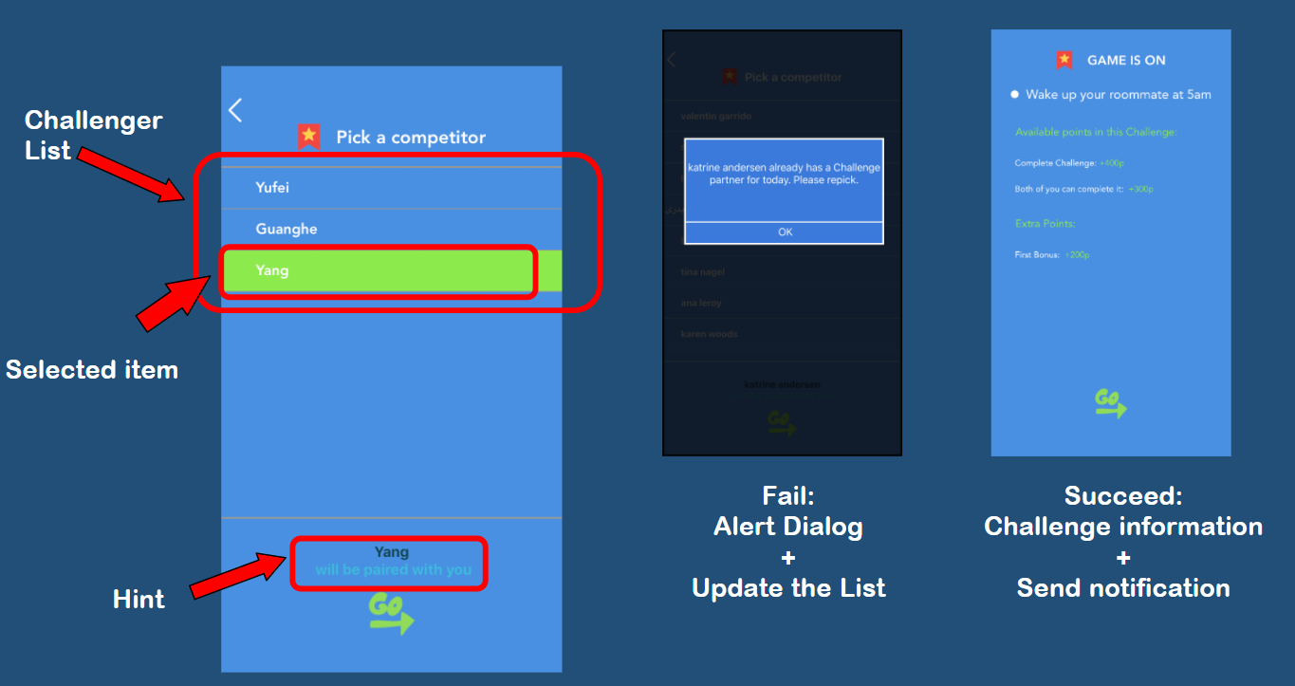

### Competition

#### Competition Page

The below image shows the main interface page for when a challenge is initiated among two competitors. The challenge description is shown as well as the two challengers.

User Can Press Button “Do It” to take a photo/video of him/herself doing challenge.

The points will update as the points are awarded to competitors once their photos are validated and confirmed.

