# System and Software Architecture Description (SSAD)

**<Populic>**

**<Team 4>**

**<Team members and roles>**

Chengyu Shen Project manager, Tester

Shiji Zhou Prototype

Yufei Hong Feasibility Analyst

Guanghe Cao Software Architect, UML modeler

Yang Wei Operational Concept Developer

Lin Xia Life Cycle Planner

William Goishi IIV&V, Quality Focal Point, Tester

**<10/07/2017>**

# Version History

| Date | Author | Version | Changes made | Rationale |
| --- | --- | --- | --- | --- |
| 10/07/2017 | Guanghe Cao | 1.0 | * The Introduction and system   analysis part of the report | * Initial draft for the whole project |

# Table of Contents

System and Software Architecture Description (SSAD) i

Version History ii

Table of Contents iii

Table of Tables iv

Table of Figures v

1. Introduction 6

1.1 Purpose of the SSAD 6

1.2 Status of the SSAD 6

2. System Analysis 7

2.1 System Analysis Overview 7

2.2 System Analysis Rationale 15

3. Technology-Independent Model 16

3.1 Design Overview 16

3.2 Design Rationale 18

4. Technology-Specific System Design 19

4.1 Design Overview 19

4.2 Design Rationale 21

5. Architectural Styles, Patterns and Frameworks 22

# Table of Tables

Table 1: Actors Summary 8

Table 2: Artifacts and Information Summary 8

Table 3: Process Description 9

Table 4: Typical Course of Action 10

Table 5: Process Description 10

Table 6: Typical Course of Action 10

Table 7: Process Description 10

Table 8: Typical Course of Action 10

Table 9: Process Description 11

Table 10: Typical Course of Action 11

Table 11: Process Description 11

Table 12: Typical Course of Action 11

Table 13: Process Description 12

Table 14: Typical Course of Action 12

Table 15: Alternate Course of Action 12

Table 16: Process Description 12

Table 17: Typical Course of Action 13

Table 18: Process Description 13

Table 19: Typical Course of Action 13

Table 20: Alternate Course of Action 13

Table 21: Process Description 14

Table 22: Typical Course of Action 14

Table 23: Process Description 14

Table 24: Typical Course of Action 15

# Table of Figures

Figure 1: System Context Diagram 7

Figure 2: Artifacts and Information Diagram 8

Figure 3: Process Diagram 9

### Introduction

#### Purpose of the SSAD

This document is going to elaborate the system analysis, system design and it model, and architectural style, parttern and framework. The main part in this document is using system context diagram and use case to show the key properties of the system.

#### Status of the SSAD

This document is the first version. It contains the first two chapter, which is the introduction and the system analysis.

### System Analysis

#### System Analysis Overview

The purpose of the challenge system is to appeal more user join in our app. In the original Map interface, we add a button to guide user open the ‘Challenge’ page, and take part in to the daily challenge, which is posted by us. The users have to challenge their friend to make a pair to compete with each other who can finish the challenge game first. Any user who can finish the challenge will have some point based on the time they spend. Also, user could invite their friend using contact list, which could make more people download the app.

##### System Context



Figure 1: System Context Diagram

Table 1: Actors Summary

| **Actor** | **Description** | **Responsibilities** |
| --- | --- | --- |
| User | General user taking part in the challenge game.(We only have one kinds of user) | • Challenge other user.  • Accept other user’s challenge.  • Confirm or decline other challenge result.  • Post their challenge result.  • Submit their idea of challenge. |

##### Artifacts & Information

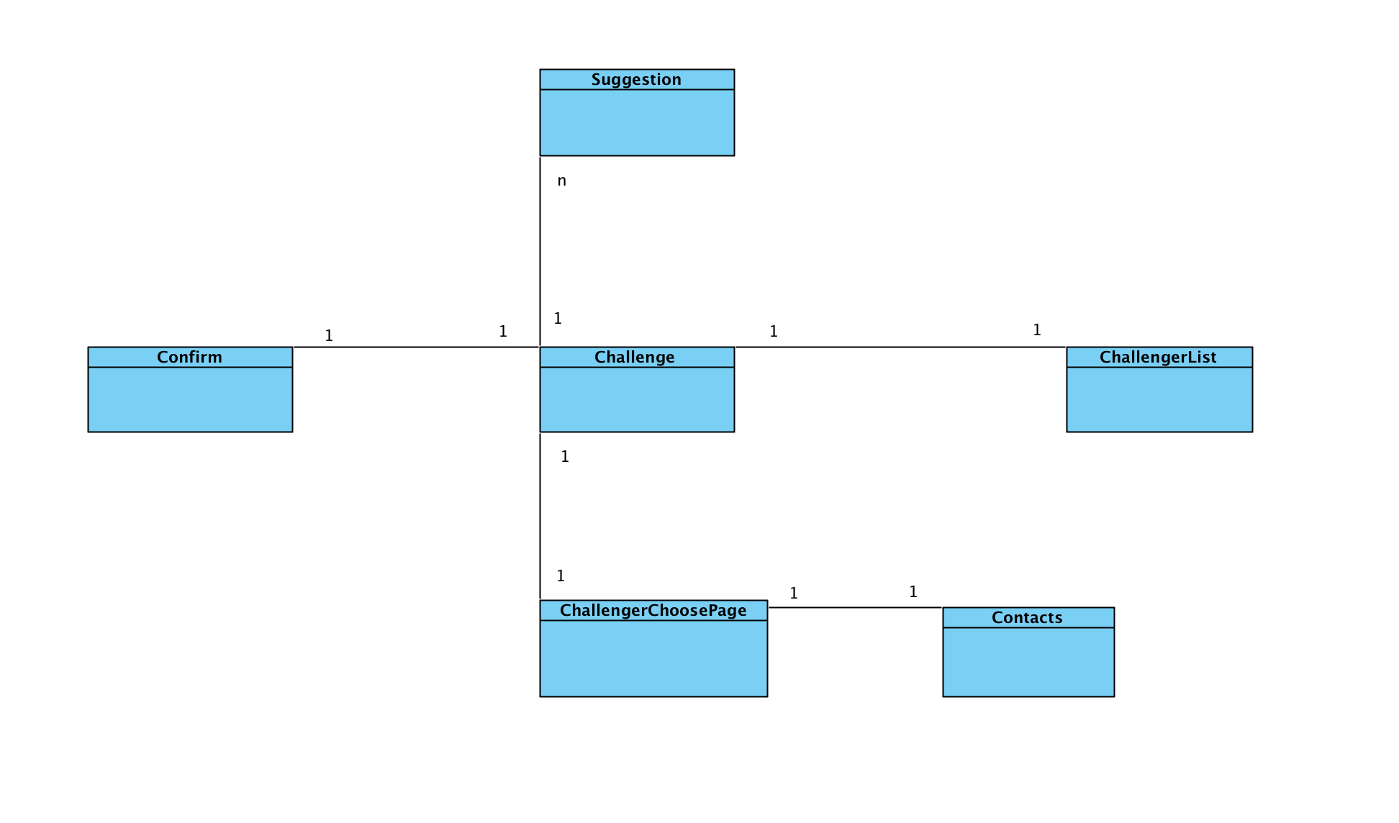

Figure 2: Artifacts and Information Diagram

Table 2: Artifacts and Information Summary

|  |  |
| --- | --- |
| **Artifact** | **Purpose** |
| Challenge | To help users know what’s the daily challenge and upcoming challenge, and guide user to other page. |
| ChallengerChooserPage | To help users choose a friend from friend list. |
| Contact | To help user contact the friend who never download this app before. |
| ChallengerList | To help user choose one of other users who have challenge this user. |
| Confirm | To help user inspect whether their opponent have finish the challenge or not. |
| Suggestion | To help us get more suggestion of the challenge idea from the users. |

##### Behavior

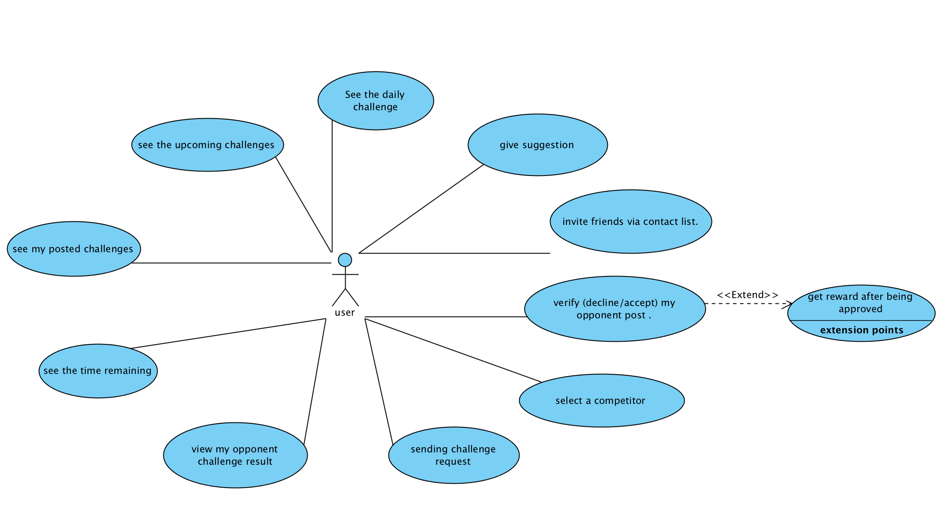

Figure 3: Process Diagram

###### Capability view

Process daily challenge

Table 3: Process Description

|  |  |
| --- | --- |
| **Identifier** | UC-1: seeing the daily challenge |
| **Purpose** | Make user interested in taking part in challenge. |
| **Requirements** |  |
| **Development Risks** | None |
| **Pre-conditions** | User click the challenge button. |
| **Post-conditions** | User is able to see the content of daily challenge. |

Table 4: Typical Course of Action

|  |  |  |
| --- | --- | --- |
| **Seq#** | **Actor’s Action** | **System’s Response** |
| **1** | Open challenge page |  |
| **2** |  | Show the daily challenge |

Process upcoming challenge

Table 5: Process Description

|  |  |
| --- | --- |
| **Identifier** | UC-2: seeing the upcoming challenge |
| **Purpose** | Make user more interested in this challenge game. |
| **Requirements** |  |
| **Development Risks** | None |
| **Pre-conditions** | User click the challenge button. |
| **Post-conditions** | User is able to see the content of upcoming challenge. |

Table 6: Typical Course of Action

|  |  |  |
| --- | --- | --- |
| **Seq#** | **Actor’s Action** | **System’s Response** |
| **1** | Open challenge page |  |
| **2** |  | Show the upcoming challenge. |

Process time remaining

Table 7: Process Description

|  |  |
| --- | --- |
| **Identifier** | UC-3: seeing the time remaining of the challenge |
| **Purpose** | Make user more urgent to finish the challenge. |
| **Requirements** |  |
| **Development Risks** | None |
| **Pre-conditions** | User click the challenge button. |
| **Post-conditions** | User is able to see the time remaining of the challenge. |

Table 8: Typical Course of Action

|  |  |  |
| --- | --- | --- |
| **Seq#** | **Actor’s Action** | **System’s Response** |
| **1** | Open challenge page |  |
| **2** |  | Show the time remaining of the challenge. |

Process challenge result

Table 9: Process Description

|  |  |
| --- | --- |
| **Identifier** | UC-4: seeing own post challenge result. |
| **Purpose** | Make users make sure what they have done. |
| **Requirements** |  |
| **Development Risks** | None |
| **Pre-conditions** | User click the own challenge list button. |
| **Post-conditions** | User is able to see own challenge result. |

Table 10: Typical Course of Action

|  |  |  |
| --- | --- | --- |
| **Seq#** | **Actor’s Action** | **System’s Response** |
| **1** | click the own challenge list button |  |
| **2** |  | Show own challenge result. |

Process y

Table 11: Process Description

|  |  |
| --- | --- |
| **Identifier** | UC-5: seeing opponent challenge result. |
| **Purpose** | Make users see what their opponent have done. |
| **Requirements** |  |
| **Development Risks** | None |
| **Pre-conditions** | User click opponent’s challenge list button. |
| **Post-conditions** | User is able to see opponent challenge result. |

Table 12: Typical Course of Action

|  |  |  |
| --- | --- | --- |
| **Seq#** | **Actor’s Action** | **System’s Response** |
| **1** | click opponent’s challenge list button. |  |
| **2** |  | Show opponent challenge result. |

###### Capability challenging

Process sending challenge

Table 13: Process Description

|  |  |
| --- | --- |
| **Identifier** | UC-6: send challenge request |
| **Purpose** | Make more users take part in the challenge game. |
| **Requirements** | User has friends in the app. |
| **Development Risks** | None |
| **Pre-conditions** | User click the challenge button. |
| **Post-conditions** | User is able to see the content of daily challenge. |

Table 14: Typical Course of Action

|  |  |  |
| --- | --- | --- |
| **Seq#** | **Actor’s Action** | **System’s Response** |
| **1** | User clicks the challenge button. |  |
| **2** |  | Showing friends list |
| **3** | User clicks the friends that he/she want to challenge |  |
| **4** |  | Sending the challenge require to other users. |

Table 15: Alternate Course of Action

|  |  |  |
| --- | --- | --- |
| **Seq#** | **Actor’s Action** | **System’s Response** |
| **1** | User clicks the challenge button. |  |
| **2** |  | Showing friends list |
| **3** | User clicks ‘go back’ |  |
| **4** |  | Return to the former page |

Process select a competitor

Table 16: Process Description

|  |  |
| --- | --- |
| **Identifier** | UC-7: select a competitor from the challenger list |
| **Purpose** | Make a pair that compete with each other |
| **Requirements** | User has friends who challenge him/her. |
| **Development Risks** | None |
| **Pre-conditions** | User click the challenger list button. |
| **Post-conditions** | User is able to have a competitor to compete about the challenge. |

Table 17: Typical Course of Action

|  |  |  |
| --- | --- | --- |
| **Seq#** | **Actor’s Action** | **System’s Response** |
| **1** | User clicks the challenge list button. |  |
| **2** |  | Showing challengerlist |
| **3** | User clicks the friends that he/she want to challenge |  |
| **4** |  | Make a pair successfully. |

Process daily challenge

Table 18: Process Description

|  |  |
| --- | --- |
| **Identifier** | UC-8: verify competitor challenger result. |
| **Purpose** | Make sure that the user finish the challenge. |
| **Requirements** | User has posted the challenge result. |
| **Development Risks** | None |
| **Pre-conditions** | User click opponent challenger list button. |
| **Post-conditions** | User is able to approve or decline their opponent’s challenge result. |

Table 19: Typical Course of Action

|  |  |  |
| --- | --- | --- |
| **Seq#** | **Actor’s Action** | **System’s Response** |
| **1** | User clicks the opponent challenge list button. |  |
| **2** |  | Showing result of opponent’s result |
| **3** | User clicks approve button |  |
| **4** |  | Opponent get the reward. |

Table 20: Alternate Course of Action

|  |  |  |
| --- | --- | --- |
| **Seq#** | **Actor’s Action** | **System’s Response** |
| **1** | User clicks the opponent challenge list button. |  |
| **2** |  | Showing result of opponent’s result |
| **3** | User clicks decline button |  |
| **n** |  | Opponent’s result cancel and have to redo the challenge. |

Process invite

Table 21: Process Description

|  |  |
| --- | --- |
| **Identifier** | UC-9: invite friend from contact list. |
| **Purpose** | Make more users download the app. |
| **Requirements** | User want to challenge the friend who do not have the app |
| **Development Risks** | None |
| **Pre-conditions** | User click contact list button. |
| **Post-conditions** | User is able to send a challenge message to friend. |

Table 22: Typical Course of Action

|  |  |  |
| --- | --- | --- |
| **Seq#** | **Actor’s Action** | **System’s Response** |
| **1** | User clicks contact list button. |  |
| **2** |  | Showing result of contact list |
| **3** | User clicks the person he/she wants to challenge. |  |
| **4** |  | Challenge invitation is sent. |

###### Capability suggestion

Table 23: Process Description

|  |  |
| --- | --- |
| **Identifier** | UC-10:giving suggestion. |
| **Purpose** | To get more idea of the challenge topic. |
| **Requirements** | User have a new idea about the topic of the challenge |
| **Development Risks** | None |
| **Pre-conditions** | User click the suggestion button. |
| **Post-conditions** | We can get the idea of the challenge topic |

Table 24: Typical Course of Action

|  |  |  |
| --- | --- | --- |
| **Seq#** | **Actor’s Action** | **System’s Response** |
| **1** | User clicks suggestion button. |  |
| **2** |  | Showing suggestion page. |
| **3** | User write ideas and submit |  |
| **4** |  | Getting suggestion. |

##### Modes of Operation

We don’t have more than one modes of operation in our system, so we will not contain any modes in this part.

#### System Analysis Rationale

In our team, there is no one who can design a good interface for the whole challenge process. And the interface is a little bit complicated and ugly. Given the user want to take part into the challenge game but without any impetus to figure out how to play the challenge game, it will be very dangerous for the app because the user would go away from the challenge game. Thus, our purpose is not accomplished because non-technology staff. The above mention is the aspects of analysis that are deemed by the team.

### Technology-Independent Model

#### Design Overview

##### System Structure

<< This section should contain

* a conceptual domain model
* a UML hardware component class diagram
* a UML software component class diagram
* a UML deployment diagram
* If necessary, a class diagram for the system's supporting software infrastructure
* and descriptions of the hardware components, software components, and, if necessary, the supporting software infrastructure components of the technology/platform-independent system architecture

More information and example can be found in **ICM EPG> Task:** **Define Technology-Independent Architecture >>**

<<Conceptual Domain Model>>

Figure 4: Conceptual Domain Model

<<Hardware Component Class Diagram>>

Figure 5: Hardware Component Class Diagram

<<Software Component Class Diagram>>

Figure 6: Software Component Class Diagram

<<Deployment Diagram>>

Figure 7: Deployment Diagram

<<Optional: Supporting Software Infrastructure Diagram>>

Figure 8: Supporting Software Component Class Diagram

Table 25: Hardware Component Description

|  |  |
| --- | --- |
| **Hardware Component** | **Description** |
|  |  |
|  |  |
|  |  |

Table 26: Software Component Description

|  |  |
| --- | --- |
| **Software Component** | **Description** |
|  |  |
|  |  |
|  |  |

Table 27: Supporting Software Component Description

|  |  |
| --- | --- |
| **Support Software Component** | **Description** |
|  |  |
|  |  |
|  |  |

##### Design Classes

This section should contain:

* UML class diagrams showing all the boundary, entity, and control classes in the design of the system being developed
* and a description of each class in the diagram

More information and example can be found in **ICM EPG> Task:** **Define Technology-Independent Architecture >>**

###### <Classes n>

<<Design Classes Class Diagram>>

Figure 9: Design Class Diagram

Table 28: Design Class Description

|  |  |  |
| --- | --- | --- |
| **Class** | **Type** | **Description** |
|  |  |  |
|  |  |  |
|  |  |  |

##### Process Realization

<< This section shows how the proposed architecture can be realized by conducting robustness analysis and constructing sequence diagrams. Make sure the elements used in robustness diagrams or sequence diagrams are traceable to the design classes, for example, by using the same names, or annotating the elements with the name(s) or id(s) of the referenced design class(s). More information and example can be found in **ICM EPG> Task:** **Define Technology-Independent Architecture >>**

<<Robustness Diagram>>

Figure 10: Robustness Diagram

<<Sequence Diagram>>

Figure 11: Sequence Diagram

#### Design Rationale

<< This section should contain an explanation of how/why the architecture/design described in previous sections was chosen. More information and example can be found in **ICM EPG> Task:** **Define Technology-Independent Architecture >>**

### Technology-Specific System Design

<< Once you know specific technology that you team is going to use, design the system and software architecture and document them in this section. >>

#### Design Overview

##### System Structure

<<Hardware Component Class Diagram>>

Figure 12: Hardware Component Class Diagram

<<Software Component Class Diagram>>

Figure 13: Software Component Class Diagram

<<Deployment Diagram>>

Figure 14: Deployment Diagram

<<Optional: Supporting Software Infrastructure Diagram>>

Figure 15: Supporting Software Component Class Diagram

Table 29: Hardware Component Description

|  |  |
| --- | --- |
| **Hardware Component** | **Description** |
|  |  |
|  |  |
|  |  |

Table 30: Software Component Description

|  |  |
| --- | --- |
| **Software Component** | **Description** |
|  |  |
|  |  |
|  |  |

Table 31: Supporting Software Component Description

|  |  |
| --- | --- |
| **Support Software Component** | **Description** |
|  |  |
|  |  |
|  |  |

##### Design Classes

###### <Classes n>

<<Design Classes Class Diagram>>

Figure 16: Design Class Diagram

Table 32: Design Class Description

|  |  |  |
| --- | --- | --- |
| **Class** | **Type** | **Description** |
|  |  |  |
|  |  |  |
|  |  |  |

##### Process Realization

<<Make sure the elements used in robustness diagrams or sequence diagrams are traceable to the design classes, for example, by using the same names, or annotating the elements with the name(s) or id(s) of the referenced design class(s). >>

<<Robustness Diagram>>

Figure 17: Robustness Diagram

<<Process Realization Diagram>>

Figure 18: Process Realization Diagram

#### Design Rationale

### Architectural Styles, Patterns and Frameworks

<< Describe any implementation architecture styles (e.g. the Prism style and 3-tier architecture), patterns (e.g. pipe-and-filter and client-server), or frameworks (e.g. Java and CORBA) used to describe the system architecture. >>

Table 33: Architectural Styles, Patterns, and Frameworks

|  |  |  |
| --- | --- | --- |
| **Name** | **Description** | **Benefits, Costs, and Limitations** |
|  |  |  |
|  |  |  |
|  |  |  |