# Prototype Report

**<Popublic>**

**<Team #04>**

|  |  |  |
| --- | --- | --- |
| **Name** | **First Role** | **Second Role** |
| Chengyu Shen | Project Manager | Operational Concept Engineer |
| Shiji Zhou | Prototyper | Software Architect & UML Modeler |
| Guanghe Cao | Software Architect & UML Modeler | Life Cycle Plan |
| Yufei Hong | Feasibility Analyst | Project Manager |
| Yang Wei | Operational Concept Engineer | Prototyper |
| Lin Xia | Life Cycle Plan | Feasibility Analyst |
| William Goishi | IIV & V | Tester |

**<10/08/2017>**

# Version History

| Date | | Author | | Version | | Changes made | | Rationale | |
| --- | --- | --- | --- | --- | --- | --- | --- | --- | --- |
| 10/08/17 | | SZ | | 1.0 | | * Draw the navigation flow of the challenge function * Design the prototype for the challenge function | | * Explore Feasibility * Gather more accurate requirements | |
|  | |  | |  | |  | |  | |
|  | |  | |  | |  | |  | |

# Table of Contents

Prototype Report i

Version History ii

Table of Contents iii

Table of Tables iv

Table of Figures v

1. Introduction 1

1.1 Purpose of the prototype report 1

1.2 Status of the prototype 1

2. Navigation Flow 2

3. Prototype 3

# Table of Tables

Table 1: Screenshot Challenge Page (Game does not start) 3

Table 2: Screenshot Contact List 4

Table 3: Screenshot ‘Pick a Competitor’ Page 5

Table 4: Screenshot Challenge Page (Game is on) 6

Table 5: Screenshot Confirm Page 7

# Table of Figures

Figure 1: Navigation Flow of Popublic Challenge System 2

Figure 2: Screenshot Challenge Page(Game does not start) 3

Figure 3: Screenshot Contact List 4

Figure 4: Screenshot ‘Pick a Competitor’ Page 5

Figure 5: Screenshot Challenge Page (Game is on) 6

Figure 6: Screenshot Confirm Page 7

### Introduction

**1.1 Purpose of the prototype report**

Before we have the prototype, we are facing a lot of risks for the whole project, and we even didn’t know about the existing of these risks. During the prototype, we could get to know these risks that we could think about only using our mind. It is like what we could use the demo to figure what’s the potential risks in our project. After we figure out the risks, we could discuss how to mitigate the risks. So that we could go to the next step with our client when we discuss the risks we find.

**1.2 Status of the prototype**

After we had the first version of prototype, we got to know that we should have a challenger list, that could help us choose one of the challengers who want to challenge us. Second, we have proposed a score system, which could help us to make the difference between the user who have finished the challenge, and the user who have not finished the challenge. Also, the score will show on the page when the game is on. Last but not the least, we have designed the confirm page, which could help the app the verified whether the users have finished the challenge game or not by their opponents.

### Navigation Flow

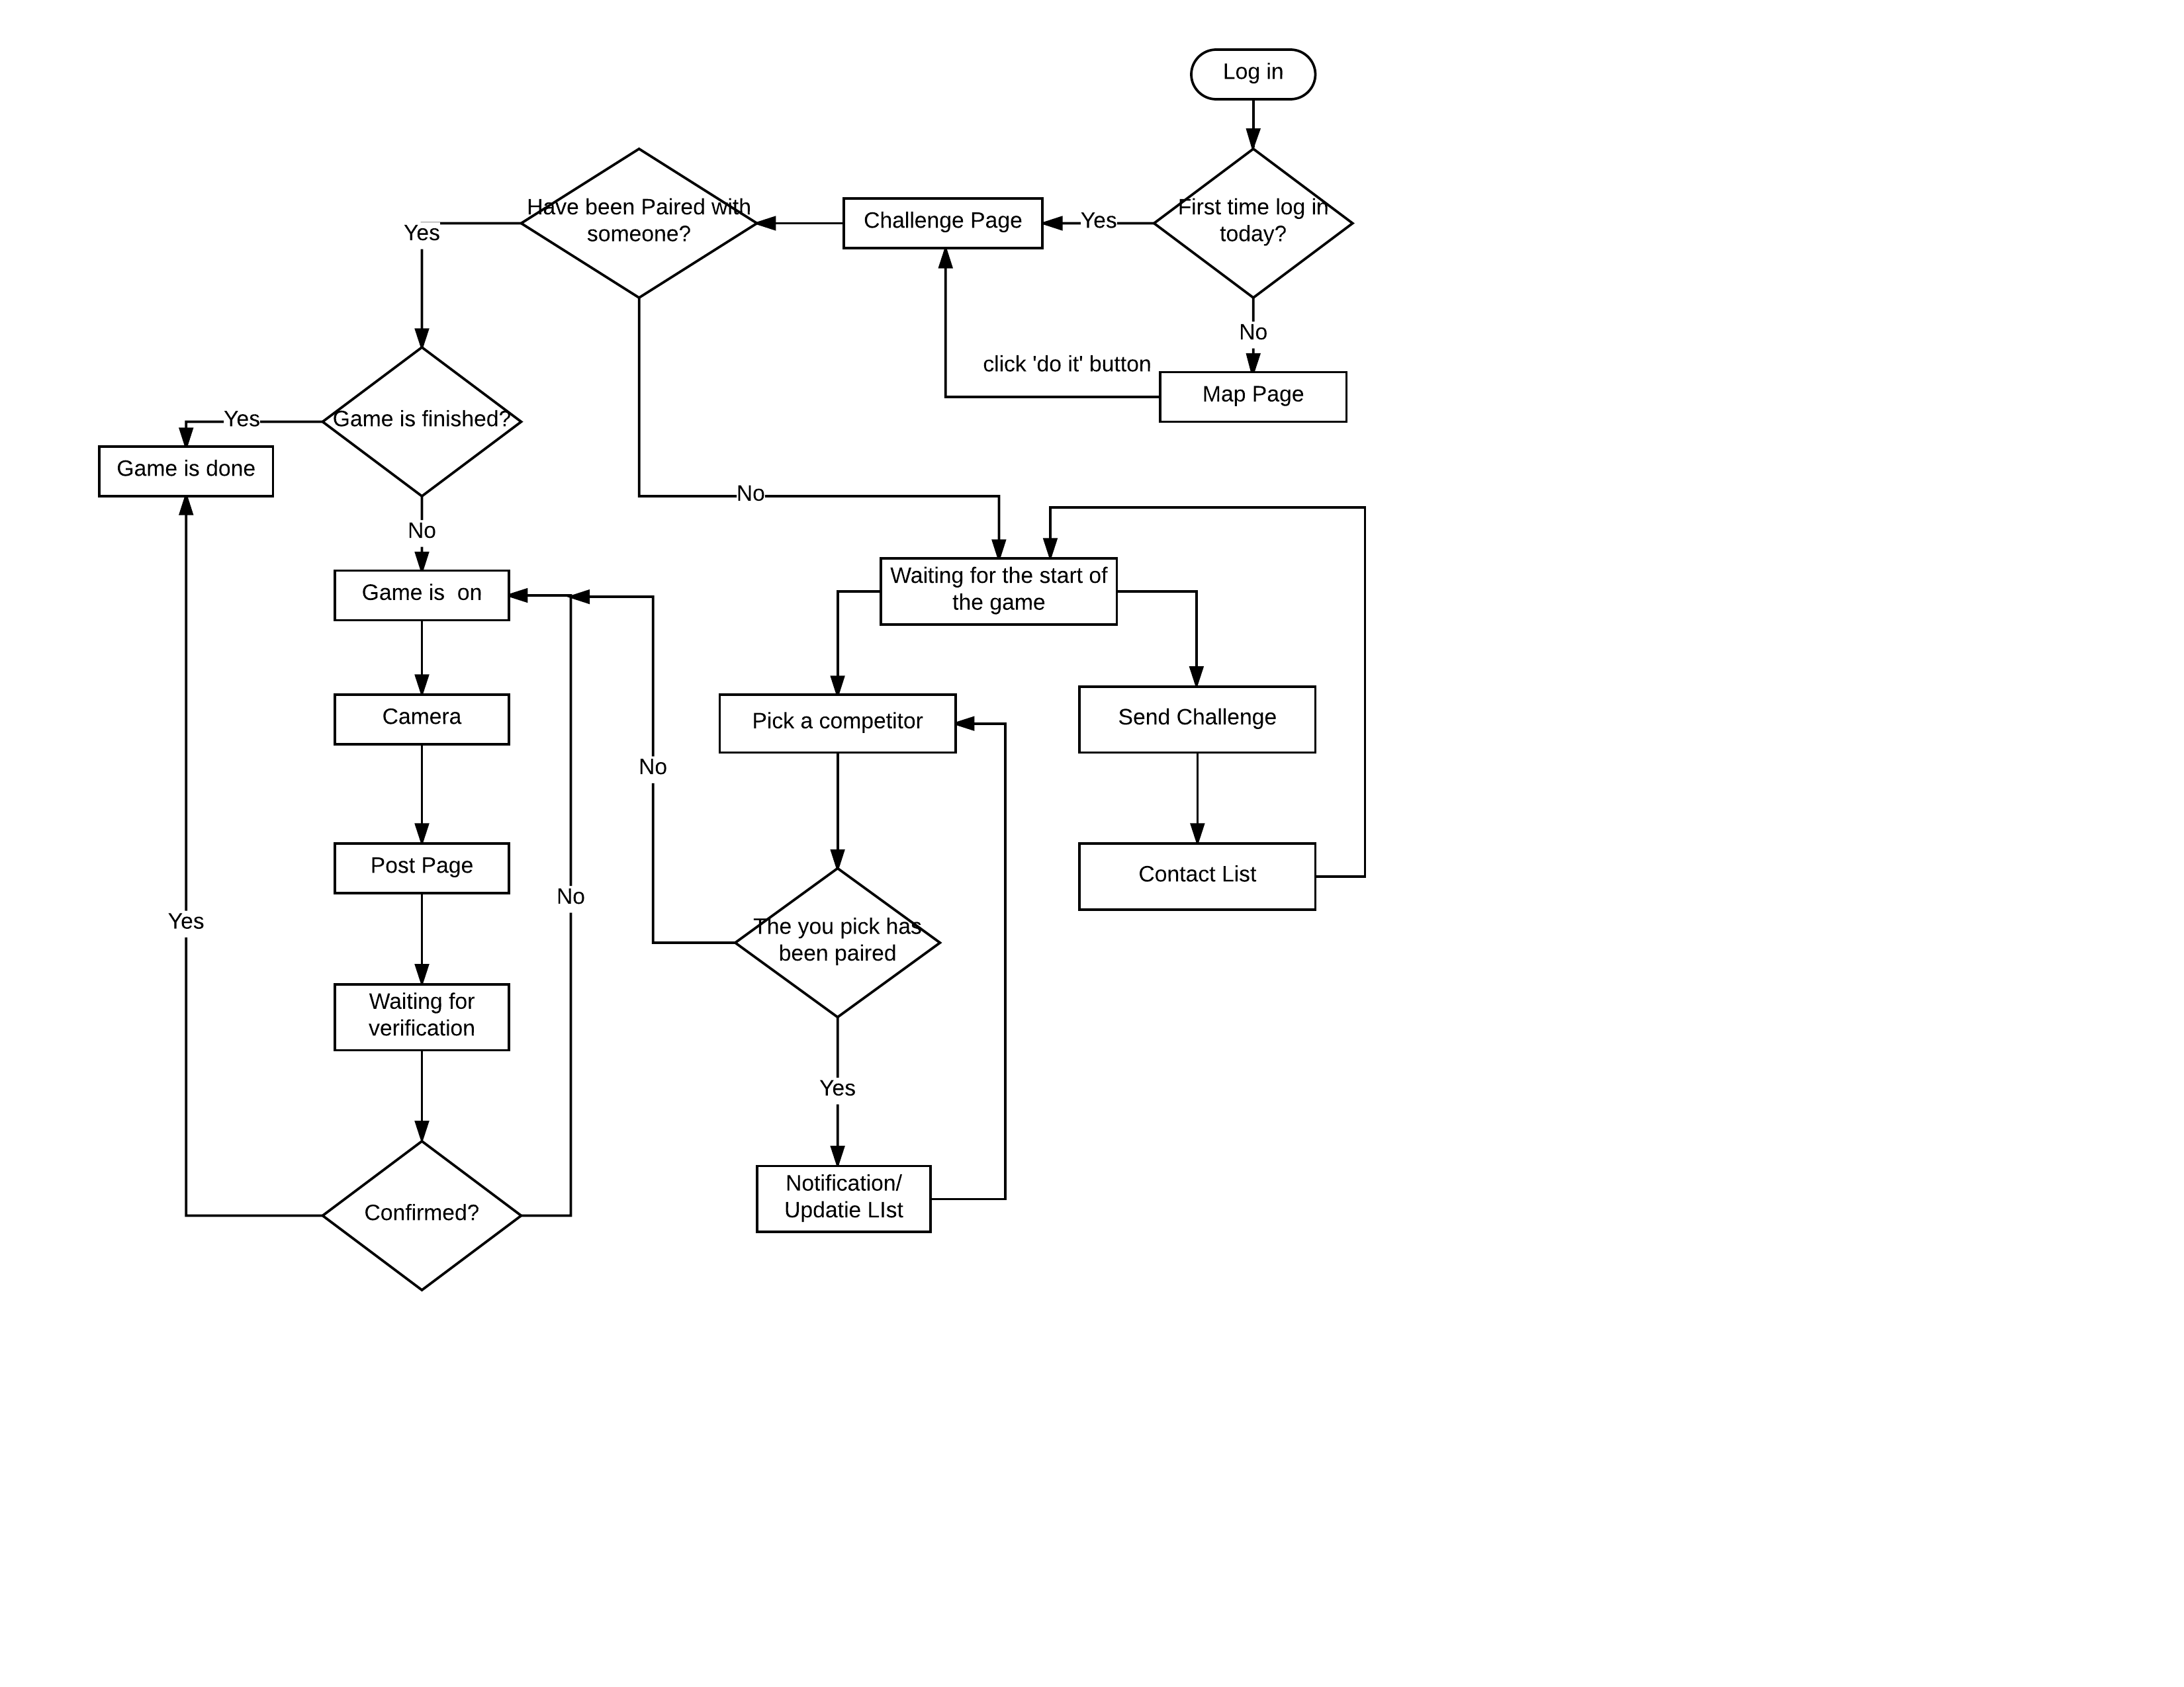

Figure : Navigation Flow of Popublic Challenge System

### Prototype

Table 1: Screenshot Challenge Page (Game does not start)

|  |  |
| --- | --- |
| Description | << This is the main page of the challenge function. Users can go to different pages related to the challenge from this page and the main information will be showed in this page >> |
| Related Capability | << CR-#6 Challenge Game Pop Screen / The user will touch the pop screen to get all daily challenge information >> |
| Pre-condition | << When the challenge icon on the Map Page is clicked or it is users’ first-time log-in today >> |
| Post condition | << ‘Pick a competitor’ page; ‘Send challenge’ page >> |

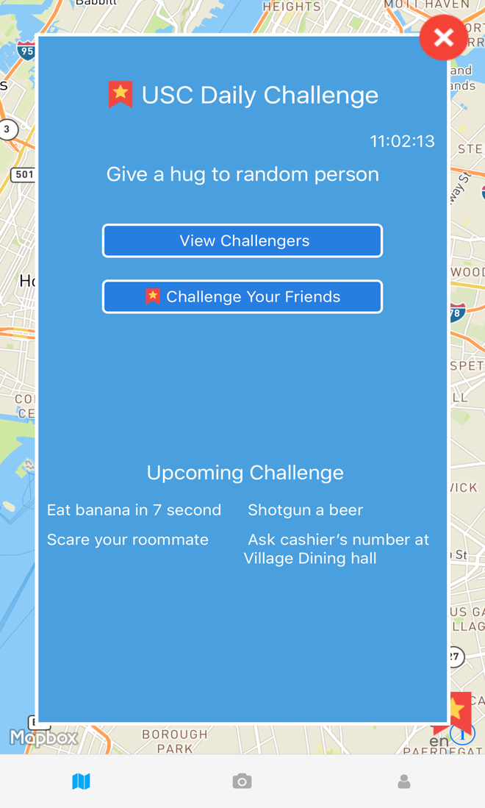

Figure 2: Screenshot Challenge Page(Game does not start)

Table 2: Screenshot Contact List

|  |  |
| --- | --- |
| Description | << In this page, users can send challenge invitation to their friend according to their contact list in the app or their mobile phones>> |
| Related Capability | << CR-#2 Challenge Complete Competition / The user can choose one friend to compete the time of finishing daily challenge >> |
| Pre-condition | << Click the ‘challenge your friends’ button in the Challenge Page >> |
| Post condition | << Get a notification of successful/failed sending >> |

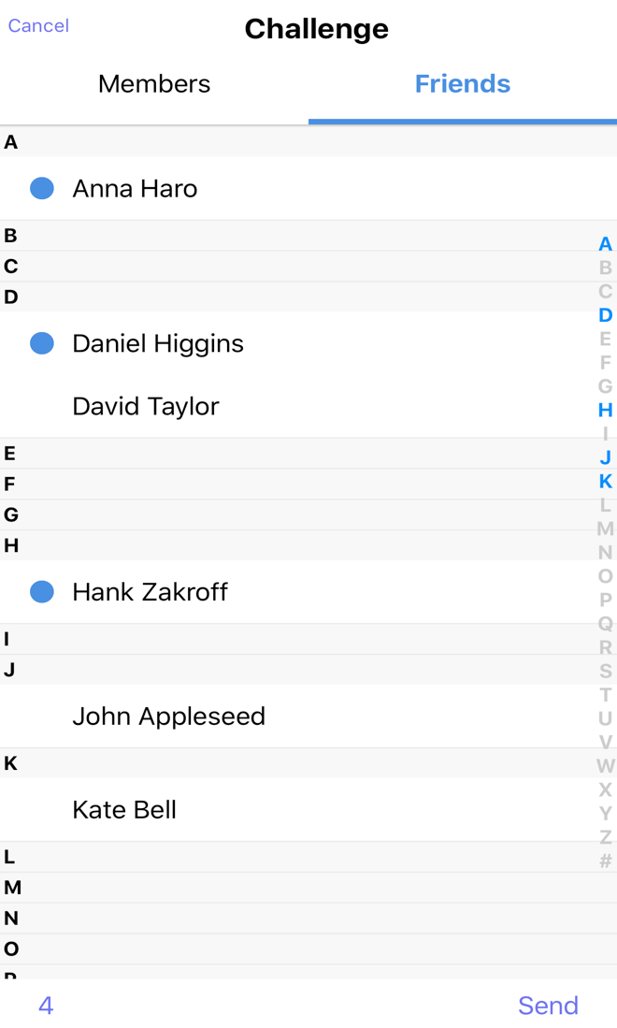

Figure 3: Screenshot Contact List

Table 3: Screenshot ‘Pick a Competitor’ Page

|  |  |
| --- | --- |
| Description | << In this page, users can pick a person to pair with among those who have sent challenge invitation to him/her >> |
| Related Capability | << CR-#2 Challenge Complete Competition / The user can choose one friend to compete the time of finishing daily challenge >> |
| Pre-condition | << Click the ‘View Challengers’ button in the Challenge Page >> |
| Post condition | << If failed, a notification box appear, the list will be updated and users can repack; If successful, users will go to the challenge message page and the game is on. >> |

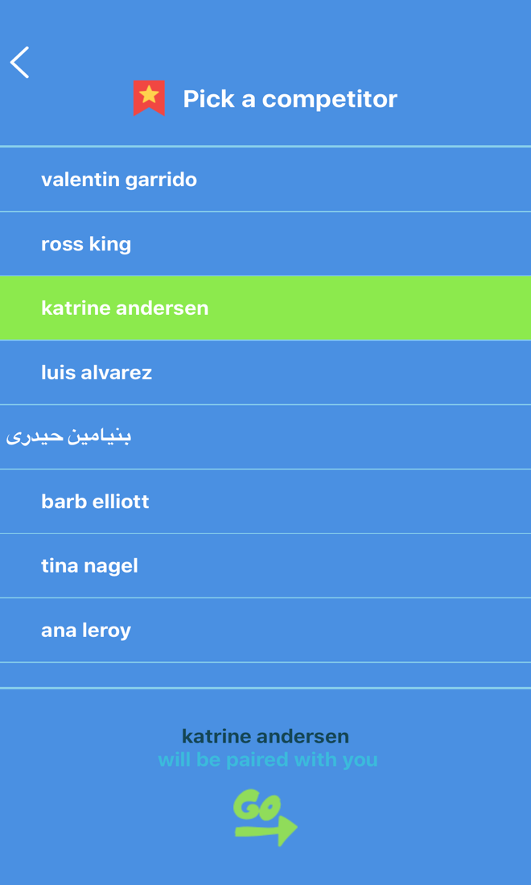

Figure 4: Screenshot ‘Pick a Competitor’ Page

Table 4: Screenshot Challenge Page (Game is on)

|  |  |
| --- | --- |
| Description | << In this page, users can see the game information of themselves and their opponents>> |
| Related Capability | << CR-#6 Challenge Game Pop Screen / The user will touch the pop screen to get all daily challenge information >> |
| Pre-condition | << Be paired with someone else >> |
| Post condition | << Click ‘Do it’ button to complete the challenge >> |

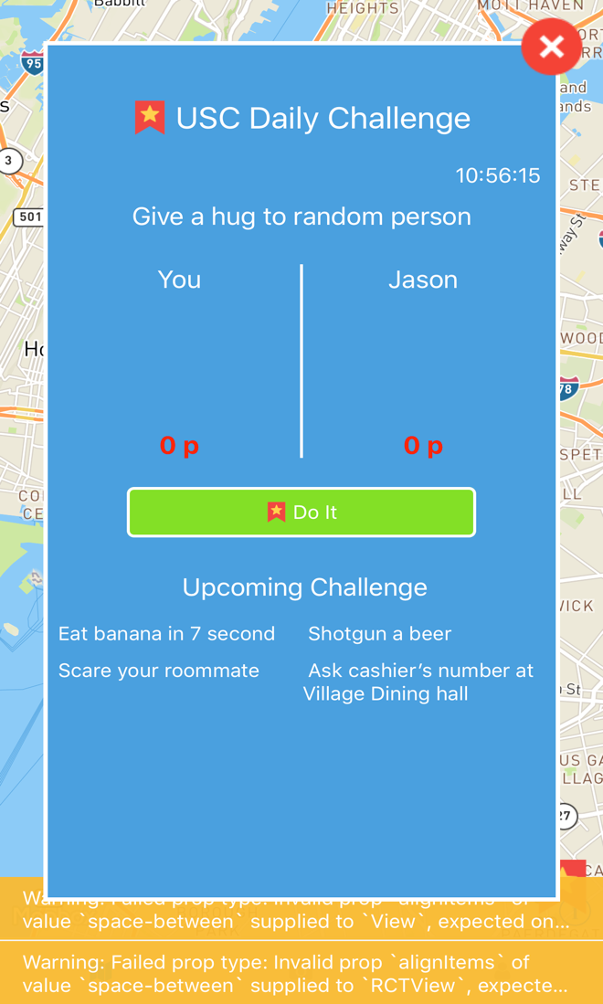

Figure 5: Screenshot Challenge Page (Game is on)

Table 5: Screenshot Confirm Page

|  |  |
| --- | --- |
| Description | << In this page, users can approve or decline their competitors’ posts>> |
| Related Capability | << CR-#5 View, Approve or Decline Challenge / The users are capable of viewing, approve or decline their friends’ challenge post.>> |
| Pre-condition | << Click the ‘go to confirm’ button in the previous page>> |
| Post condition | << Click ‘Approve’ button to approve or click ‘Decline’ button to decline >> |



Figure 6: Screenshot Confirm Page