Operational Concept Description (OCD)

Populic

Name | Role
Chengyu Shen | Project Manager, Operational Concept Engineer
Shiji Zhou | Prototyper, Software Architect
Yufei Hong | Feasibility Analyst, Project Manager
Guanghe Cao | Software Architect, Life Cycle Planner
Yang Wei | Operational Concept Engineer, Prototyper
Lin Xia | Life Cycle Planner, Feasibility Analyst
William Goishi | IIV & V, Quality Focal Point, Tester

12/01/2017

Version History
Date | Author | Version | Changes made | Rationale
09/21/17 | YW | 1.0 | - Initial draft | - Initial draft
10/05/17 | YW | 1.1 | - Added section 3.3 | - Section 3.3 was added to provide traceability for the outcome in the Benefits Chain
10/10/17 | YW | 1.2 | - Modified program diagram  - Modified Benefit-Chain diagram  - Modified proposed business workflow | - Diagram was modified based on Prof and TAs advice
12/01/17 | YW | 1.3 | - Modified constraints | - Keep consistency

Table of Contents
Operational Concept Description (OCD) i
Version History ii
Table of Contents iii
Table of Tables iv
Table of Figures v
1. Introduction 1
1.1 Purpose of the OCD 1
1.2 Status of the OCD 1
2. Shared Vision 2
2.1 Benefits Chain 2
2.2 System Capability Description 3
2.3 System Boundary and Environment 4
3. System Transformation 5
3.1 Information on Current System 5
3.2 System Objectives, Constraints and Priorities 7
3.3 Proposed New Operational Concept 9
3.4 Organizational and Operational Implications 12

Table of Tables
Table 1: The Program Model 2
Table 2: Level of Service Goals 8
Table 3: Relation to Current System 9

Table of Figures
Figure 1: Benefits Chain Diagram of Populic 3
Figure 2: System Boundary and Environment Diagram of Populic 4
Figure 3: Business Workflow Diagram of Populic 11
Figure 4: Element Relationship Diagram of Populic (NDI-intensive project) 10
Figure 5: Proposed Business Workflows Diagram of Populic 11

Introduction

Purpose of the OCD

This document provides, in detail, the shared visions and goals of the stakeholders of the Populic. This project will be implemented on the application designed by Vili Vaananen and his team. The success-critical stakeholders of the project are Vili Vaananen, as the project owner and maintainer; the USC students, as users.

Status of the OCD

The status of the OCD is currently at the version number 1.2 in the Development phase. The operational concept of current system is to implement risk mitigation part identified in the exploration phase.

Shared Vision
Table 1: The Program Model
Assumptions:
●Users have iPhone and have Internet.
●Users would like to show their posts.
●Users would like to challenge their friends.

Stakeholders | Initiatives | Value Propositions | Beneficiaries
- Developers  - Client  - Maintainers  - Users | - Develop the challenge part of the app  - Design the challenge game UI.  - Maintain the app  - Do the challenge and give feedback  - Challenge their friends | - Attracting more people to join the activities  - To promote challenge activities  - Increase users’ happiness | - Users  - Clients
Cost  - Maintenance costs  - Development costs |  | Benefits (Metrics)  - Increase the number of users in “Populic”  - Increase the revenue in the future  - Increase the posts

Benefits Chain

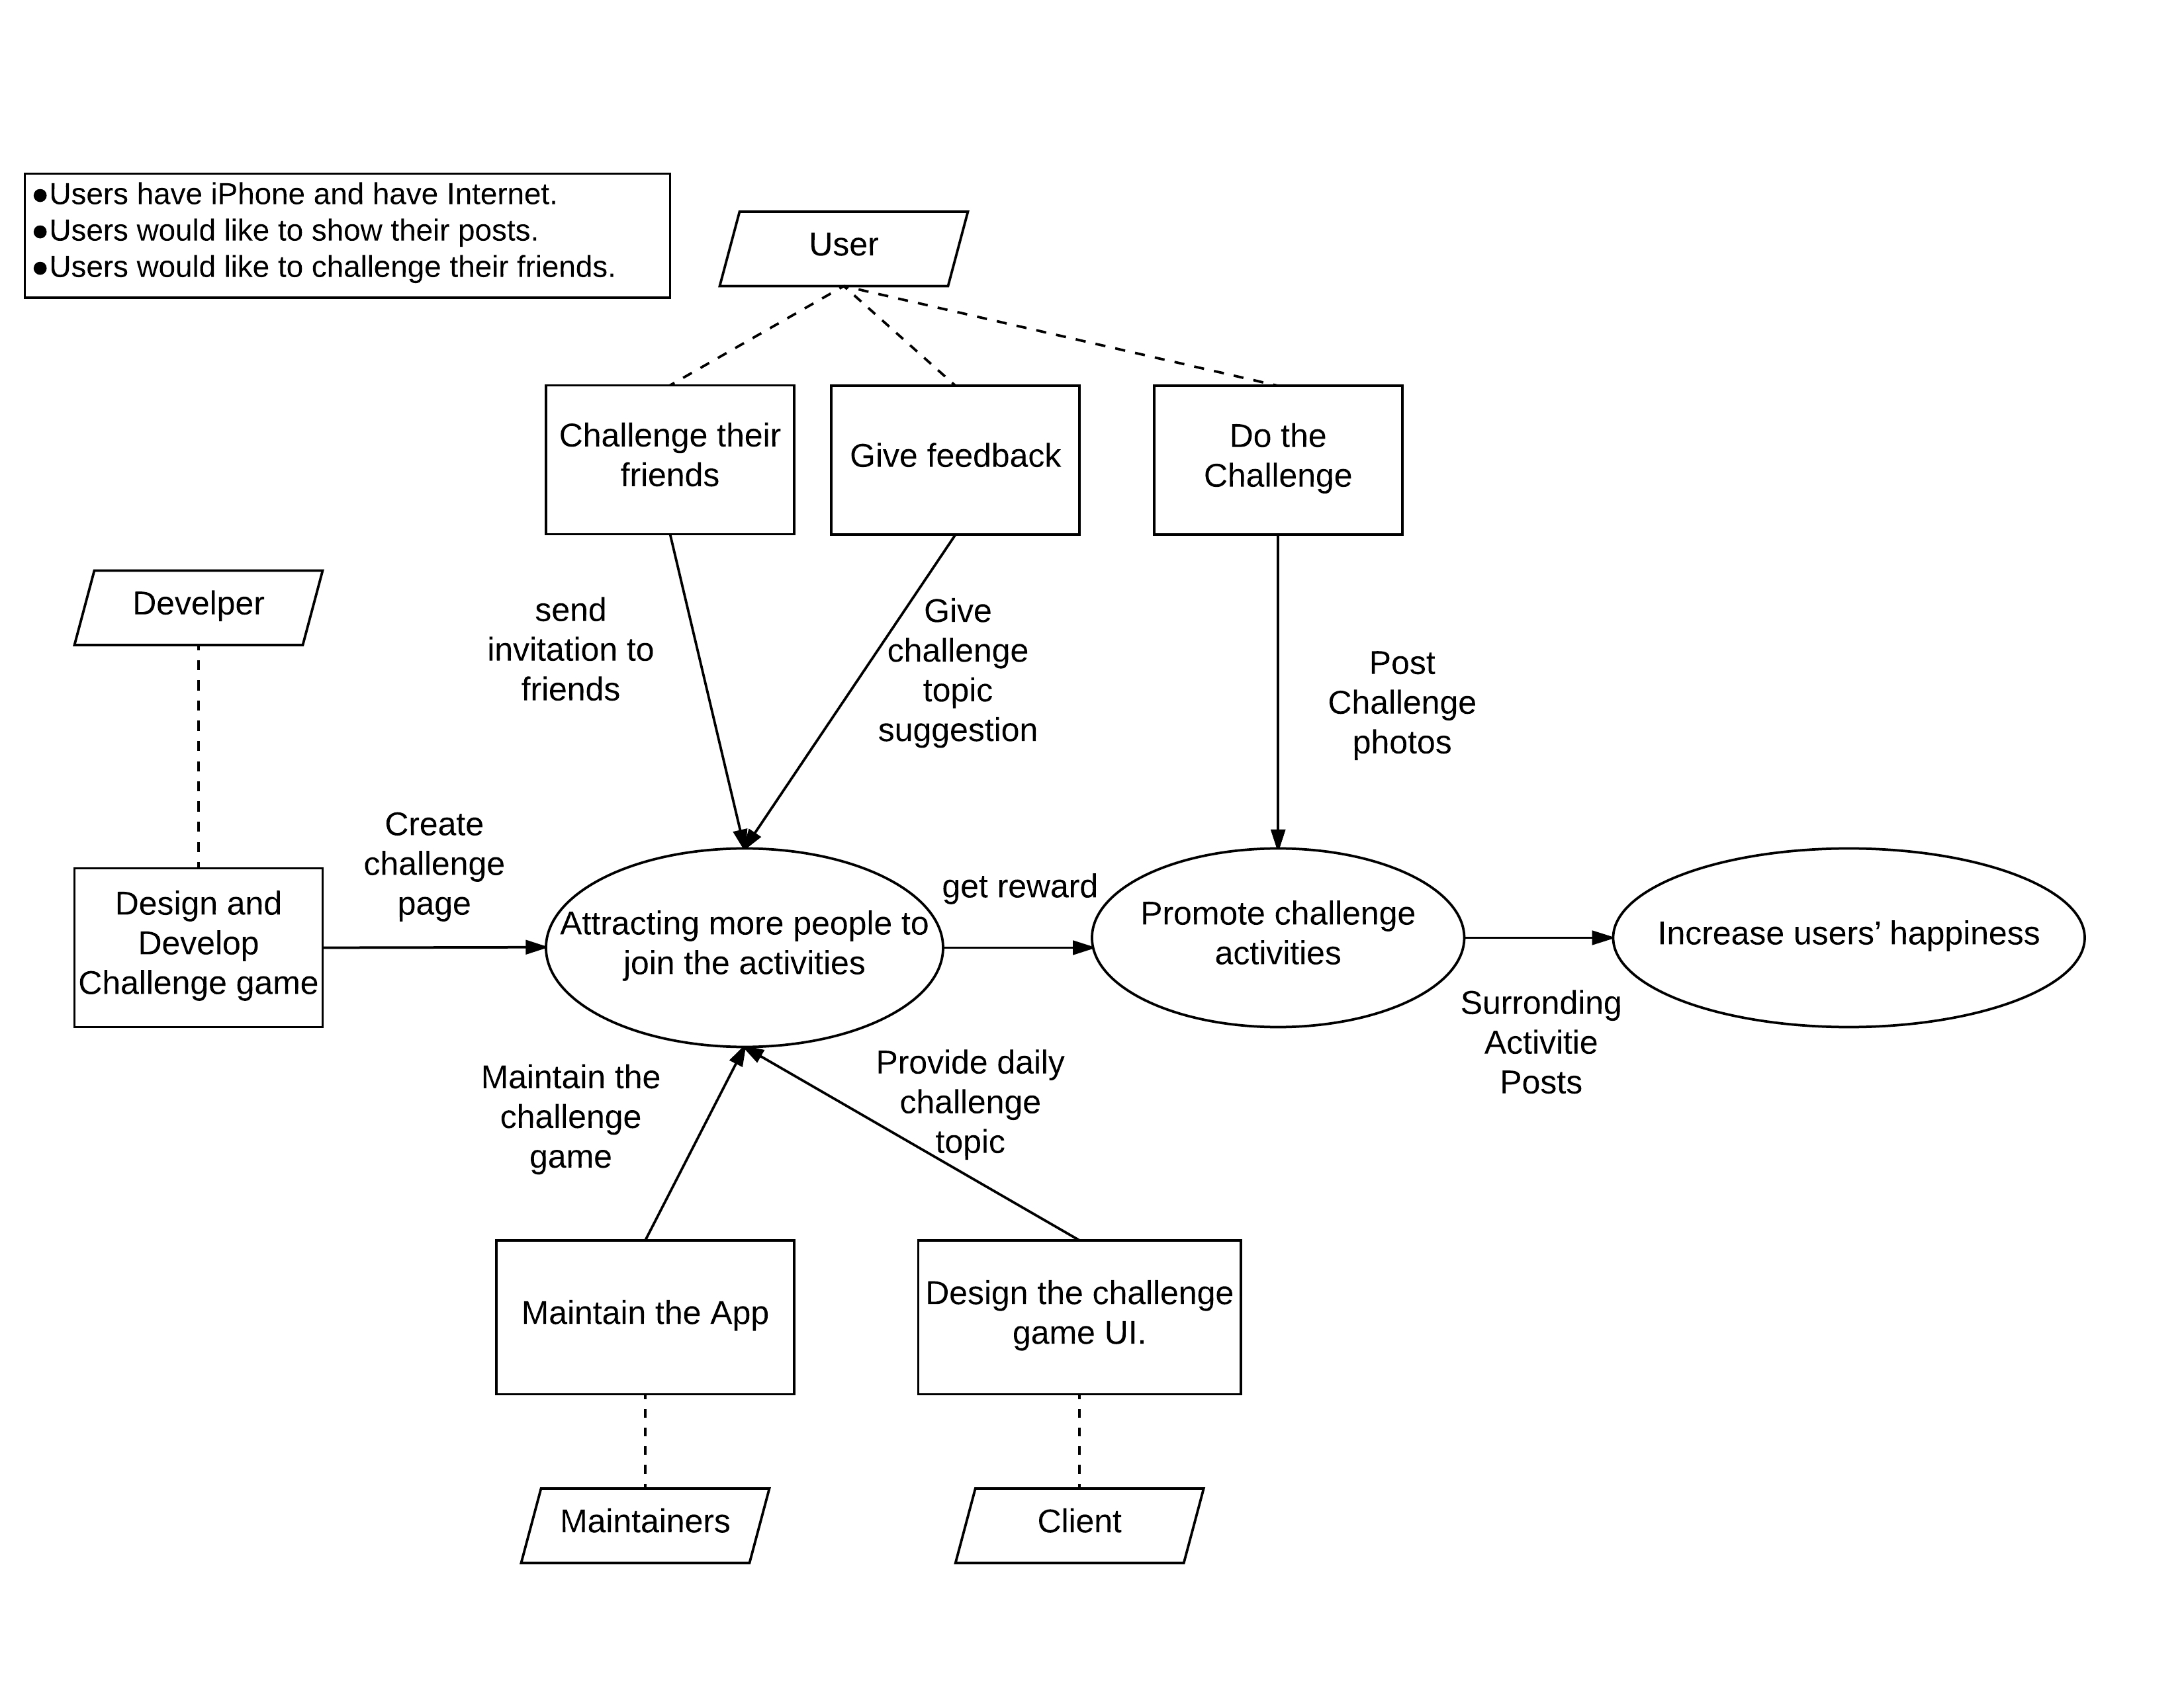
Figure 1: Benefits Chain Diagram of Volunteer Tracking System

System Capability Description
- The Goal of the Popublic is to allow people to conveniently check the surrounding community. It also aims to help activity holders from schools, and other organizations (or even individuals) to promote their activities. Thus, our target customers are such on campus students who are interested in attend the out-door or in-door activities.
- The system consists a pop screen that allow users access all functions relating to daily challenge
- The system provides functions that posting challenge photos/videos on communities and check surrounding communities.

System Boundary and Environment
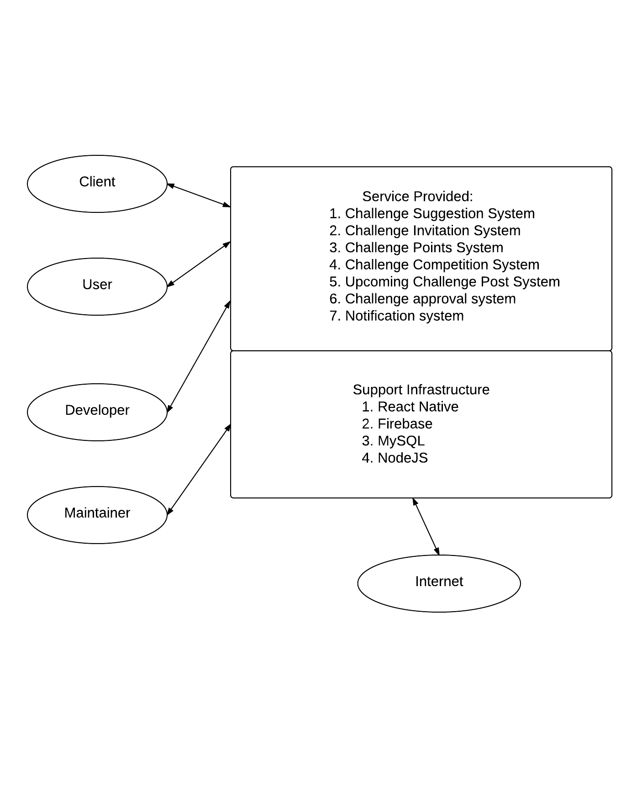
Figure 2: System Boundary and Environment Diagram of Challenge

System Transformation

Information on Current System

Infrastructure
The current system comprises of a IOS application that give a platform for both user and
activity holders. A Map based user current location will be displayed on main page, all built surrounding communities will be automatically shown on Map. There exists a registration system that user can register account via Facebook account and Gmail account. The users and activity holders also can create communities, connect built in phone camera and post pictures.

Artifacts
Artifact | Description
Use Case Diagrams | Describe the required features of the system
Activity Diagrams | Defines the flow of a certain process
Design Document | The software description that is given to the development team.
Software Architecture | The structure of a software system.
Prototype | Created to avoid any system risks and defects
Data Model | The relationship between entities.

Current Business Workflow
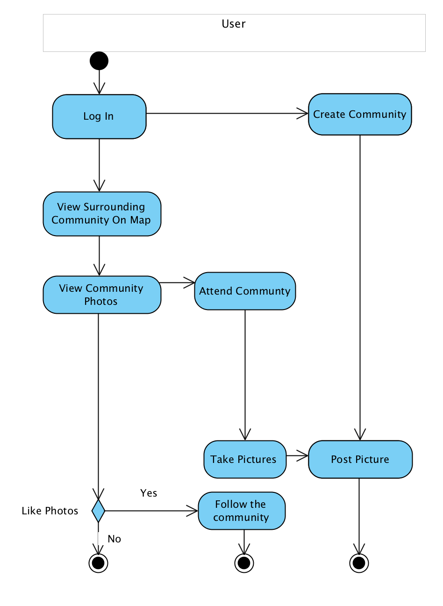

Figure 3: Current Business Workflow Diagram of Populic

System Objectives, Constraints and Priorities

Capability Goals

Capability Goals | Priority Level
OC-1 Challenge Photos and Videos Post: The system can post challenge photos and videos on community | Must Have
OC-2 Challenge Complete Competition: The user can choose one friend to compete the time of finishing daily challenge | Must Have
OC-3 Challenge Game Topic Suggestion: The user can send their feedback and challenge ideas to client. | Must Have
OC-4 Upcoming 5 Days Challenge Topic Post: The system will post further 5 days daily challenge. | Must Have
OC-5 View, Approve or Decline Challenge Photos/Videos: The users are capable of viewing, approve or cancel their friends challenge post. | Must Have
OC-6 Challenge Game Pop Screen: The user will touch the pop screen to get all daily challenge information | Must Have
OC-7 Notification: The user will get notification from challenge game. | Must Have
OC-8 Competition Reward: The user will get points reward from challenge game. | Must Have
OC-9 In-App friend List, Phone Contact List Access and SMS: The user can access the iPhone contact list and send challenge invitation through iPhone msg system, also can send invitation through notification to friends in-App. | Should Have

Level of Service Goals
Table 2: Level of Service Goals
Level of Service Goals | Priority Level | Referred WinWin Agreements
LOS-1: The layout should be responsive and at least support all size of iPhone | Must Have | Win Condition (WC_4610): As a user, I can use different iPhone models to play challenge game.

Organizational Goals
OG-1: Enlarge user’s happiness.
OG-2: Raise interactions between different users.
OG-3: Increase the number of active users in Populic

Constraints
CO-1: iOS as an Operating Systems.
CO-2: React Native as a development language for front-end development language.
CO-3: Node.js as a development language for back-end development language.
CO-4: MySQL as backend for system.
CO-5: Firebase as backend for application notification system

Relation to Current System
Table 3: Relation to Current System
Capabilities | Current System | New System
Roles and Responsibilities | • User can view photos and videos in communities.  • User can add picture to communities that every user can see. | • User can view challenge photos and videos in communities.  • User can add challenge picture to communities that every user can see.  • User can view challenge picture from their followers and friends.
User Interactions | N/A | • Check all challenge information in Challenge pop screen  • Get online and offline App notification
Infrastructure | AWS, Firebase | AWS, Firebase, MySQL, React
Stakeholder Essentials and Amenities | Developers, Client, Maintainers, Users, Activity Holders | Developers, Client, Maintainers, Users
Future Capabilities | N/A | Reward System

Proposed New Operational Concept

Element Relationship Diagram
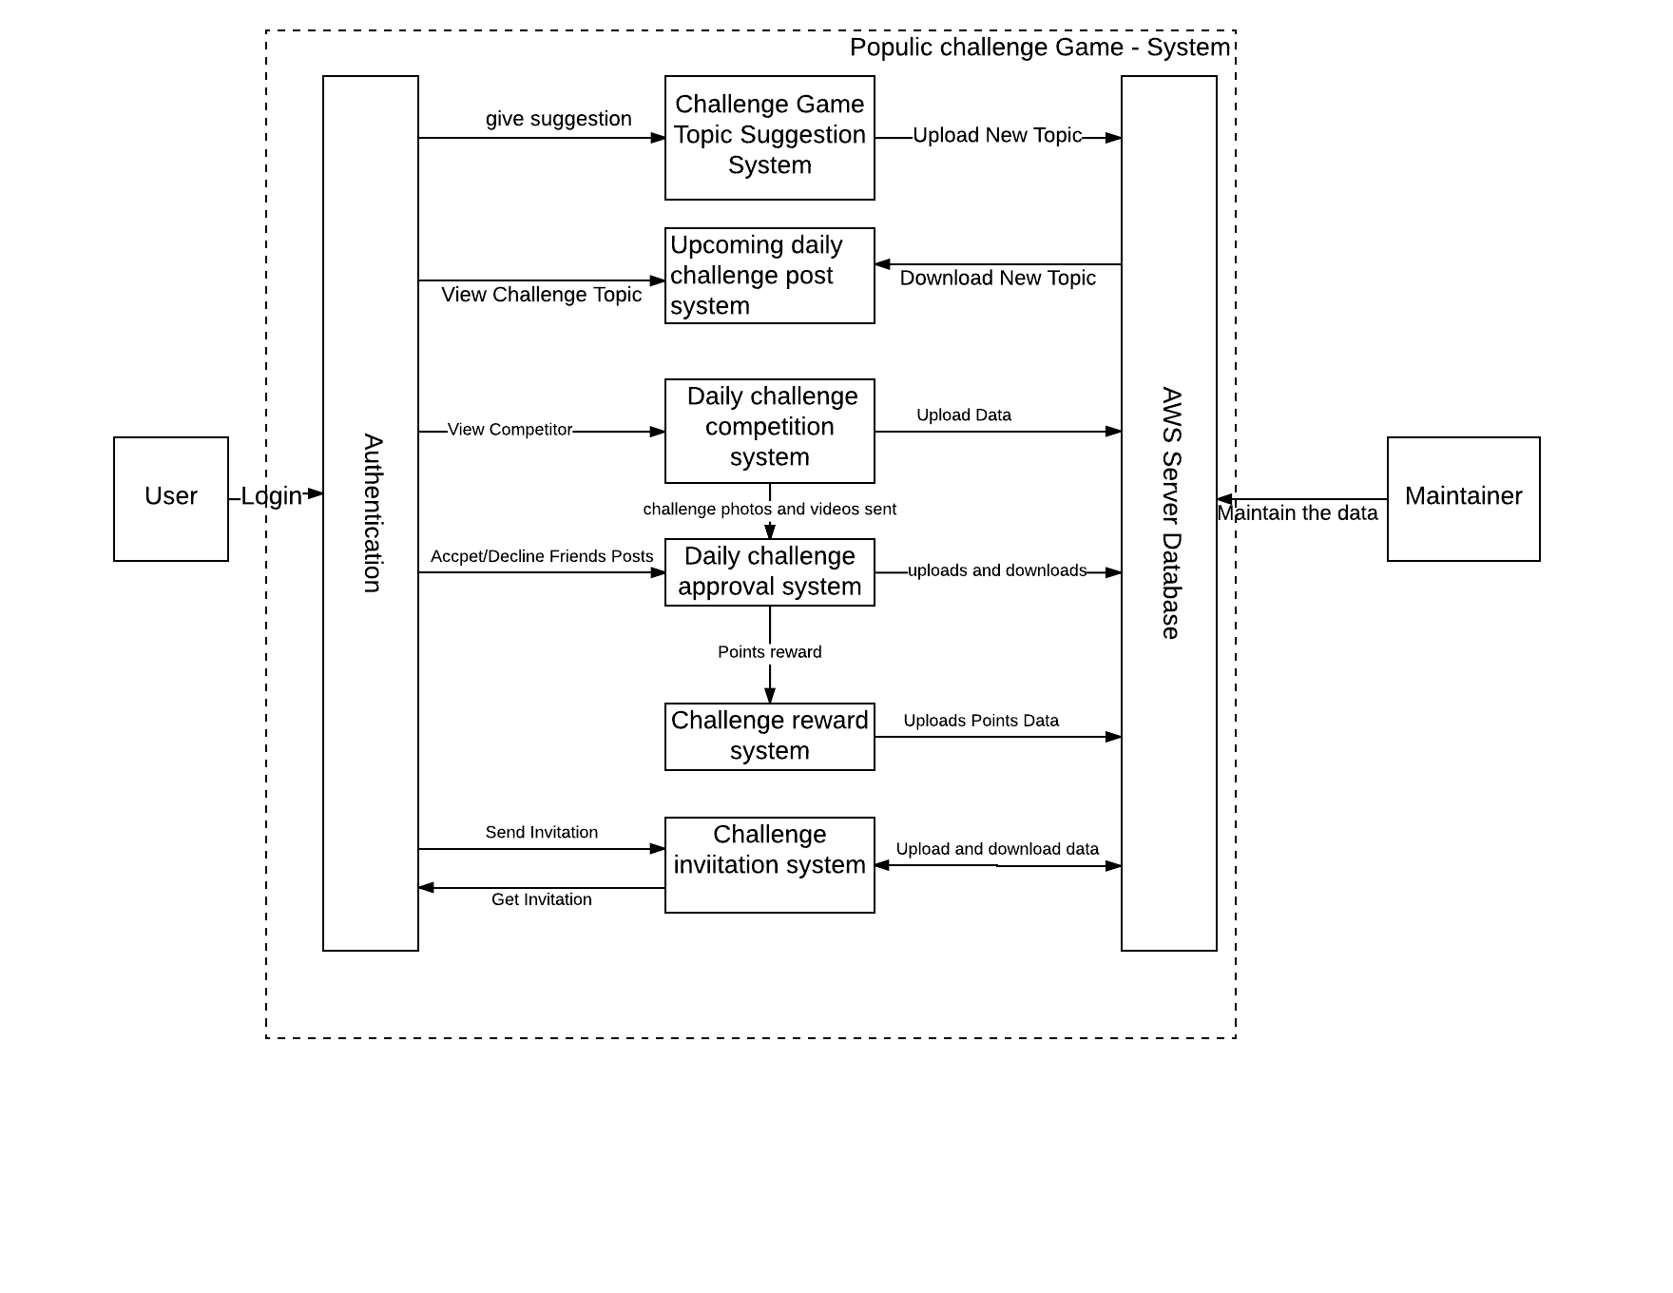
Figure 4: Element Relationship Diagram

Business Workflows
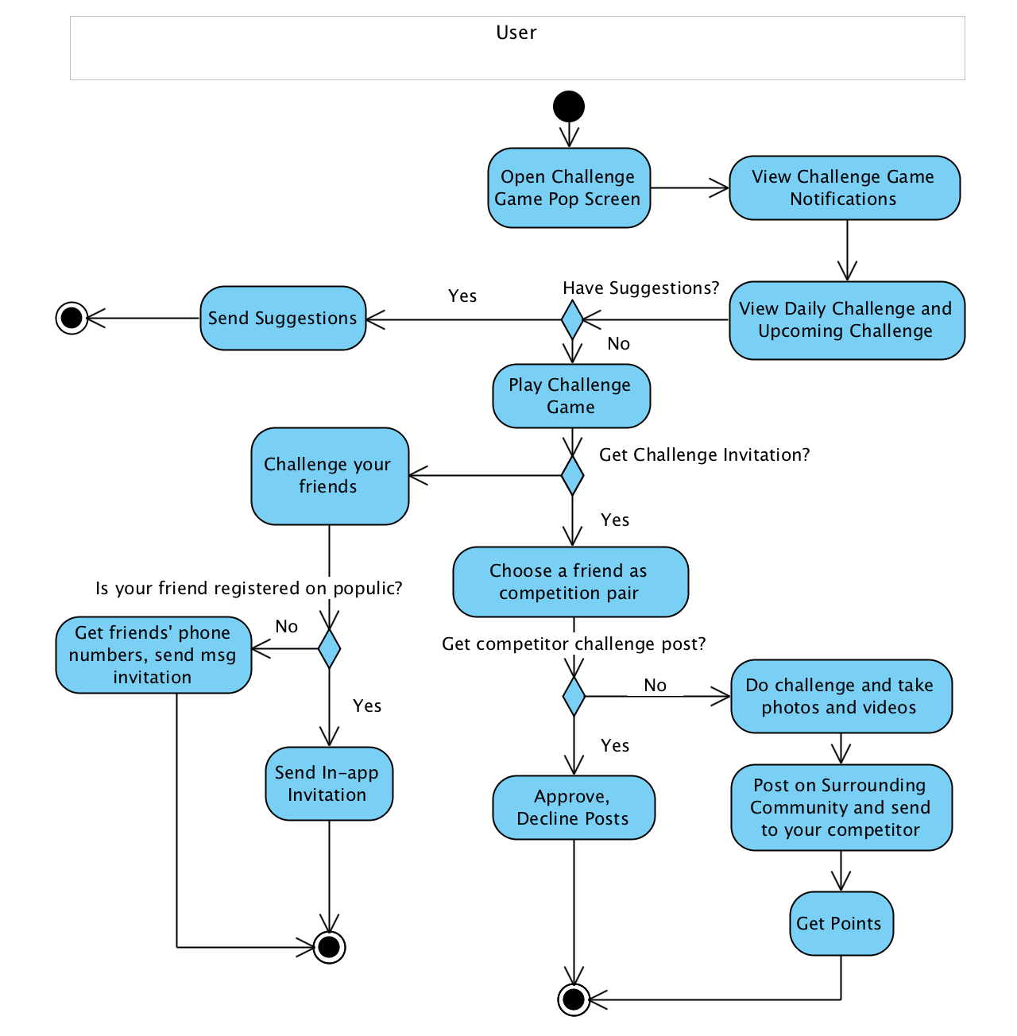
Figure 5: Proposed Business Workflow Diagram of Populic

Organizational and Operational Implications

Organizational Transformations
The need to hire a new system maintainer to take care of the system, the system maintainer will be responsible for choosing the daily challenge topic.

Operational Transformations
As the challenge is intended to supplement the current program, it is not likely to cause any significant changes in the current operational procedures.

