Life Cycle Plan (LCP)

Populic

Team No.4

Chengyu Shen (Product Manager)
Shiji Zhou (Designer/Prototyper)
Yufei Hong (Feasibility Analyst)
Guanghe Cao (Software Architecture)
Yang Wei (Operational Concept Engineer)
Lin Xia (Life Cycle Planner)
William Goishi (Quality Focal Point)

Version History
Date | Author | Version | Changes made | Rationale
10/08/17 | Lin | 1.0 | Original template for use with Populic v1.0 | Initial draft for use with Populic v1.0
10/11/17 | Lin | 1.1 | Add COCOMO Estimation | Add scale factor according to COCOMO II

Table of Contents
Life Cycle Plan (LCP) i
Version History ii
Table of Contents iii
Table of Tables iv
Table of Figures v
1. Introduction 1
1.1 Purpose of the LCP 1
1.2 Status of the LCP 1
1.3 Assumptions 1
2. Milestones and Products 2
2.1 Overall Strategy 2
2.2 Project Deliverables 2
3. Responsibilities 5
3.1 Project-specific stakeholder’s responsibilities 5
3.2 Responsibilities by Phase 5
3.3 Skills 6
4. Approach 7
4.1 Monitoring and Control 7
4.2 Methods, Tools and Facilities 7
5. Resources 8
6. Iteration Plan 10
6.1 Plan 10
6.1.1 Capabilities to be implemented 10
6.1.2 Capabilities to be tested 10
6.1.3 Capabilities not to be tested 11
6.1.4 CCD Preparation Plans 11
6.2 Iteration Assessment 11
6.2.1 Capabilities Implemented, Tested, and Results 11
6.2.2 Core Capabilities Drive-Through Results 11
6.3 Adherence to Plan 12

Table of Tables
Table 1: Artifacts Deliverables in Exploration Phase 4
Table 4: Artifact deliverable in Foundations Phase 5
Table 5: Artifact deliverable in Development Phase 6
Table 6: Stakeholder's Responsibilities in each phase 7
Table 7: COCOMOII Scale Driver 12
Table 8: COCOMOII Challenge Cost Driver 12
Table 13: Construction iteration capabilities to be implemented 16
Table 14: Construction iteration capabilities to be tested 16
Table 15: Capabilities implemented, tested, and results 17

Table of Figures
    - Introduction

Purpose of the LCP
The Life Cycle Plan(LCP) document acts as a primary management tool to satisfy Populic’s Project Requirement. The document includes all the artifacts of each phase, the team members’ contribution at each stage and the milestone of five phases.

The Objectives of the Life Cycle Plan:
- Aids in the construction and transitioning of the project.
- Helps in maximizing the utility of people and resources throughout the life cycle of the project.
- Will manage and control the progress of the project and ensure timely execution of each of the phases.
- Ensure quality of project and feasibility through business-case analysis and resources available.

Status of the LCP
The status of the LCP is currently at version 1.1. The latest version that will be delivered to the client.

Assumptions
  - The duration of the project is 16 weeks which is entire 2017 Fall Semester.
    - Milestones and Products

Overall Strategy
The Populic project is following Architected Agile process because there is no Non-Development Item or Web service that would fit to most of the core capabilities.

Exploration phase
Duration: 09/12/2017-09/22/2017
Concept: identify initial scope of the product through the analysis of previous version. Understand the application architecture and life-cycle plan through client meetings and win-win negotiation. Based on capability of each member decide the team roles.
Deliverables: Valuation Report and Team Website, Client Interaction Report, Project Plan, Progress Report
Milestone: Valuation Commitment Review
Strategy: One Incremental Commitment Cycle

Valuation phase
Duration: 09/22/2017-10/2/2017
Concept: Negotiate with client to plan the final function and requirement. Seek the potential COTS which could be used in the later development phase according to the determined requirement. Identify all the risks and rank them. Attempt to implement the high risk prototype and discus the method to mitigate those risks.
Deliverables: Win-Condition Report, High Risk Prototype, Project Plan, Progress Report.
Milestone: Foundation Commitment Review
Strategy: One Incremental Commitment Cycle

Foundation phase
Duration: 10/02/2017- 10/18/2017
Concept: According to determined COTS and requirement, finish the whole High risks function prototype. Discuss with client and improve the prototype. Select the NDI and finish the life-cycle plan and architecture.
Deliverables: Development Commitment Package, Risk and Defect Report, Project Plan, Progress Report.
Milestone: Development Commitment Review
Strategy: One Incremental Commitment Cycle

Development phase
Duration: 10/19/2017- 09/12/2017
Concept: Each team member implements their individual part according to the prototype and test each subsystem and function. After finishing the peer code review, Have the team member who is charge of IV&V and client review the whole system and function to check all the functions which are discussed in previous phase
Deliverables: Core Capability Drive-Through Report, Risk and Defect Report, Progress Report, Technical Debt Report
Milestone: Transition Readiness Review, Core Capability Drive-Through
Strategy: One Incremental Commitment Cycle

Project Deliverables

Exploration Phase

Table 1: Artifacts Deliverables in Exploration Phase
Artifact | Due date | Format | Medium
Client Interaction Report | 9/17/2017 | .doc, .pdf | Soft copy
Evaluation of Valuation Commitment Package | 09/27/2017 | .xls | Soft copy
Project Effort | Every Sunday | Text | ER system
Project Plan | Every other Sunday | .mpp, .pdf | Soft copy
Progress Report | Every other Sunday | .xls | Soft copy
Jira | Every Friday | Text/ticket | Jira Website

Valuation Phase
Table 2: Artifact deliverable in Valuation Phase
Artifact | Due date | Format | Medium
Win-Condition Report | 09/27/2017 | .pdf | soft copy
High Risk Prototype | 09/27/2017 | .pdf | soft copy
Progress Report | Every other Sunday | .pdf | soft copy
Jira | Every Friday | Text/ticket | Jira Website
Project Plan | Every other Sunday | .pdf | soft copy

Foundations Phase
Table 2: Artifact deliverable in Foundations Phase
Artifact | Due date | Format | Medium
Project Plan | Every other Sunday | .pdf | soft copy
Risk and Defect Report | Every other Sunday | .xls | soft copy
Jira | Every Friday | Text/ticket | Jira Website
Progress Report | Every other Sunday | .pdf | soft copy
FC Package  - Feasibility Evidence Description(FED)  - Operational Concept Description(OCD)  - Life Cycle Plan(LCP)  - Prototype Report  - System and Software Architecture Description (SSAD) | 10/15/2017 | .doc,.pdf | soft copy
On-Campus Technical Debt Report | Every other Friday | .xls | soft copy
QFP Technical Debt Report | Every other Friday | .xls | soft copy

Development Phase
Table 3: Artifact deliverable in Development Phase
Artifact | Due date | Format | Medium
Progress Report | Every other Sunday | .xls | soft copy
Risk and Defect Report | Every other Sunday | .xls | soft copy
Project Plan | Every other Sunday | .mpp ,.pdf | soft copy
Jira | Every Friday | text | Jira Website
DC Package | 12/05/2017 | .doc,.pdf | soft copy
Project Archive | 12/05/2017 | .doc,.pdf | soft copy
Individual Critique | 12/05/2017 | .doc,.pdf | soft copy
On-Campus Technical Debt Report | Every other Friday | .xls | soft copy
QFP Technical Debt Report | Every other Friday | .xls | soft copy

    - Responsibilities

Project-specific stakeholder’s responsibilities
this project doesn’t have any project-specific stakeholder.

Responsibilities by Phase
The following table is a template for stakeholder’s responsibilities in each phase.
Table 4: Stakeholder's Responsibilities in each phase
Team Member / Role | Primary / Secondary Responsibility
Team Member / Role | Exploration | Valuation | Foundations | Development- Construction Iteration | Development- Transition Iteration
Name:  Villi Vaananen  (Client) | Primary Responsibility  Give the overview and description of the application | Primary Responsibility  Negotiate the requirements and team responsibility with team members | Primary Responsibility  Review the project progress | Primary Responsibility  Check the prototype and project schedule and support the feedback | Primary Responsibility  Negotiate with the all team member for transition of the project
Name:  chengyu Shen (Product Manager) | Primary Responsibility  Learn the project and negotiate with client. Finish the project reports. Organize the team meeting  Secondary Responsibility  Develop Website | Primary Responsibility  Negotiate with client to decide the requirement  Secondary Responsibility  Maintain the website | Primary Responsibility  Design application prototype  Organize the team meeting. Report the project schedule  Secondary Responsibility  Develop Website | Primary Responsibility  Finish the development assignment  Keep a track of the progress schedule | Primary Responsibility  Help client finish transition job.
Name:  Shiji Zhou (Designer/Prototyper) | Primary Responsibility  Learn the project.  Participate in win-win negotiation | Primary Responsibility  Analysis the COTS and risk, identify the high risk part of project.  Reports | Primary Responsibility  Finish the prototype design and live demo  Secondary Responsibility  Create OCD document | Primary Responsibility  Develop the challenge display function. | Primary Responsibility  Submit relative document and help with transition of the project
Name:  Yufei Hong  (Requirements Engineer) | Primary Responsibility  Learn the project.  Participate in win-win negotiation | Primary Responsibility  Negotiate with client identify the accurate requirements better | Primary Responsibility  Finish related documents. | Primary Responsibility  Develop the daily challenge part of the application. | Primary Responsibility  Submit relative document and help with transition of the project
Name:  Guanghe Cao (Software Architecture) | Primary Responsibility  Learn the project.  Participate in win-win negotiation | Primary Responsibility  Analysis the COTS and design the software architecture | Primary Responsibility  Work on SSAD document and development | Primary Responsibility  Develop camera function of the application | Primary Responsibility  Submit relative document and help with transition of the project
Name:  Yang Wei  (Software Developer) | Primary Responsibility  Learn the project.  Participate in win-win negotiation | Primary Responsibility  Analysis the potential COTS and divide the whole system into sub part according to functionality | Primary Responsibility  Work on OCD document and set up system integration | Primary Responsibility  Develop the contact list page and invite function | Primary Responsibility  Submit relative document and help with transition of the project
Name:  Lin Xia  (Software Developer) | Primary Responsibility  Learn the project.  Participate in win-win negotiation  Secondary Responsibility  Develop team Website | Primary Responsibility  Analysis the potential COTS and divide the whole system into sub part according to functionality | Primary Responsibility  Work on LCP document and set up system integration | Primary Responsibility  Develop the daily challenge UI page and design API to get data from the server. | Primary Responsibility  Submit relative document and help with transition of the project
Name:  William Goishi (Quality Focal Point) | Primary Responsibility  Learn the project.  Participate in win-win negotiation | Primary Responsibility  Analyze risk and rationality of requirement and offer some solutions mitigate the risk | Primary Responsibility  Work on FED document | Primary Responsibility  Design the usage case and test cases for testing | Primary Responsibility  Submit relative document and help with transition of the project

Skills

Team members | Role | Skills
Chengyu Shen | Product Manager | Current skills: Designing Prototype, UML Diagram, Web Development, IOS application development  Required skills: react native developing ,Management
Shiji Zhou | Designer/Prototyper | Current skills: Designing Prototype, Web Development, IOS application development  Required skills: react native developing ,Management
Name:  Yufei Hong  (Requirements Engineer) | Requirements Engineer | Current skills: UML Diagram, Web Development, IOS application development  Required skills: react native developing ,Management
Name:  Guanghe Cao (Software Architecture) | Software Architecture | Current skills: Designing Prototype, UML Diagram, Web Development, IOS application development  Required skills: react native developing ,Management
Name:  Yang Wei  (Software Developer) | Software Developer | Current skills: Designing Prototype, UML Diagram, Web Development, IOS application development  Required skills: react native developing
Name:  Lin Xia  (Software Developer) | Software Developer | Current skills: Designing Prototype, UML Diagram, Web Development, Android application development  Required skills: react native developing ,negotiation skill
Name:  William Goishi (Quality Focal Point) | Quality Focal Point | Current skills: Designing Prototype, UML Diagram, Web Development, IOS/ Android application development  Required skills: negotiation skill

    - Approach

Monitoring and Control
We use five methods to monitor and control the project.
- Progress Reports are used to keep a track of the project schedule and project plan which made in last week
- Project Plan is used to record the deadline of each document and development schedules
- Weekly Team Meetings are for discussion progress detail with all the team members
- Slack is used to communicate with client and their engineer.
- Communication outside of team meetings is done using a group chat on Wechat

Closed Loop Feedback Control
Our teams take following steps to get and provide feedback:
- Each team member is in the Wechat group if they have any problem they can directly ask for help
- We use team website to share all the documents created by any team member
- We use Github to record and review the code and check the development schedules.
- Email is used to send reminder about the meetings and deadline of submitting document

Reviews
Each task and function is finished, we will have code review and arrange all the related documents. After that, we will clarify all the development process and discussion if there are some parts we can improve upon. All the module based functions will undergo individual testing and then integration testing in which will provide feedback on whether another review is required or not.

Methods, Tools and Facilities

Tools | Usage | Provider
Xcode | Used to develop react native development | Apple
Webstorm | Used to develop react native development | JetBrains
Github | Used to record the version control. | Github
Wechat | Used for source code management | Tencent
Microsoft Office Visio | Used to design and draw UML and workflow | Microsoft

5. Resources
Identify the following information in order to estimate the software cost:
- Estimated CSCI577a Effort : X team members at X hrs/week for 12 weeks
- Total estimated effort: 672 hours
- Budget information: $0
- Project duration: 12 weeks
- Component modules in your development project: Invitation Module, Challenge Module, Score Module.
- Programming language used: JavaScript node.js
Table 5: COCOMOII Scale Driver
Scale Driver | Value | Rationale
PREC | LOW | The team has no experience in developing application base on the
FLEX | HIGH | The client is flexible about the requirements
RESL | LOW | Team don’t have much knowledge and experience to identify the COTS and risk
TEAM | HIGH | Less interaction and collaboration among team members
PMAT | LOW | SEI CMM process maturity
Total Scale Factor = 18.97

Table 6: COCOMOII Challenge Cost Driver
Cost Driver | Value | Rationale
TOOL | VHI | We just use Xcode to development
RELY | NOM | This is separate function and don’t have much dependency
PCON | NOM | The developers are continuity, all of them will work on this project until the end of this semester
APEX | LOW | None of the developers have react native development experience
LTEX | LOW | Some developers have no JavaScript development experience
DOCU | LOW | The react native is new technic, there are few document which we can use
ACAP | HIGH | On one in this team has experience about designing pop box UI
DATA | HIGH | There is no any API which we can fetch data from server
SITE | NOM | The client’s developers are not in American， so they can not give much help.
CPLX | HIGH | The logic flow between different users is easy to design, but it still need do much effort on it
RUSE | LOW | The client didn’t offer any previous code about the challenge display
PCAP | NOM | The programmer needs more programming experience about the react native.
PVOL | LOW | React native framework updates at irregular intervals.
SCED | LOW | This project needs to be finished in 12 weeks
TIME | NOM | This module does not have huge impact on execution time
STOR | NOM | The client doesn’t offer any place to store the challenge content data
PLEX | NOM | The team members don’t have any develop experience on react native.

Table 9: COCOMOII Score Cost Driver
Cost Driver | Value | Rationale
TOOL | VHI | We just use Xcode to development
RELY | NOM | This is separate function and don’t have much dependency
PCON | NOM | The developers are continuity, all of them will work on this project until the end of this semester
APEX | LOW | None of the developers have react native development experience
DATA | LOW | The is no API we can access the users information
RUSE | LOW | The client didn’t offer any previous code about the online shop
LTEX | LOW | Some developers have no JavaScript development experience
DOCU | LOW | The react native is new technic, but there are a lot documents which we can use
SITE | NOM | The client’s developers are not in American， so they can not give much help.
ACAP | HIGH | On one in this team has experience about designing online shop.
DATA | HIGH | There is no any API which we can fetch data from server
STOR | NOM | The client doesn’t offer any place to store the online shop data.
CPLX | NOM | The logic flow between different users is not easy to design
PLEX | NOM | The team members don’t have any develop experience on react native, but we can learn it quickly
PCAP | HIGH | Some of team members are not graduate students with Computer Science background
TIME | NOM | This module does not have much requirement on execution time
PVOL | NOM | React native framework updates at irregular intervals.
SCED | LOW | This project needs to be finished in 12 weeks
Table 10: COCOMOII Invitation Cost Driver
Cost Driver | Value | Rationale
TOOL | VHI | We just use Xcode to development
RELY | NOM | This is separate function and don’t have much dependency
PCON | NOM | The developers are continuity, all of them will work on this project until the end of this semester
APEX | LOW | None of the developers have no react native development experience
RUSE | LOW | The client didn’t offer any previous code about the invitation function
LTEX | LOW | Some developers have no JavaScript development experience
PCAP | HIGH | The programmer needs more programming experience about the react native.
TIME | NOM | This module does not have huge impact on execution time
DOCU | LOW | The react native is new technic, but there are a lot document which we can use
PLEX | NOM | The team members don’t have any develop experience on react native, but it’s not very difficult to learn.
SITE | NOM | The client’s developers are not in American， so they can not give much help and communication.
ACAP | NOM | On one in this team has experience about using Listview component
DATA | HIGH | The IOS don’t allow application get users all contact information
PVOL | NOM | React native framework updates at irregular intervals.
STOR | NOM | The client doesn’t offer any place to store contact list
SCED | LOW | This project needs to be finished in 12 weeks
CPLX | NOM | The function can display all the contact list of user offer check book which users can check and send messages to their friends to invite them, this logic is not work flow to design

Overall COINCOMO Result
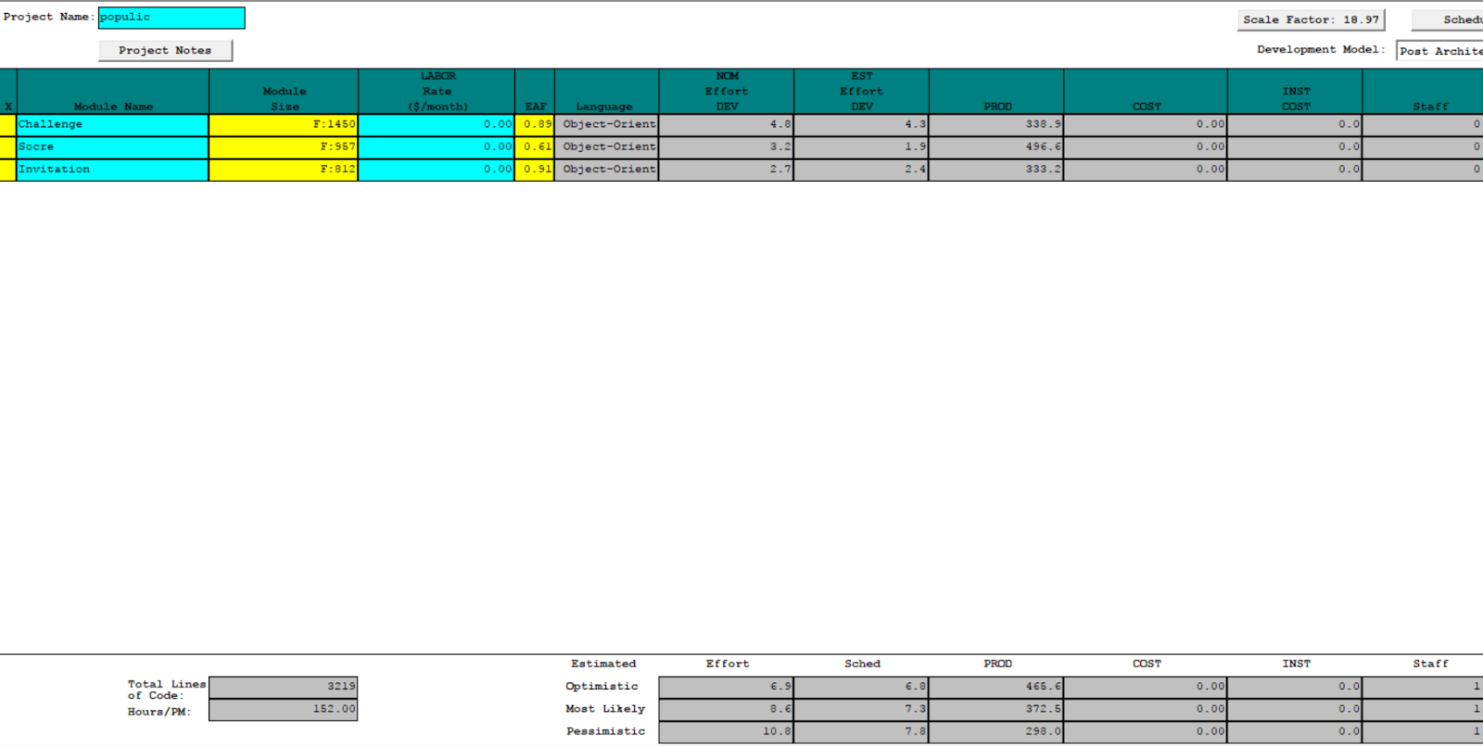

COINCOMO Cost Driver
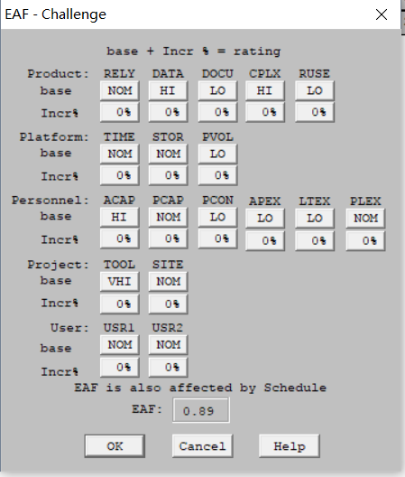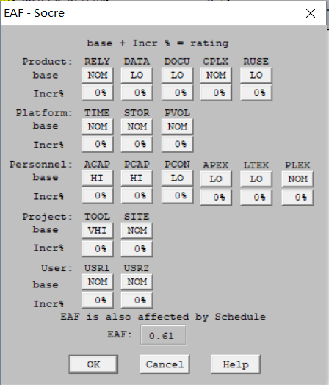
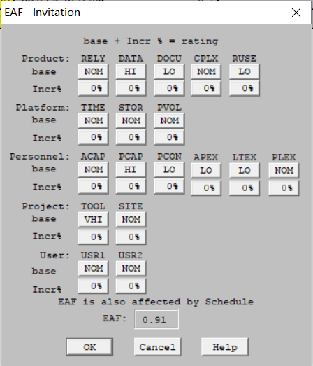

6. Iteration Plan

6.1 Plan
We plan use two cycles to finish the development phase. The first cycles will aim at finishing all the frontend part including all page’s UI, UX and the API of getting the data. And we will ensure all the front-end part can work well for the Core Capability Drive. During this phase, we need do some improvement according to client’s feedback and test result. This feedback would be very helpful for our next stage.
The second cycle will focus on back end. We will learn to use node.js to write API of support data to front-end and test the full functionality of the application. We will also help the client fix other functional bugs and improve our development schedule according the previous stage’s feedback.
After the development phase, our team members will focus on transitioning the system smoothly, finishing all the relative documents and list all the key point which the following development should be noticed.

6.1.1 Capabilities to be implemented
Table 7: Construction iteration capabilities to be implemented
ID | Capability | Description | Priority | Iteration
1 | Challenge Photos and Videos Post | The user can post challenge photos and videos on communities | High | 1
2 | Challenge Complete Competition | The user can choose one friend to compete the time of finishing daily challenge | High | 1
3 | Challenge Game Suggestion | The user can send their feedback and challenge ideas to client | Medium | 2
4 | upcoming 4 Days Daily Challenge Post | The system will post further 4 days daily challenge. | High | 1
5 | View, Approve or Decline Challenge: | The users are capable of viewing, approve or decline their friends challenge post. | High | 1
6 | Challenge Game Pop Screen | The user will touch the pop screen to get all daily challenge information | High | 1
7 | Offline & Online Notification | The user will get notification from populic. | High | 1
8 | Competition Reward | The user will get reward points from challenge competition | Medium | 1

6.1.2 Capabilities to be tested
Table 8: Construction iteration capabilities to be tested
ID | Capability | Description | Priority | Iteration
1 | Challenge Photos and Videos Post | The user can post challenge photos and videos on communities | High | 2
2 | Challenge Complete Competition | The user can choose one friend to compete the time of finishing daily challenge | High | 2
3 | Challenge Game Suggestion | The user can send their feedback and challenge ideas to client | Medium | 2
4 | upcoming 4 Days Daily Challenge Post | The system will post further 4 days daily challenge. | High | 2
5 | View, Approve or Decline Challenge | The users are capable of viewing, approve or decline their friends challenge post. | High | 2
6 | Challenge Game Pop Screen | The user will touch the pop screen to get all daily challenge information | High | 2
7 | Offline & Online Notification | The user will get notification from populic. | High | 2
8 | Competition Reward | The user will get reward points from challenge competition | Medium | 2

6.1.3 Capabilities not to be tested
All the capabilities were test to ensure the application work well in any situation.

6.1.4 CCD Preparation Plans
CCD is scheduled around November 5th to 10th. The client and his development team member will take part in. The clients will test all the challenge functions and give the feedback. And we will plan our next iteration according to that feedback. The client and his team members will act as a user and follow the instruction to run all the relative function to challenge each other.

Given below are the our team member preparation plan for Core Capability Drive through session:
1. Make sure that the challenge content which fetch from server is correct and display perfectly.
2. Make sure that we can upload all the user’s challenge information and the data passing to the database is clear and conforming to the specification
3. Make sure that the server and database are up
4. Make sure all the pages are responsive.
5. Make sure that we have done a dry run with the whole team before the actual CCD session.
6. Ensure all of the client’s requirements have been implemented and tested.

