Group 10

Tzuchien,Liu

Guantao Zhao

Project 1 – BlackJack

***Project description***

BlackJack is the most popular gambling card game. It’s also known as Twenty-One. In this project, we will implement a multi-player BlackJack casino with text-version. In detail, we will realize rules of BlackJack.( <https://www.bicyclecards.com/how-to-play/blackjack/>) Users can define how many players want to join and then start their game. We will show cards information by texts. Each player has their own bet. In each round, players take turn decide which action they want to take and how much they want to bet.

***Requirements completed and not completed***

* Make a bet from minimum value to All In. (O)
* The dealer will give you two cards and show one of his cards. (O)
* You have an option to add more cards by choosing 'HIT' but you lose automatically if your value of cards exceeds 21. You can choose “STAND” too. You can choose to add your bet when you hit. (O)
* The dealer will reveal his hidden card and must always hit if they have 16 or lower. They will stop hitting if they have 17 or more.  (O)
* You win when the combined value of your cards is greater than that of the dealer. (O)
* Shuffle if only one set of cards left in the deck. (O)
* In most versions of Blackjack, when you are dealt a pair (two of the same card), you have the option to split them into two new hands. You are dealt two more cards (one for each new hand) and your bet is doubled. You play each hand normally — you get two chances to beat the dealer (or lose). (O)
* Implement multiple decks (O)
* Implement hint for players if they want to know the possibility about the card(O)
* Remove player if player run out of their bet. (O)

We complete all requirement we have in the proposal. It’s a complete blackjack game.

***Design and approach***

We use java as out programming language. We define cards, deck, hand, and player classes. BlackJack is our main program. In this main program, we will use our defined class to run all the blackjack process. We use IO.java as our input and output helper.

***Citations***

Rules: <https://www.bicyclecards.com/how-to-play/blackjack/>

***Results***

1. ***Start process, input player’s info***

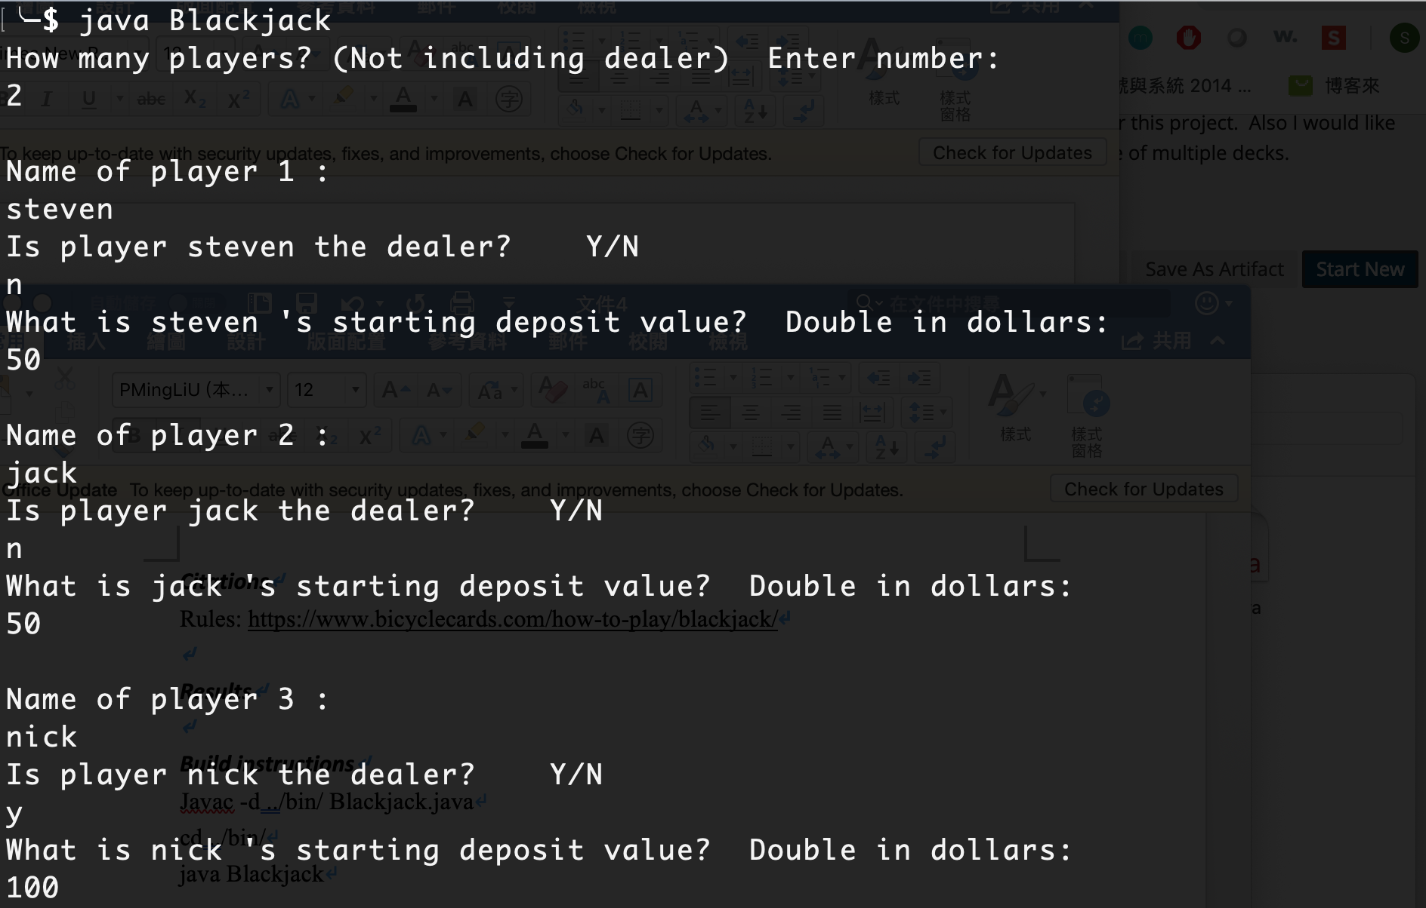

1. ***Start to put your bet***

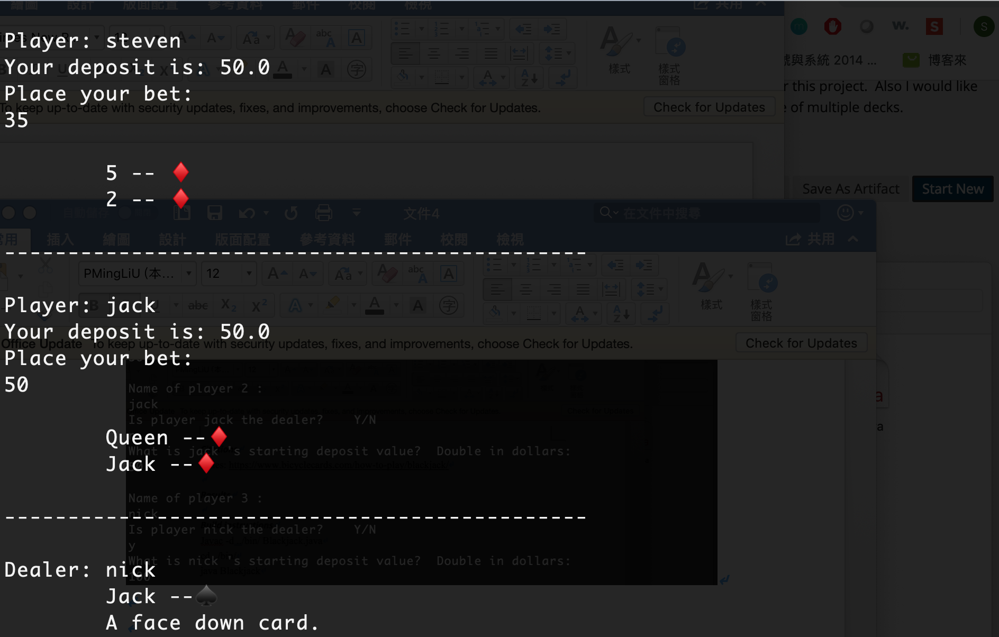

1. ***You can decide to get a hint or not, you can try to double down or not***

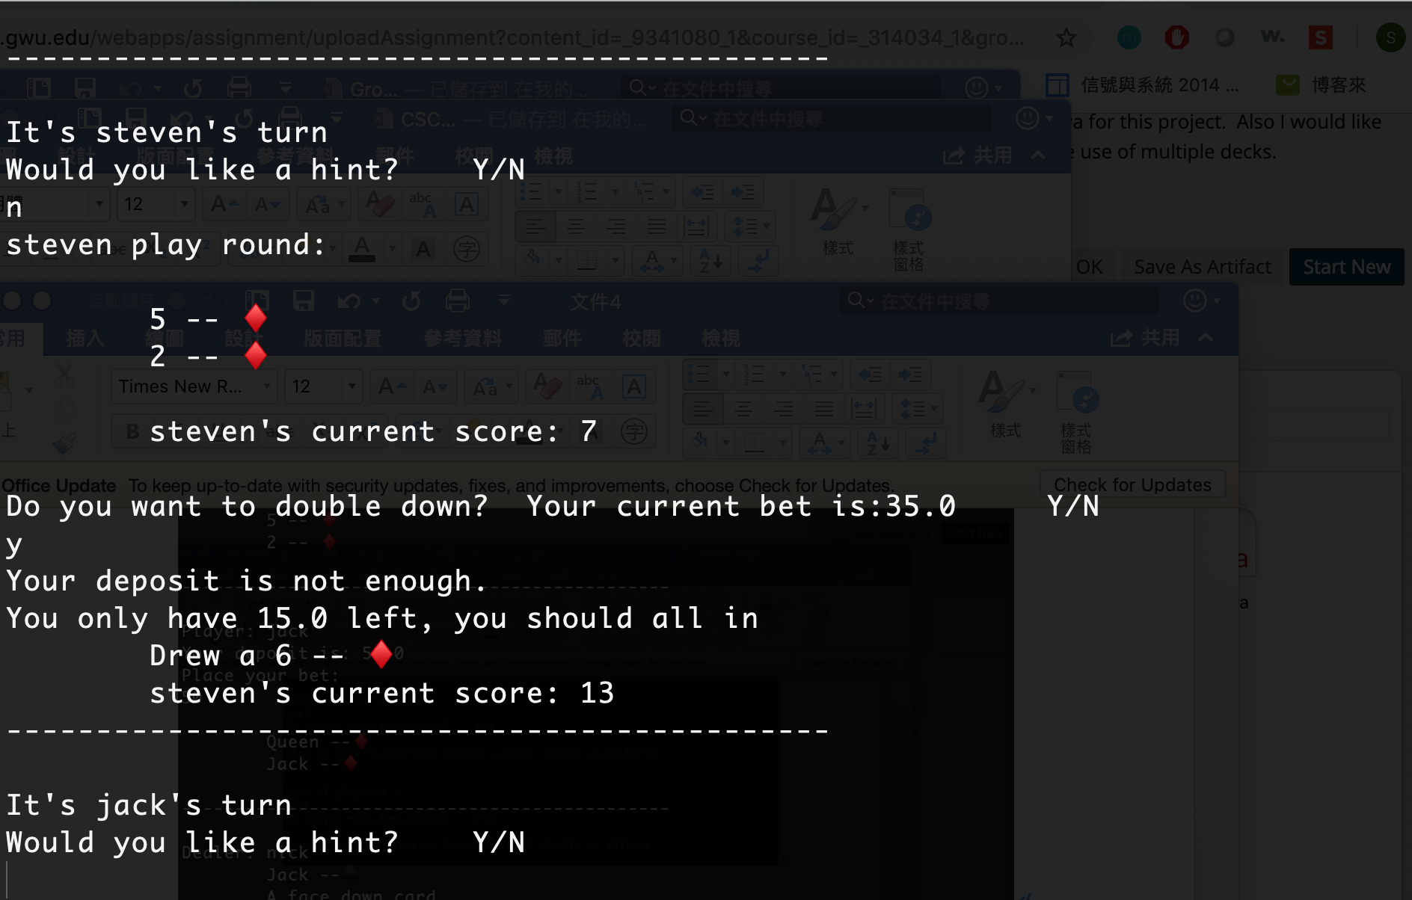

1. ***If you have same cards, you can decide to split your card,***

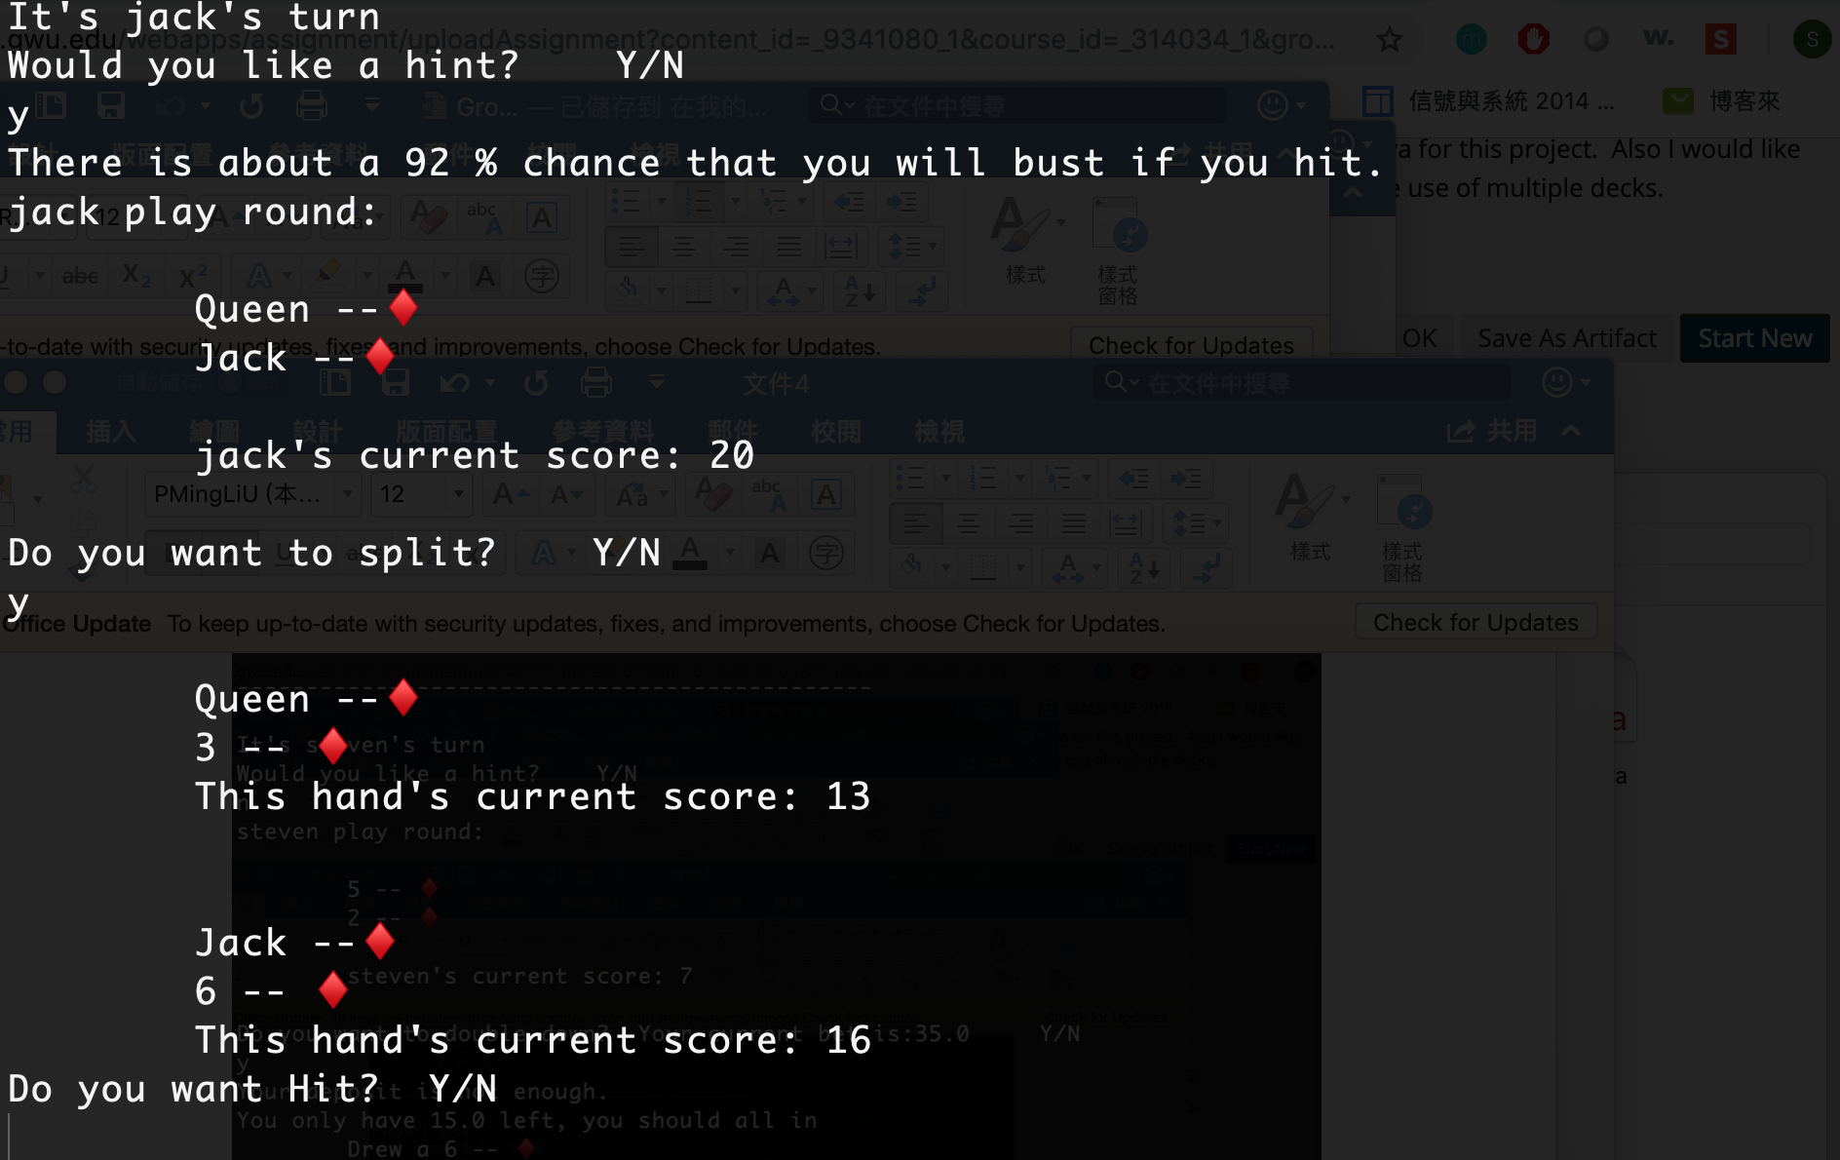

1. ***This is the result of this round, we will show your value and dealer’s value, and we show who win we lose, we will calculate the money left in everyone’s bank. At last, if someone run out of his money, we will remove him.***

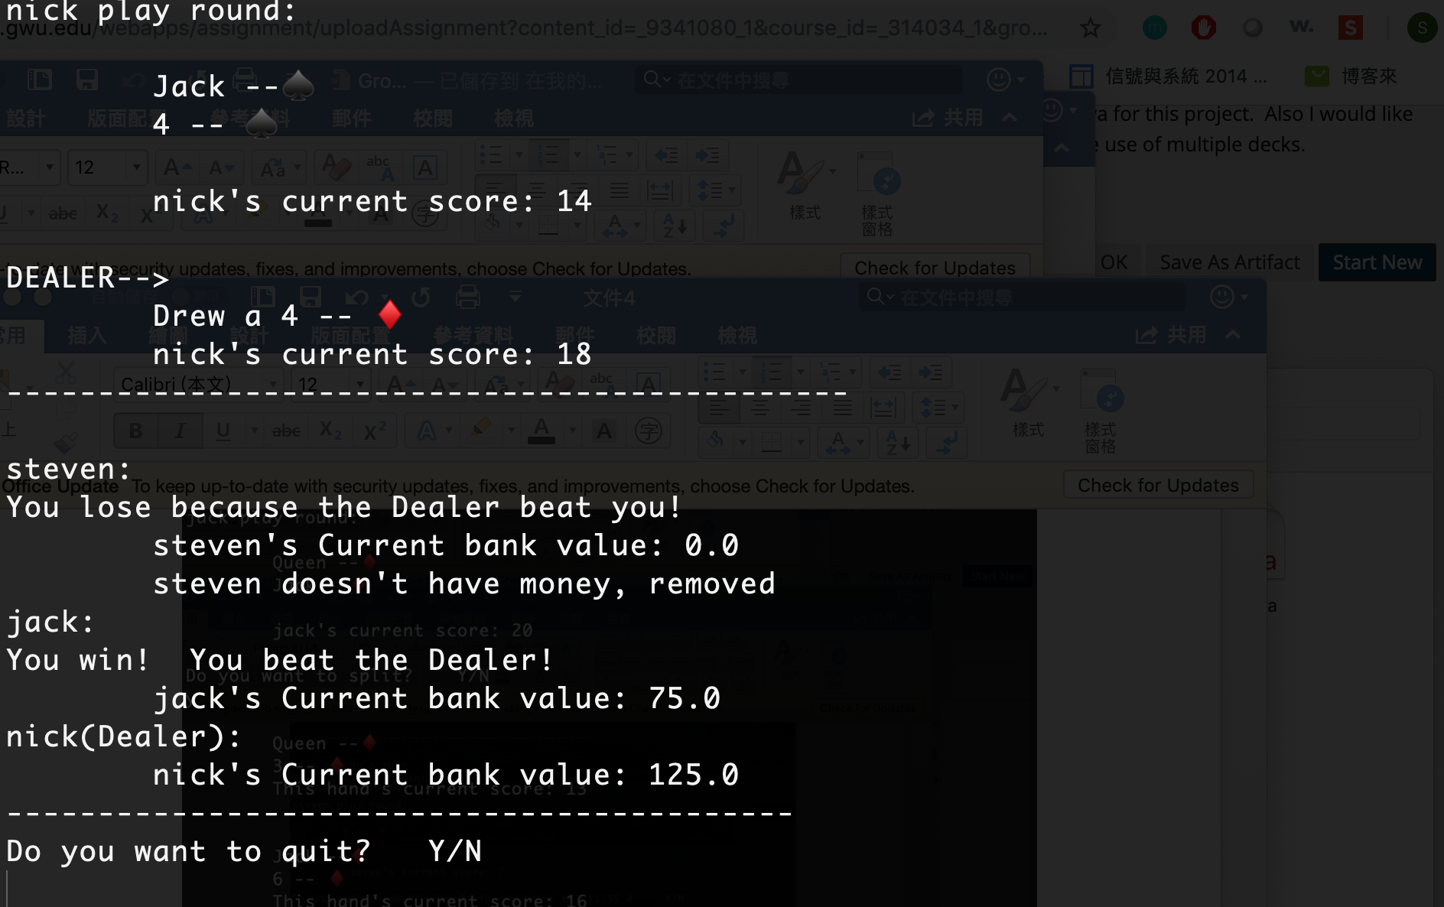

***Build instructions***

1. Go to src directory
2. Javac -d ../bin/ Blackjack.java
3. cd ../bin/
4. java Blackjack
5. you can start to enjoy this game.

***Github***

<https://github.com/CSCI6221-Spring-2019-Renner/Group10-project1>