group11:Tingge Yao;Jiayi Xi;Yichi Zhang

Code

Github link:

<https://github.com/CSCI6221-Spring-2019-Renner/group11-project1>

Documentation

1.Requirements completed and not completed

completed:

1.ui interface

2. Ability to play against players and players

3. Can repent any time

4. Simple AI, implement player vs AI

Not completed:

1. Ability to judge the outcome and score

2. Ability to save the game and load the game

3. Record names and scores for different players and generate leaderboards

4. Implement networking features

5.Can start new games multiple times

2.Design and approach

a two-dimensional array used by the board for storage

Repentance operation uses the stack's data structure to store the location of each step

The main class implements the creation and initialization of the framework by calling chessbutton, etc., and then transfers the control to MyChessPosition to start the game.

AI implementation uses greedy algorithm, direct search and minmax algorithm

Class call relationship:

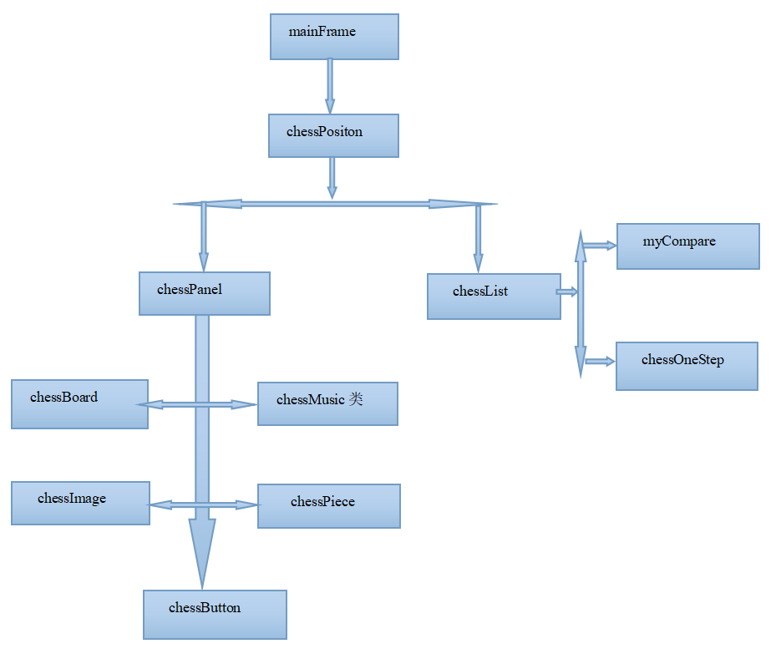

3.Citations

<http://www.ntu.edu.sg/home/ehchua/programming/java/j4a_gui.html>

<https://netbeans.org/kb/docs/java/gui-functionality.html>

<https://howtoprogramwithjava.com/java-ui/>

4.Results

Screenshots, etc.

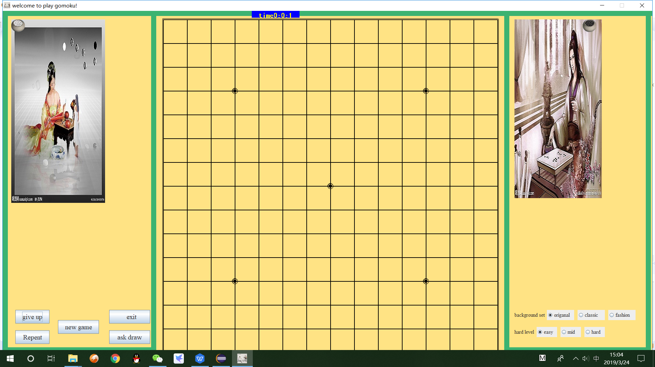

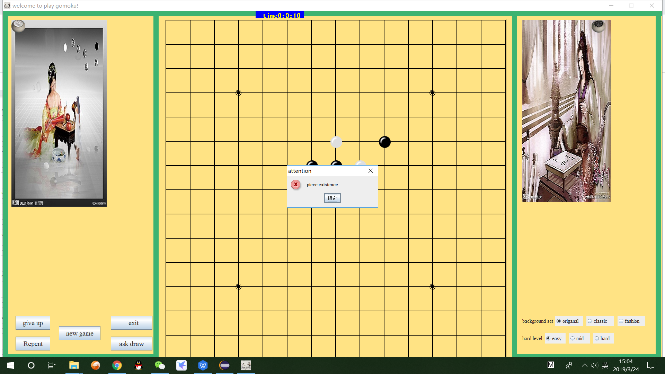

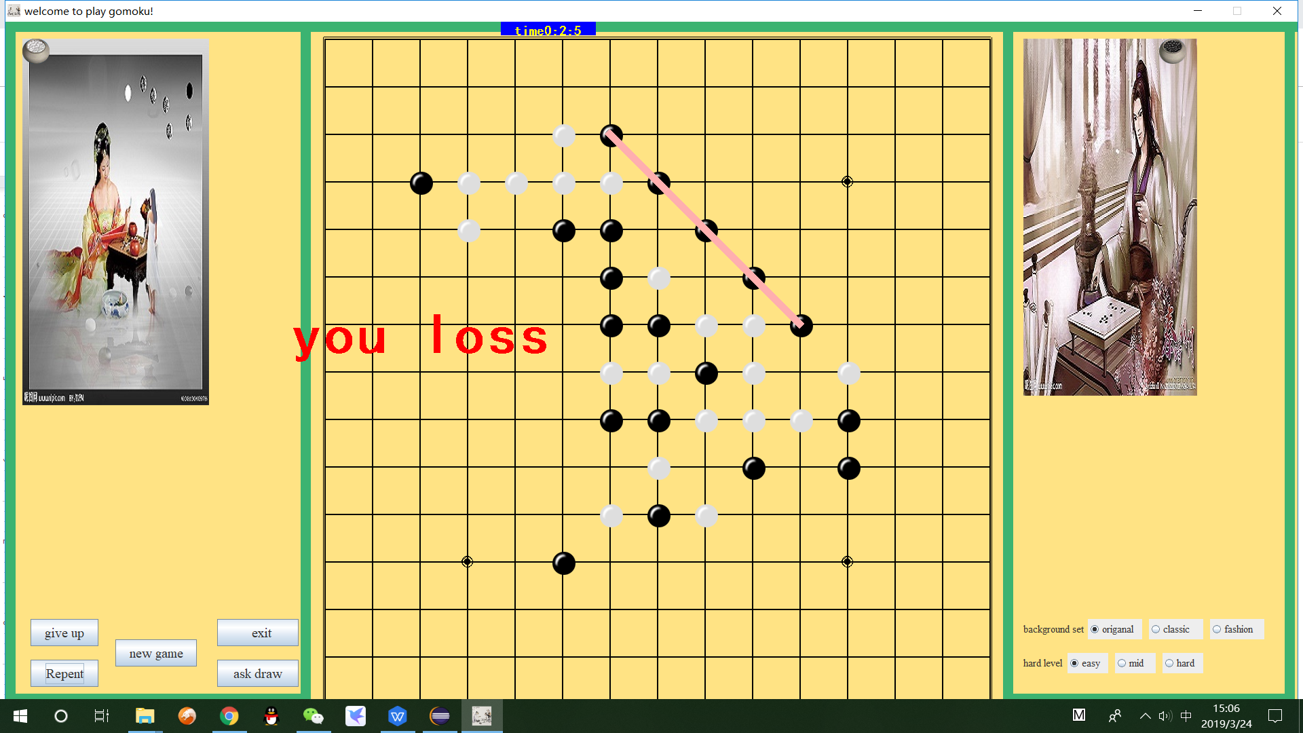

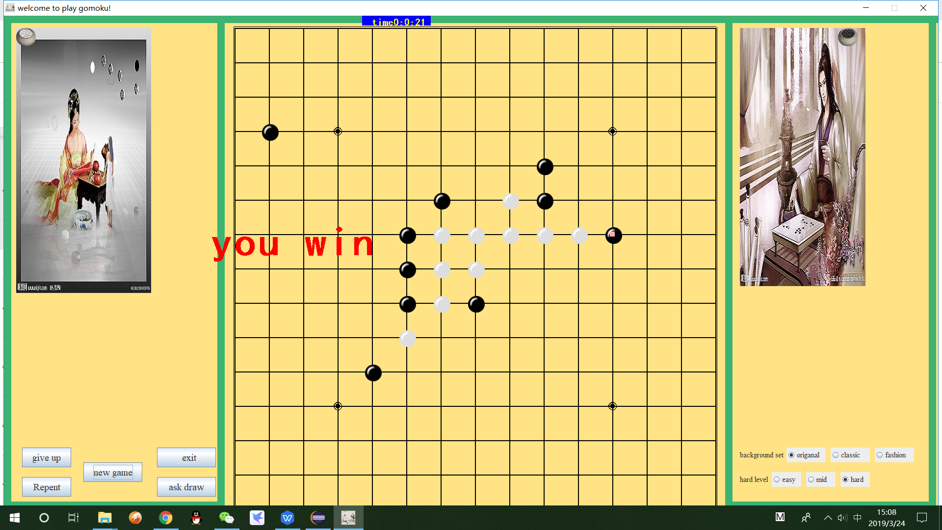

What did you learn?

Learning experience:

In the actual operation process, we borrowed the relevant java code and compared it. There are differences and connections between the syntax of Java and Scala. The biggest insights are in the following points.

1. Classes in Scala

Classes are not declared public, and there can be multiple classes in a single Scala source file. Scala's class definitions can have parameters, called class parameters, which are accessible throughout the class. Then we can use new to instantiate the class and access the methods and variables in the class.

2. Scala inheritance

Scala inherits a base class similar to Java, but we need to pay attention to the following:

a.Override a non-abstract method must use the override modifier.

b. Only the main constructor can write parameters to the constructor of the base class.

3. In Scala, there is no static thing, but it also provides us with a singleton mode implementation, which is to use the keyword object. When using singleton mode in Scala, in addition to the defined class, an object object with the same name is defined. The difference between it and the class is that the object object cannot take parameters.

4. Scala can call Java classes and give us a lot of help.

5.Build instructions

Just run the code, and everything will be OK.