Action Vending

The goal of this project is to create a human-centered, touchscreen-based smart vending machine interface that will sell high-end digital cameras in public, round-the-clock settings like tech centers, malls, pop-up events, cruise ships, hotels and airports. When traveling, it is not uncommon for people to have their personal items lost, stolen, or just forgotten and this vending machine looks to solve this by selling some of the more popular consumer products, digital cameras and accessories, from an easy to access vending machine with 24/7 access.
The wi-fi capable machine will even provide product details, comparison and reviews from major retailers, in the users native language, giving consumers information to help them make an informative, confident decision with their purchase. This design incorporates elements from all the designs put together so far.
All of the designs alternatives use a large, high resolution touch-screen to interact with the customer. Tactile, physical button interfaces do not provide any benefit to the user experience for the product being sold, so the final interface will be digital.
While evaluating, one of the immediate issues discovered is that without having multiple iterations of design mock-ups to test and try out, implementing an interface that is self-intuitive, easy to use, and able to accommodate physical characteristics, localization, and any disabilities, it extremely challenging. We don’t want to make the interface too complicated where it drives away interest, but it must allow some form of product interaction in a virtual manner, as well as provide a dictionary of terms that users can better understand the product features. The goal being to find a balance between a “Tell Me” and “Try Me” experience for the users.
Our approach to solve for some of the design challenges we discovered is to leverage existing interfaces that have accepted HCI expert feedback and opinion since we do not have access to the ability to observer many users interacting with the interface, and are limited by time. We will make some predictive assumptions for our evaluation, typically combining a combination of the designs from the Part2 document.
Physical Case
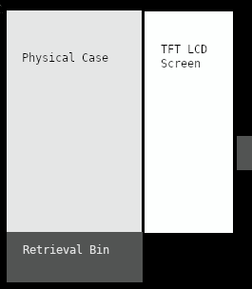
Design Summary:
Physical Characteristics:
The machine will comprise of three sections:
1. a physical glass display, showcasing products.
2. a large touchscreen interface for the consumer to research and purchase items.
3. a payment, and receipt scanner interface.

UI:
A single, large TFT LCD rectangular screen, 115cm (~45in) in height, 61cm (~24in) in width, about 90cm (36in) from the ground. It is large enough to display actual size images of the largest products.
The large screen will help solve for vision and physical disabilities that might limit users from making purchases.
Evaluation Summary:
No changes here, we initially envisioned having a large screen to accommodate for vision and physical differences between people, and this machine mock-up works well. The only possible change here is the placement of the retrieval bin. Individuals with back problems may have difficulty bending down to retrieve the item, and can be exaggerated if the item purchased has some significant weight to it. It can be placed higher.
Welcome Screen
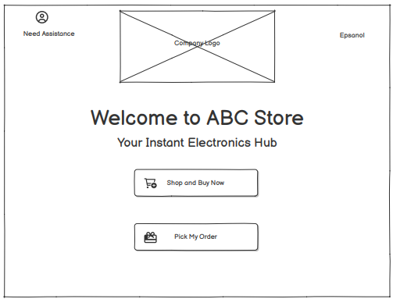
Design Summary:
The initial screen, activated upon initial touch, positions itself in proximity to where users initiate their first touch on the screen. This solves for the physical characteristic differences between individuals.
Aside from the localization, and help functionality, the two main purposes of this screen is to allow users to shop, or retrieve a purchased item from another location. One change we can improve upon here, is to add the ability to adjust font and control sizes for people with vision disabilities.
Evaluation Summary:
The logo design, greeting, assistance, and pick-up functionality needs to still be incorporated. The functioning product does not have it implemented yet. The color scheme does not yet adhere to people with color-blindness, and we are working on incorporating a pallette that addresses most, not all, forms of color-blindness.

Purchase Mode
Design Summary:
Two designs, one focused on the “Tell Me” format, and the other, “Try Me”, were designed.
Design 1 (Tell Me) is for users who prefer clear, written guidance and structured, step-by-step flows. The goal in design 1 is to provide three tailored picks, details between them, and a quick purchase option. This is tailored for individuals that know what they want.
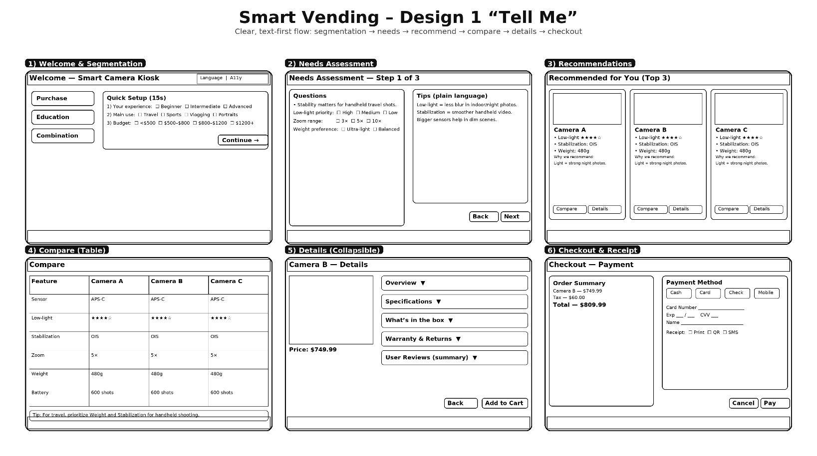
Design 2 is modeled for individuals who like to interact, research, and learn about differences between products. They are not necessarily sure or confident for what they are looking for.

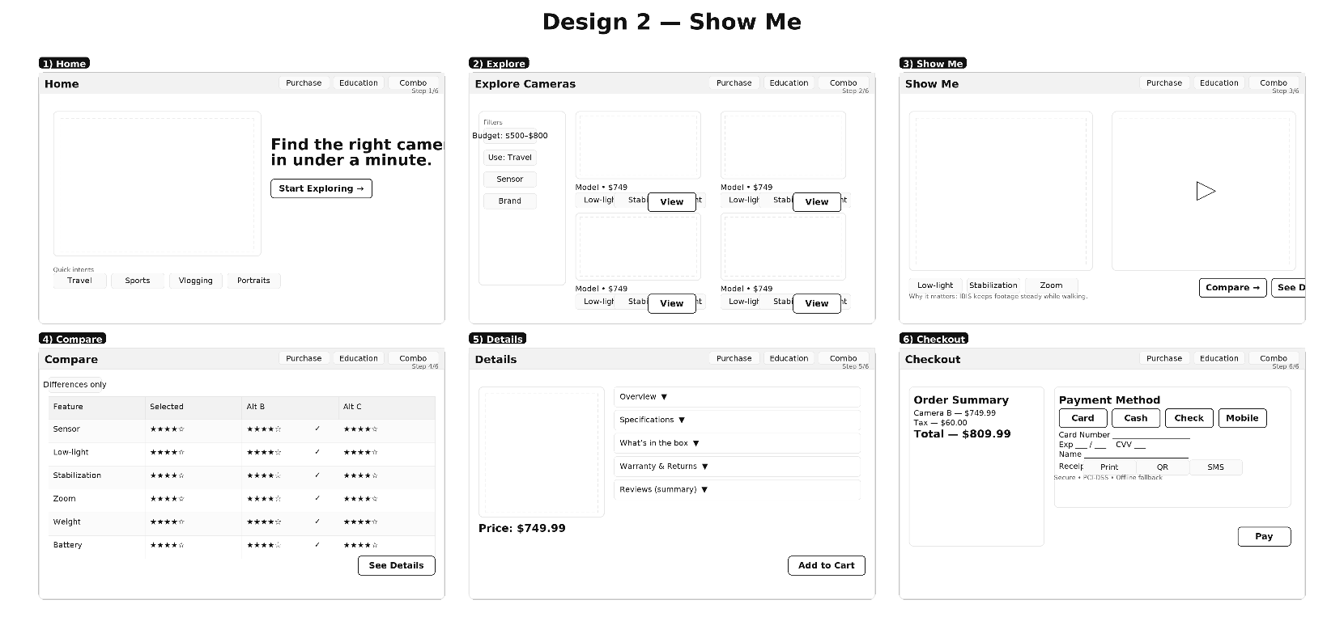

Evaluation Summary:
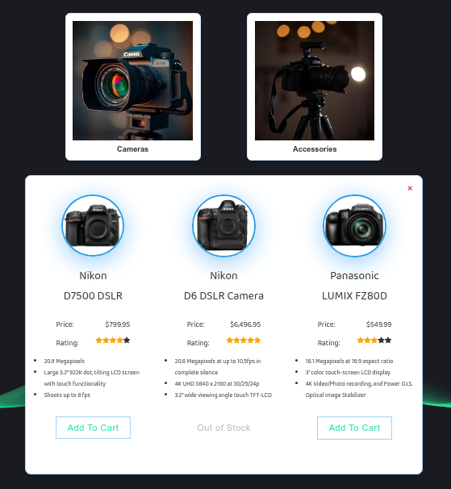
Based on the expectation highlighted in our Part2 document, we are implementing a hybrid of design 1 and design 2, while utilizing the Learning mode to provide a more enriched interface for customers to review products.
The initial purchase mode will contain a recommendation of popular products, average rating, key details, and a purchase option. A control for the Learning mode still has to be added.
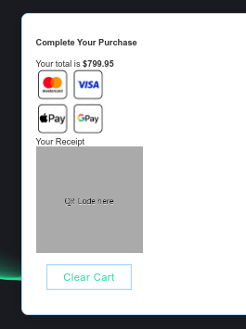
The checkout feature has been truncated to save document real-estate, and it will include a summary of items purchased along with the ability to return to the product or learning mode screens before checkout.

