Raspberry Pi Soil-moisture instrumentation Test and
Experiment

Last summer of 2019, my daughter and I spent time in thinking about her upcoming 8 grade science project. As a dad that loves raspberry pi, I saw the opportunity to propose a project that can benefit my curiosity. I told her that I wish that I could explore an existing Rpi DIY project that collect soil moisture data. I told her that we need to divide this task into two departments. I commit that I will take charge of the instrumentation while she takes charge on which science project she could do in relation to soil-moisture.

My side:

The first thing I did was to gather existing raspberry pi projects that detects and monitors soil moisture. I was aware that I needed to apply some devOps strategy to minimize material, time and maximize results . The first choice was to materialize the soil-moisture monitoring test made by Pi4IoT (Pi4IoT, 2018). The demonstration used an analog soil moisture sensor, an analog to digital converter , a raspberry pi and IBM's NodeRed visual programming. The video tutorial was awesome and was properly documented.

Alpha Testing.

This was the day when I got hold of all my hardware material based on the list that was instructed by Pi4IoT. I did my breadboarding, connected the resistors to the analog to digital converter (ADC). Wired the soil-moisture sensor with jumper cables and connected the pi to ADC. The video tutorial had walk me through to the necessary libraries and dependencies the ADC needs. This time, I discovered the importance of Adafruit's MicroPython (Adafruit, ND).

After downloading and installing the microPython requirements. It was time to test the simple python script to run the soil moisture sensor. The test was a success, this was also the time to run node-red and call the python soil-moisture code to execute. I was happy in seeing that the soil-moisture DIY was a success.

The Science Project Proposal:

The day comes that my daughter had to submit her science project proposal. Her proposal was to conduct an experiment on which soil covering such as mulch, lava rocks, and straw are the most effective in insulating the soil to retain its moisture. With a little bit of luck, the science teacher did approve my daughters science project proposal.

Requirement preparation:

Just to make things interesting, I did consider to handle this job like project managers do. I did observed by requirements, testing phase , deliveries, debugging, data integrity , quality , and retrieval, and processing. The science project requires 12 moisture sensors, 3 sensors in each group including the control group. I had to setup 4 raspberry pi and 4 ADC to accommodate the 12 moisture sensors.

All the hardwares that I needed were available in Amazon and Adafruit Industries. I preferred Amazon since we had prime membership and that deliveries towards orders would arrive 24hrs there after with free shipping.

Problem encountered.

I thought that my testing phase was done during my explorations I mentioned above. To my surprise, as the water drains to the bottom , the dashboard gauge on my Node Red increase from 0-100 instead of 100-0. I tried to debug the given function code but failed to correct the problem. I tried to check the soil-moisture schematic from the sensor to the ADC and from ADC to the raspberry GPIO.

I knew that the problem was on the NodeRed function node in parsing the python code. It took me a day to troubleshoot and debug the problem. I have to comment out some of the calculation parsing at the function node and add a range node to do the calculation and negation process. Please see node red flow collection link below.

In addition, I have to integrate an existing Raspberry pi Sense hat temperature and humidity data for each group, the lava rock group, the mulch group, the straw group, and the control group. I spent a day in researching on how to integrate the temperature and humidity data for each group. Then I found that I can use MQTT to retrieve from a separate raspberry pi and pass its data to each group (MQTT, ND ). Good thing a have a spare raspberry pi to act as my Mosquitto MQTT server. There were tons of Mosquitto Broker video guides out there, I choose to pick BRUH Automation video tutorial (BRUH Automation, 2016).

With the video tutorial guide, it only took me 15 minutes or less to setup the broker. The next hurdle was on how to use MQTT node at Node Red to publish and subscribe a sensor data. Again, Youtube research was the way to go. The quickest and basic video guide was Steve Cope's MQTT video tutorial (Cope, 2018).

Some minor doubts were also considered, if the data that is being save through comma separated value (csv) node, can do automatic saving once a power failure occurs. Will there be an overwrite saving mechanism once the power is back to normal? So I did some power failure and power back test to see if how the csv node and actual csv file behaves. With some luck my doubts were cleared on how the csv node handles the saved data, how the last data is save before power failure, and how it will add the new data from the set csv file name when power is back to normal.

Scaling process and Physical setup:

Once a single group was set up. All I did was to scale, I did an image of the sd card and clone it using raspberry pi’s native imaging application. I made sure that after the imaging was done a new rpi name and password were established. I also made sure that each rpi were properly tag and name. I also check each csv file to make sure its name belongs to the correct group. All in all I made 3 sd card images. I arranged all of the 4 groups on a table. One pi for each group. One IP address, one unique csv file name. I tested all the raspberry pi on each group together with its sensors, node red dash board gauges and each of groups csv files.

And now I can say that all are ready for deliveries.

Day 1 start date:

The first day did start very well . All the sensors are properly functioning at the dashboard from the temperature and humidity sensor, MQTT mosquitto server, and all 12 moisture sensors. I also checked the CSV files of each group and its data log. So far so good.

The Hiccups :

I believe we were on our third day of our experiment, all the raspberry pi group(lava, straw, mulch and control) crashed. I tried to troubleshoot and debug on of the group and found out that the calling process of temperature and humidity was not properly set and thus had created a systems overflow. I did some adjustment on the timing and on the number of allowable data called per minute.

Up and Running:

After the debugging process was done. The system was working well. All 4 raspberry pi's with their sensors were running smoothly. Time to time I check and downloaded the captured data through simple HTTP server commands. The experiment run almost 30 days. I am aware that the soil-moisture sensor quality are not that good but in this experiment, the sensors lasted 30 days in an indoor temperature controlled environment. I would suggest that the sensor must be change every 30 days or purchase a high quality soil-moisture sensor like the adafruit STEMMA soil sensor (Adafruit, ND) .

Data Visualization and Collection:

As mention above, this experiment was using IBM's Node Red visual program. This would mean that a real time moisture data can be accessed and displayed in a web browser. The Node Red dashboard node was responsible in displaying all the soil-moisture sensor readings and the csv node was responsible in storing the data gathered by the soil-moisture sensor. Each group has its own IP address, dashboard and unique csv file name.

In addition and in parallel process, my daughter was religiously probing an analog soil-moisture reader for 14 days . Each day my daughter would log all of the groups soil-moisture reading in a separate spread sheet. In this process, we can validate and compare the automated and manual soil-moisture readings.

Data Processing:

Since each group has its own IP addresses, a simple HTTP Server can be also executed in each group for easy data download. After each unique csv files were downloaded, I did use a spreadsheet to check if the data log was in its proper column title. I then made a simple formula to do a total average from the 3 mounted soil-moisture sensor readings in each group. All of the data processing was done using open office calc. After the checking and formula calculation, the data sets was ready for a bar and line chart visualization.

The manual data gathered was processed using Libre Office calc. My daughter and I used a spreed sheet to do some average formula to all the data sets on each group. After that, the data sets were ready for a bar and line chart visualization

The result.

After the bar and line chart was generated. I can safely assumed that the 14 day manual and the automated soil-moisture data gathered are similar. Visually my daughter and I had found no major differences on the bar and line chart in comparing the manual and automated data. I believe that with this result, I can safely consider that the automated data gathering instrumentation works and its data is validated.

The science experiment:

The science experiment and documentation was made by Gabrielle Cadosales. The project was selected by Forest Grove middle school to represent at the St. Lucie county Science Fair for the environmental science category. The project can be found at Gihub.

Conclusion:

The instrumentation I had provided and the science experiment of my daughter was a great experience. At least I learned how to implement a small scale Internet of things edge. The best part was that my daughter had analyzed the csv logs that was save for the last 21 days. The data analysis was processed via Libre Office spreadsheet. It was fun to know that this experiment has a business potential if scaled up to monitor agricultural fields. In conclusion, I would like to share this experience to everybody. Below are the resources and pictures of how and what did we do to materialized this project. I am aware that this has a lot of things and avenue to be improve. Me and my daughter are happy and open if there are ideas out there to improve this experiment.

Screenshots and Node Red Flow.

Main Soil-moisture Flow

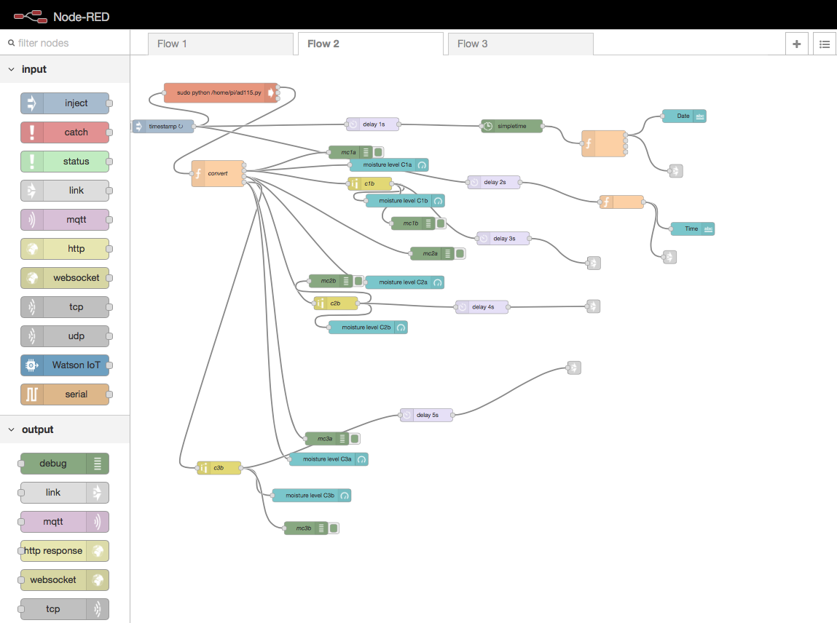

MQTT flow.

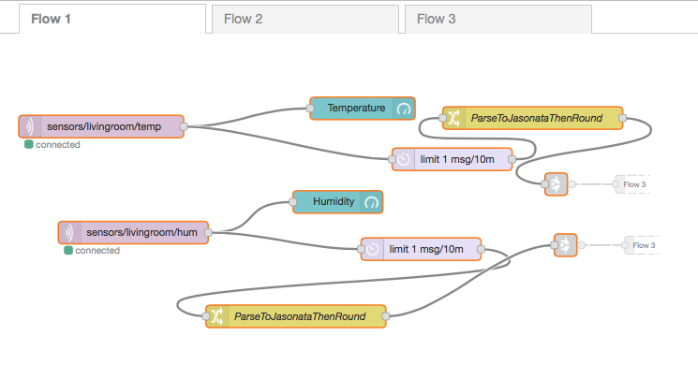

CSV for data collection flow

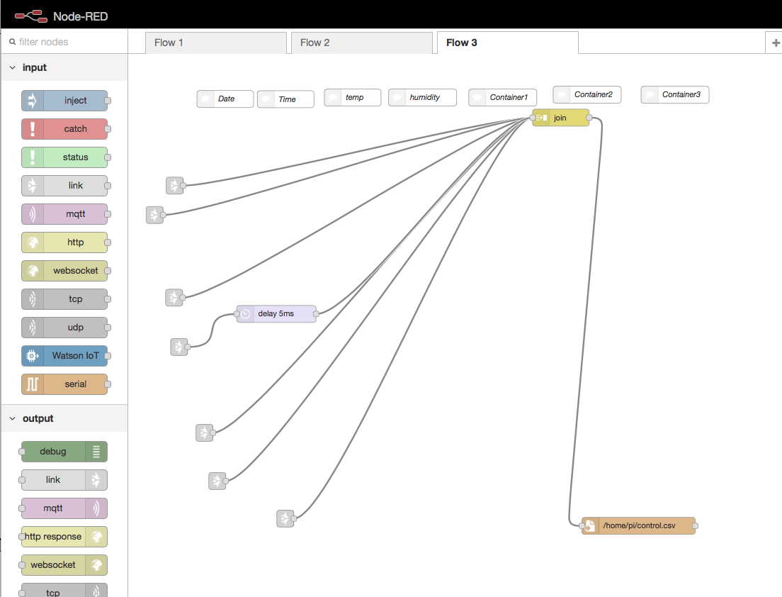

Dash board screenshots:

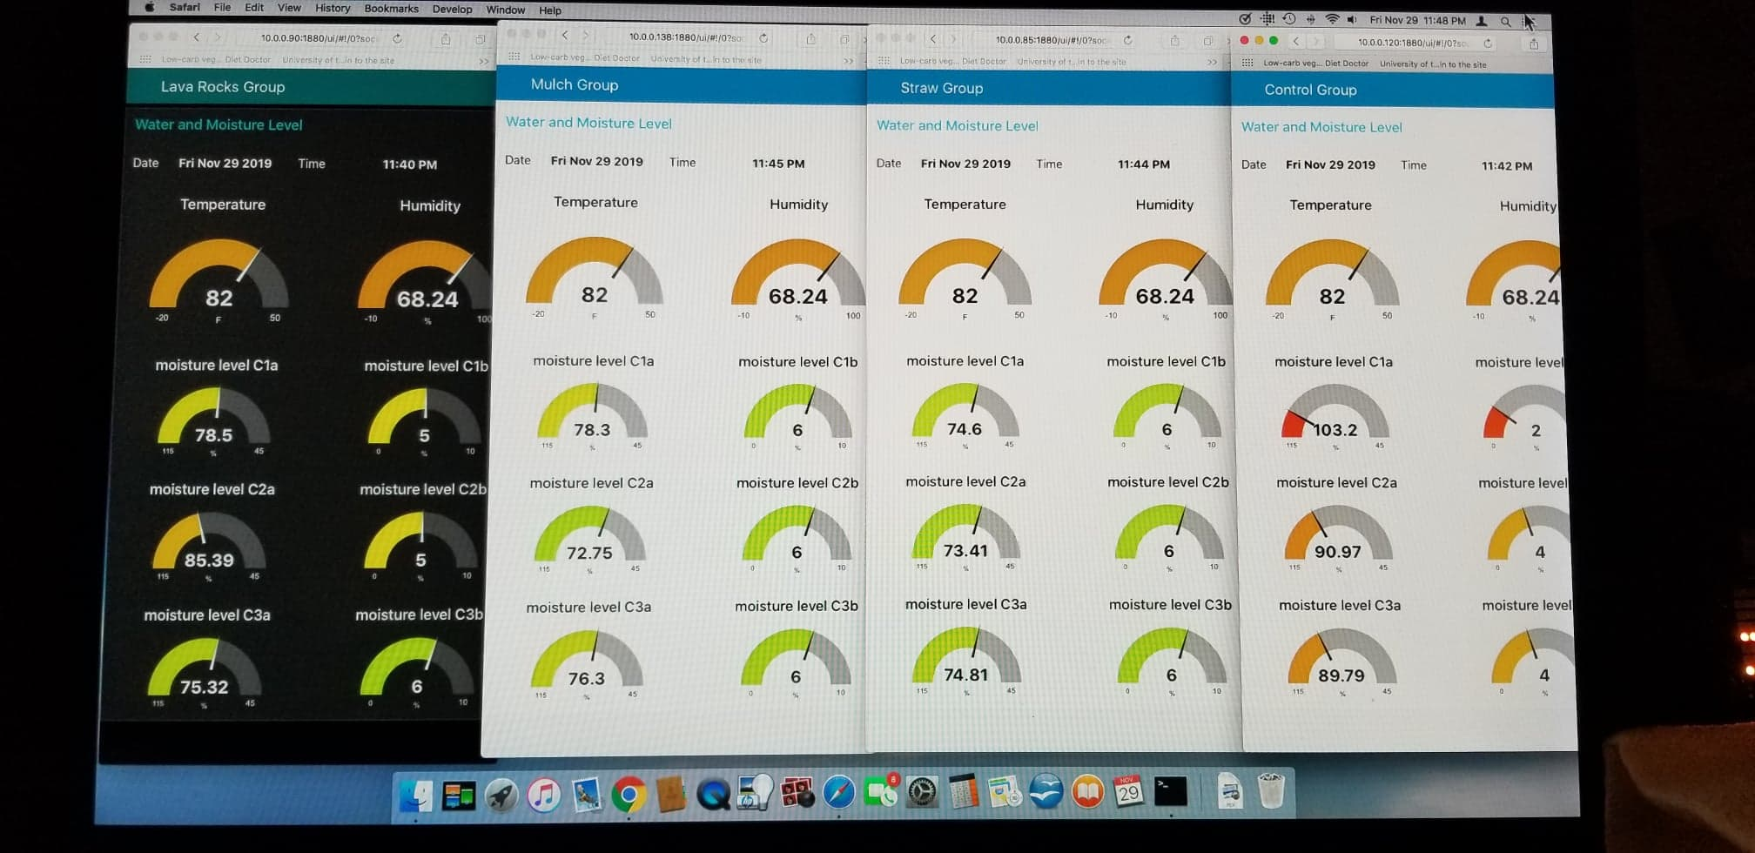

Fritzing breadboarding

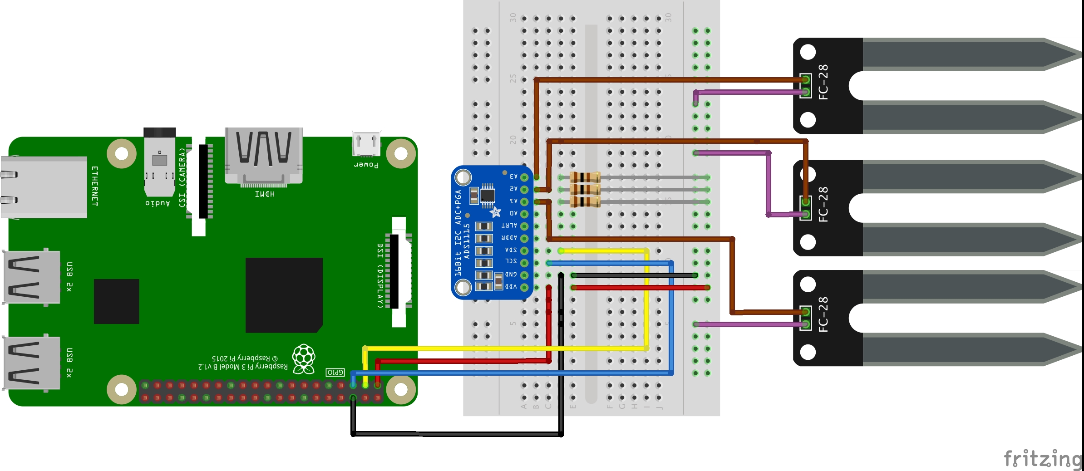

Node Red collection flow link:

https://flows.nodered.org/collection/c9sPcbTlucQp

Achievements and Awards:

The science project of my daughter was selected by their middle school to represent the environment category at the St. Lucie county science fair in Florida. Unfortunately, the science project did not win any award but the experience and the experimentation was enough to learn many things.

Reference:

Adafruit (N.D.) Adafruit STEMMSA Soil Sensor I2C Capacitive Moisture Sensor. Retrieve from https://www.adafruit.com/product/4026

Cope, Steve (March 7, 2018). MQTT Publish and Subscribe Using Node Red. Retrieve from https://www.youtube.com/watch?time_continue=103&v=XDrwgMSQrEY&feature=emb_logo

BRUH Automation (July 19, 2016). How-to-get Started with Mosquitto MQTT Broker on a Raspberry pi. Retrieve https://www.youtube.com/watch?time_continue=12&v=AsDHEDbyLfg&feature=emb_logo

MQTT (ND). MQTT.org. Retrieve from https://mqtt.org.

Adafruit (ND). Micropython . Retrieve from https://www.adafruit.com/micropython

Pi4IoT December 21, 2018. Monitoring of Moisture and Water level with Node-RED. Retrieved from https://www.youtube.com/watch?v=gJo88YZkhzc&feature=emb_logo

