**Project Report**

**On**

**“Home Automation”**

*With the help of Cisco Packet Tracer*



Name- Sujal Samai

Div- Life of Raspberry Pi

Div Head- Vanshika Sharma

**What Is IoT?**

* As the world progress continuously, there is one thing which has assured that this progress can be achieved efficiently i.e., technology. Technology is increasing so rapidly that we just can’t explain it. It has made possible to get connected to everyone even on the times of Pandemic and has become a part of our lives. So basically, which technology are we talking about here? It is indeed the Internet of Things. It is because of this one concept that we can communicate and build network with anybody in the world. So, you must be wondering what exactly is IOT? In this project we have tried to answer that and had tried to practically use IOT to connect our home devices, so that even they can communicate. For now, let’s understand the basic meaning of IOT.
* The Internet of Things is the concept of connecting any device (so long as it has an on/off switch) to the Internet and to other connected devices. The IoT is a giant network of connected things and people – all of which collect and share data about the way they are used and about the environment around them.

**What is a smart home?**

* A home is smart when it can help with the day-to-day of life by automating tech for security, convenience, comfort, and entertainment.
* When devices can “talk” to one another in our home, it creates a unique ecosystem that makes our life easier. Appliances and devices that can communicate on a home network include some appliances, lighting, heating, A/C, shades, security system, sound systems, TVs, and so much more.
* A smart home’s devices are connected with each other and can be accessed through one central point—a [smartphone](https://www.investopedia.com/terms/s/smartphone.asp), tablet, laptop, or game console. Door locks, televisions, thermostats, home monitors, cameras, lights, and even appliances such as the refrigerator can be controlled through one home automation system.
* Once connected, services such as a smart doorbell, smart security system, and smart appliances are all part of the [internet of things](https://www.investopedia.com/terms/i/internet-things.asp) (IoT) technology, a network of physical objects that can gather and share electronic information

**Problem Statement**

* Some gadgets are meant to be plugged in and out of power outlets at different intervals, while others are supposed to be left connected in.
* All of this needs a human physically attending to each of the devices on a regular basis so that there is no gadget is turned on/off unnecessarily.
* Some gadgets, if not correctly managed, consume a lot of energy, resulting in additional power costs. All of this monitoring and control may be carried out without the need to be there or inside the house. So how to do this?

**Objective**

* To monitor and operate household appliances from a far-off distance.
* To save time and to make effective use of energy.
* To have better control over our living environment and improve our freedom.
* To make communication with relatives more convenient.
* To enhance personal security.
* To serve as a visual warning system in the event of an emergency.

**Advantages of Home automation systems:**

* Reduced installation costs
* First and foremost, because no cabling is required, installation expenses are considerably reduced. Wired systems need cabling, which is costly in terms of both material and expert wire laying (for example, through walls).
* Increased energy efficiency
* Depending on how you use your smart-home technology, it’s possible to make your space more energy-efficient. For example, Lights and motorized shades can be programed to switch to an evening mode as the sun sets, or lights can turn on and off automatically when you enter or leave the room, so you never have to worry about wasting energy.
* Maximizing home security
* When you incorporate security and surveillance features in your smart home network, your [home security can skyrocket](http://www.adt.com/resources/benefits-of-smart-homes-technology).  Home automation systems can connect motion detectors, surveillance cameras, automated door locks, and other tangible security measures throughout your home so you can activate them from one mobile device before heading to bed.
* Integration of mobile devices
* Associating mobile devices such as PDAs and Smartphones with the automation system is now feasible everywhere and at any time thanks to wireless networks, as the specific physical location of a device is no longer necessary for a connection.

**Methodology**

* We will utilize the Cisco packet tracer which is basically a [cross-platform](https://en.wikipedia.org/wiki/Cross-platform) visual [simulation](https://en.wikipedia.org/wiki/Simulation) tool designed by [Cisco Systems](https://en.wikipedia.org/wiki/Cisco_Systems) that allows users to create [network topologies](https://en.wikipedia.org/wiki/Network_topologies) and imitate modern [computer networks](https://en.wikipedia.org/wiki/Computer_networks). The software allows users to simulate the configuration of Cisco routers and switches using a simulated command line interface.
* We will use it to construct a smart house, which includes several smart items used for home automation such as a smart fan, smart window, smart door, smart light, smart siren, smart camera, smart devices (laptops, tv etc.) and many sensors.
* Home Gateway is utilized to operate this smart object and sensor since it provides a programming environment for controlling smart objects linked to it as well as controlling mechanisms by registering smart devices with Home Gateway.
* A web interface offered by the Home Gateway may be used to remotely administer the IoE device. The internal (LAN) IP address of the Home Gateway is 192.168.25.1, but it may also be reached through its Internet-facing IP address.

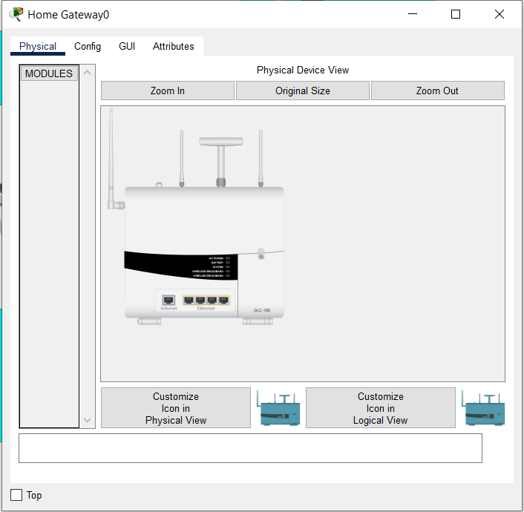

Physical setup of Home Gateway in Cisco Packet Tracer

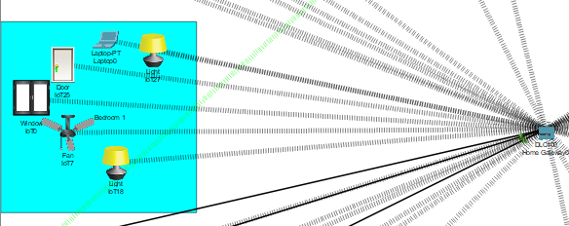

Sneak Peak to how our logical view is designed

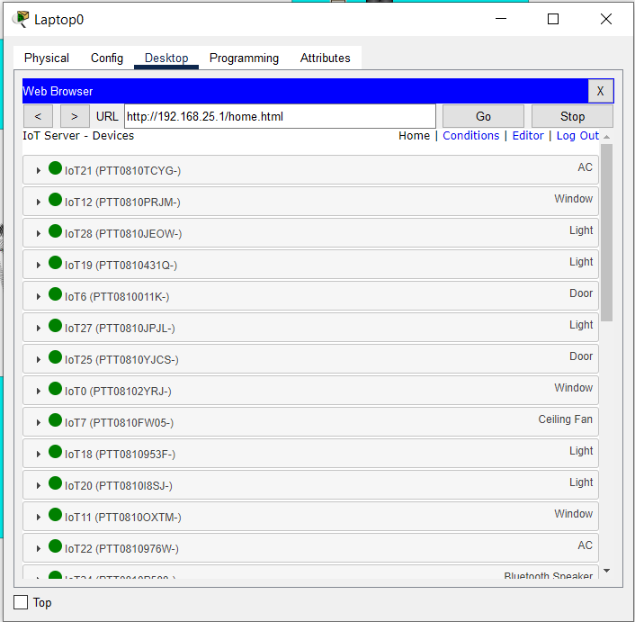

Devices Connected in the network

**Conclusion**

* With the help of Cisco Packet tracer, I could connect different IOE devices used for home automation, and could built a smart home utilizing the newly available features in the software to complete this project. I utilized a home gateway to register smart devices and operate them, as well as a Microcontroller (MCU) to link various sensors and IOE devices. Talking about MCU, they are essentially simple miniature personal computers (PCs) designed to control small features of a larger component, without a complex front-end operating system (OS).
* As we all know, the world is becoming increasingly linked with the rise of Internet, IoT just contributes to this trend and further increases the chances to link our devices. Many IT entrepreneurs have already begun to profit from the Internet of Things. Putting profits aside, if we consider the IoT in a larger sense, with the immense possibilities it opens, we may conclude that it has a bright future and will transform the globe in the next five years.
* By connecting basic appliances to the Internet of Things, home automation has been experimentally proved to operate well, and the appliances have been successfully controlled remotely over the internet. The proposed system not only monitors sensor data such as temperature, gas, light, and motion sensors but also actuates a process based on the need, such as turning on the light.
* It also records the sensor parameters in a timely manner on the website (database). This will allow the user to assess the state of different metrics in the house at any time and from any location.