**Learning Math and Science through Adinkra**

Gabriel Boakye and Ron Eglash

**Part 1: the curves of life**

Adinkra symbols are used in the African nation of Ghana to decorate cloth. Each symbol has a proverb or saying that goes with it. The shapes of the symbols are not arbitrary. Rather, they too embody traditional knowledge. Understanding these shapes can illuminate ideas from math and science.

One of the most important shapes in adinkra symbols is the spiral. For example, this adinkra symbol, “dwennimmen” shows four spirals. The spirals are in pairs because this represents two rams butting heads. Its proverb says: “it is the heart, and not the horns, that leads a ram to bully.” We take responsibility for our actions! It is not genetics (the horns you were born with) but rather your efforts (from your heart) that matter.



When we see ram’s horns in real life, we notice that the spiral grows larger and larger as it curves toward the head. This is a special type of curve called an exponential or “logarithmic” spiral.

|  |  |
| --- | --- |
| Logarithmic spiral | Ram’s horns |

If we coil up a rope or hose, we get a linear spiral. Unlike the logarithmic spiral, the linear spiral does not grow along its curve. The space between each revolution of the curve is the same. Ropes are not alive, they do not grow!

|  |  |
| --- | --- |
| linear spiral | coil of rope |

|  |
| --- |
| Kwatakye atiko |

One adinkra pattern that uses the linear spiral is Kwatakye atiko. Why would that be a linear spiral? Kwatakye was a war captain for one of the Ashanti kings; he is said to have cut his hair in this fashion. If you think about cutting hair with a small razor, the width of the blade never changes, so it is more like the rope: a linear spiral. In fact most linear spirals are human-made (mosquito coils, garden hose, etc.). Sometimes even the adinkra symbols based on log spirals in nature will be changed to linear spirals by artists who want to add their own style.

Nature-made curves, on the other hand, are more often logarithmic spirals.

|  |  |  |
| --- | --- | --- |
|  |  |  |
| African land snail, Ghana | Spiral aloe from Lesotho | Hawaiian fern |
|  |  |  |
| Pine cone | Chicken’s foot | Dog tail |
|  | C:\Users\eglash\Documents\African Fractals\PRESENTATIONS\PIPS\lusona\6.4\7.12.3.gif |  |
| Human hair | Sea shell | Swan |

**Some adinkra symbols that use logarithmic spirals**

|  |  |
| --- | --- |
| Dwennimmen: ram’s horns  “The ram will fight fiercely against an adversary, but it also submits quietly to slaughter.”  Meaning that the strong must also be capable of humility. | C:\Users\eglash\Documents\CSDT\CULTURAL PROJECTS\Af and AfAm\adinkra\our symbol images\dwennimmen.jpg |
| Sankofa: “return and get it.” It is not wrong to go back for that which you have forgotten. The saying is used in the context of cultural traditions; for example Ghanaians recovering traditions that were lost to colonialism, or African Americans seeking a heritage that was lost in the slave trade.  There are two versions of the symbol. On the left you see a bird looking backwards. We have added a spiral so you can see how the bird’s natural curve inspires the more abstract version on the right. |  |
| Akoko nan: chicken’s foot  "The hen treads on her chicks, but she does not kill them."  Meaning that those in authority should nurture those they are in charge of, but not pamper them. It is a symbol of both nurturing and discipline. |  |
| Gye Nayme  “Except God.”  A symbol of the supremacy of the Creator. |  |

Dwennimmen is an arc of a logarithmic spiral because it is based on the horn of a living animal. Similarly, sankofa is based on the logarithmic curve of a bird’s neck; Akoko nan on the curve of a chicken’s foot. But what do the logarithmic curves of the Gye Nayme symbol represent?

Recall the meaning of the Gye Nayme symbol: “only god has the power of life.” Power is represented by the bumps on the Gye Nayme symbol: these are the knuckles of a fist; the symbol for power. Thus the curves are representing not any one particular organism, but rather a general conception of life. In other words, the inventors of the Gye Nayme symbol asked the question, “what geometric form is most common to living organisms?” And they correctly answered: logarithmic curves. Adinkra is not only a source of cultural heritage for Ghana, but a source of mathematical heritage as well.

|  |
| --- |
| gye nayme |

Now we know why adinkra stamps include logarithmic curves: because they are the “curves of life”. But why do living things have these curves?

Lets take a single cell, the basic unit of all life on earth. In some cases a cell will reproduce by splitting in two (“fission”). If each of those “daughter cells” split in two, and their daughters split in two, and so on, then we have a simple doubling sequence:

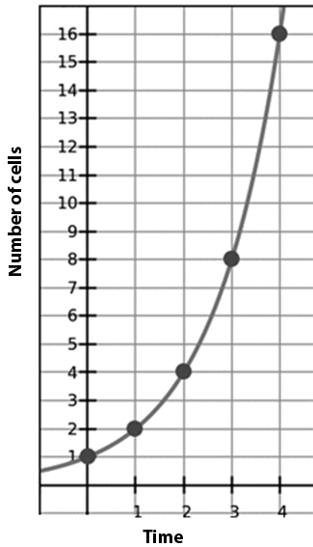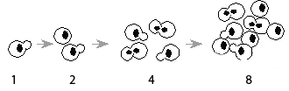

Let’s say that the number of cells double each time period (for example each day). The number of cells at time t is Nt. At time t=0 we have 1 cell, so we write N0=1, N1=2, N3=4, etc. to show each cycle or “iteration”. Then we can write an “iterative” equation: Nt = N0*2t. If we plot each point we notice that it follows the curve of a continuous equation, y = 2x.

Of course, real cells rarely reproduce this fast, because not every cell will split in every cycle. Suppose when a cell splits it has one daughter that is immature and has to wait 1 cycle to reproduce, and another that is mature and ready to split. It would then look like this:

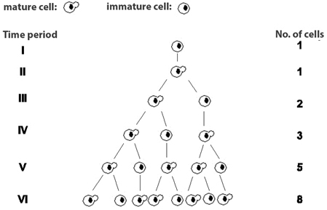

You might recognize this sequence (1,1,2,3,5,8…) as the start of the Fibonacci series. Its iterative equation looks like this: Nt+1 = Nt + Nt-1. As before, the continuous equation for a curve along this line is based on an exponent. The doubling sequence and the Fibonacci sequence are just two of an infinite number of sequences that make such exponential curves. It’s easy to make up your own! For example how does the population increase if it takes two cycles for an immature cell to develop into a mature?

Now suppose that instead of just a bunch of individual cells, they actually came together to create some structures – plant flowers, shells, horns, whatever the living organism needs. Typically, there are some parts that repeat at different sizes—flower petals, flourets, shell chambers, leaves, etc. Since size of those parts are related to the number of cells inside it, you can see how increasing cells by expotential growth, such as the doubling sequence or Fibonacci sequence above, creates living structures with expotential shapes. Sometimes those structures will rotate around a central axis. Thus we might get something roughly like this:

|  |  |
| --- | --- |
| http://1.bp.blogspot.com/-QqPoU5GX5iw/UPDaKB6JL-I/AAAAAAAAAco/BZnppEdjZoo/s320/fibonacci_spiral_by_hop41-d4xna2n.jpg |  |

Now we can see how the iterative equation governing cell growth tells us something about the continuous equation of the spiral. The spiral’s equation in polar coordinates is radius = Ctheta, where theta is the angle and c is a constant. You can think of c as the “coil” parameter. For a tightly coiled log sprial, c is smaller, as in figure A below. For a loosely coiled spiral, its larger (more “open”) as in figure B below.

|  |  |
| --- | --- |
| A  C:\Users\Adminstrator\Desktop\1.0008.PNG  C:\Users\Adminstrator\Desktop\1.0008codelet.PNG  Exponential Parameter =1.0008 A more closed or tightly coiled spiral. | B  C:\Users\Adminstrator\Desktop\1.0015.PNGC:\Users\Adminstrator\Desktop\1.0015codelet.PNG  Exponential Parameter =1.0015 A more open or loosly coiled spiral. |

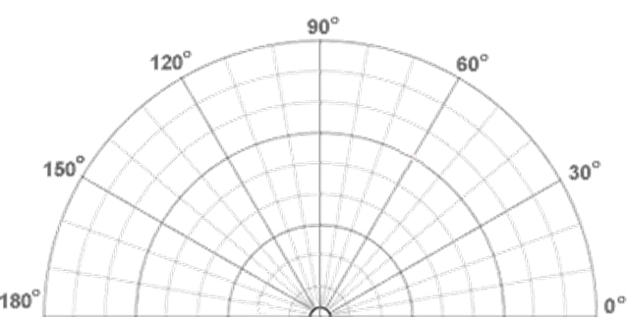

You can experiment with different values of C using our adinkra software, available online at [www.csdt.rpi.edu](http://www.csdt.rpi.edu) or on a disk. But even without the software, you can determine the value of C for any spiral in nature, using just a pencil, paper and protractor. If you don’t have a protractor, you can make one by cutting out this image. Then follow these steps:

First, pick the spot that seems to be the center of the sprial. Then measure the radius (distance from the center) at regular angles (e.g. every 90 degrees). For example, in the case of the left “loosely coiled) sprial (C= 1.0071) we measure:

|  |  |  |  |  |
| --- | --- | --- | --- | --- |
| angle | 450 | 540 | 630 | 720 |
| radius | 24 | 44 | 86 | 163 |
| Log10 radius | 1.38 | 1.64 | 1.93 | 2.21 |

Recall that radius = Ctheta. So to determine the value of C, we need to use the logarithmic or “log” function. The log is a sort of inverse exponent -- it tells you what exponent, applied to its “base” (in this case 10) would produce the number under investigation. Taking the log of both sides of the equation, we have: log(radius) = theta*log(C). So log(radius)/theta = log(C). We can determine log(radius)/theta by measuring the slope in the graph below. Then we just use that slope as the expontent of the base. The slope is .82/270 = .003. And C= 10.003 = 1.0071. Plugging that back into the software, we get the same curve we measured! Now you can try it with curves from nature, art, fashion, etc.

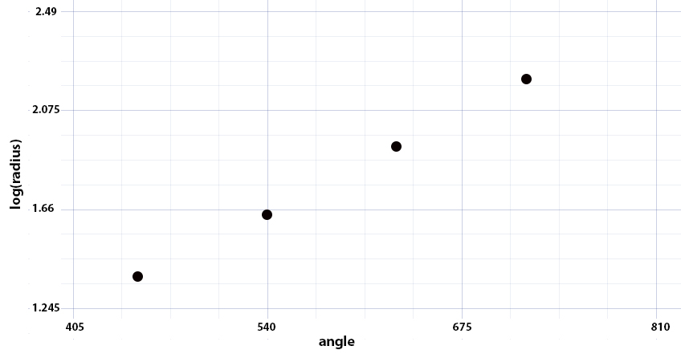

In the case of the computer-generated spiral above, the plot forms a straight line. In the case of a spiral from nature such as a shell, there may be variations in the curve or just measurement errors, but you can use the graph to make a “best fit” for the slope just by eyeball. By investigating log spirals in this way – measuring the change of radius with angle, and applying that constant to the adinkra software (<www.csdt.rpi.edu>) to simulate it —you can use the mathematical heritage of African tradition to explore the curves of life.