**Experiment-1**

Aim🡪

1.create a java project using maven.

2.Run the following maven goals on this project.

* Clean
* Compile
* Install

Screenshot🡪

1. **Clean🡪**

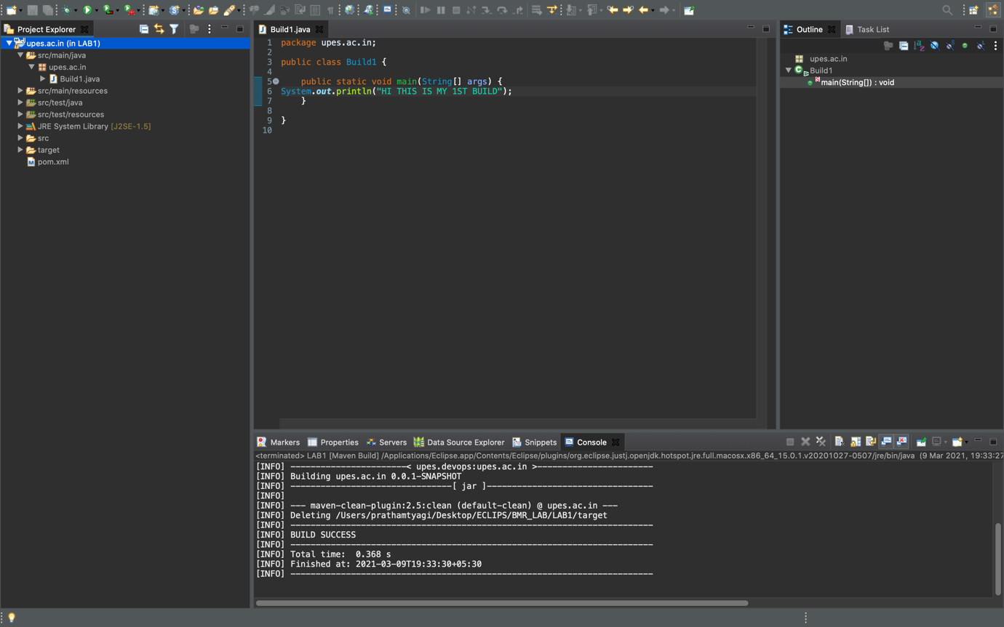

1. **Compile🡪**

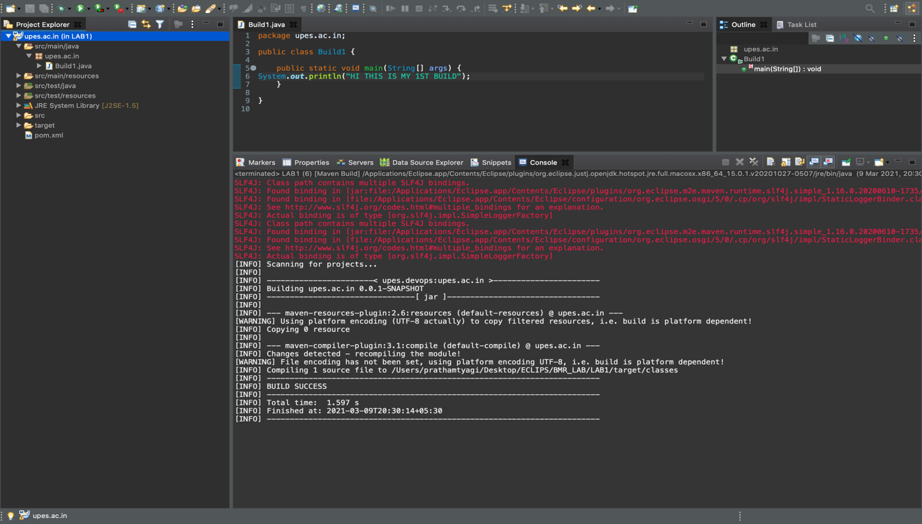

**3.install🡪**