**SCM ASSIGNMENT**

TO CREATE A PULL REQUEST:-

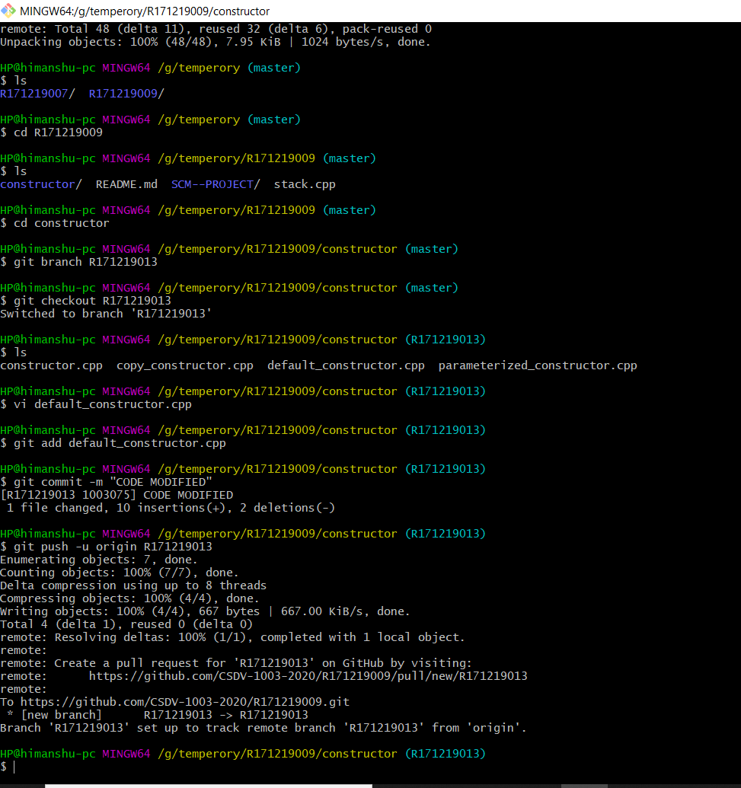

IT SHOWS ON GIT HUB LIKE:-

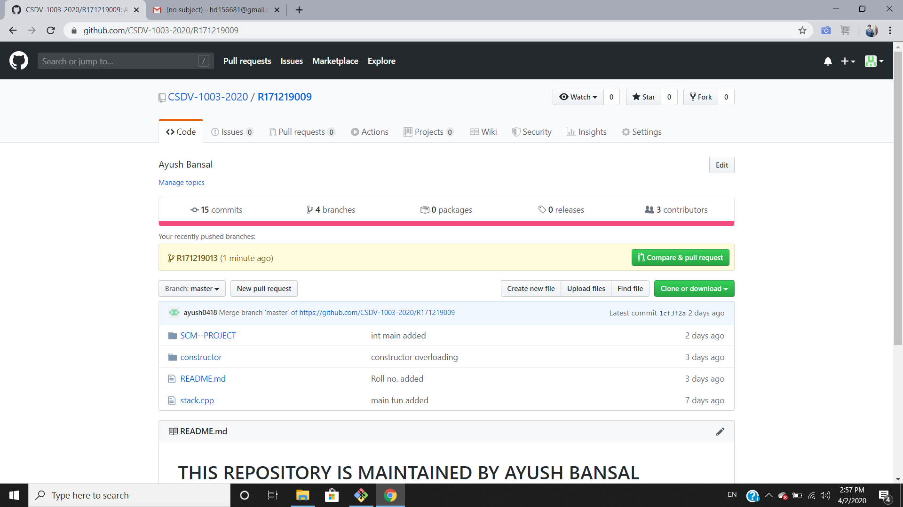

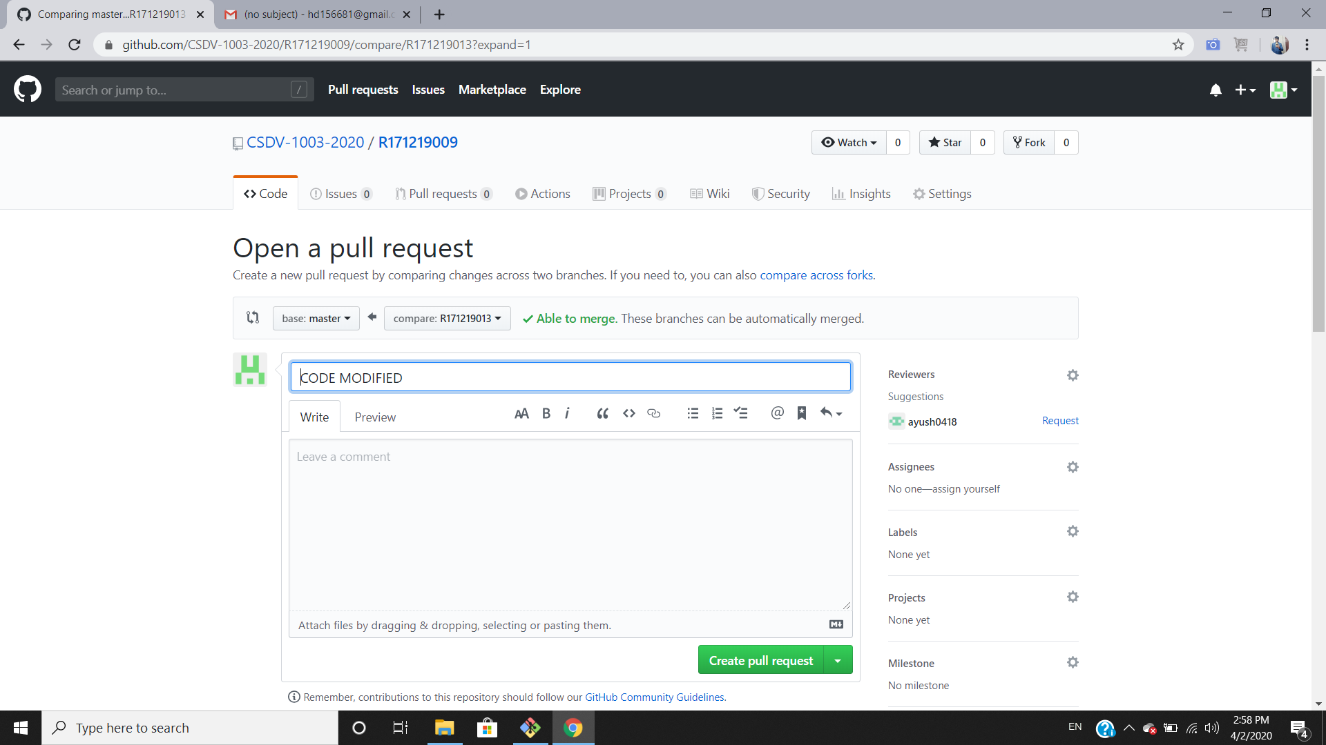

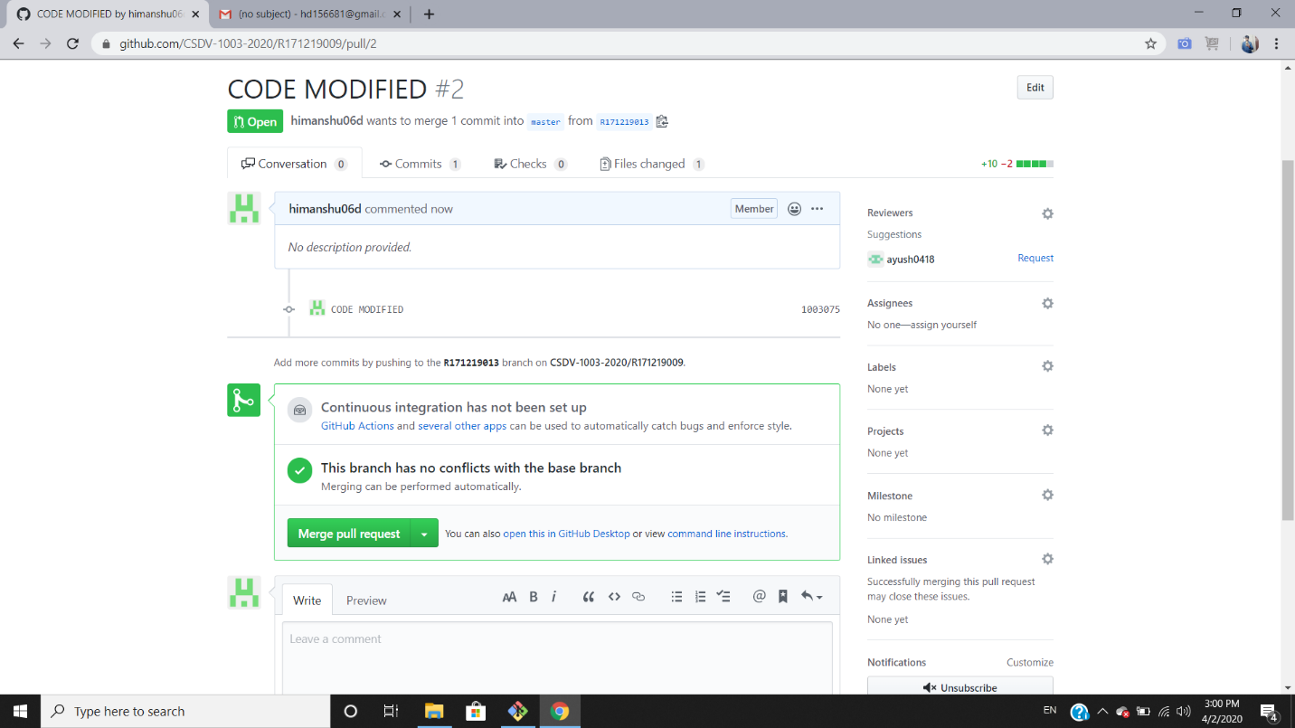

TO CLOSE A PULL REQUEST:-

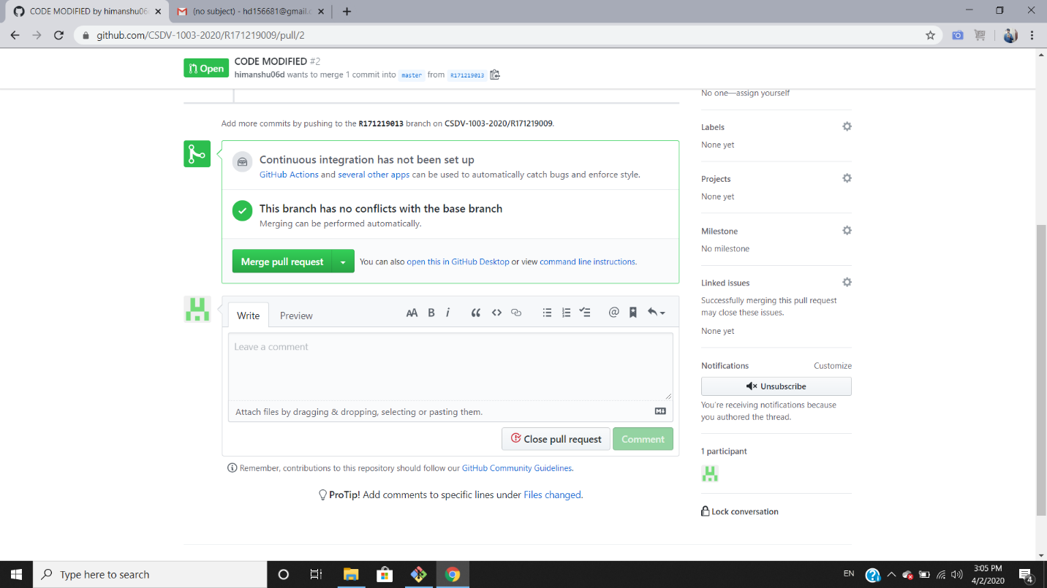

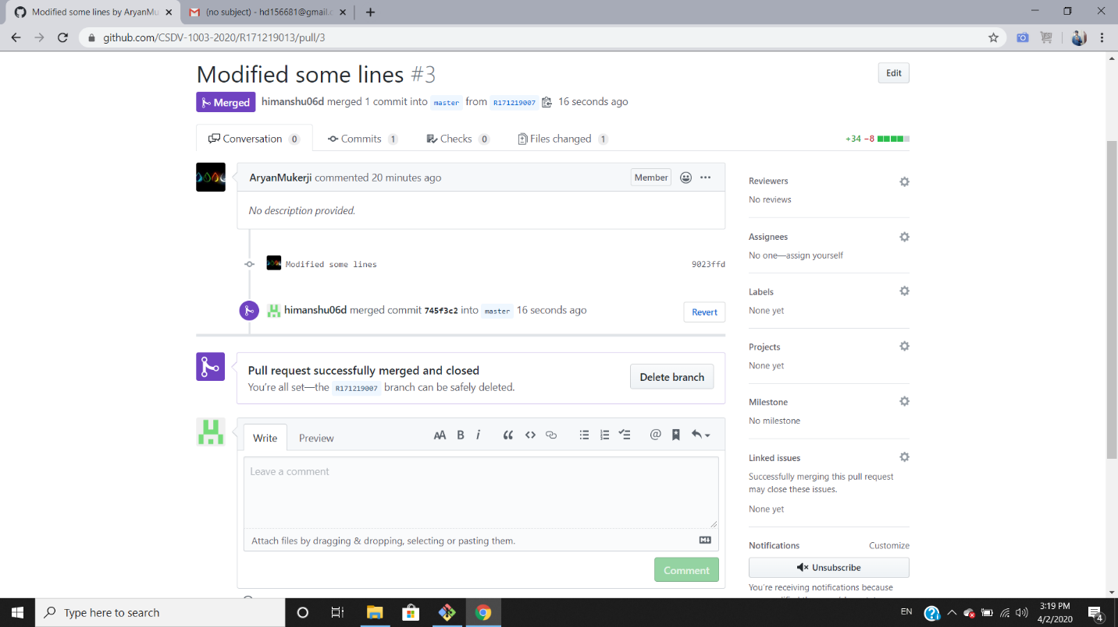

BY:-

HIMANSHU DUBEY

R171219013

500075125