This is the recent workflow of the repository.

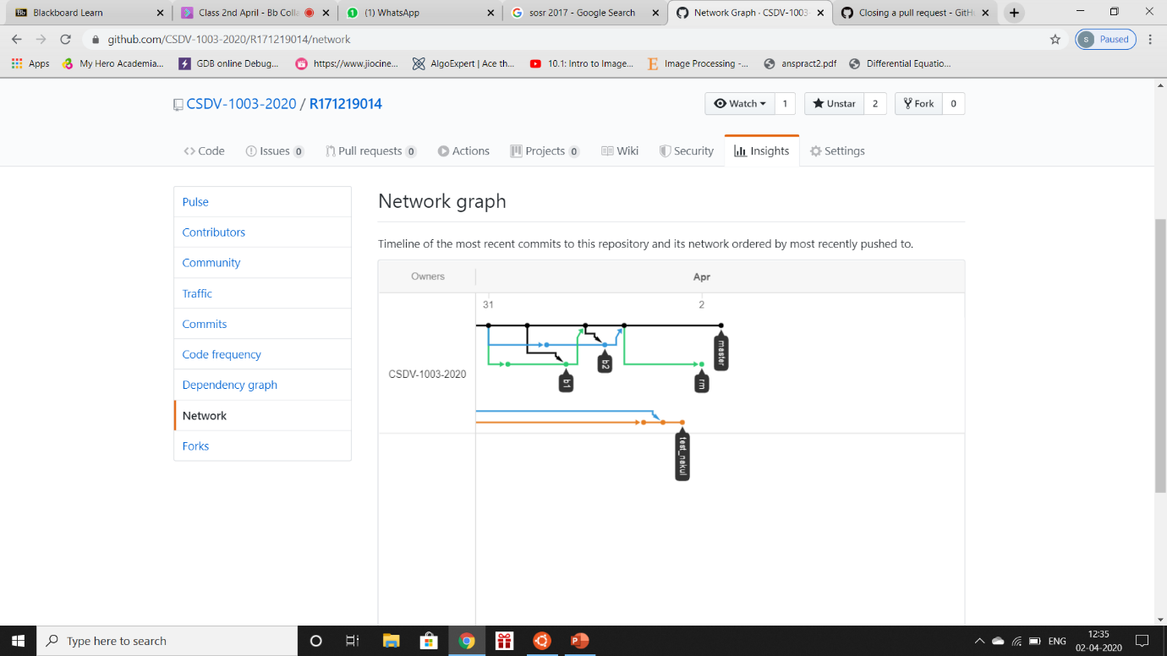

comparing branches ‘rm’ and ‘master’. Creating a pull request.

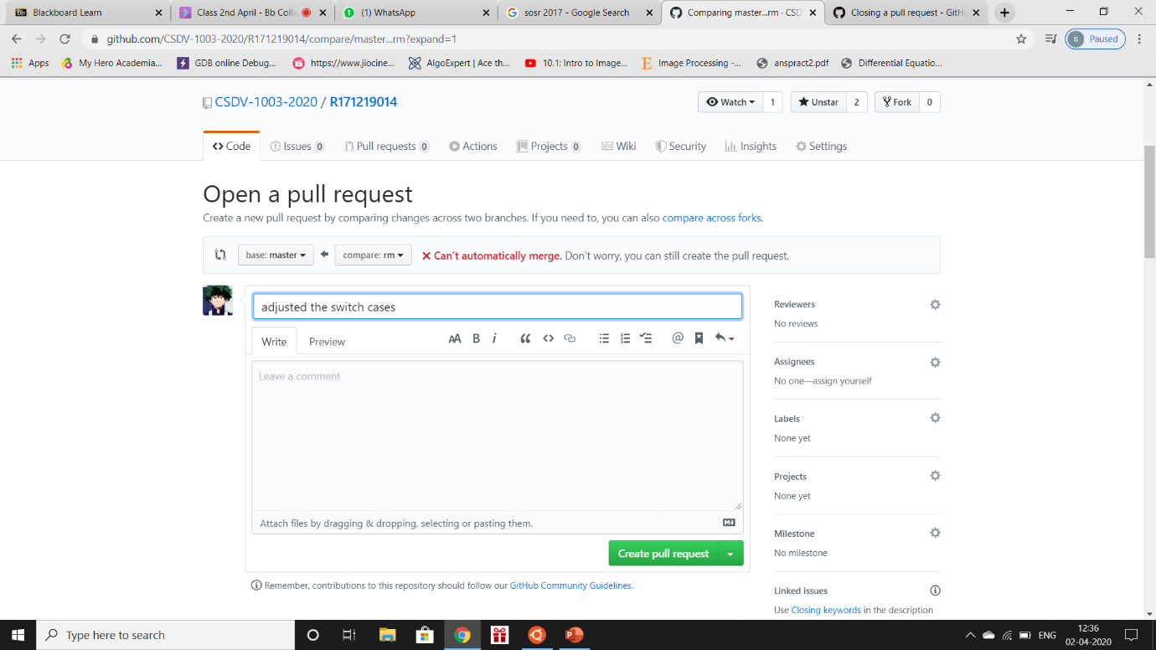

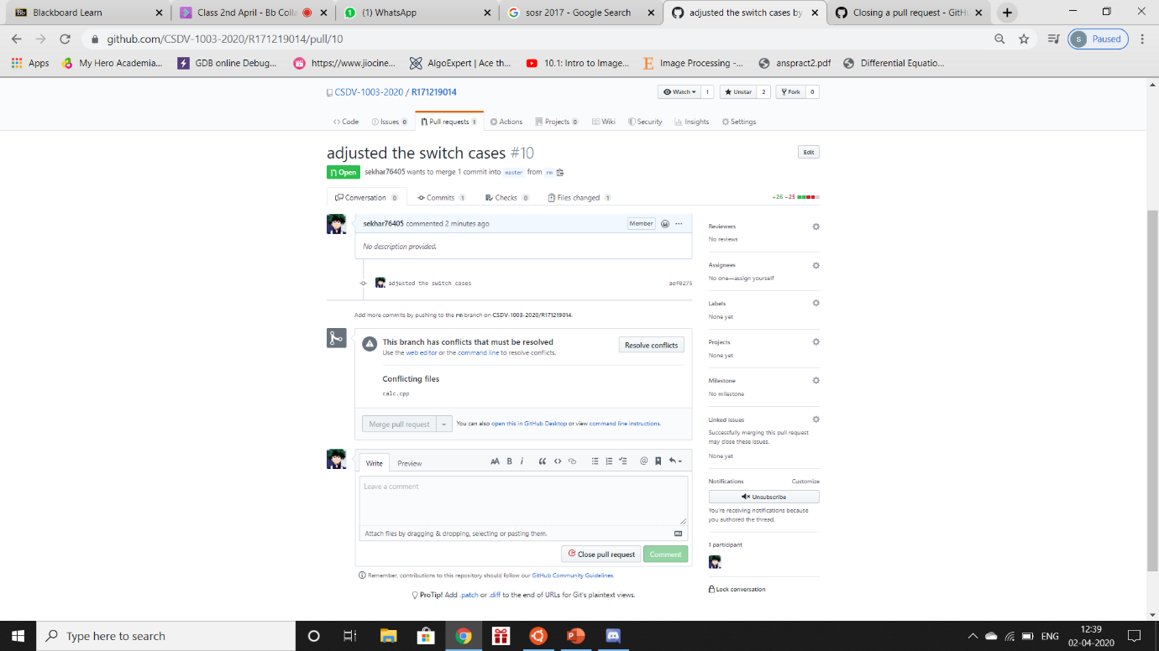opened a pull request with conflicts.

Resolving Conflicts in the code or comparing the different versions of the same file.

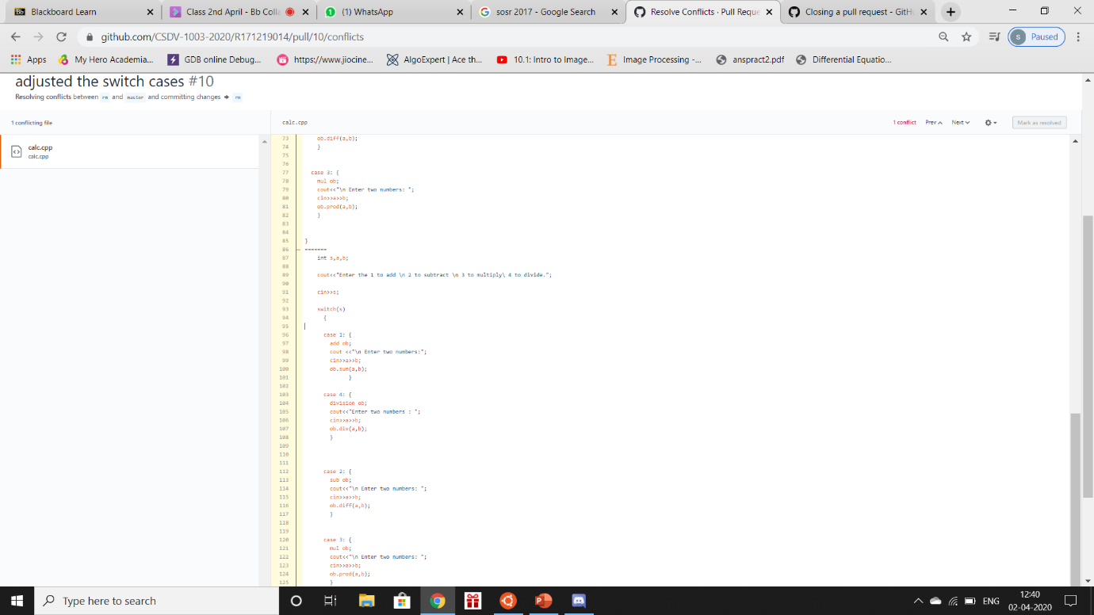

Closing the pull request without merging.

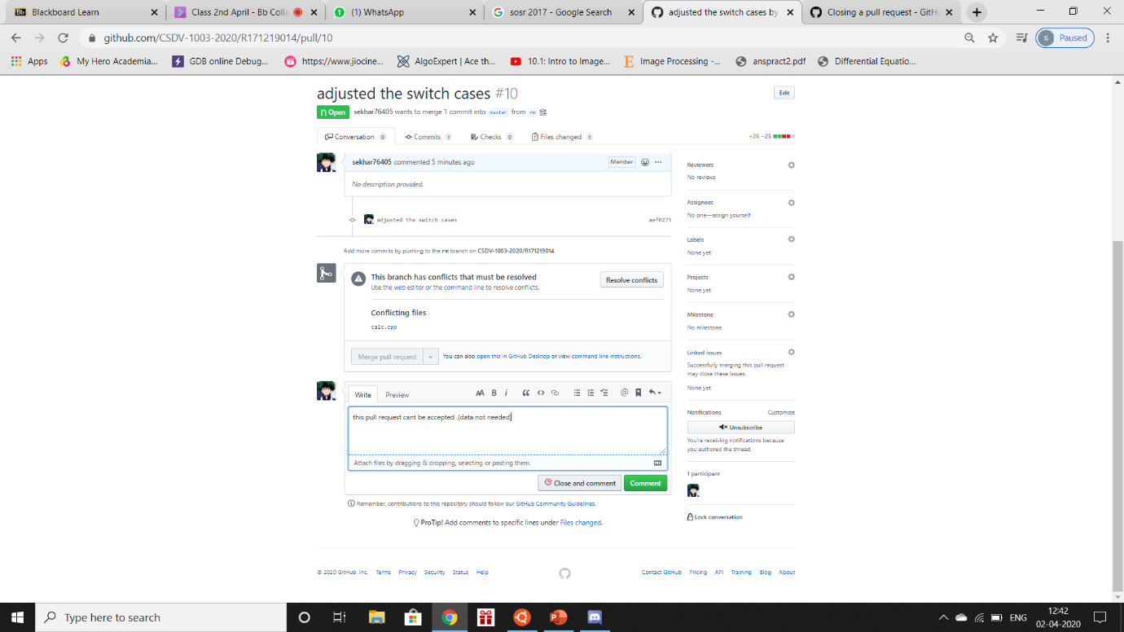

Pull Request succesfully closed.

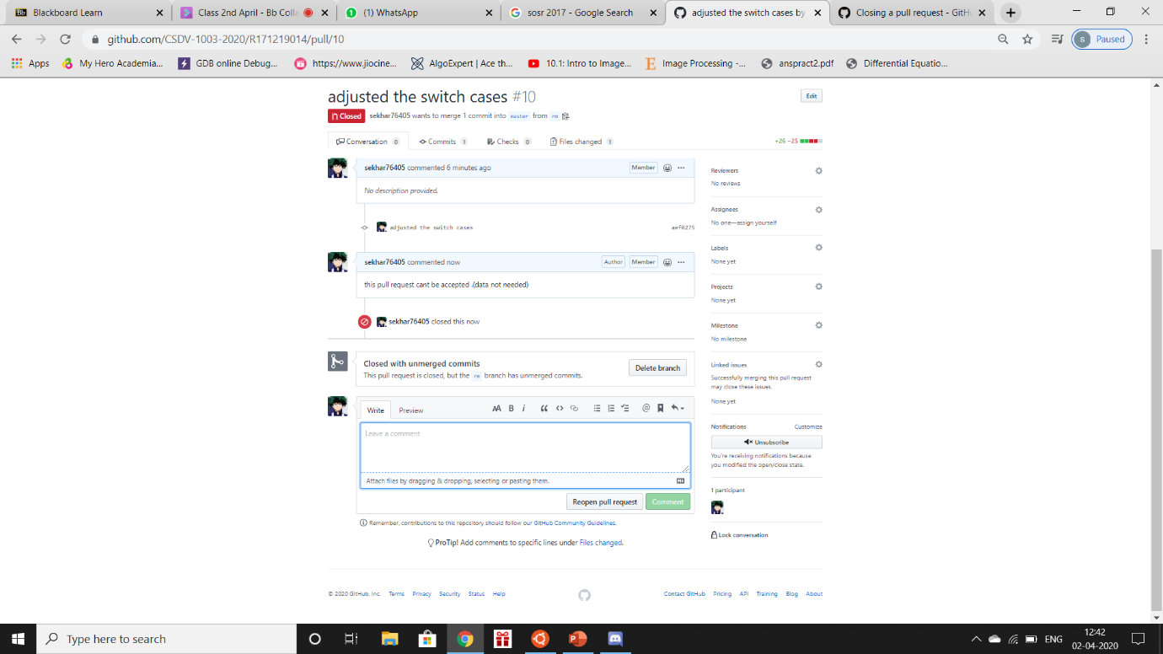

TOTAL PULL REQUESTS :- 0

