**SCM-ASSIGNMENT**

**1)Merging pull request:-** First we commit changes from the other branch and then we will try to merge those changes with the master branch by having pull request and we do not face any conflicts then we will directly merge the changes. This can be explained with the help of following images.

**In this image we are creating a pull request**

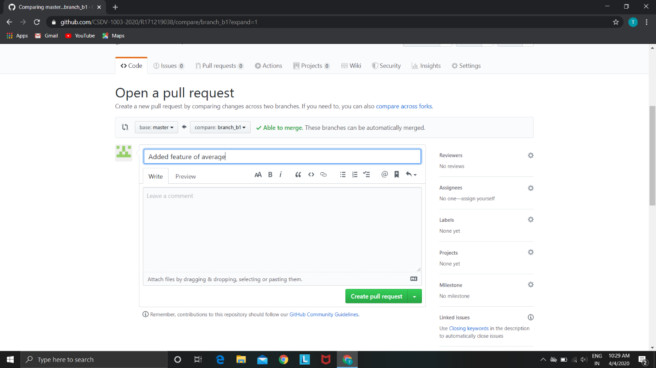

**In this image we are merging a pull request**

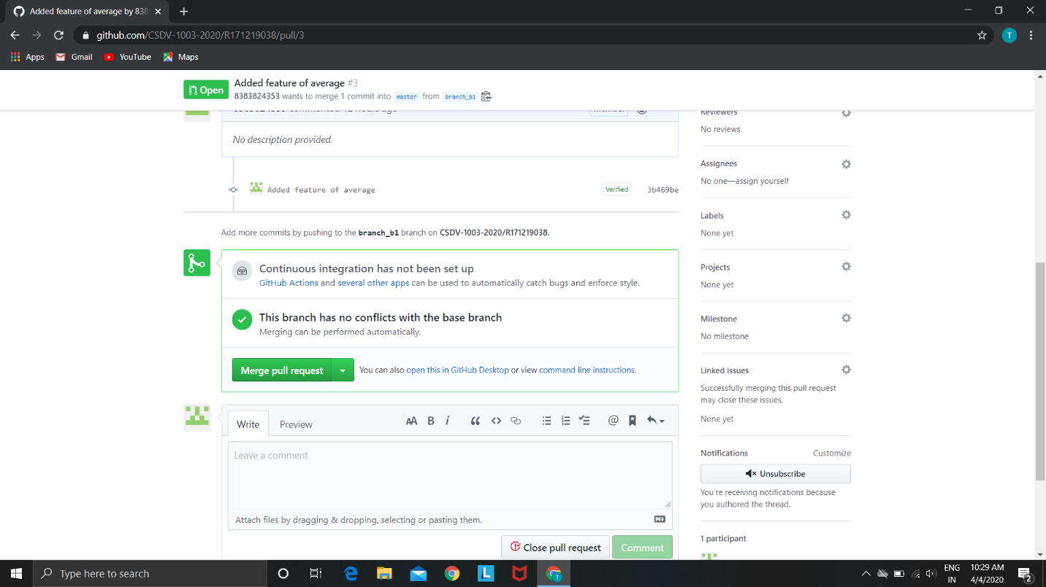

**Closing pull request:-** If we don't want to merge the changes into a master branch then we simply close the pull request but we can reopen it later if we want. The following images will help in understanding the method.

**In this image we are first creating a pull request**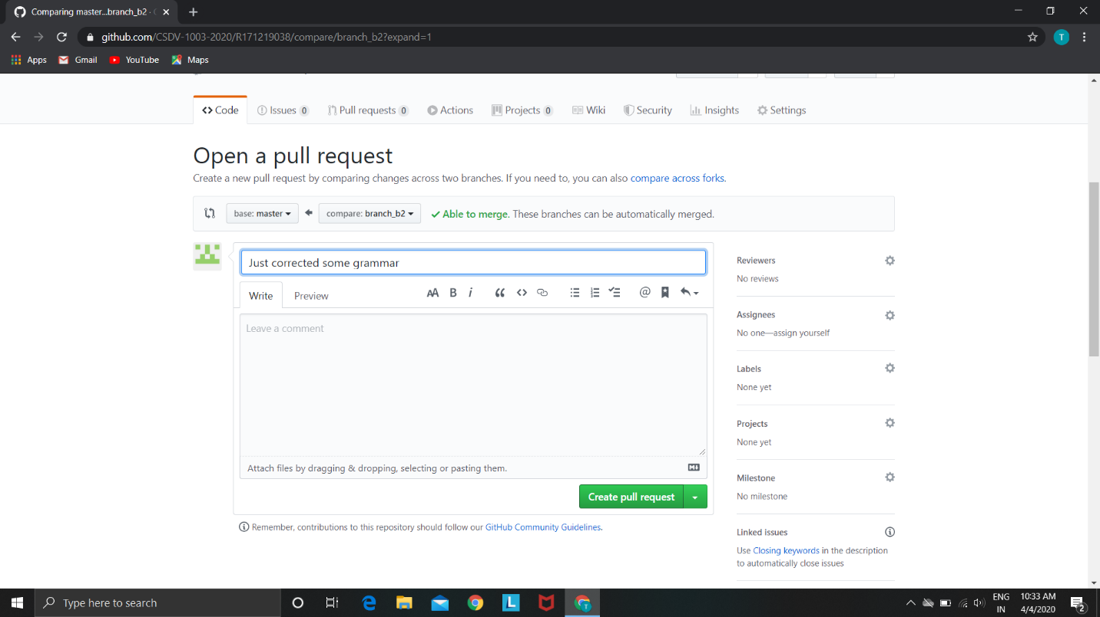

**In this image we are closing the pull request**

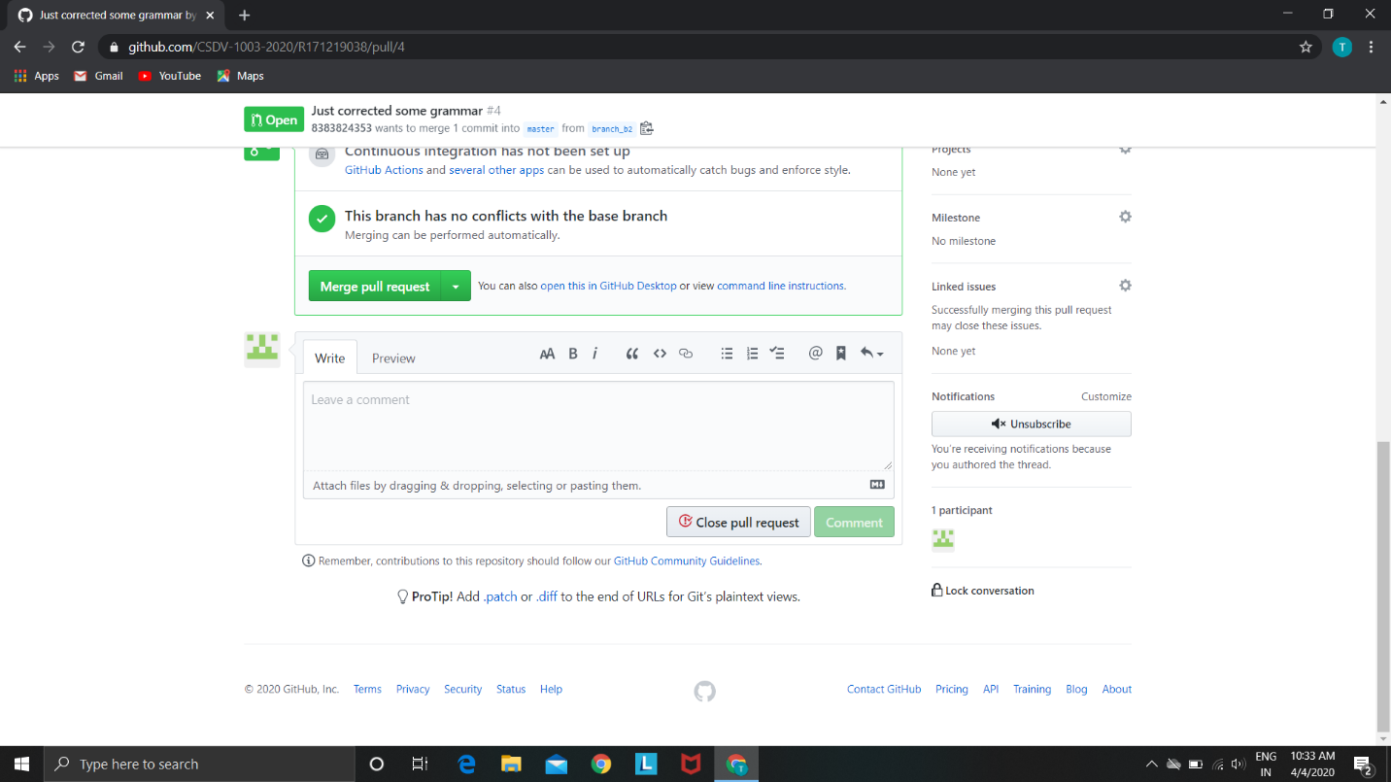

**In this image we can reopen the pull request if we want**

