## ASSIGNMENT_04

## Creating a pull request

* A pull request from another user can be either created by clone his/her repo into git bash and make changes and commit them ,then create a pull request or you can fork his/her repo to your repo and then create a pull request.

I am going by the forking method.

* The repo before forking was :

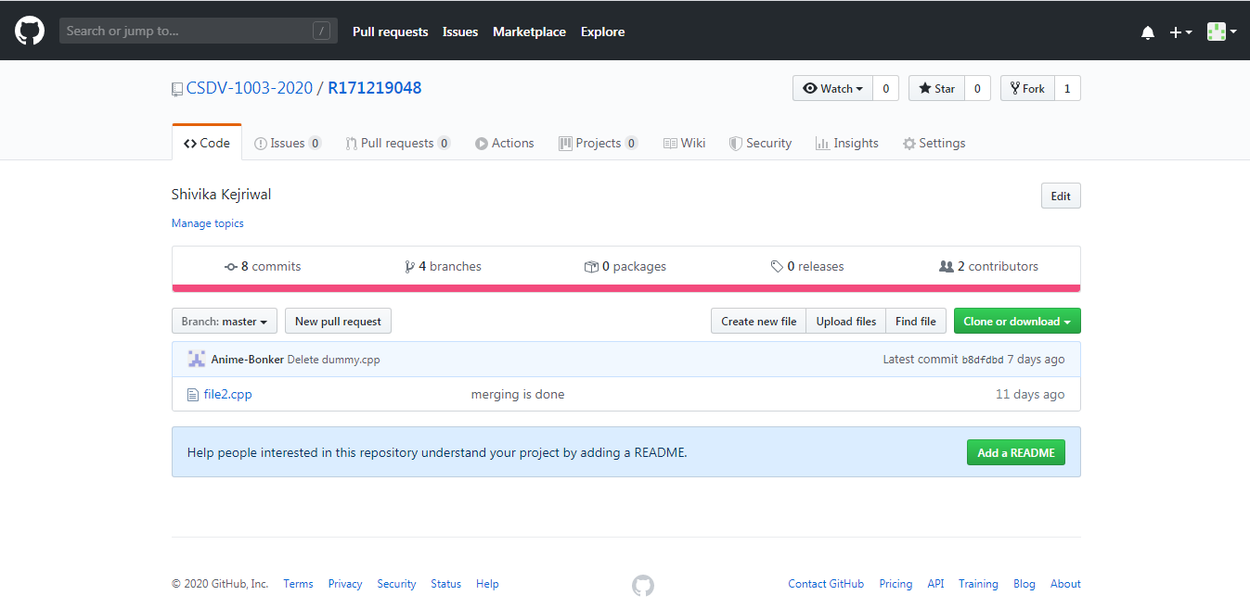

* The repo after commiting was:

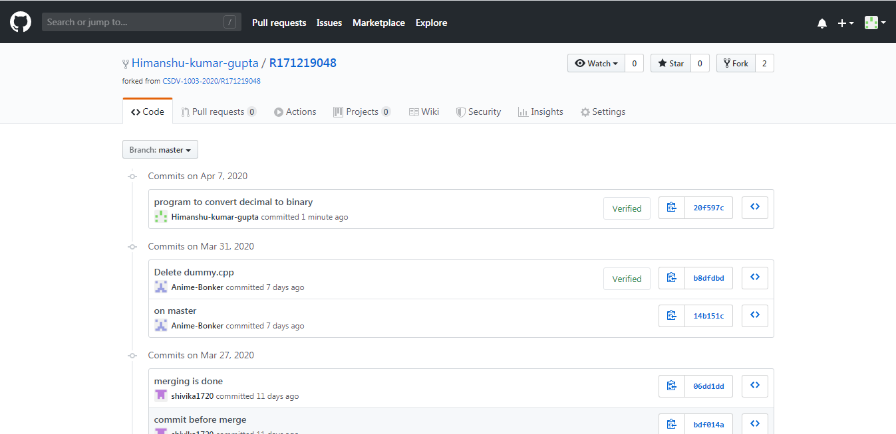

* Then create a pull request in the above window by clicking on ‘new pull request’.

You will observe a window like this:

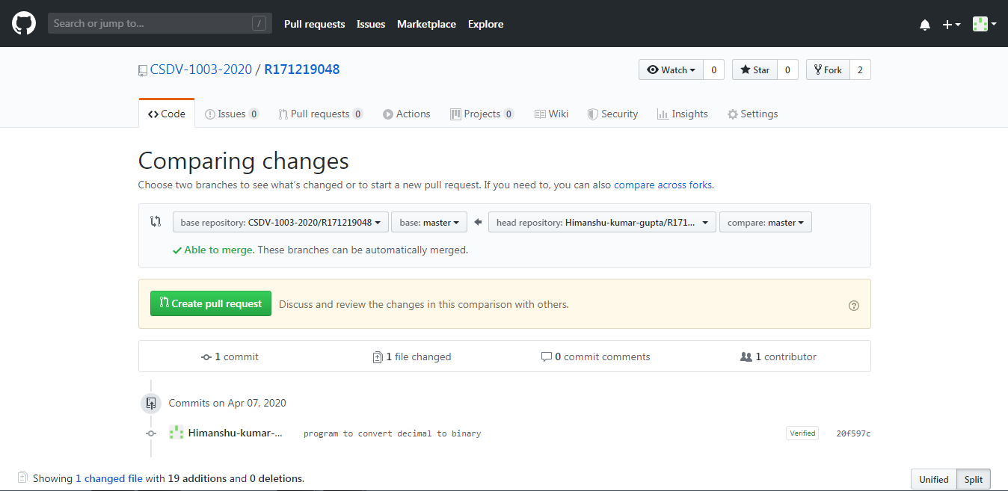

* Click on ‘Create pull request’.

You will observe a window like this:

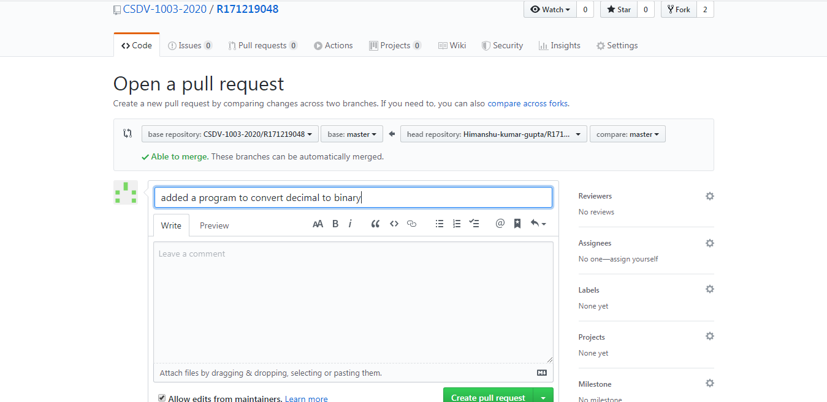

* Edit the pull request message and click on ‘Create pull request’.
* Now the pull request will be shown on other’s user repo,wait for him/her to accept and merge the pull request.

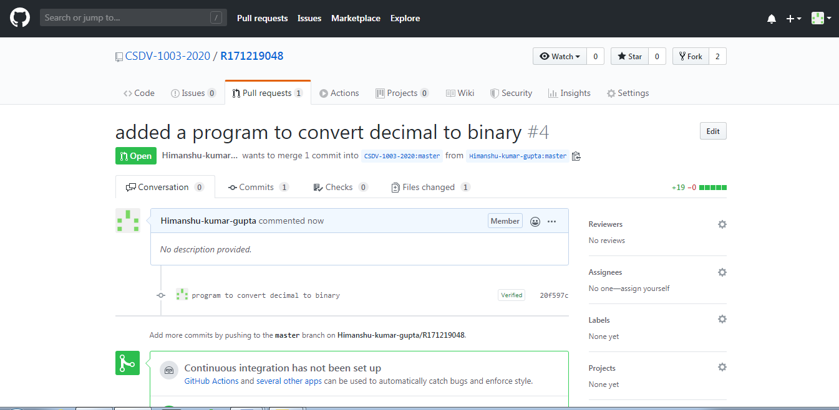

## Accepting/closing a pull request

* Look for the pull request created by other user in your repo in ‘Pull requests’ section.
* You will observe a window like this:

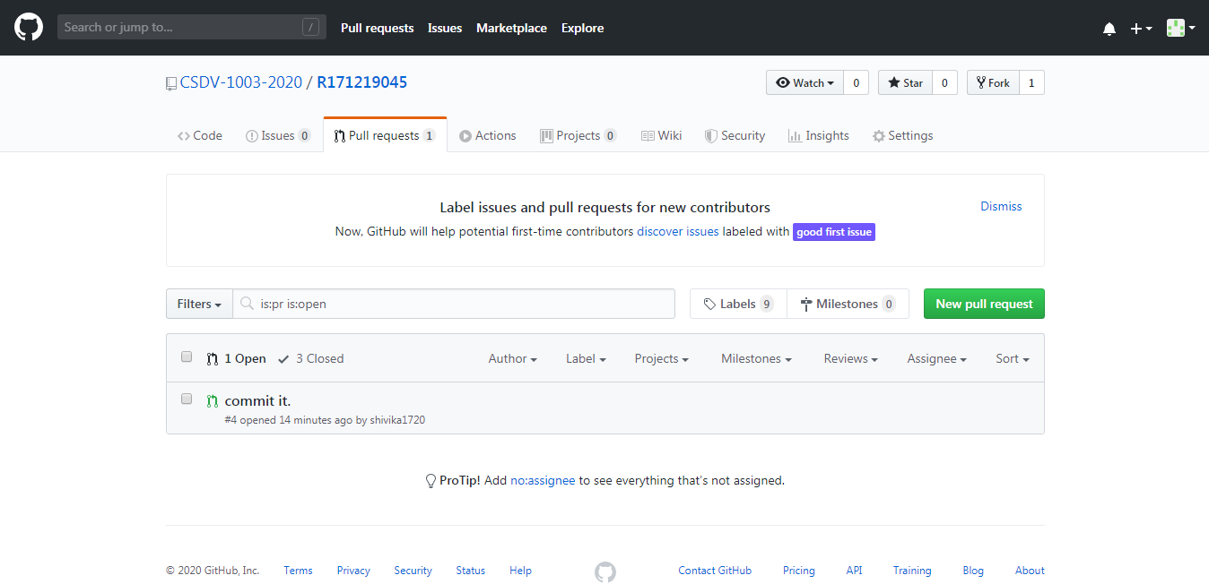

* Now open the pull request created by other user.

And review the changes made by other user.

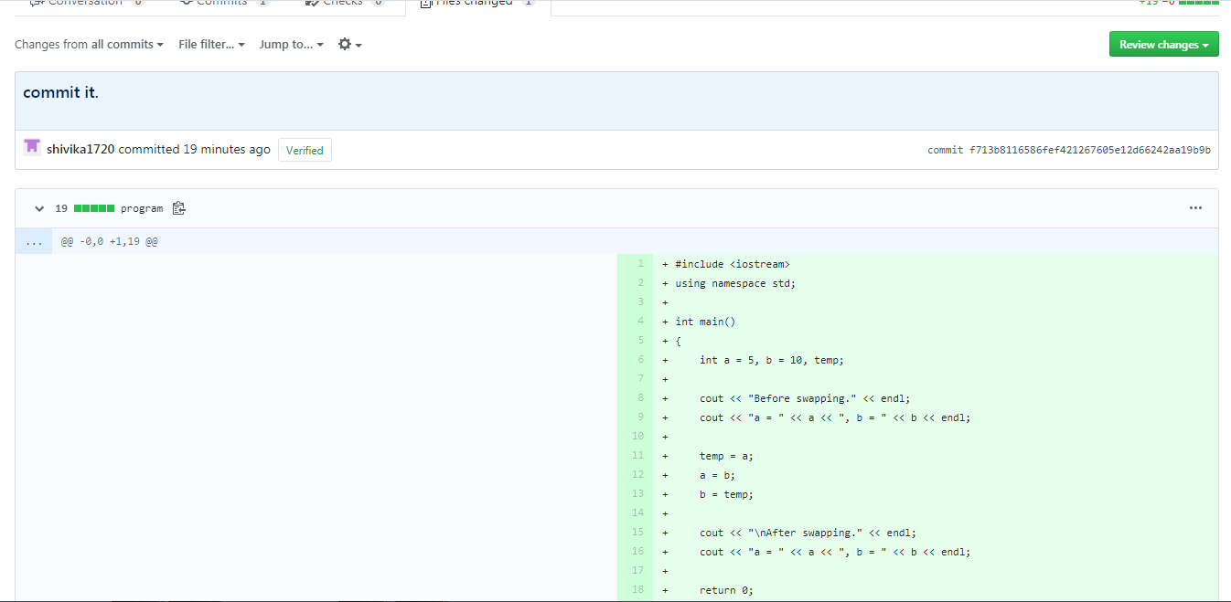

* After reviewing get back to the pull request window and click on ‘Merge Pull request’ option.

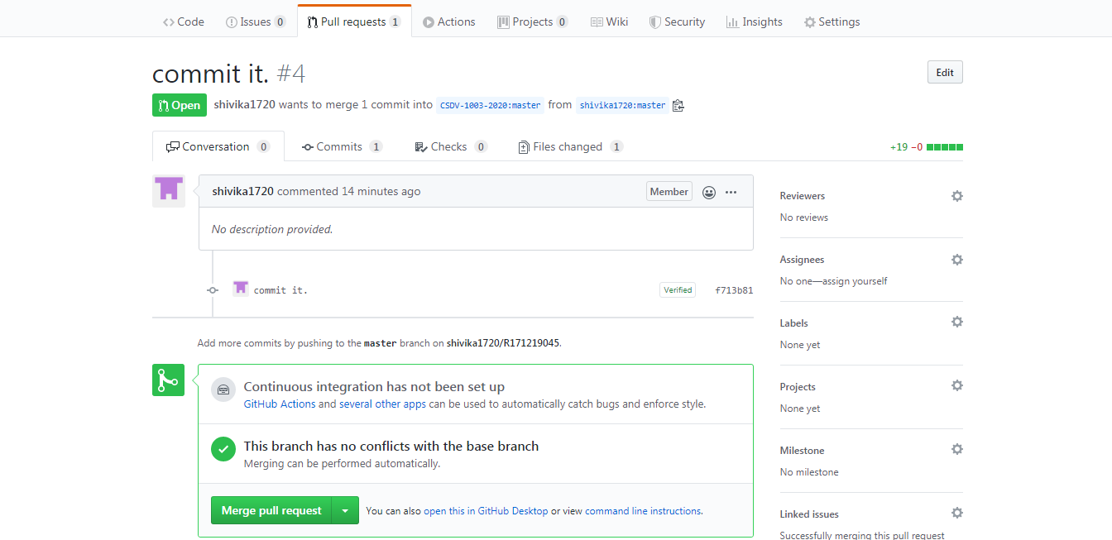

* Click on ‘Confirm Merge’ option.

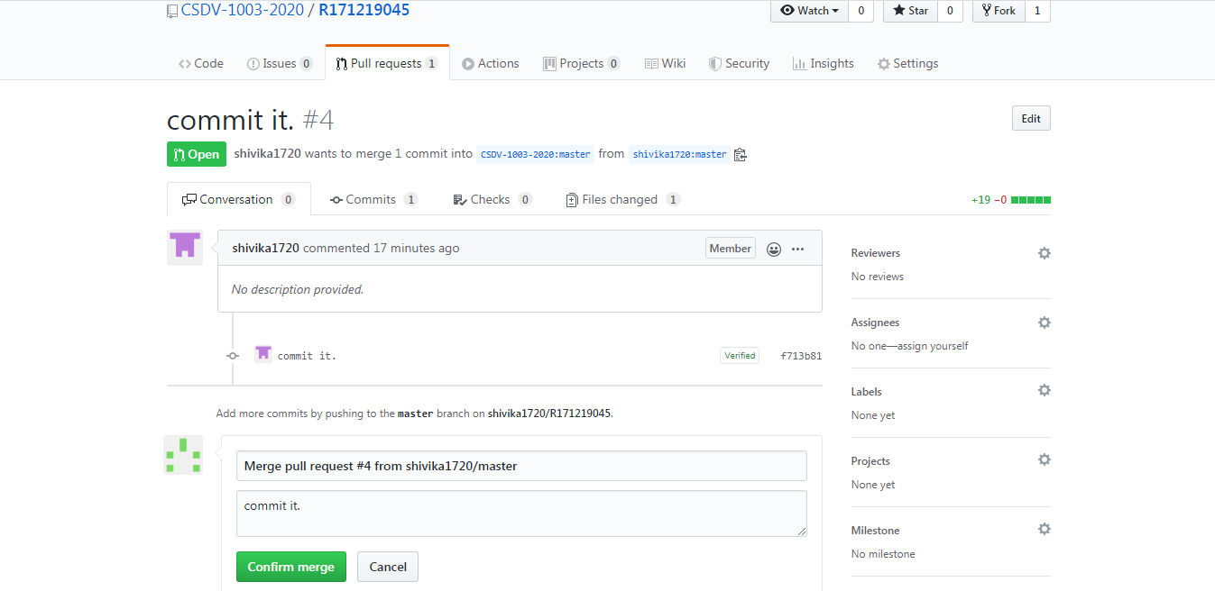

* After that the pull request will me merged and closed.

