ASSIGNMENT-04

**CREATING PULL REQUEST:**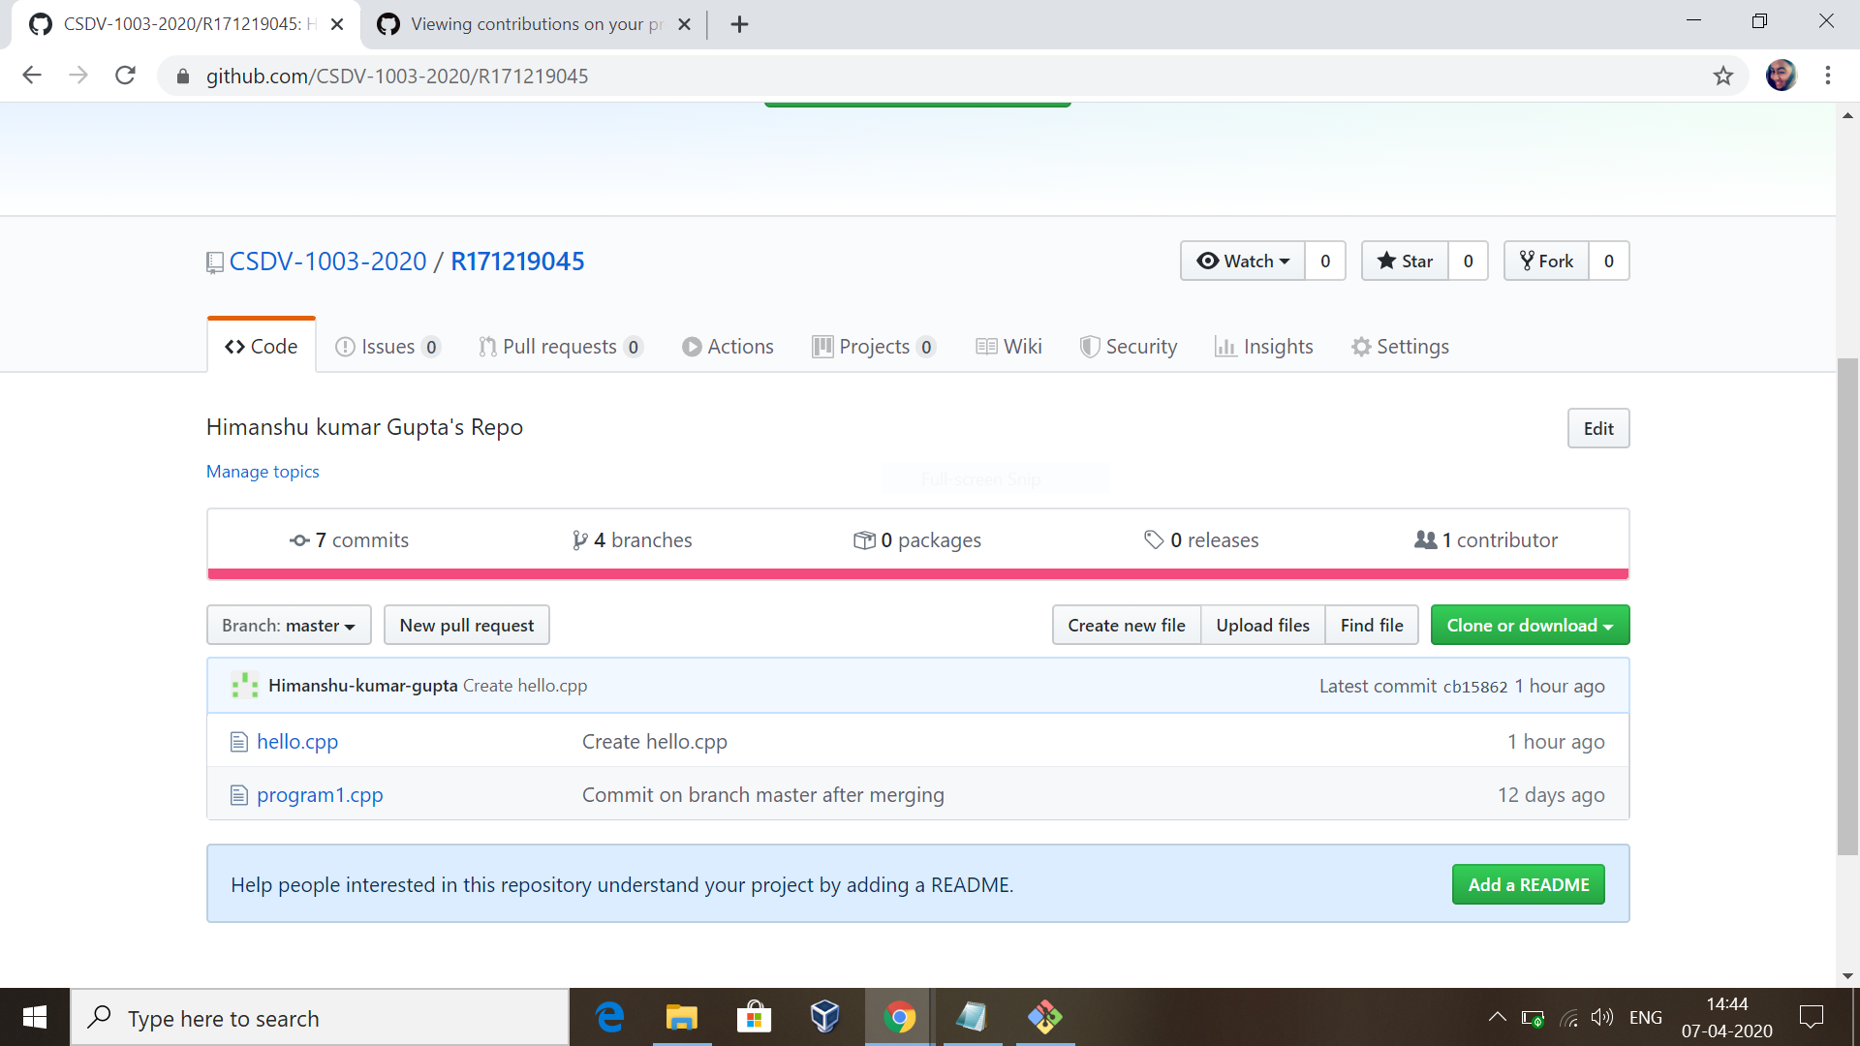

To create a pull request to another person’s repo, first fork their repo to your repo and then click on “new pull request’’ button as shown above.

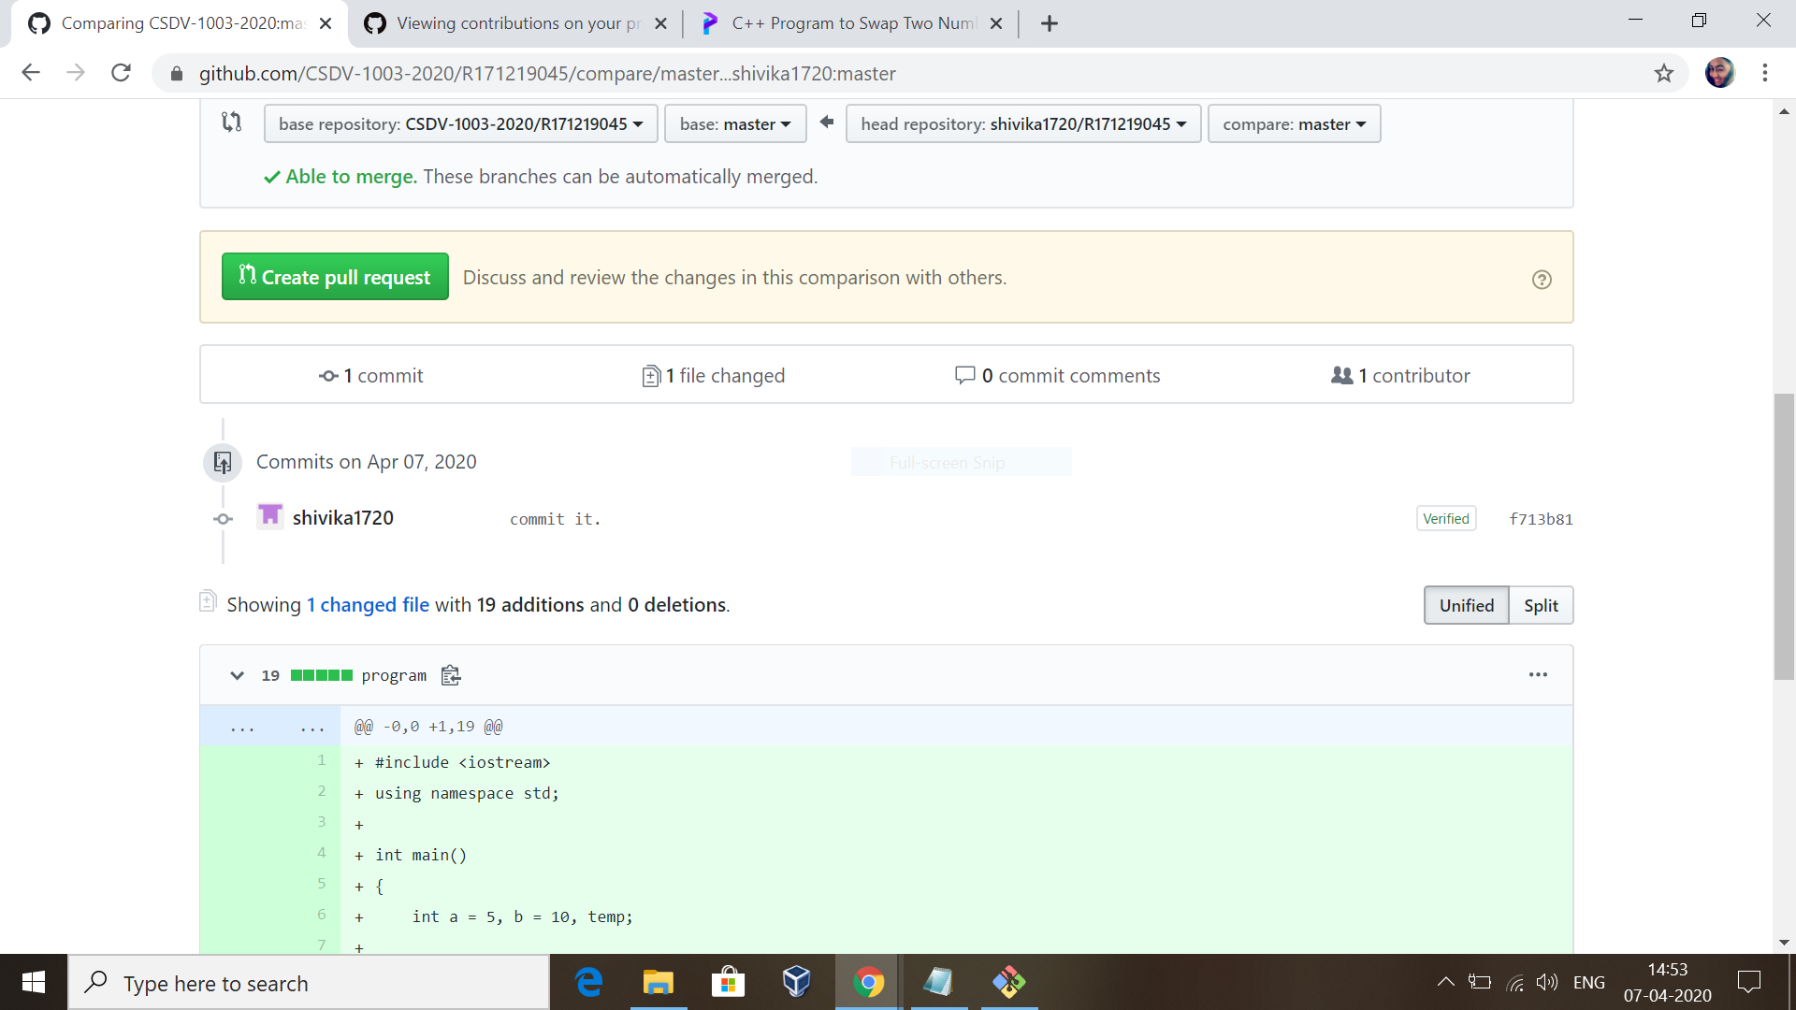

Now click on create pull request button in green present on left side of the screen.

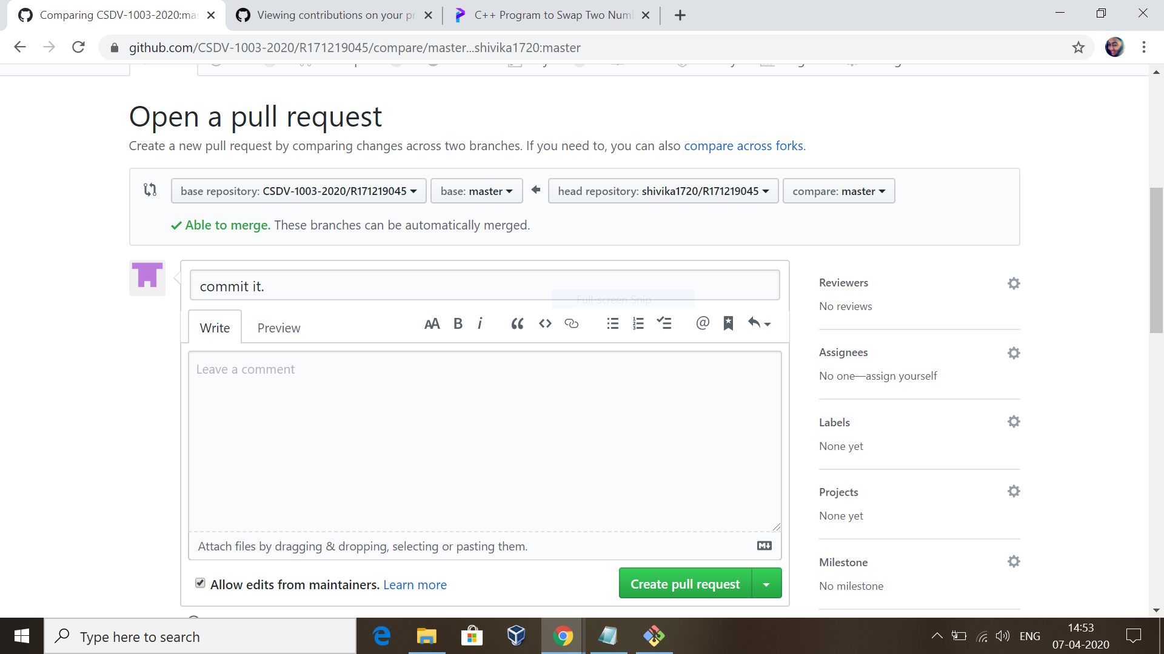

After this you will see the above screen. You have to do commit and then click on create pull request button present at bottom right side of the screen.

After this the pull request has been successfully sent to the other person.

**CLOSING OR CONFIRMING THE PULL REQUEST:**

Open your repo and click on pull request bar and open the request you received.

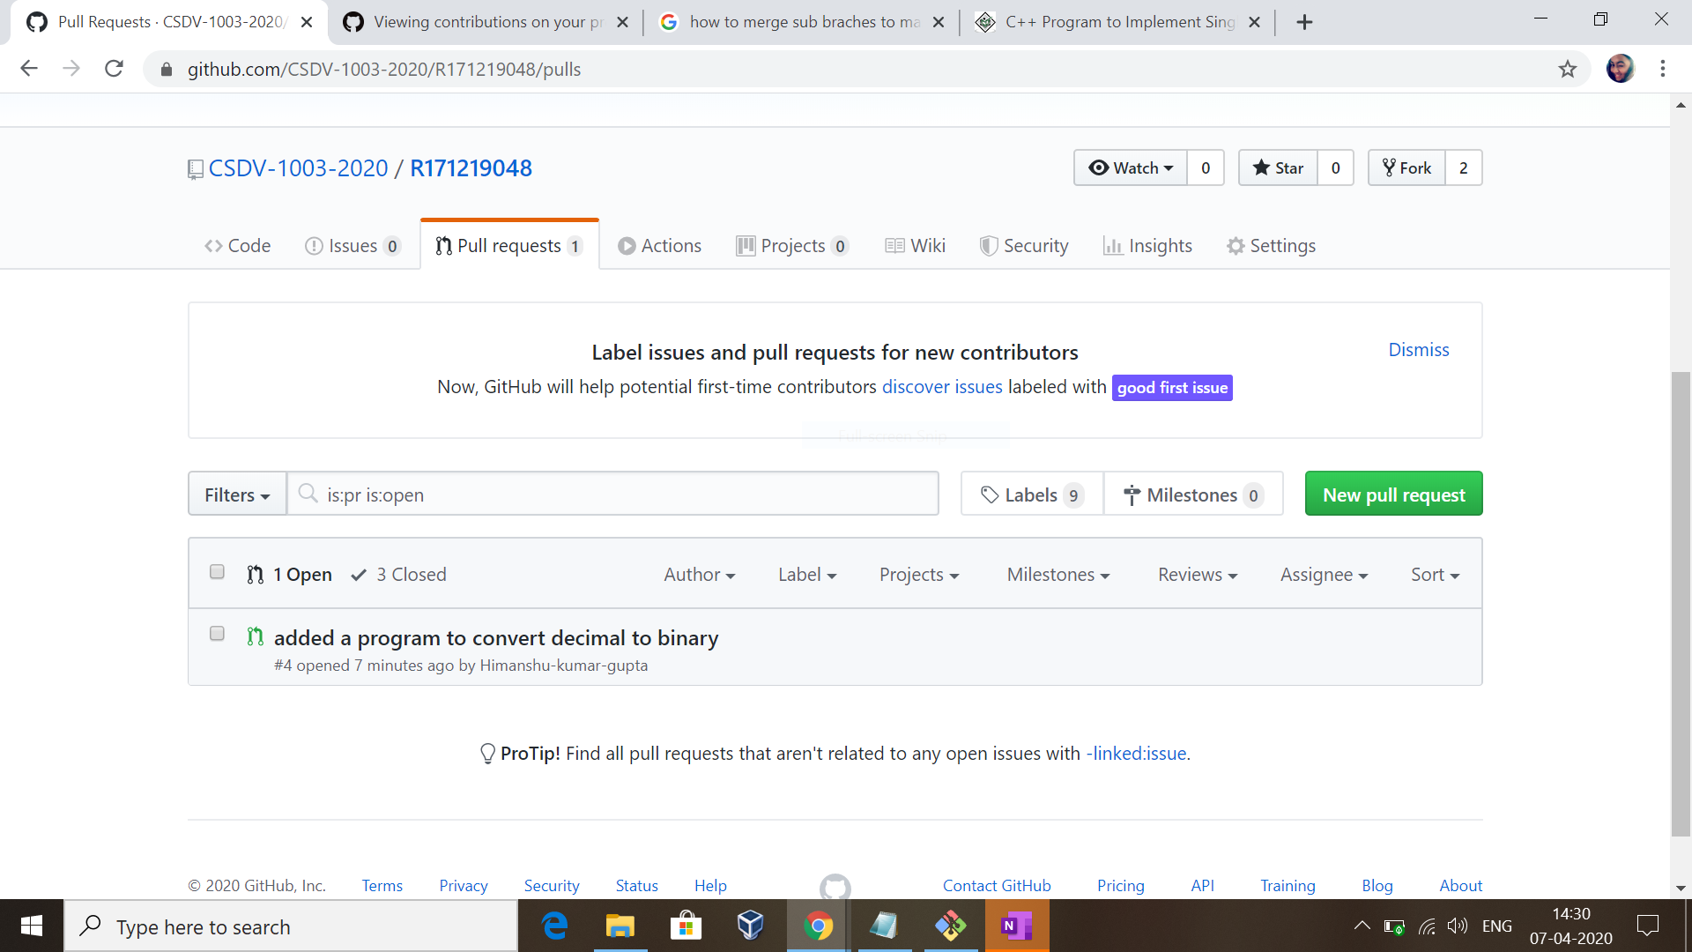

And if you find it worthy then accept it otherwise can delete the request.

So to accept the request , click on merge pull request button as shown on the screen in next page.

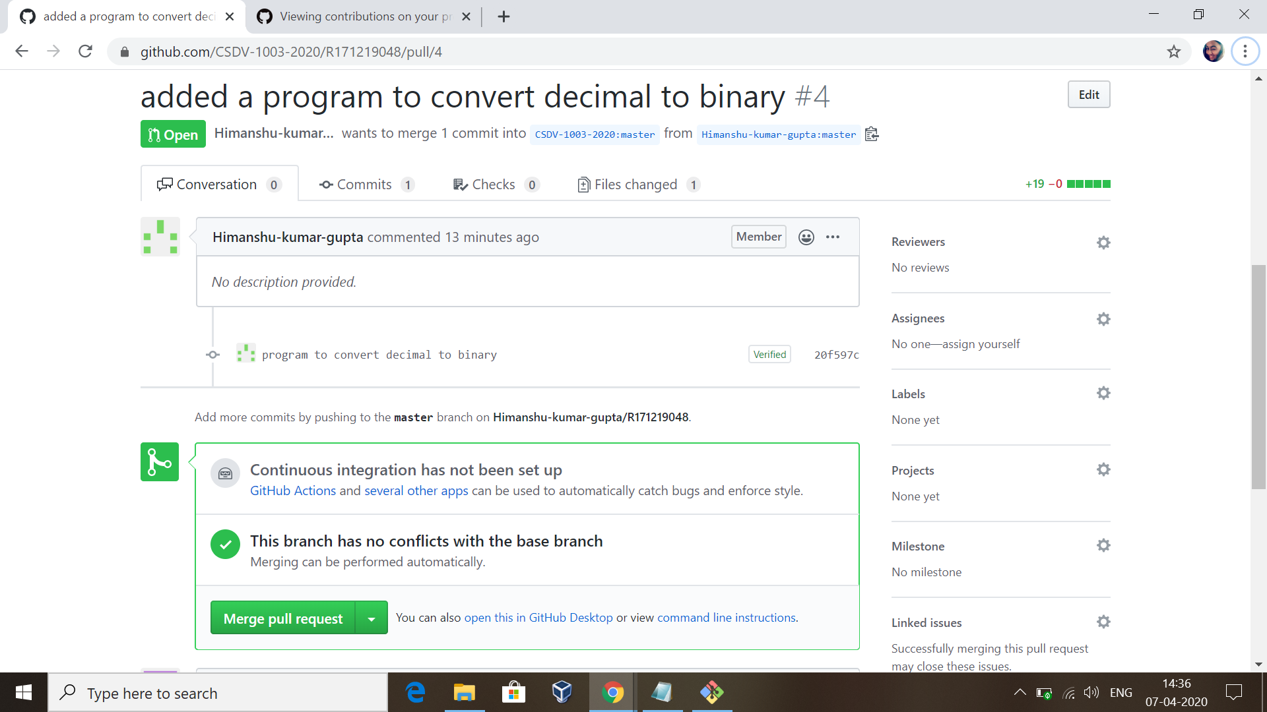

Now click on confirm merge pull request button. 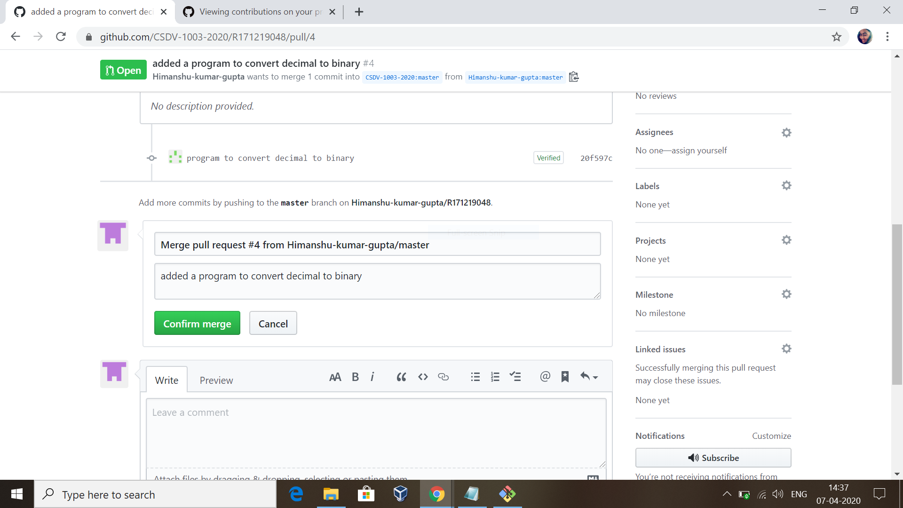

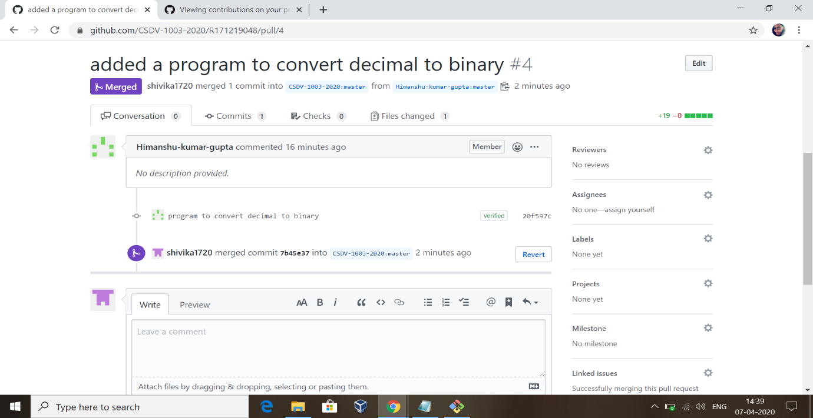

Hence in this way pull request is accepted.