SCM ASSIGNMENT

HOW TO OPEN AND CLOSE A PULL REQUEST

OPENING A PULL REQUEST
-Open your repository on GitHub .
-Click on then it will show weather it is able to merge with/without conflicts
-Check the branch which you want to create pull request with master or some other branch then click  then you are done. Pull request created
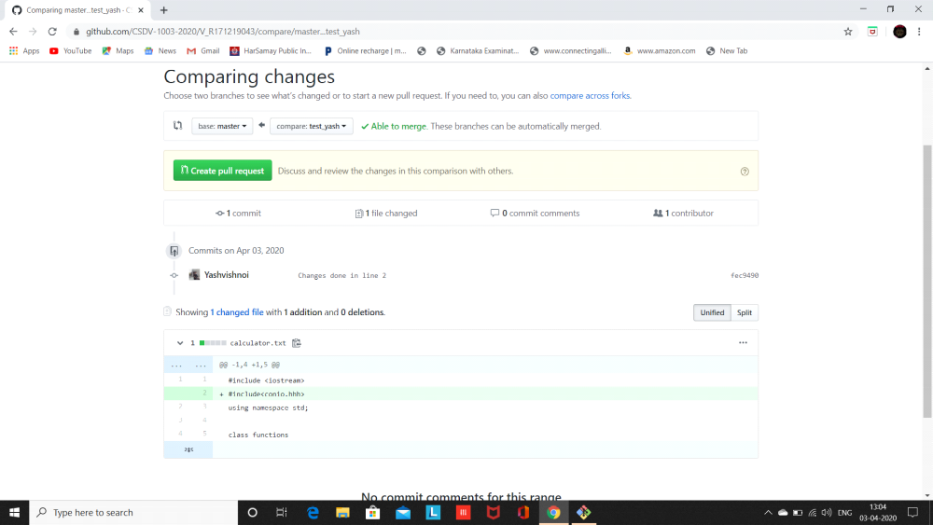
CLOSING A PULL REQUEST
Closing a pull request by merging or simply closed. In merging there are two possibility .
(i) Auto-Merging
(ii) Merging by resolving conflicts
CASE-I: AUTO MERGING
Open you GitHub account and open a repository in which there is pending pull request.
- Click on  it shows the number of pull request pending.

- Click on any pull request that you want to close
- Now you have two option to close the pull request –
(i)-Simply click on close pull request without merging.
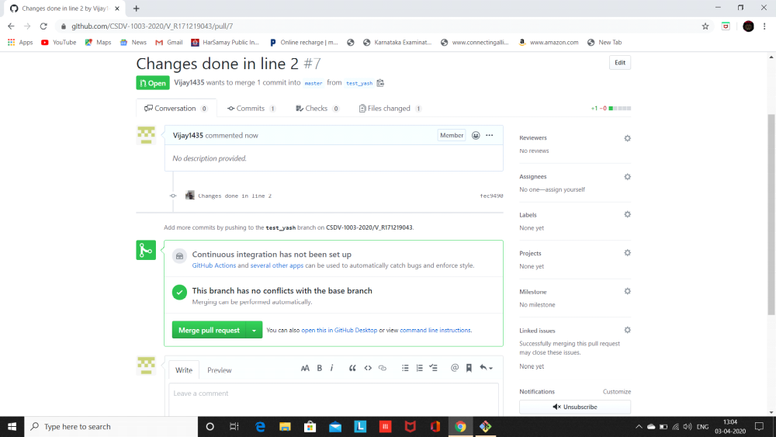
(ii)-Click on Merge pull request it will merge and automatically close the pull request
- case-2 merging conflict
- Do the first and second step same as in case of auto merging.
- Now you have two option to close the pull request –
(i)- Close the pull request without solving the conflict.
(ii)-Resolve conflict and then merge. Steps are follow
Click on resolve conflict
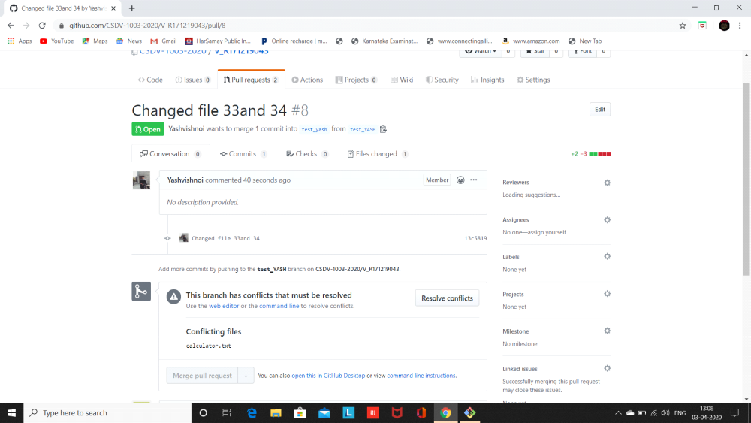
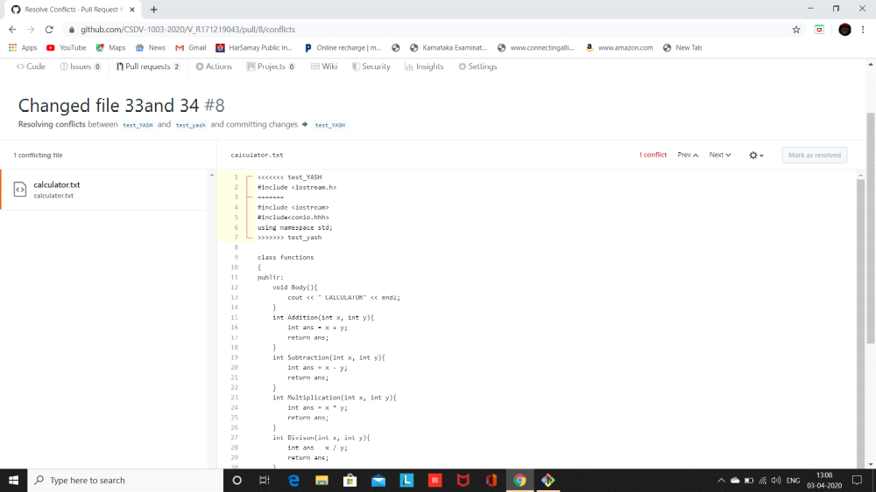
Then click commit merge
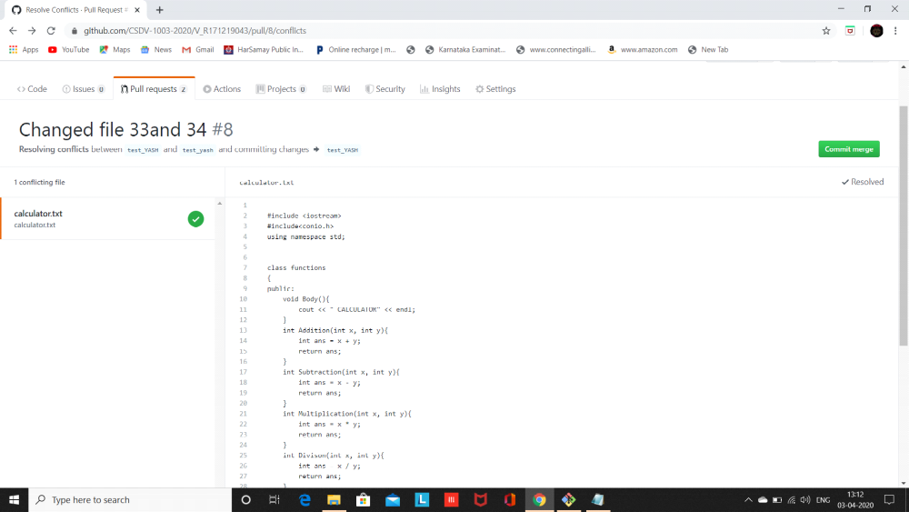
when you done this then a new screen appear click on merge pull request button
then you click confirm merge
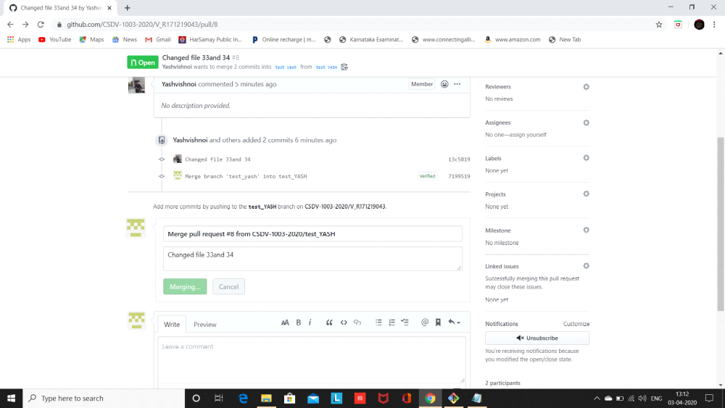
then your pull request is successfully merged.
