ASSIGNMENT

- Python Program to Print Hello world.
print('Hello world”)
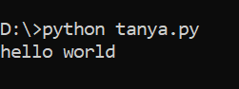
- Python Program to Add Two Numbers.

# This program adds two numbers

num1 = 1.5
num2 = 6.3

# Add two numbers
sum = num1 + num2

# Display the sum
print('The sum of {0} and {1} is {2}'.format(num1, num2, sum))
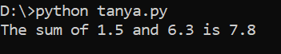
- Python Program to Find the Square Root.

# Python Program to calculate the square root

# Note: change this value for a different result
num = 8

# To take the input from the user
#num = float(input('Enter a number: '))

num_sqrt = num ** 0.5
print('The square root of %0.3f is %0.3f'%(num ,num_sqrt))
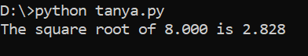

- Python Program to Calculate the Area of a Triangle.

# calculate the area
area = (s*(s-a)*(s-b)*(s-c)) ** 0.5
print('The area of the triangle is %0.2f' %area)
# Python Program to find the area of triangle

a = 5
b = 6
c = 7

# Uncomment below to take inputs from the user
# a = float(input('Enter first side: '))
# b = float(input('Enter second side: '))
# c = float(input('Enter third side: '))

# calculate the semi-perimeter
s = (a + b + c) / 2

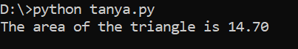
5 ) Python Program to Solve Quadratic Equation.
# Solve the quadratic equation ax**2 + bx + c = 0

# import complex math module
import cmath

a = 1
b = 5
c = 6

# calculate the discriminant
d = (b**2) - (4*a*c)

# find two solutions
sol1 = (-b-cmath.sqrt(d))/(2*a)
sol2 = (-b+cmath.sqrt(d))/(2*a)

print('The solution are {0} and {1}'.format(sol1,sol2))
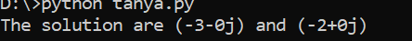
- Python Program to Swap Two Variables.
# Python program to swap two variables

x = 5
y = 10

# To take inputs from the user
#x = input('Enter value of x: ')
#y = input('Enter value of y: ')

# create a temporary variable and swap the values
temp = x
x = y
y = temp

print('The value of x after swapping: {}'.format(x))
print('The value of y after swapping: {}'.format(y))
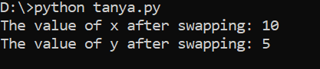

- Python Program to Generate a Random Number.

# Program to generate a random number between 0 and 9

# importing the random module
import random

print(random.randint(0,9))

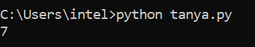

- Python Program to Convert Kilometers to Miles.

# Taking kilometers input from the user
kilometers = float(input("Enter value in kilometers: "))

# conversion factor
conv_fac = 0.621371

# calculate miles
miles = kilometers * conv_fac
print('%0.2f kilometers is equal to %0.2f miles' %(kilometers,miles))

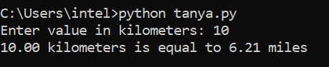

- Python Program to Convert Celsius To Fahrenheit.
# Python Program to convert temperature in celsius to fahrenheit

# change this value for a different result
celsius = 37.5

# calculate fahrenheit
fahrenheit = (celsius * 1.8) + 32
print('%0.1f degree Celsius is equal to %0.1f degree Fahrenheit' %(celsius,fahrenheit))

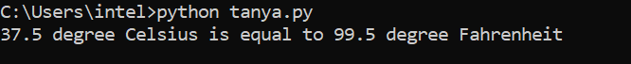
- Python Program to Check if a Number is Positive, Negative or 0.
num = float(input("Enter a number: "))
if num > 0:
print("Positive number")
elif num == 0:
print("Zero")
else:
print("Negative number")e
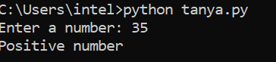
- Python Program to Check if a Number is Odd or Even.

# Python program to check if the input number is odd or even.
# A number is even if division by 2 gives a remainder of 0.
# If the remainder is 1, it is an odd number.

num = int(input("Enter a number: "))
if (num % 2) == 0:
print("{0} is Even".format(num))
else:
print("{0} is Odd".format(num))
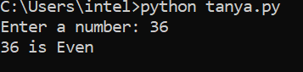

- Python Program to Check Leap Year.
# Python program to check if year is a leap year or not

year = 2000

# To get year (integer input) from the user
# year = int(input("Enter a year: "))

# divided by 100 means century year (ending with 00)
# century year divided by 400 is leap year
if (year % 400 == 0) and (year % 100 == 0):
print("{0} is a leap year".format(year))

# not divided by 100 means not a century year
# year divided by 4 is a leap year
elif (year % 4 ==0) and (year % 100 != 0):
print("{0} is a leap year".format(year))

# if not divided by both 400 (century year) and 4 (not century year)
# year is not leap year
else:
print("{0} is not a leap year".format(year))
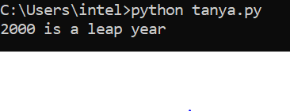

13) Python Program to Find the Largest Among Three Numbers
# Python program to find the largest number among the three input numbers

# change the values of num1, num2 and num3
# for a different result
num1 = 10
num2 = 14
num3 = 12

# uncomment following lines to take three numbers from user
#num1 = float(input("Enter first number: "))
#num2 = float(input("Enter second number: "))
#num3 = float(input("Enter third number: "))

if (num1 >= num2) and (num1 >= num3):
largest = num1
elif (num2 >= num1) and (num2 >= num3):
largest = num2
else:
largest = num3

print("The largest number is", largest)
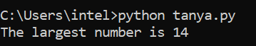

14) Python Program to Check Prime Number.
# Program to check if a number is prime or not

num = 29

# To take input from the user
#num = int(input("Enter a number: "))

# define a flag variable
flag = False

if num == 0 or num == 1:
print(num, "is not a prime number")
elif num > 1:
# check for factors
for i in range(2, num):
if (num % i) == 0:
# if factor is found, set flag to True
flag = True
# break out of loop
break

# check if flag is True
if flag:
print(num, "is not a prime number")
else:
print(num, "is a prime number")
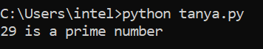
15) Python Program to Print all Prime Numbers in an Interval.
# Python program to display all the prime numbers within an interval

lower = 900
upper = 1000

print("Prime numbers between", lower, "and", upper, "are:")

for num in range(lower, upper + 1):
# all prime numbers are greater than 1
if num > 1:
for i in range(2, num):
if (num % i) == 0:
break
else:
print(num)
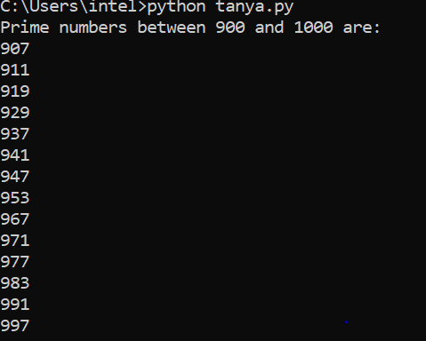
16) Python Program to Display the multiplication Table.
# Multiplication table (from 1 to 10) in Python

num = 12

# To take input from the user
# num = int(input("Display multiplication table of? "))

# Iterate 10 times from i = 1 to 10
for i in range(1, 11):
print(num, 'x', i, '=', num*i)
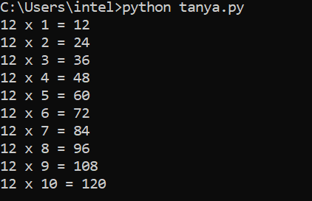
17) Python Program to Find the Factorial of a Number.
# Python program to find the factorial of a number provided by the user.

# change the value for a different result
num = 7

# To take input from the user
#num = int(input("Enter a number: "))

factorial = 1

# check if the number is negative, positive or zero
if num < 0:
print("Sorry, factorial does not exist for negative numbers")
elif num == 0:
print("The factorial of 0 is 1")
else:
for i in range(1,num + 1):
factorial = factorial*i
print("The factorial of",num,"is",factorial)
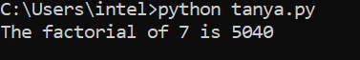
18) Python Program to Print the Fibonacci sequence.
# Program to display the Fibonacci sequence up to n-th term

nterms = int(input("How many terms? "))

# first two terms
n1, n2 = 0, 1
count = 0

# check if the number of terms is valid
if nterms <= 0:
print("Please enter a positive integer")
# if there is only one term, return n1
elif nterms == 1:
print("Fibonacci sequence upto",nterms,":")
print(n1)
# generate fibonacci sequence
else:
print("Fibonacci sequence:")
while count < nterms:
print(n1)
nth = n1 + n2
# update values
n1 = n2
n2 = nth
count += 1
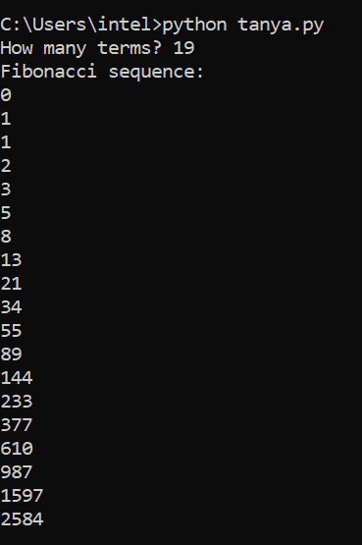
19) Python Program to Check Armstrong Number.
# Python program to check if the number is an Armstrong number or not

# take input from the user
num = int(input("Enter a number: "))

# initialize sum
sum = 0

# find the sum of the cube of each digit
temp = num
while temp > 0:
digit = temp % 10
sum += digit ** 3
temp //= 10

# display the result
if num == sum:
print(num,"is an Armstrong number")
else:
print(num,"is not an Armstrong number")
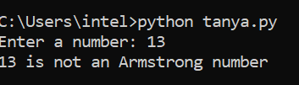
20) Python Program to Find Armstrong Number in an Interval.
# Program to check Armstrong numbers in a certain interval

lower = 100
upper = 2000

for num in range(lower, upper + 1):

# order of number
order = len(str(num))

# initialize sum
sum = 0

temp = num
while temp > 0:
digit = temp % 10
sum += digit ** order
temp //= 10

if num == sum:
print(num)
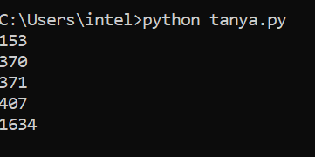
21) Python Program to Find the Sum of Natural Numbers.
# Sum of natural numbers up to num

num = 16

if num < 0:
print("Enter a positive number")
else:
sum = 0
# use while loop to iterate until zero
while(num > 0):
sum += num
num -= 1
print("The sum is", sum)
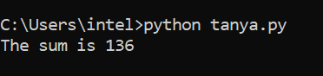
22) Python Program to Display Powers of 2 Using Anonymous Function.
# Display the powers of 2 using anonymous function

terms = 10

# Uncomment code below to take input from the user
# terms = int(input("How many terms? "))

# use anonymous function
result = list(map(lambda x: 2 ** x, range(terms)))

print("The total terms are:",terms)
for i in range(terms):
print("2 raised to power",i,"is",result[i])
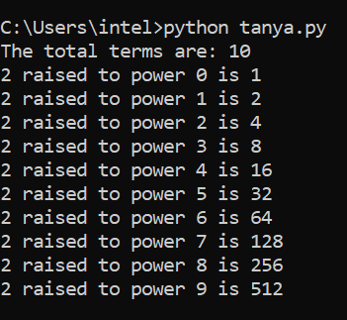
23) Python Program to Find Numbers Divisible by Another Number.
# Take a list of numbers
my_list = [12, 65, 54, 39, 102, 339, 221,]

# use anonymous function to filter
result = list(filter(lambda x: (x % 13 == 0), my_list))

# display the result
print("Numbers divisible by 13 are",result)

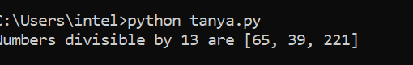

24) Python Program to Find ASCII Value of Character.
# Program to find the ASCII value of the given character

c = 'p'
print("The ASCII value of '" + c + "' is", ord(c))
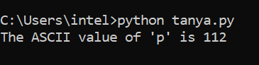
25) Python Program to Find HCF or GCD.
# Python program to find H.C.F of two numbers

# define a function
def compute_hcf(x, y):

# choose the smaller number
if x > y:

smaller = y
else:
smaller = x
for i in range(1, smaller+1):
if((x % i == 0) and (y % i == 0)):
hcf = i
return hcf

num1 = 54
num2 = 24

print("The H.C.F. is", compute_hcf(num1, num2))
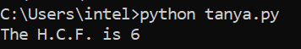
26) Python Program to Find LCM.
# Python Program to find the L.C.M. of two input number

def compute_lcm(x, y):

# choose the greater number
if x > y:
greater = x
else:
greater = y

while(True):
if((greater % x == 0) and (greater % y == 0)):
lcm = greater
break
greater += 1

return lcm

num1 = 54
num2 = 24

print("The L.C.M. is", compute_lcm(num1, num2))

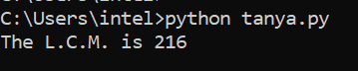
27) Python Program to Find the Factors of a Number.
# Python Program to find the factors of a number

# This function computes the factor of the argument passed
def print_factors(x):
print("The factors of",x,"are:")
for i in range(1, x + 1):
if x % i == 0:
print(i)

num = 320

print_factors(num)
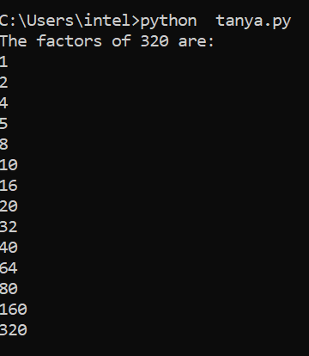
28) Python Program to Make a Simple Calculator.
# This function adds two numbers
def add(x, y):
return x + y

# This function subtracts two numbers
def subtract(x, y):
return x - y

# This function multiplies two numbers
def multiply(x, y):
return x * y

# This function divides two numbers
def divide(x, y):
return x / y

print("Select operation.")
print("1.Add")
print("2.Subtract")
print("3.Multiply")
print("4.Divide")

while True:
# take input from the user
choice = input("Enter choice(1/2/3/4): ")

# check if choice is one of the four options
if choice in ('1', '2', '3', '4'):
try:
num1 = float(input("Enter first number: "))
num2 = float(input("Enter second number: "))
except ValueError:
print("Invalid input. Please enter a number.")
continue

if choice == '1':
print(num1, "+", num2, "=", add(num1, num2))

elif choice == '2':
print(num1, "-", num2, "=", subtract(num1, num2))

elif choice == '3':
print(num1, "*", num2, "=", multiply(num1, num2))

elif choice == '4':
print(num1, "/", num2, "=", divide(num1, num2))

# check if user wants another calculation
# break the while loop if answer is no
next_calculation = input("Let's do next calculation? (yes/no): ")
if next_calculation == "no":
break
else:
print("Invalid Input")
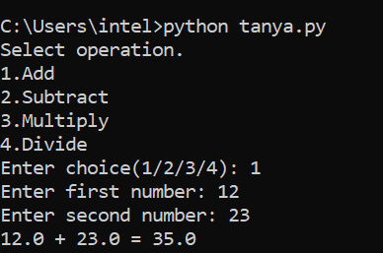
29) Python Program to Shuffle Deck of Cards.
# Python program to shuffle a deck of card

# importing modules
import itertools, random

# make a deck of cards
deck = list(itertools.product(range(1,14),['Spade','Heart','Diamond','Club']))

# shuffle the cards
random.shuffle(deck)

# draw five cards
print("You got:")
for i in range(5):
print(deck[i][0], "of", deck[i][1])

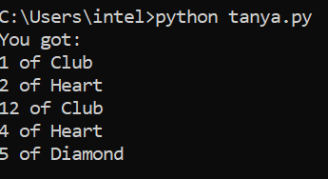
30) Python Program to Display Calendar.
# Program to display calendar of the given month and year

# importing calendar module
import calendar

yy = 2014 # year
mm = 11 # month

# To take month and year input from the user
# yy = int(input("Enter year: "))
# mm = int(input("Enter month: "))

# display the calendar
print(calendar.month(yy, mm))
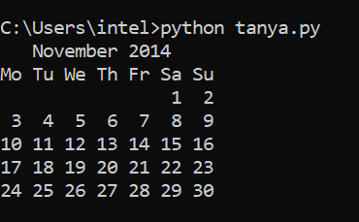
31) Python Program to Display Fibonacci Sequence Using Recursion.
# Python program to display the Fibonacci sequence

def recur_fibo(n):
if n <= 1:
return n
else:
return(recur_fibo(n-1) + recur_fibo(n-2))

nterms = 10

# check if the number of terms is valid
if nterms <= 0:
print("Plese enter a positive integer")
else:
print("Fibonacci sequence:")
for i in range(nterms):
print(recur_fibo(i))

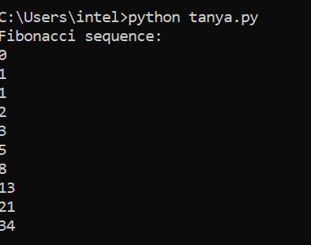
32) Python Program to Find Sum of Natural Numbers Using Recursion.
# Python program to find the sum of natural using recursive function

def recur_sum(n):
if n <= 1:
return n
else:
return n + recur_sum(n-1)

# change this value for a different result
num = 16

if num < 0:
print("Enter a positive number")
else:
print("The sum is",recur_sum(num))
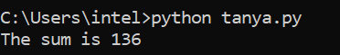
33) Python Program to Find Factorial of Number Using Recursion.
# Factorial of a number using recursion

def recur_factorial(n):
if n == 1:
return n
else:
return n*recur_factorial(n-1)

num = 7

# check if the number is negative
if num < 0:
print("Sorry, factorial does not exist for negative numbers")
elif num == 0:
print("The factorial of 0 is 1")
else:
print("The factorial of", num, "is", recur_factorial(num))

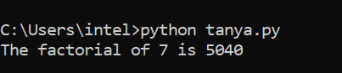
34) Python Program to Add Two Matrices.
# Program to add two matrices using nested loop

X = [[12,7,3],
[4 ,5,6],
[7 ,8,9]]

Y = [[5,8,1],
[6,7,3],
[4,5,9]]

result = [[0,0,0],
[0,0,0],
[0,0,0]]

# iterate through rows
for i in range(len(X)):
# iterate through columns
for j in range(len(X[0])):
result[i][j] = X[i][j] + Y[i][j]

for r in result:
print(r)
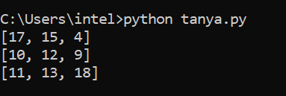

35) Python Program to Transpose a Matrix.
# Program to transpose a matrix using a nested loop

X = [[12,7],
[4 ,5],
[3 ,8]]

result = [[0,0,0],
[0,0,0]]

# iterate through rows
for i in range(len(X)):
# iterate through columns
for j in range(len(X[0])):
result[j][i] = X[i][j]

for r in result:
print(r)
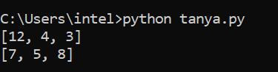
36) Python Program to Multiply Two Matrices.
# Program to multiply two matrices using nested loops

# 3x3 matrix
X = [[12,7,3],
[4 ,5,6],
[7 ,8,9]]
# 3x4 matrix
Y = [[5,8,1,2],
[6,7,3,0],
[4,5,9,1]]
# result is 3x4
result = [[0,0,0,0],
[0,0,0,0],
[0,0,0,0]]

# iterate through rows of X
for i in range(len(X)):
# iterate through columns of Y
for j in range(len(Y[0])):
# iterate through rows of Y
for k in range(len(Y)):
result[i][j] += X[i][k] * Y[k][j]

for r in result:
print(r)
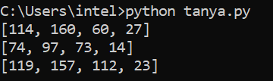
37) Python Program to Check Whether a String is Palindrome or Not.
# Program to check if a string is palindrome or not

my_str = 'aIbohPhoBiA'

# make it suitable for caseless comparison
my_str = my_str.casefold()

# reverse the string
rev_str = reversed(my_str)

# check if the string is equal to its reverse
if list(my_str) == list(rev_str):
print("The string is a palindrome.")
else:
print("The string is not a palindrome.")
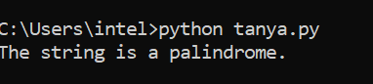
38) Python Program to Remove Punctuations From a String.
# define punctuation
punctuations = '''!()-[]{};:'"\,<>./?@#$%^&*_~'''

my_str = "Hello!!!, he said ---and went."

# To take input from the user
# my_str = input("Enter a string: ")

# remove punctuation from the string
no_punct = ""
for char in my_str:
if char not in punctuations:
no_punct = no_punct + char

# display the unpunctuated string
print(no_punct)
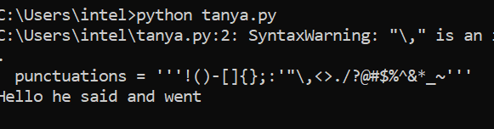
39) Python Program to Sort Words in Alphabetic Order.
# Program to sort alphabetically the words form a string provided by the user

my_str = "Hello this Is an Example With cased letters"

# To take input from the user
#my_str = input("Enter a string: ")

# breakdown the string into a list of words
words = [word.lower() for word in my_str.split()]

# sort the list
words.sort()

# display the sorted words

print("The sorted words are:")
for word in words:
print(word)

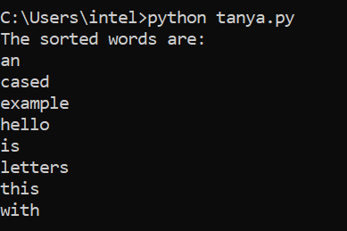
40) Python Program to Illustrate Different Set Operations.
# Program to perform different set operations like in mathematics

# define three sets
E = {0, 2, 4, 6, 8};
N = {1, 2, 3, 4, 5};

# set union
print("Union of E and N is",E | N)

# set intersection
print("Intersection of E and N is",E & N)

# set difference
print("Difference of E and N is",E - N)

# set symmetric difference
print("Symmetric difference of E and N is",E ^ N)
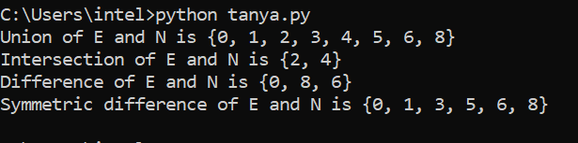
41) Python Program to Count the Number of Each Vowel.
# Program to count the number of each vowels

# string of vowels
vowels = 'aeiou'

ip_str = 'Hello, have you tried our tutorial section yet?'

# make it suitable for caseless comparisions
ip_str = ip_str.casefold()

# make a dictionary with each vowel a key and value 0
count = {}.fromkeys(vowels,0)

# count the vowels
for char in ip_str:
if char in count:
count[char] += 1

print(count)
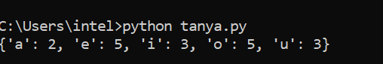
42) Python Program to Merge Mails.

# Python Program to Merge Mails

# List of names
names = ["Tanya", "Rahul", "Priya"]

# Open template file
with open("template.txt", "r") as file:
template = file.read()

# Generate mails
for name in names:
mail = template.replace("{name}", name)

# Create new file for each mail
with open(name + ".txt", "w") as output:
output.write(mail)

print("Mails merged successfully!")

43) Python Program to Find the Size (Resolution) of an Image.
def jpeg_res(filename):
""""This function prints the resolution of the jpeg image file passed into it"""

# open image for reading in binary mode
with open(filename,'rb') as img_file:

# height of image (in 2 bytes) is at 164th position
img_file.seek(163)

# read the 2 bytes
a = img_file.read(2)

# calculate height
height = (a[0] << 8) + a[1]

# next 2 bytes is width
a = img_file.read(2)

# calculate width
width = (a[0] << 8) + a[1]

print("The resolution of the image is",width,"x",height)

jpeg_res("img1.jpg")
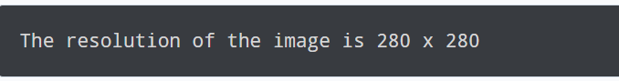
44) Python Program to Find Hash of File.
# Python program to find the SHA-1 message digest of a file

# importing the hashlib module
import hashlib

def hash_file(filepath):
""""This function returns the SHA-1 hash
of the file passed into it"""

# make a hash object
h = hashlib.sha1()

# open file for reading in binary mode
with open(filepath,'rb') as file:

# loop till the end of the file
chunk = 0
while chunk != b'':
# read only 1024 bytes at a time
chunk = file.read(1024)
h.update(chunk)

# return the hex representation of digest
return h.hexdigest()

message = hash_file("track1.mp3") # Use path of the file
print(message)
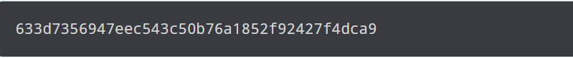
45) Python Program to Create Pyramid Patterns.
rows = int(input("Enter number of rows: "))

for i in range(rows):
for j in range(i+1):
print("* ", end="")
print()
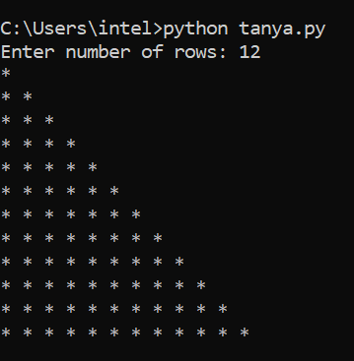

46) Python Program to Merge Two Dictionaries.
dict_1 = {1: 'a', 2: 'b'}
dict_2 = {2: 'c', 4: 'd'}

print(dict_1 | dict_2)

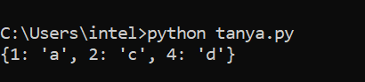

47) Python Program to Safely Create a Nested Directory.
import os

# Nested directory path
path = "parent_folder/child_folder/sub_child_folder"

# Safely create nested directories
os.makedirs(path, exist_ok=True)

print("Nested directory created successfully")
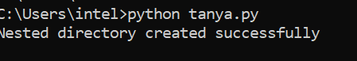

48) Python Program to Access Index of a List Using for Loop.
my_list = [21, 44, 35, 11]

for index, val in enumerate(my_list):
print(index, val)
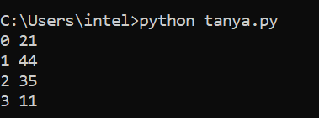
49) Python Program to Flatten a Nested List.
my_list = [[1], [2, 3], [4, 5, 6, 7]]

flat_list = [num for sublist in my_list for num in sublist]
print(flat_list)
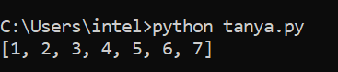

50) Python Program to Slice Lists.
my_list = [1, 2, 3, 4, 5]

print(my_list[:])
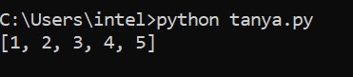

51) Python Program to Iterate Over Dictionaries Using for Loop.
dt = {'a': 'juice', 'b': 'grill', 'c': 'corn'}

for key, value in dt.items():
print(key, value)
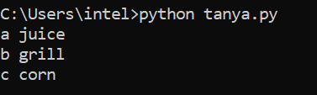

52) Python Program to Sort a Dictionary by Value.
dt = {5:4, 1:6, 6:3}

sorted_dt = {key: value for key, value in sorted(dt.items(), key=lambda item: item[1])}

print(sorted_dt)
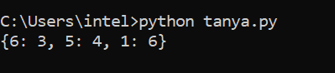

53) Python Program to Check If a List is Empty.
my_list = []
if not my_list:
print("the list is empty")
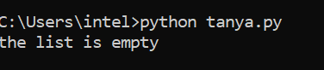

54) Python Program to Catch Multiple Exceptions in One Line.
# Python Program to Catch Multiple Exceptions in One Line

try:
a = int(input("Enter first number: "))
b = int(input("Enter second number: "))

result = a / b
print("Result =", result)

# Catch multiple exceptions in one line
except (ValueError, ZeroDivisionError) as e:
print("Error occurred:", e)
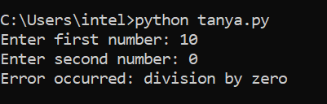
55) Python Program to Concatenate Two Lists.
list_1 = [1, 'a']
list_2 = [3, 4, 5]

list_joined = list_1 + list_2
print(list_joined)
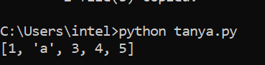
56) Python Program to Check if a Key is Already Present in a Dictionary.
my_dict = {1: 'a', 2: 'b', 3: 'c'}

if 2 in my_dict:
print("present")
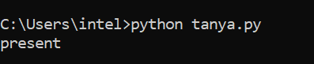
57) Python Program to Get the Last Element of the List.
my_list = ['a', 'b', 'c', 'd', 'e']

# print the last element
print(my_list[-1])
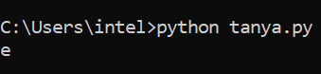
58) Python Program to Get a Substring of a String.
my_string = "I love python."

# prints "love"
print(my_string[2:6])

# prints "love python."
print(my_string[2:])

# prints "I love python"
print(my_string[:-1])

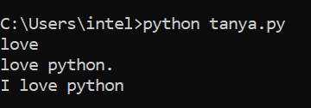
59) Python Program to Print Output Without a Newline.
# print each statement on a new line
print("Python")
print("is easy to learn.")

# new line
print()

# print both the statements on a single line
print("Python", end=" ")
print("is easy to learn.")
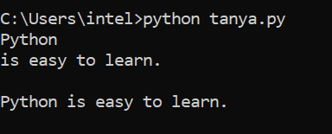
60) Python Program to Randomly Select an Element From the List.
import random

my_list = [1, 'a', 32, 'c', 'd', 31]
print(random.choice(my_list))
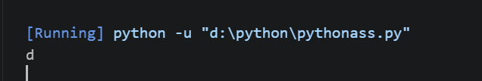

61) Python Program to Count the Occurrence of an Item in a List.
freq = ['a', 1, 'a', 4, 3, 2, 'a'].count('a')
print(freq)
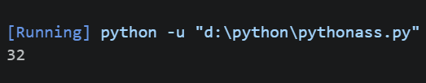

62) Python Program to Delete an Element From a Dictionary.
my_dict = {31: 'a', 21: 'b', 14: 'c'}

del my_dict[31]

print(my_dict)
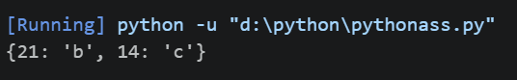

63) Python Program to Create a Long Multiline String.
my_string = '''The only way to
learn to program is
by writing code.'''

print(my_string)
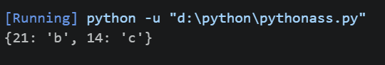

64) Python Program to Extract Extension From the File Name.
import os
file_details = os.path.splitext('/path/file.ext')
print(file_details)
print(file_details[1])
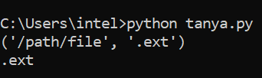

65) Python Program to Get the Class Name of an Instance.

class Vehicle:
def name(self, name):
return name

v = Vehicle()
print(v.__class__.__name__)
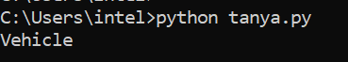

66) Python Program to Convert Two Lists Into a Dictionary.

index = [1, 2, 3]
languages = ['python', 'c', 'c++']

dictionary = dict(zip(index, languages))
print(dictionary)
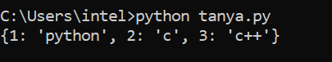

67) Python Program to Trim Whitespace From a String.

my_string = " Python "

print(my_string.strip())
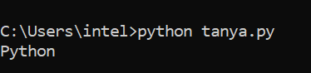

68) Python Program to Differentiate Between type() and isinstance() .

class Polygon:
def sides_no(self):
pass

class Triangle(Polygon):
def area(self):
pass

obj_polygon = Polygon()
obj_triangle = Triangle()

print(type(obj_triangle) == Triangle) # true
print(type(obj_triangle) == Polygon) # false

print(isinstance(obj_polygon, Polygon)) # true
print(isinstance(obj_triangle, Polygon)) # true

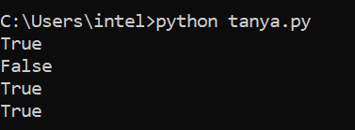

69) Python Program to Get the File Name From the File Path.

import os

# file name with extension
file_name = os.path.basename('/root/file.ext')

# file name without extension
print(os.path.splitext(file_name)[0])
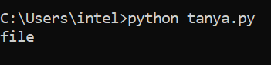

70) Python Program to Represent enum.
from enum import Enum

class Day(Enum):
MONDAY = 1
TUESDAY = 2
WEDNESDAY = 3

# print the enum member
print(Day.MONDAY)

# get the name of the enum member
print(Day.MONDAY.name)

# get the value of the enum member
print(Day.MONDAY.value)
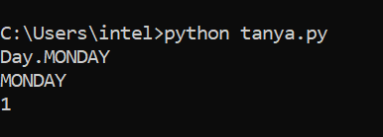

71) Python Program to Return Multiple Values From a Function.
def name():
return "John","Armin"

# print the tuple with the returned values
print(name())

# get the individual items
name_1, name_2 = name()
print(name_1, name_2)
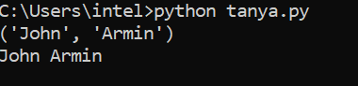
72) Python Program to Get Line Count of a File.
def file_len(fname):
with open(fname) as f:
for i, l in enumerate(f):
pass
return i + 1

print(file_len("my_file.txt"))

73) Python Program to Find All File with .txt Extension Present Inside a Directory.
import glob, os

os.chdir("my_dir")

for file in glob.glob("*.txt"):
print(file)
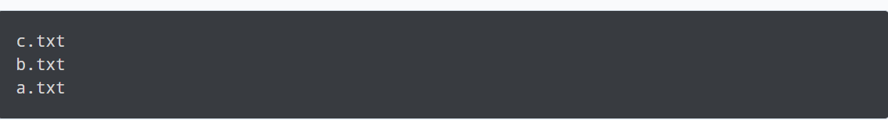

74) Python Program to Iterate Through Two Lists in Parallel.
list_1 = [1, 2, 3, 4]
list_2 = ['a', 'b', 'c']

for i, j in zip(list_1, list_2):
print(i, j)
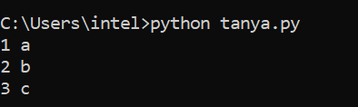

75) Python Program to Check the File Size.
import os

file_stat = os.stat('my_file.txt')
print(file_stat.st_size)
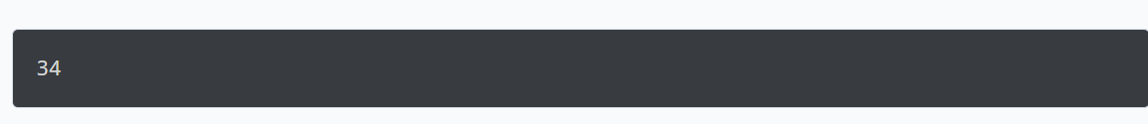

76) Python Program to Reverse a Number.
num = 1234
reversed_num = 0

while num != 0:
digit = num % 10
reversed_num = reversed_num * 10 + digit
num //= 10

print("Reversed Number: " + str(reversed_num))

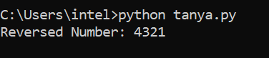

77) Python Program to Compute the Power of a Number.
base = 3
exponent = 4

result = 1

while exponent != 0:
result *= base
exponent-=1

print("Answer = " + str(result))
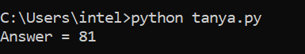

78) Python Program to Count the Number of Digits Present In a Number.
num = 3452
count = 0

while num != 0:
num //= 10
count += 1

print("Number of digits: " + str(count))

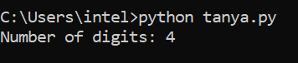

79) Python Program to Check If Two Strings are Anagram.
str1 = "Race"
str2 = "Care"

# convert both the strings into lowercase
str1 = str1.lower()
str2 = str2.lower()

# check if length is same
if(len(str1) == len(str2)):

# sort the strings
sorted_str1 = sorted(str1)
sorted_str2 = sorted(str2)

# if sorted char arrays are same
if(sorted_str1 == sorted_str2):
print(str1 + " and " + str2 + " are anagram.")
else:
print(str1 + " and " + str2 + " are not anagram.")

else:
print(str1 + " and " + str2 + " are not anagram.")

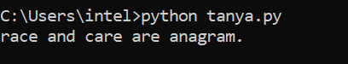

80) Python Program to Compute all the Permutation of the String.
def get_permutation(string, i=0):

if i == len(string):
print("".join(string))

for j in range(i, len(string)):

words = [c for c in string]

# swap
words[i], words[j] = words[j], words[i]

get_permutation(words, i + 1)

print(get_permutation('yup'))

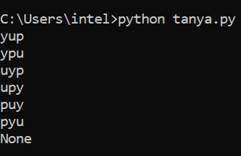

81) Python Program to Create a Countdown Timer.
import time

def countdown(time_sec):
while time_sec:
mins, secs = divmod(time_sec, 60)
timeformat = '{:02d}:{:02d}'.format(mins, secs)
print(timeformat, end='\r')
time.sleep(1)
time_sec -= 1

print("stop")

countdown(5)
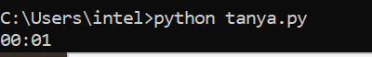

82) Python Program to Count the Number of Occurrence of a Character in String.
count = 0

my_string = "Programiz"
my_char = "r"

for i in my_string:
if i == my_char:
count += 1

print(count)
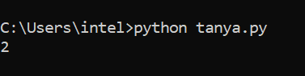

83) Python Program to Remove Duplicate Element From a List.

list_1 = [1, 2, 1, 4, 6]

print(list(set(list_1)))
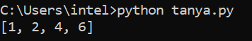

84) Python Program to Convert Bytes to a String.

print(b'Easy \xE2\x9C\x85'.decode("utf-8"))

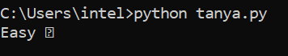

85) Python Program to Find Prime Numbers in a Given Range.

r=int(input("Enter upper limit: "))
for a in range(2,r+1):
k=0
for i in range(2,a//2+1):
if(a%i==0):
k=k+1
if(k<=0):
print(a)
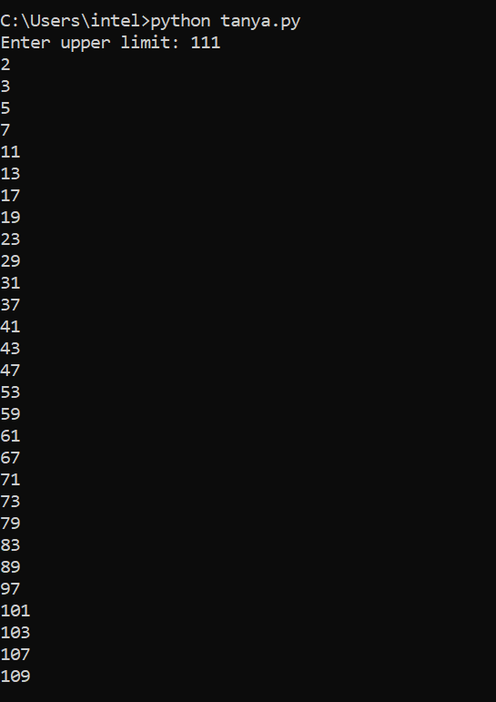

86) Python Program to Check Prime Number.

# Prime Number Program in Python using For Loop

a=int(input("Enter number: "))
k=0
for i in range(2,a//2+1):
if(a%i==0):
k=k+1
if(k<=0):
print("Number is prime")
else:
print("Number isn't prime")

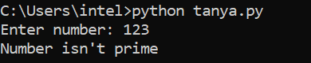

87) Python Program to Check whether a Number is Prime or Not using Recursion.

def check(n, div = None):
if div is None:
div = n - 1
while div >= 2:
if n % div == 0:
print("Number not prime")
return False
else:
return check(n, div-1)
else:
print("Number is prime")
return 'True'
n=int(input("Enter number: "))
check(n)
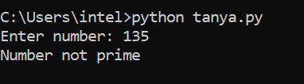

88) Python Program to Check Whether a Given Number is Perfect Number.

n = int(input("Enter any number: "))
sum1 = 0
for i in range(1, n):
if(n % i == 0):
sum1 = sum1 + i
if (sum1 == n):
print("The number is a Perfect number!")
else:
print("The number is not a Perfect number!")
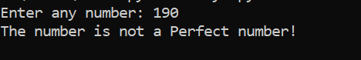

89) Python Program to Find the Sum of Natural Numbers.

n=int(input("Enter a number: "))
sum1 = 0
while(n > 0):
sum1=sum1+n
n=n-1
print("The sum of first n natural numbers is",sum1)

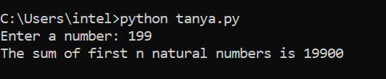

90) Python Program to Print Numbers in a Range Without using Loops.
def printno(upper):
if(upper>0):
printno(upper-1)
print(upper)
upper=int(input("Enter upper limit: "))
printno(upper)

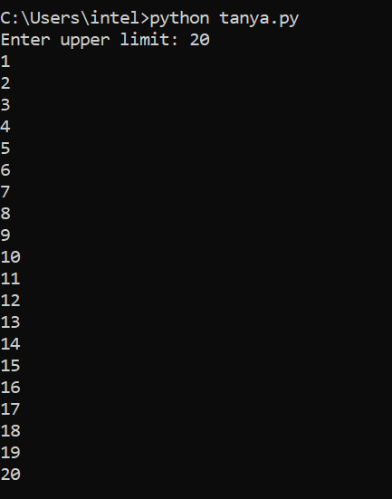

91) Python Program to Find the Prime Factors of a Number.

n=int(input("Enter an integer:"))
print("Factors are:")
i=1
while(i<=n):
k=0
if(n%i==0):
j=1
while(j<=i):
if(i%j==0):
k=k+1
j=j+1
if(k==2):
print(i)
i=i+1
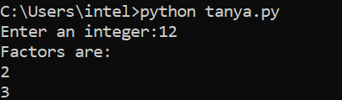

92) Python Program to Check If Two Numbers are Amicable Numbers or Not.

x=int(input('Enter number 1: '))
y=int(input('Enter number 2: '))
sum1=0
sum2=0
for i in range(1,x):
if x%i==0:
sum1+=i
for j in range(1,y):
if y%j==0:
sum2+=j
if(sum1==y and sum2==x):
print('Amicable!')
else:
print('Not Amicable!')
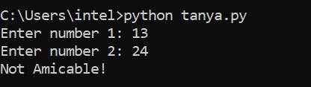

93) Python Program to Find Whether a Number is a Power of Two.

def is_power_of_two(n):
"""Return True if n is a power of two."""
if n <= 0:
return False
else:
return n & (n - 1) == 0

n = int(input('Enter a number: '))

if is_power_of_two(n):
print('{} is a power of two.'.format(n))
else:
print('{} is not a power of two.'.format(n))

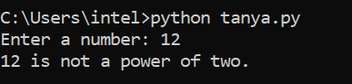

94) Python Program to Find All Perfect Squares in the Given Range.

l=int(input("Enter lower range: "))
u=int(input("Enter upper range: "))
a=[]
a=[x for x in range(l,u+1) if (int(x**0.5))**2==x and sum(list(map(int,str(x))))<10]
print(a)
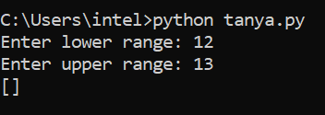

95) Python Program to Check Armstrong Number.

# Armstrong Number Program in Python

n=int(input("Enter any number: "))
a=list(map(int,str(n)))
b=list(map(lambda x:x**3,a))
if(sum(b)==n):
print("The number is an armstrong number. ")
else:
print("The number is not an arsmtrong number. ")
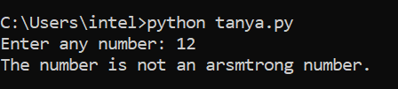

96) Python Program to Print All Possible Combinations of Three Digits.
a=int(input("Enter first number:"))
b=int(input("Enter second number:"))
c=int(input("Enter third number:"))
d=[]
d.append(a)
d.append(b)
d.append(c)
for i in range(0,3):
for j in range(0,3):
for k in range(0,3):
if(i!=j&j!=k&k!=i):
print(d[i],d[j],d[k])
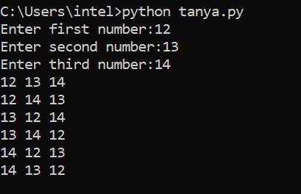

97) Python Program to Find Largest Number in a List.
a=[]
n=int(input("Enter number of elements:"))
for i in range(1,n+1):
b=int(input("Enter element:"))
a.append(b)
a.sort()
print("Largest element is:",a[n-1])
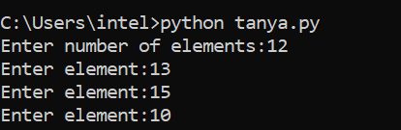

98) Python Program to Print Sum of Negative Numbers, Positive Even Numbers and Positive Odd numbers in a List.
n=int(input("Enter the number of elements to be in the list:"))
b=[]
for i in range(0,n):
a=int(input("Element: "))
b.append(a)
sum1=0
sum2=0
sum3=0
for j in b:
if(j>0):
if(j%2==0):
sum1=sum1+j
else:
sum2=sum2+j
else:
sum3=sum3+j
print("Sum of all positive even numbers:",sum1)
print("Sum of all positive odd numbers:",sum2)
print("Sum of all negative numbers:",sum3)
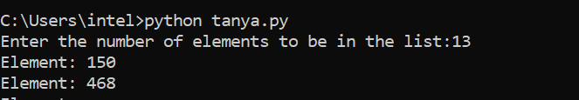
99) Python Program to Return the Length of the Longest Word from the List of Words.
a=[]
n= int(input("Enter the number of elements in list:"))
for x in range(0,n):
element=input("Enter element" + str(x+1) + ":")
a.append(element)
max1=len(a[0])
temp=a[0]
for i in a:
if(len(i)>max1):
max1=len(i)
temp=i
print("The word with the longest length is:")
print(temp)
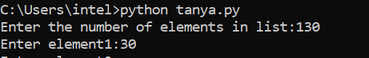
100) Python Program to Sort a List According to the Second Element in Sublist.
a=[['A',34],['B',21],['C',26]]
for i in range(0,len(a)):
for j in range(0,len(a)-i-1):
if(a[j][1]>a[j+1][1]):
temp=a[j]
a[j]=a[j+1]
a[j+1]=temp

print(a)
