04 ஆகஸ்ட் 2016
19:30

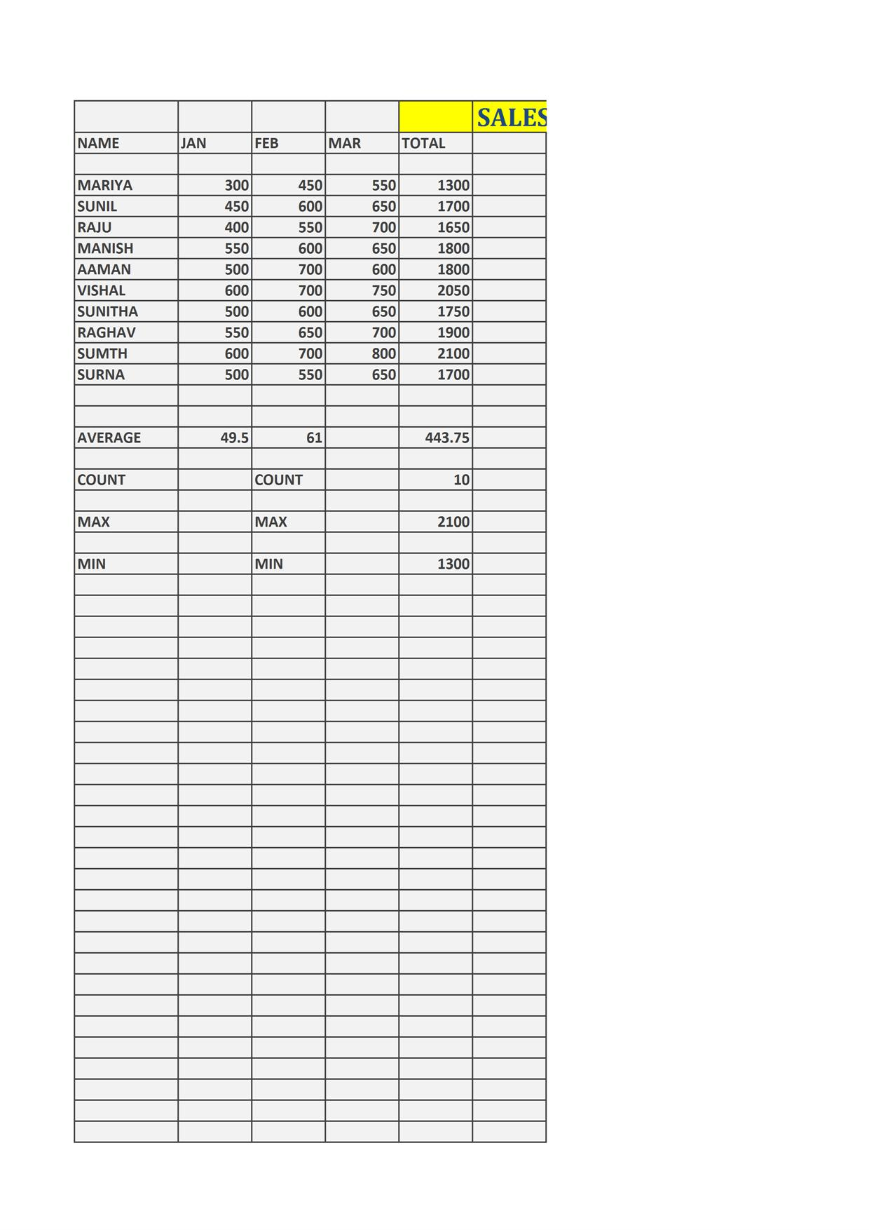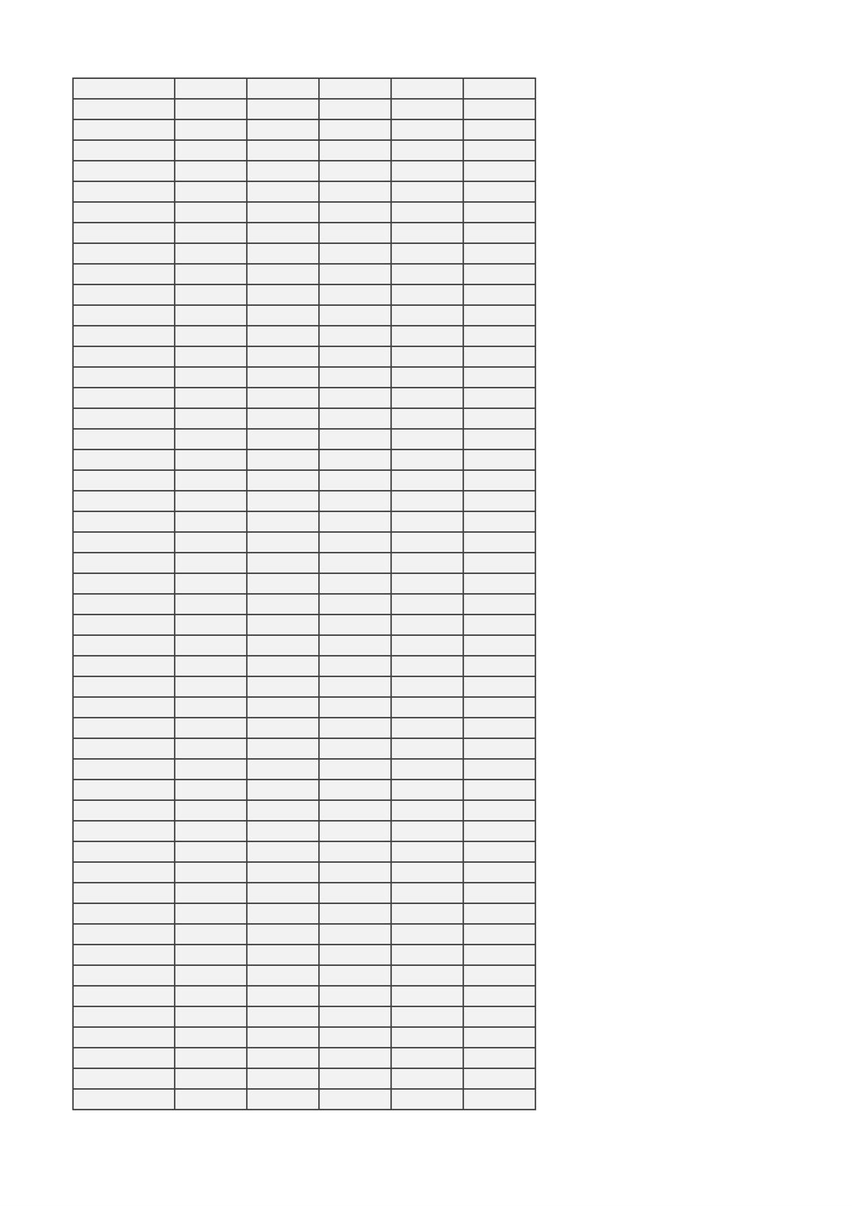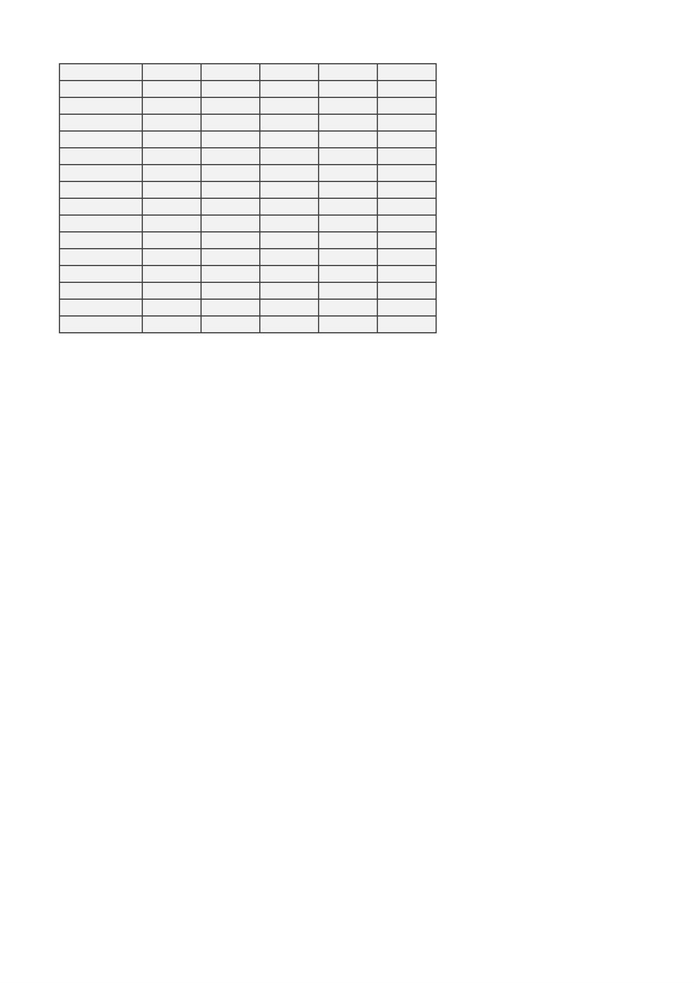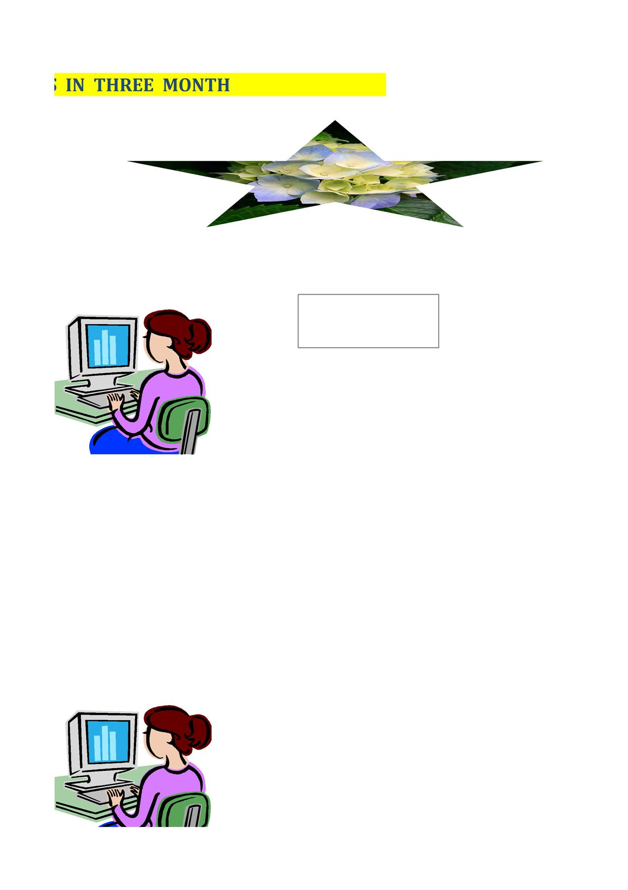

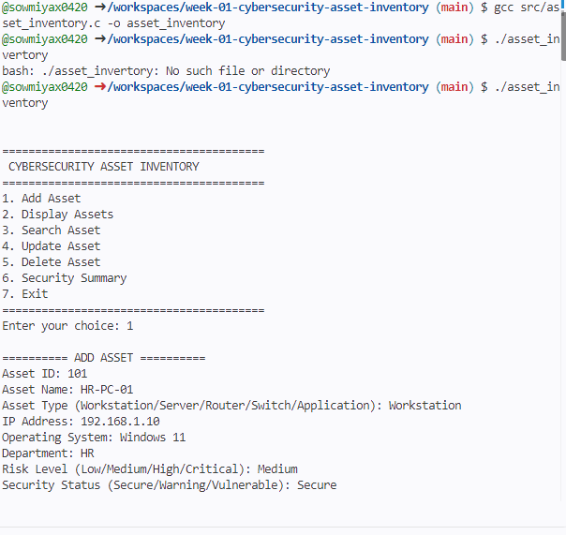

Screen clipping taken: 17-09-2026, 19:53

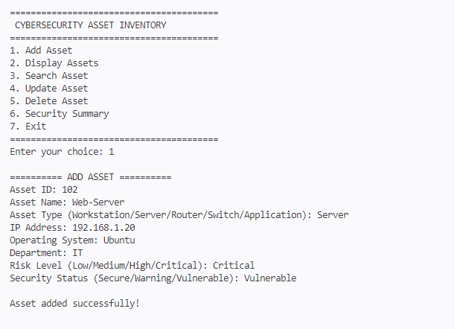

Screen clipping taken: 17-09-2026, 19:54

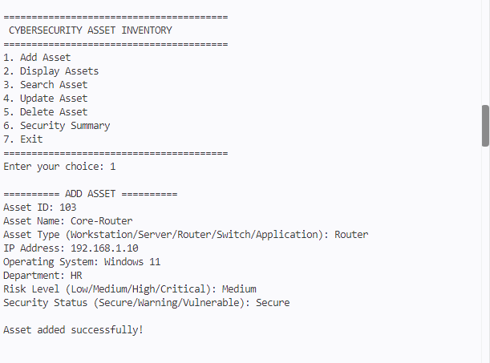

Screen clipping taken: 17-09-2026, 19:57

Screen clipping taken: 17-09-2026, 19:58

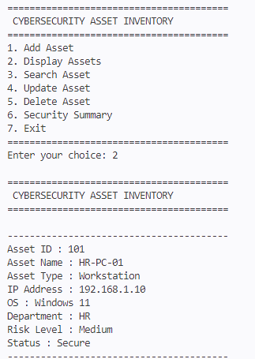

Screen clipping taken: 17-09-2026, 19:58

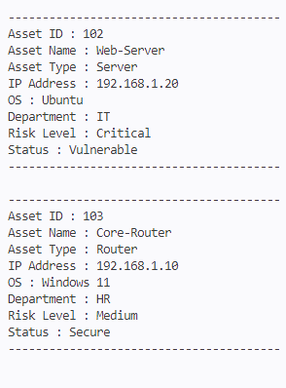

Screen clipping taken: 17-09-2026, 19:59

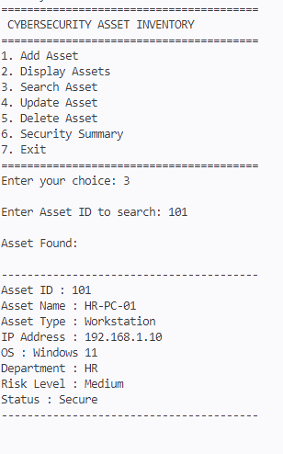

Screen clipping taken: 17-09-2026, 20:00

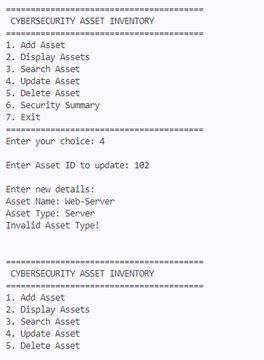

Screen clipping taken: 17-09-2026, 20:00

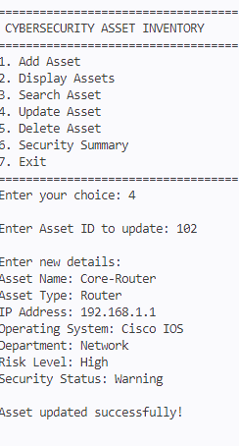

Screen clipping taken: 17-09-2026, 20:01

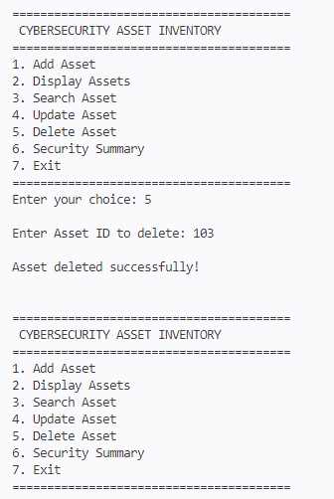

Screen clipping taken: 17-09-2026, 20:02

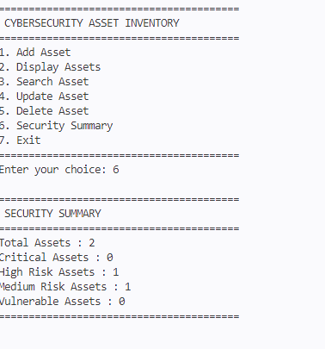

Screen clipping taken: 17-09-2026, 20:02

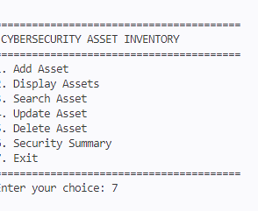

Screen clipping taken: 17-09-2026, 20:03

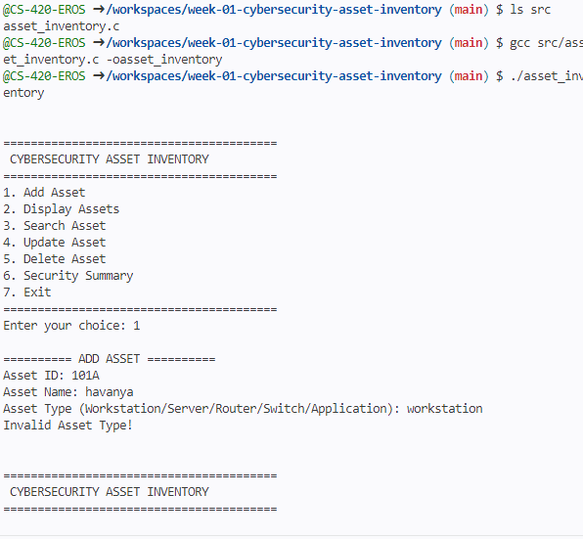

Screen clipping taken: 18-09-2026, 19:28

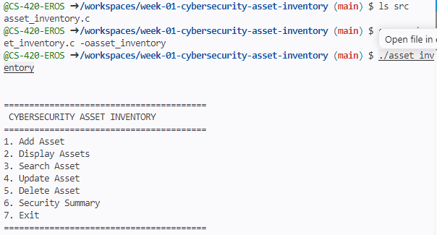

Screen clipping taken: 18-09-2026, 19:28

