
School of Computing and Information Systems
Bsc (Hons) BIDA
Bsc (Hons) MTECh
Bsc (Hons) ABC
BSC (HONS) CSE
ABC103 – WEB and multimedia development YEAR 2 Semester 2
OPEN BOOK Assessment Test Answer Booklet

CANDIDATE NUMBER: fcse20-027
CANDIDATE NAMES: Tlhongbotho Mumsy Moilwa
CONTACT NUMBER: 77550502
MODULE LEADER:
EXAMINATION DATE: | 31 MAY 2021 - 1130

Start each Question on a new page

Candidates may answer any four (4) questions
Question 1
Use the sample code below to answer the following questions.
- Does this code below comply with html5 standards, support your answer with relevant examples from this code above?
<html>
<head><title> Home </title></head>
<body bgcolor = "#FBF5EF">
<a href = "#">Home</a>
<a href = "#">About Us</a>
<a href = "#">Our Courses</a>
<a href = "Staff.html">Our Staff</a>
<a href = "#">Student Life</a>
<h1 align = "center"> Welcome to BAC</h1>
<p>Lorem ipsum dolor sit amet, consectetuer adipiscing elit. Aenean commodo ligula eget dolor. Aenean massa. Cum sociis natoque penatibuset magnis dis parturient montes, nascetur ridiculus mus. Donec quam felis, ultricies nec, pellentesque eu, pretium quis, sem. Nulla consequat massa quis enim.Donec pede justo, fringilla vel, aliquet nec, vulputate eget, arcu. In enim justo, rhoncus ut,imperdiet a, venenatis vitae, justo. Nullam dictum felis eu pede mollis pretium. Integer tincidunt.Cras dapibus. Vivamus elementum semper nisi. <b>Aenean vulputate eleifend <i>tellus</i>.</b> <br/> Aenean leo ligula,porttitor eu, consequat vitae, eleifend ac, enim. Aliquam lorem ante, dapibus in, viverra quis, feugiat a, tellus.
Phasellus viverra nulla ut metus varius laoreet. Quisque rutrum. Aenean imperdiet. Etiam ultricies nisi vel augue. Curabitur ullamcorper ultricies nisi. Nam eget dui. Etiam rhoncus. Maecenas tempus, tellus eget condimentum rhoncus, sem quam semper libero, sit amet adipiscing sem neque sed ipsum. Nam quam nunc, blandit vel, luctus pulvinar, hendrerit id, lorem. Maecenas nec odio et ante tincidunt tempus. Donec vitae sapien ut libero venenatis faucibus. Nullam quis ante. Etiam sit amet orci eget eros faucibus tincidunt. Duis leo. Sed fringilla mauris sit amet nibh. Donec sodales sagittis magna. Sed consequat, leo eget bibendum sodales, augue velit cursus nunc, </p>
<p>Etiam ultricies nisi vel augue. Curabitur ullamcorper ultricies nisi. Nam eget dui. Etiam rhoncus. Maecenas tempus, tellus eget condimentum rhoncus, sem quam semper libero, sit amet adipiscing sem neque sed ipsum. Nam quam nunc, blandit vel, luctus pulvinar, hendrerit id, lorem. Maecenas nec odio et ante tincidunt tempus. Donec vitae sapien ut libero venenatis faucibus. Nullam quis ante. Etiam sit amet orci eget eros faucibus tincidunt. Duis leo. Sed fringilla mauris sit amet nibh. Donec sodales sagittis magna. Sed consequat, leo eget bibendum sodales, augue velit cursus nunc,</p><h2 align = "center">Our mission</h2><p align = "right">Lorem ipsum dolor sit amet, consectetuer adipiscing elit. Aenean commodo ligula eget dolor. Aenean massa. Cum sociis natoque penatibuset magnis dis parturient montes, nascetur ridiculus mus. Donec quam felis, ultricies nec, pellentesque eu, pretium quis, sem. Nulla consequat massa quis enim.Donec pede justo, fringilla vel, aliquet nec, vulputate eget, arcu.</p> <table align = "center" cellspacing = "4" cellpadding = "4"><th>Center no</th><th> Population</th><th>available courses</th><th>Location</th><tr><td>001</td> <td>10000</td> <td>6 </td> <td>Gaborone</td></tr><tr><td>002</td> <td>5000</td> <td>3 </td> <td>F-town</td></tr><tr><td>003</td> <td>5000</td> <td>3 </td> <td>Lobatse</td></tr></table>
</body>
[5 Marks]
Answer here

- Differentiate between html5 and html4.  Html5 | [2 Marks]
Answer here

- Have CSS been used in the code above, if so what kind of CSS have been used? | [2 Marks]
Answer here

- Give 3 instances where that CSS have been applied and explain them in detail. | [6 Marks]
Answer here

- Draw a sketch of how the code above will look like in a webpage. | [10 Mark]
Answer here

Total Marks [25]

Question 2

- The webmaster for BAC website has resigned after creating the content as in question 1. The school have hired you to improve the look and feel of the webpage. You decided to work on the layout first, draw a wireframe that includes the header, sidebar, content, and footer. b. Without using css, edit the code in question 1 above to realize your wireframe design.
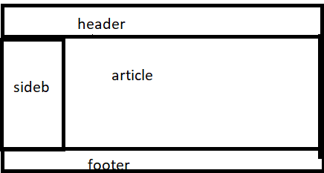

[8 marks]
Answer here

- Write an external CSS for the layout above. | [8 Marks]
Answer here

- The school informs you that they want the website to accessible in different platforms, how would you incorporate their concerns (screen resolution dilemma) in your design. | [5 marks]
Answer here

- Explain what whitespaces are, and why you will incorporate them in your design. | [2 Marks]
Answer here

- Suppose the website you have created has been approved by the BAC board and it must be hosted how will you identify the best web hosting (hosting checklist) service. | [2 Marks]
Answer here

Total Marks [25]

Question 3

- After your work in BAC as a web designer you have been appointed as a manager by a big web consultancy firm that develops websites for several high-profile companies. As a manager one of your duties is to a assemble a website development team. List at least 5 posts you would create. | [5 marks]
Answer here

- An entertainment and news client wants your webservices. The team sits together to organize the information, discuss 3 organizing information structures that are appropriate. | [6 Marks]
Answer here

- Of the 3 above select decide on the best structure and give reasons to support your choice. | [4 marks]
Answer here

- Consider the https://zm-vle-uu.unicaf.org/login/index.php url, identify the protocol, domain name, path and file from it. | [4 Marks]
Answer here

Use the following wireframe to answer questions below.  - Write an external CSS code to achieve this layout design. Focus only on the CSS not the html code. | [6 Marks]
Answer here

Total Marks [25]
Question 4
Consider the following code snippet when answering the questions below.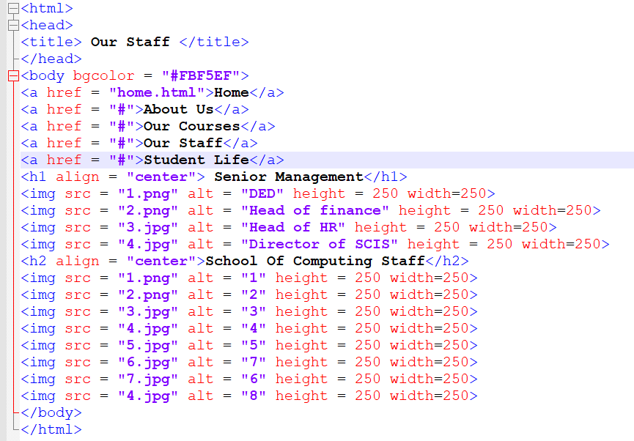

- Suppose this file containing this code was in directory C:/User/kamogelo/myfirst website. Will it still run without errors? | [2 Marks]
Answer here

- Suppose images {1.png, 2.jpg, 3.png, 4.jpg, 5.jpg, 6.png, and 7.png} are in the same directory as in question 4a, produce a sketch (or wireframe) of how the webpage will look like. | [8 Marks]
Answer here

- To clean-up the coding environment you chose to create a folder named “imgs” in C:/User/kamogelo/myfirst website directory and move all images {1.png, 2.png, 3.jpg, 4.jpg, 5.jpg, 6.jpg, and 7.jpg} there. Do you think the web page will show all the images if your answer is no, modify the code above to accommodate for these changes? | [6 Marks]
Answer here

- With the aid of example, illustrate 3 types of CSS. | [6 Marks]
Answer here

- In CSS differentiate between absolute and relative units. | [3 Marks]
Answer here

Total Marks [25]

End of Exam

ACKNOWLEDGEMENT
I acknowledge to the College and I hereby confirm that the submitted work is entirely my own and I have not (i) used the services of any agency or person(s) providing specimen, model or colluded in the preparation of the work I submit for this open book examination; (ii) given assistance in accessing this paper or in providing specimen, model or colluded with other candidates submitting for this open-book examination.

__________________________________ ________________________________________

Append SIGNATURE ID number for student

__________________________________

FOR OFFICE USE
DATE RECEIVED:
SIGNATURE OF MODULE LEADER

