Names: Zelpha Thomas, Jie Tan

CSE220 Programming for Computer Engineers

Spring2014

Lab5

1. Repository URL : <https://github.com/CSE220GROUP16/lab2_part2/commits/master>
2. Team members GithubID:

|  |  |  |
| --- | --- | --- |
| Contribution | Contributor | Username/github ID |
| 2 | Zelpha Thomas | zathomas25 |
| 2 | Jie Tan | jietan25 |

1. UML design file

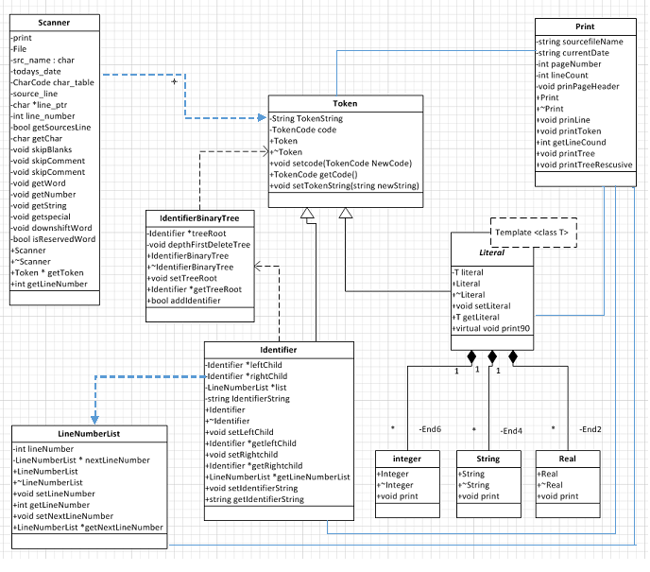

1. Github history

