

**SCHOOL OF ELECTRICAL ENGINEERING AND COMPUTING**

**COMPUTER SCIENCE AND ENGINEERING PROGRAM**

**COMPUTER ARCHITECTURE AND ORGANIZATION PROJECT**

**SMALL PROCESSOR DESIGN**

**BY:**

1. **Kaleab Alebachew**
2. **Fituma Amsallu**

**Submitted to: Simegnew Y. Alaba**

**April 2019**

**Q.** Design an 8-bit processor with the following specifications

* The ALU can add, subtract, multiply, divide and perform all logical operations
* It supports 2 addressing formats and 2 addressing modes (direct and indirect)
* Uses only 8 opcodes

*The design should only be implemented using atomic digital elements

*Submission should include design documentation and simulation

*Simulation should include instructions from memory to implement the above specifications

# Problem Specifications

## ALU

* Add
* Multiply
* Subtract
* Divide
* Bit wise AND
* Bit wise OR

## Control Unit

* Zero address format
* One address format
* Direct addressing
* Indirect addressing

## Registers

* PC
* MBR
* MIR
* Stack
* Stack pointer
* Accumulator
* ALU helpers

# Design Specifications

## ALU design

Design methodology will be to implement every requirement singularly and finally multiplex them.

### Adder

Our processor will be using 8 full adders in parallel to implement instantaneous 8 bit addition.

### Multiplier

The algorithm used here is implementing multiplication as repeated addition and this is done by using a down counter and a register.

### Subtractor

Complements one input then adds them

### Dividor

Uses repeated subtraction and counts the number of times the subtraction can take place.

### Logical: And

A simple And gate

### Logical: Or

A simple Or gate

### Logical: inverter

A simple Not gate

# Perfections

## ALU

### Multiplier

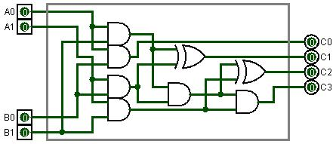

Figure 12 A better implementation of multiplier 2x2 bit