Heaven's light is our guide
Rajshahi University of Engineering & Technology (RUET)
Rajshahi-6204, Bangladesh
DEPARTMENT OF COMPUTER SCIENCE & ENGINEERING
PROJECT DESIGN REPORT
Lab 2 — Software Process Models, Requirement Analysis & MVP Development
Inventory Management System
Process Model: Incremental
Field | Details
Course No. | CSE 3206
Course Title | Software Engineering Sessional
Lab No. | Lab 2
Group No. | Group #10, Section B (1st 30)
Scenario No. | 30 — Inventory Management System
Series | 22
GitHub Repository | github.com/CSE3206/ims
Date of Submission | ____________________

Submitted By | Submitted To
Evangel Puri — Roll: 2203089  MD Najmul Islam Nahid — Roll: ________  Ummey Rukaiya — Roll: ________  Section: B, Series: 22 | Course Teacher, CSE 3206  Department of Computer Science & Engineering  Rajshahi University of Engineering & Technology

Table of Contents

(If the page numbers are not shown, right-click the table and choose “Update Field”.)

1. Team Information
SL | Name | Roll | GitHub | Role in the Team | Git Branch
01 | Evangel Puri (Evan) | 2203089 | Mathew2004 | Team lead & Integration Lead — authentication, users, product catalogue | feature/auth-catalog
02 | MD Najmul Islam Nahid (Najmul) | ________ | NAJMUL-NAHID | Developer — suppliers, purchase orders, goods receipt (stock in) | feature/purchasing
03 | Ummey Rukaiya (Rukaiya) | ________ | Ummey-Rukaiya | Developer — stock ledger, sales orders (stock out), dashboard & reports | feature/inventory-reports

The work was split into three vertical feature slices. Each member owns one feature end to end — the database tables, the API routes, the service logic and the React pages that use them. No one was only "the frontend person" or "the backend person", so every member worked across the whole stack and has a working feature to demonstrate. The split is documented in docs/TEAM.md in the repository.

2. Project Title
Inventory Management System (IMS) — a full-stack web application for a small warehouse that tracks products, buys stock in from suppliers, sells stock out to customers, and keeps a complete audit trail of every unit that moves.

3. Problem Statement
Many small and medium businesses still track their stock in paper registers or loose spreadsheets. This causes the same problems again and again:
- The stock count on paper drifts away from what is actually on the shelf, so staff cannot tell what is really available.
- There is no warning when an item is about to run out, so fast-moving items go out of stock and sales are lost.
- Purchase and supplier records are kept separately from stock records, so reordering depends on one person’s memory.
- When several people handle stock, there is no record of who changed what, so a shortage cannot be traced.
- Preparing a simple stock-value or best-seller report takes hours of manual counting.
The client needs one system where products, suppliers, purchase orders, sales orders and every stock movement are recorded in one place, with role-based access and low-stock alerts, so that stock data stays accurate and decisions are based on real numbers.

4. Project Objectives
- Maintain a central product catalogue with categories, suppliers, units, cost and selling prices, and reorder levels.
- Record purchases from suppliers through purchase orders, and add stock only when goods are actually received.
- Record sales to customers through sales orders, check availability before confirming, and remove stock only when an order is fulfilled.
- Record every change to a stock quantity in an append-only ledger with the user, reason and document reference.
- Warn managers when a product falls to or below its reorder level.
- Enforce role-based access (admin, manager, staff) on the server.
- Provide a dashboard and reports (valuation, top products, daily stock flow) with CSV export.
- Deliver the system in increments and build it collaboratively with Git feature branches and pull requests.

5. Stakeholder Analysis
Stakeholder | Type | Interest in the System | Main Needs
Business Owner / Client | Primary, external | Accurate stock data, less money locked in unsold stock | Dashboard, valuation and top-product reports
Inventory Manager | Primary user (manager role) | Runs day-to-day purchasing and stock | Purchase orders, low-stock list, master data (products, suppliers)
Store / Counter Staff | Primary user (staff role) | Records stock and raises sales orders | Simple screens, quick product search, stock in/out
System Administrator | Secondary user (admin role) | Keeps accounts correct and secure | User management, role assignment, account deactivation
Supplier | External | Supplies goods against purchase orders | Correct product lines, quantities and costs
Customer | External | Buys goods through sales orders | Orders that are only confirmed when stock is available
Development Team | Internal | Builds and delivers the increments | Clear requirements, clear file ownership
Course Teacher | Evaluator | Assesses process and documentation | Traceable requirements, Git history, working MVP

6. Functional Requirements
Fourteen functional requirements were identified. The last column shows the feature branch (and the team member) responsible for each one.
ID | Requirement | Priority | Branch
FR-01 | The system shall let a user register and log in with email and password, and issue a JWT on success. | High | auth-catalog
FR-02 | The system shall give each user one role — admin, manager or staff — and restrict each API route by role. | High | auth-catalog
FR-03 | The system shall let an admin add users, change their role or password, and deactivate accounts. | Medium | auth-catalog
FR-04 | The system shall let managers create, update and delete product categories, showing a product count for each. | Medium | auth-catalog
FR-05 | The system shall let managers create and update products (SKU, name, category, supplier, unit, cost price, selling price, reorder level). | High | auth-catalog
FR-06 | The system shall let users search products by name or SKU, filter by category, supplier or low stock, sort and paginate. | High | auth-catalog
FR-07 | The system shall let managers maintain suppliers with contact person, email, phone and address. | Medium | purchasing
FR-08 | The system shall let managers raise a multi-line purchase order with an auto-generated number (e.g. PO-2026-0001). | High | purchasing
FR-09 | The system shall move a purchase order through draft → ordered → received (or cancelled), and on receipt add every line to stock in one transaction and update each product’s cost price. | High | purchasing
FR-10 | The system shall record every stock change in a ledger with a signed quantity, the balance after the change, a reason, a document reference and the user. | High | inventory-reports
FR-11 | The system shall allow manual stock in, stock out, and a stock-take adjustment that sets the counted quantity. | High | inventory-reports
FR-12 | The system shall move a sales order through draft → confirmed → fulfilled (or cancelled), check availability on confirm, and deduct stock on fulfil. | High | inventory-reports
FR-13 | The system shall show a dashboard with total stock value, low-stock and out-of-stock counts, revenue, value by category and recent movements. | High | inventory-reports
FR-14 | The system shall produce inventory valuation, top-product and daily stock-flow reports, each downloadable as CSV. | Medium | inventory-reports

7. Non-functional Requirements
ID | Category | Requirement
NFR-01 | Security | Passwords shall be stored only as bcrypt hashes and never logged or returned by the API.
NFR-02 | Security | Every protected route shall check the JWT and the user’s role on the server (requireAuth, requireRole); a disallowed request returns 403 even if the URL is typed in directly.
NFR-03 | Security | A failed login shall return the same message for an unknown email and a wrong password, so the API does not reveal which emails exist.
NFR-04 | Data integrity | products.quantity shall be written only by applyMovement() in stock.service.js, which locks the product row (SELECT … FOR UPDATE) and writes the new quantity and the ledger row in one transaction.
NFR-05 | Data integrity | Stock shall never go below zero except through a deliberate stock-take adjustment; SKUs, category names and user emails shall be unique.
NFR-06 | Reliability | Receiving a purchase order or fulfilling a sales order shall either apply all of its lines or none of them.
NFR-07 | Usability & consistency | Every endpoint shall use the same response envelope — { data }, { data, pagination } or { error: { message, details } } — so every page handles results and field errors the same way.
NFR-08 | Performance | List endpoints shall be paginated, with a maximum page size of 200 rows.
NFR-09 | Auditability | Ledger rows shall be append-only and record the acting user and the server time.
NFR-10 | Maintainability | Code shall be layered (route → validation → service → database) and split by feature, so one member’s slice can change without editing another’s.
NFR-11 | Testability | Validation rules and auth middleware shall be covered by automated tests runnable with one command (npm test).

8. User Stories and Use Cases

8.1 User Stories
ID | Role | Story | Acceptance Criteria
US-01 | Inventory Manager | As a manager, I want to add a product with a reorder level so that the system warns me before it runs out. | SKU is unique (duplicate returns 409); the product appears in the list; it shows in the low-stock list when quantity ≤ reorder level.
US-02 | Inventory Manager | As a manager, I want to receive a purchase order so that all the goods delivered are added to stock at once. | Every line is added in one transaction; one ledger row per line; cost price updated; receiving twice is rejected.
US-03 | Store Staff | As staff, I want to confirm a sales order only when there is enough stock so that we do not promise goods we do not have. | Confirm fails with a per-line shortage list when stock is short; fulfil deducts stock and writes ledger rows.
US-04 | Business Owner | As the owner, I want a dashboard with stock value and low-stock items so that I know what to reorder without counting shelves. | Dashboard shows stock value, low/out-of-stock counts, revenue, value by category and recent movements.
US-05 | Administrator | As an admin, I want role-based access so that counter staff cannot delete products or manage users. | A staff token gets 403 on /users and on product delete; admins can change roles and deactivate accounts.

8.2 Use Case — Receive a Purchase Order (UC-02)
Element | Description
Use Case Name | Receive Purchase Order
Actors | Inventory Manager or Store Staff (primary)
Precondition | The user is logged in; the purchase order exists in status draft or ordered.
Main Flow | 1. User opens Purchase Orders and selects the order.  2. The detail drawer shows the supplier, line items and total.  3. User clicks “Receive”.  4. The system opens one database transaction.  5. For each line, applyMovement() locks the product row, adds the quantity and writes a ledger row with reference PO-number.  6. Each product’s cost price is set to the unit cost actually paid.  7. The order status becomes received and the transaction commits.
Alternative Flow | 3a. The order is already received or cancelled — the system refuses with a clear message and nothing changes.
Postcondition | Stock for every line has increased, and a matching ledger row exists for each line.
Exception | If any step fails, the whole transaction rolls back — no partial receipt is stored.

9. Assumptions and Constraints

9.1 Assumptions
- The business runs from a single warehouse in this release.
- Staff have a web browser and an internet connection.
- Opening stock is entered once when a product is created; it is written to the ledger as the first movement.
- Payments, invoicing and accounting are handled outside this system.

9.2 Constraints
- The MVP had to be built by three students within the lab timeline.
- The system is a web application only; no native mobile app is in scope.
- A free-tier serverless PostgreSQL database (Neon) is shared by all three members.
- All work must be delivered through a shared GitHub repository using feature branches and pull requests.

10. Selected Software Process Model
Selected model: Incremental Development. (This is also the suggested model for Scenario 30 in the lab brief.)
The system is split into three increments. Each increment is planned, built and tested on its own and ends with working software. The increments line up with our three feature branches, and they follow the build order in docs/TEAM.md — each increment depends only on the ones before it.
Increment | Branch / Owner | Scope | Delivered Capability
Increment 1 — Foundation | feature/auth-catalog (Evan) | Login, roles, user admin, categories, products | Users can sign in and manage the catalogue every other feature refers to.
Increment 2 — Stock & Sales | feature/inventory-reports (Rukaiya) | Stock ledger, manual stock actions, sales orders, dashboard, reports | Every stock change is recorded; goods can be sold; managers see the dashboard.
Increment 3 — Purchasing | feature/purchasing (Najmul) | Suppliers, purchase orders, goods receipt | Stock can be bought in from suppliers through the same ledger.

11. Justification of the Process Model
- The features split cleanly. Catalogue, stock/sales and purchasing are separate modules with clear boundaries. This is exactly the shape the Incremental model expects, and it allowed one increment per team member.
- Dependencies run in one direction. Purchasing needs products and the stock ledger; the ledger needs products. Building Increment 1 first, then 2, then 3 means no one is blocked by work that does not exist yet.
- The core is stable, the details are not. The rule “every stock change goes through the ledger” was fixed from the start, while report formats and order workflows could be refined later. Incremental delivery lets us fix the stable part first.
- The client gets value early. After Increment 1 the catalogue is usable; after Increment 2 the paper stock register can be replaced.
- Risk is spread out. A bug in the reports cannot break login or the catalogue, which were built and tested in an earlier increment.
- It suits a semester-long project. Later labs (design patterns, testing) can extend one increment at a time without disturbing the others.

12. Comparison with Alternative Models

12.1 Why not Waterfall
Waterfall needs all requirements fixed before design starts and delivers nothing usable until the end. Our report formats and order workflows were still being refined while the catalogue was already clear, and a three-person team working in parallel needs working pieces early to integrate against. Any late change would force us back through every phase.

12.2 Why not the Prototype Model
The Prototype model is for projects whose requirements are unknown and must be discovered with throwaway mock-ups. An inventory system is a well-understood problem; the uncertainty was in details, not the concept. Throwaway code would waste time we did not have. Our first increment is real code that the client keeps.

12.3 Why not Agile Scrum
Scrum needs a product owner available for every sprint review, daily stand-ups and a frequently re-prioritised backlog. Our client gives occasional feedback, and a student team on a fixed lab schedule cannot run real sprint ceremonies. Incremental development gives the same “working software early” benefit with much less process overhead.

12.4 Why not Spiral
Spiral is built around repeated risk analysis for high-risk projects. A CRUD-based web application with a well-known architecture has low technical risk, so the extra risk-analysis cycles would add cost without benefit.
Model | Works best when | Our situation | Verdict
Waterfall | Requirements are fully known and stable | Details still evolving; parallel work needs early integration | Rejected
Prototype | Requirements are largely unknown | Core requirements already clear | Rejected
Agile Scrum | A full-time product owner and sprint ceremonies | Occasional client feedback, fixed lab schedule | Rejected
Spiral | High technical or financial risk | Standard web application, low risk | Rejected
Incremental | Separable modules that build on each other | Exactly our case — one increment per branch | Selected

13. MVP Design Overview

13.1 Scope of the MVP
The MVP covers all three increments at a basic level: sign-in with roles, the product catalogue, suppliers and purchase orders, the stock ledger, sales orders, a dashboard and three reports. It is kept small — plain CSS, no state-management library, and one shared database — so that the design decisions are easy to see and explain.

13.2 Technology Stack
Layer | Choice | Reason
Frontend | React 18 + Vite + React Router 6 | Fast development server; standard single-page routing.
Backend | Node.js + Express 4 | Small and familiar; easy to read and explain.
Database | PostgreSQL (Neon, serverless) | Relational integrity (unique SKUs, foreign keys, transactions); free tier shared by all three members.
ORM | Drizzle ORM + drizzle-kit | SQL-shaped query builder, so the SQL being written stays visible.
Authentication | JWT + bcrypt | Stateless tokens; no session store to run.
Validation | Zod | One schema both validates and converts each request.
Testing | Node.js built-in test runner | No extra test framework needed; npm test runs everything.
Version control | Git + GitHub | Feature branches, pull requests and merge commits.

13.3 Architecture — How a Request Flows
Every feature follows the same layers, which is what allowed three people to build three features side by side:
React page → services/api.js → Express router (routes/*.routes.js)
→ requireAuth / requireRole (middleware/auth.js)
→ validate(Zod schema) (validators/schemas.js)
→ service function (services/*.service.js)
→ Drizzle ORM → PostgreSQL

13.4 Data Model
Table | Key Columns | Owner
users | id, name, email (unique), passwordHash, role, isActive | Evan
categories | id, name (unique), description | Evan
products | id, sku (unique), name, categoryId, supplierId, unit, costPrice, sellingPrice, quantity, reorderLevel, isActive | Evan
suppliers | id, name, contactPerson, email, phone, address, isActive | Najmul
purchase_orders | id, poNumber, supplierId, status, expectedAt, receivedAt, notes, total, createdBy | Najmul
purchase_order_items | id, purchaseOrderId, productId, quantity, unitCost | Najmul
stock_movements | id, productId, type (in/out/adjustment), quantity (signed), quantityAfter, reason, reference, userId, createdAt | Rukaiya
sales_orders | id, soNumber, customerName, customerEmail, status, fulfilledAt, notes, total, createdBy | Rukaiya
sales_order_items | id, salesOrderId, productId, quantity, unitPrice | Rukaiya

13.5 Core Screens
Screen | Purpose | Owner
Login | Sign in; redirect to the dashboard | Evan
Products / Categories / Users | Catalogue management and user administration | Evan
Suppliers / Purchase Orders | Supplier records; create, order, receive and cancel POs | Najmul
Dashboard | Stock value, low stock, revenue, value by category, recent movements | Rukaiya
Stock Movements / Sales Orders / Reports | Ledger and manual stock actions; sales order lifecycle; reports with CSV export | Rukaiya

13.6 Key Design Decisions
- The stock rule. products.quantity is changed only by applyMovement(). It locks the product row, updates the quantity and appends a ledger row in the same transaction, so the quantity and its history can never disagree.
- Status changes are separate endpoints (/order, /receive, /cancel, /confirm, /fulfil), so each transition can enforce its own rule — for example, a received order cannot be received again.
- Role checks happen on the server, not only by hiding buttons in the browser.
- Product updates ignore `quantity`, so stock cannot be edited around the ledger.
- One response envelope for every endpoint, agreed by all three members before coding started.

14. GitHub Collaboration Evidence
Repository: https://github.com/CSE3206/ims — the full workflow the team agreed on is written in docs/WORKFLOW.md, and the work split in docs/TEAM.md.

14.1 Branch Model
main ← stable, release-only
└── develop ← integration branch
├── feature/auth-catalog (Evan)
├── feature/purchasing (Najmul)
└── feature/inventory-reports (Rukaiya)

Branch | Owner | Purpose
main | Evan (Integration Lead) | Stable, demo-ready code. Receives work only through pull requests.
develop | Evan | Integration branch where features are brought together.
feature/auth-catalog | Evan | Increment 1 — authentication, users, categories, products.
feature/inventory-reports | Rukaiya | Increment 2 — stock ledger, sales orders, dashboard, reports.
feature/purchasing | Najmul | Increment 3 — suppliers, purchase orders, goods receipt.
chore/team-scaffold | Evan | Team set-up: members’ GitHub usernames and a trial scaffold. Not merged.
docs/lab-report | Evan | Documentation branch for this report.

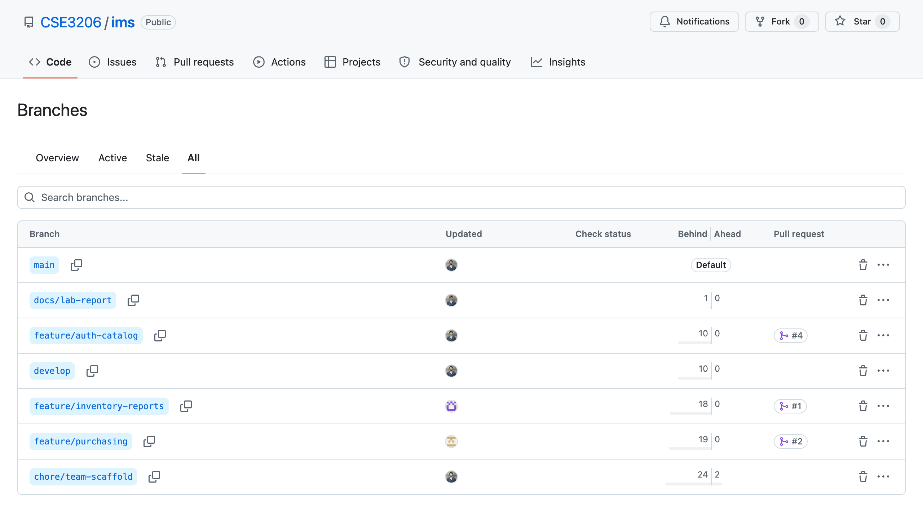
Figure 1: All branches on GitHub. Each feature branch is linked to its pull request (#1, #2, #4).

14.2 Features of Each Branch
This section describes what each feature branch delivers, the API it exposes, the pages it adds, and the commits made on it.

A. feature/auth-catalog — Authentication, Users & Product Catalogue (Evan)
This branch is the foundation of the system. Every other feature refers to a product and needs a signed-in user, so it was planned first.
Features
- Authentication — register and log in with email and password. Passwords are hashed with bcrypt; a successful login returns a JWT that the React app stores and sends with every request. GET /auth/me returns the current user.
- Role-based access — three roles, admin > manager > staff. The requireAuth middleware checks the token and requireRole() checks the role on every protected route; a wrong role gets 403. Deactivated accounts cannot log in.
- User administration (admin only) — add users, change a user’s name, role or password, deactivate or delete accounts (an admin cannot delete themselves).
- Categories — create, rename and delete categories. Each category shows a live count of its products; deleting one leaves its products uncategorised.
- Products — create, update and delete products with SKU, name, description, category, supplier, unit, cost price, selling price and reorder level. An opening quantity is written to the ledger as the first stock movement.
- Search and filtering — search by name or SKU, filter by category, supplier or low stock (quantity ≤ reorderLevel), sort by several columns and paginate. GET /products/low-stock lists everything that needs reordering.
- Bug fix on this branch — the product update schema was built as createProductSchema.partial(), but Zod still applies default values inside a partial schema. Editing only a product’s name therefore reset its prices to 0, unit to “pcs” and reorder level to 10. The update schema was rewritten without defaults and without quantity, and a regression test was added.
- Tests — 47 automated tests for register/login validation, token and role checks, category and product validation, and product search/pagination parsing. Added the npm test script for the backend.
API endpoints
Method | Path | Role | Description
POST | /auth/register | — | Create an account
POST | /auth/login | — | Exchange credentials for a JWT
GET | /auth/me | staff | Current user
GET / POST / PATCH / DELETE | /users, /users/:id | admin | User administration
GET / POST / PATCH / DELETE | /categories, /categories/:id | staff (read), manager (write) | Category CRUD with product count
GET | /products, /products/low-stock, /products/:id | staff | Search, filter, sort, paginate
POST / PATCH | /products, /products/:id | manager | Create / update (quantity ignored on update)
DELETE | /products/:id | admin | Delete a product

Pages: Login.jsx, Products.jsx, Categories.jsx, Users.jsx, plus AuthContext.jsx and ProtectedRoute.jsx.
Commits on this branch
Commit | Message | Files changed
66e8949 | chore(api): add npm test script for the backend node:test suite | 2 files, +3 / −1
eeb3547 | test(auth): cover register, login and user update validation | 1 file, +130
68f747a | test(auth): cover requireAuth token checks and requireRole permissions | 1 file, +80
b857bf4 | fix(catalog): stop product PATCH resetting omitted fields to defaults | 2 files, +57 / −1
d7b6920 | test(catalog): cover category and product create validation | 1 file, +83 / −1
1a17d72 | test(catalog): cover product search, filter and pagination query parsing | 1 file, +78 / −1
5c1e7ec | docs(api): document auth errors, user admin and product update rules | 1 file, +73

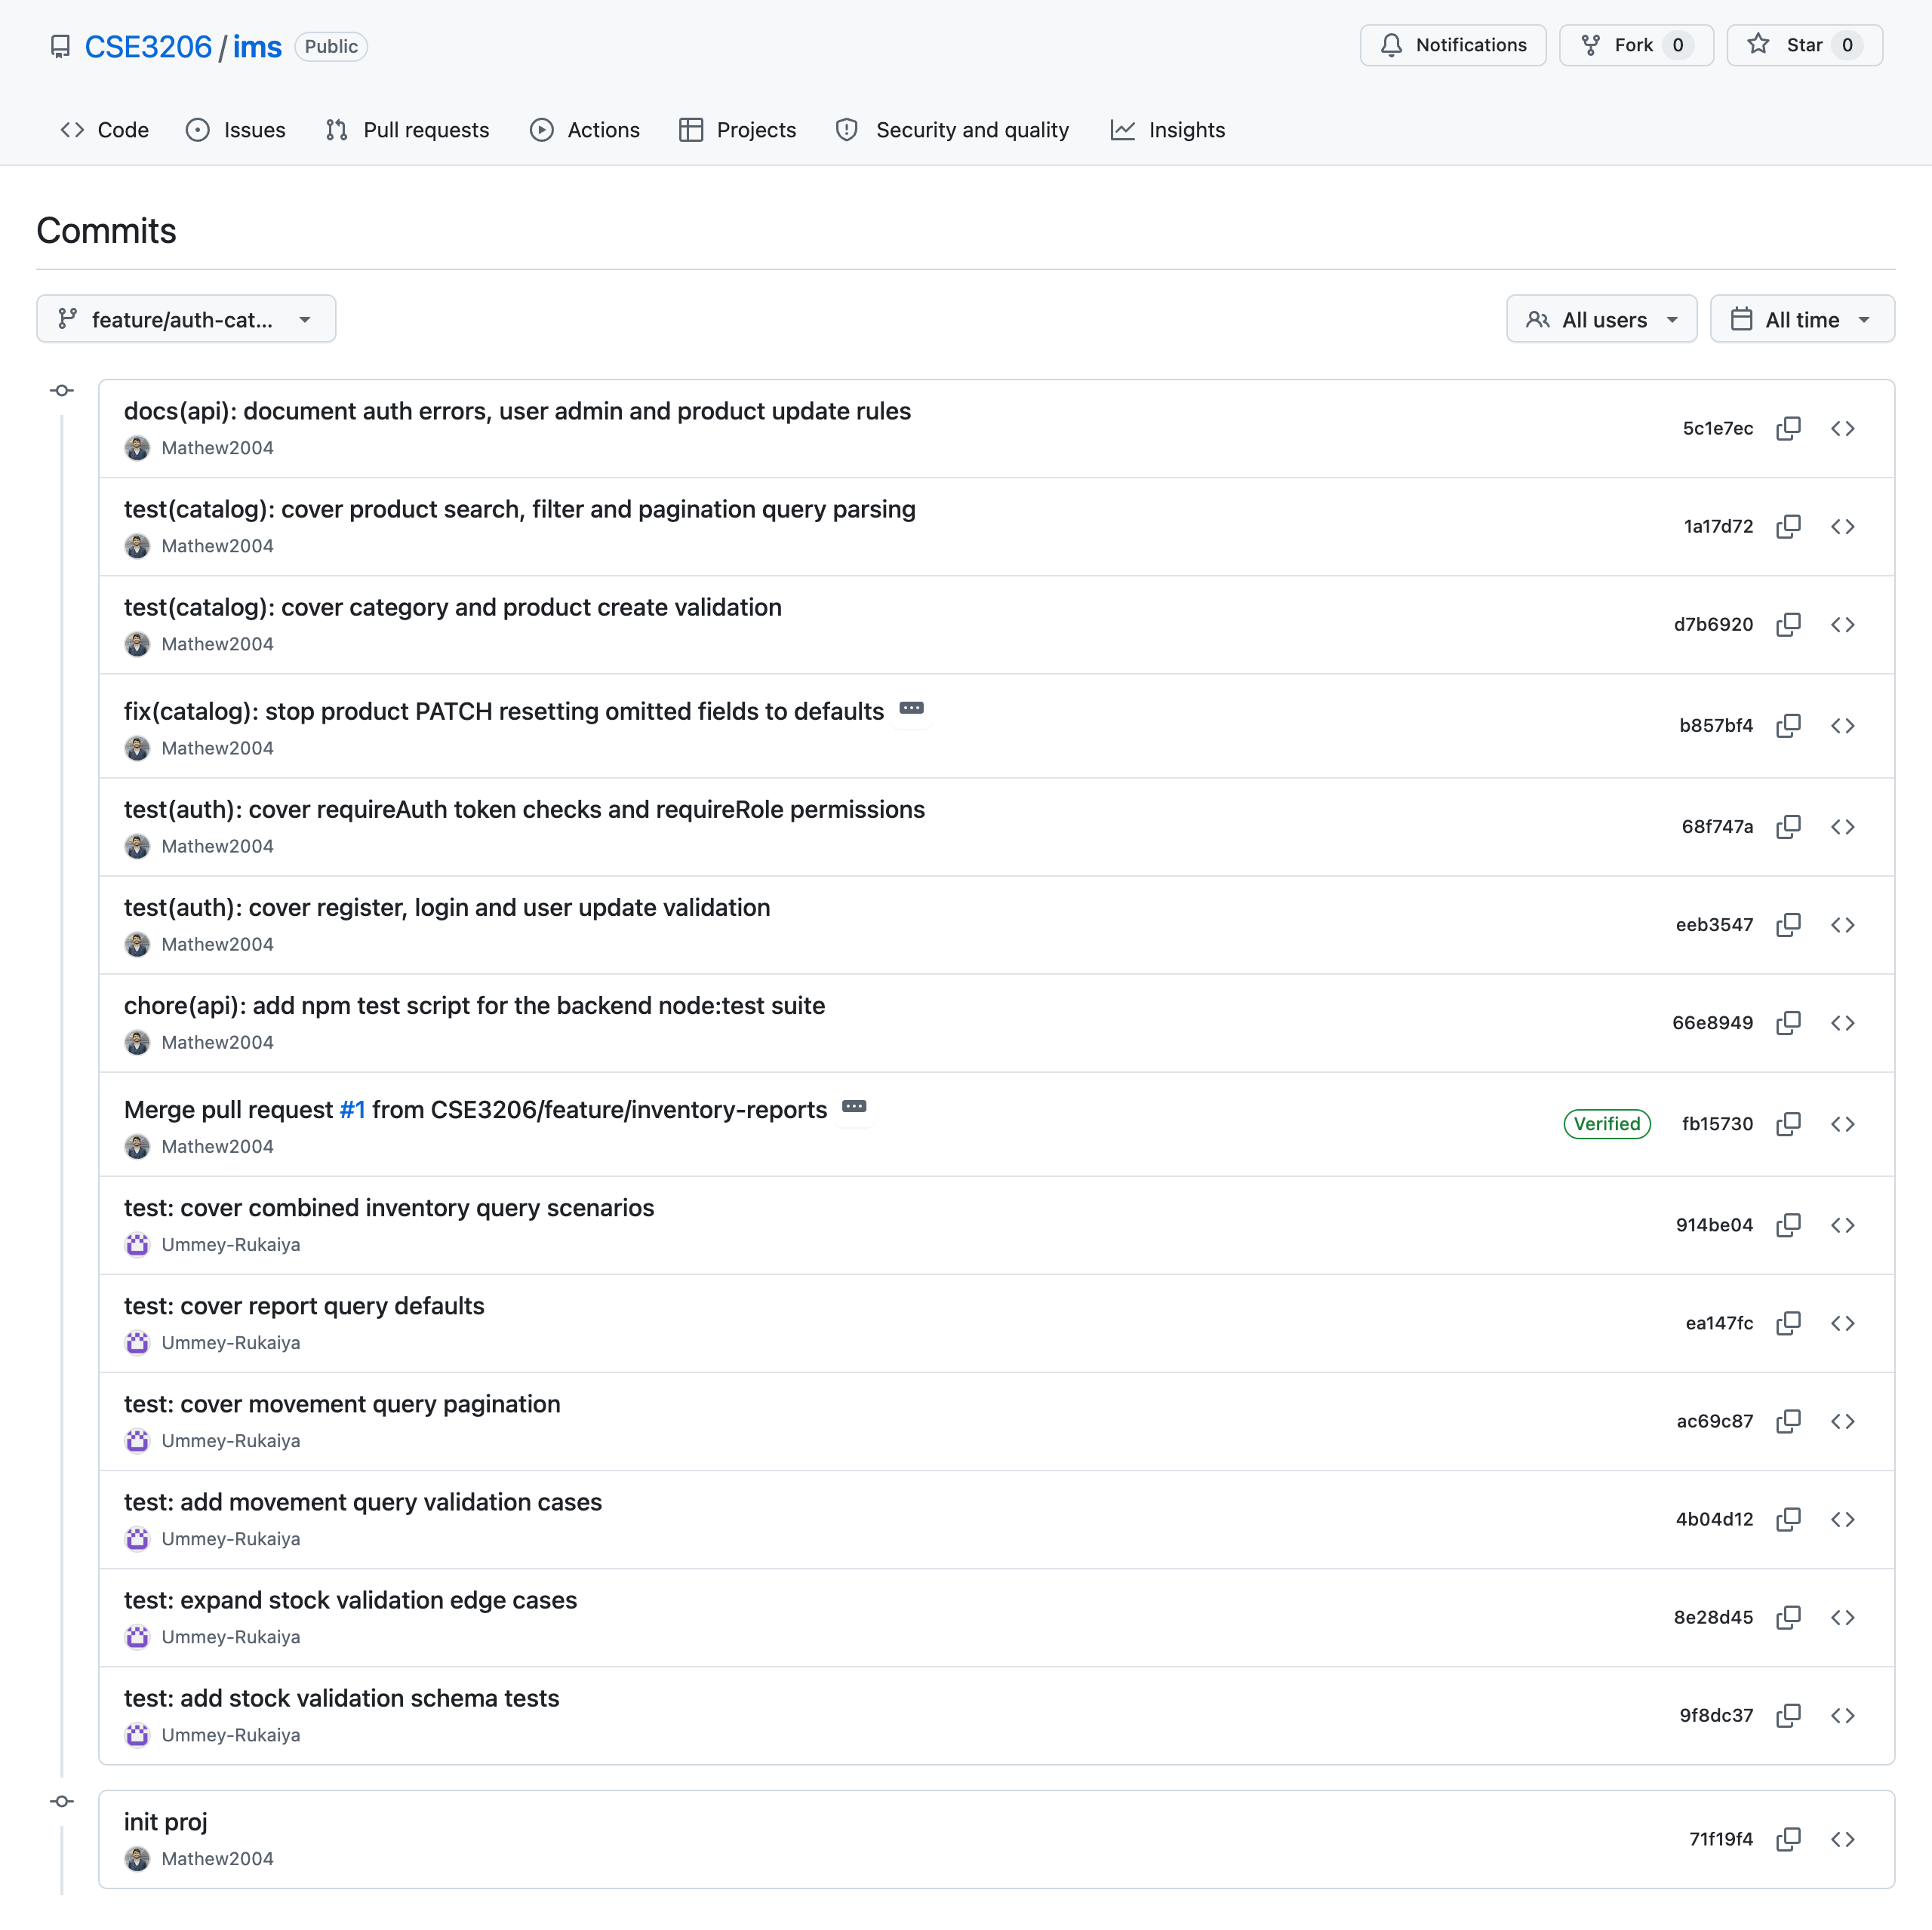
Figure 2: Commit history of feature/auth-catalog. The branch was started from develop after PR #1, so Rukaiya’s commits appear below Evan’s.

B. feature/inventory-reports — Stock Ledger, Sales, Dashboard & Reports (Rukaiya)
The stock ledger is the heart of the inventory system: both purchasing and sales go through it. The dashboard built on this branch is the first screen a user sees.
Features
- Transactional stock ledger — applyMovement() is the only function allowed to change products.quantity. It locks the product row (SELECT … FOR UPDATE), computes the new balance, refuses to go below zero, and appends an immutable stock_movements row with a signed quantity (+50 in, −10 out), the balance after, the reason, a document reference and the user.
- Manual stock actions — stock in and stock out for goods that move outside an order, and a stock-take adjustment where the user enters the counted quantity and the system works out the difference.
- Movement history — the ledger, newest first, filterable by product, movement type and date range, with pagination.
- Sales orders — draft → confirmed → fulfilled, or cancelled. Confirming checks that every line has enough stock and returns a per-line shortage list if not; fulfilling deducts the stock through the ledger; numbers are generated like SO-2026-0001.
- Dashboard — total stock value, low-stock and out-of-stock counts, fulfilled revenue, stock value by category, the low-stock list and the most recent movements, all in one API call.
- Reports — inventory valuation (per-product value at cost), top-selling products (fulfilled orders only) and daily stock flow (units in vs. out per day). Every report can be downloaded as CSV with ?format=csv.
- Tests — 24 validation tests for stock in/out quantities (positive accepted; zero and negative rejected), stock-take adjustments, movement-list filters and page limits, and report options (JSON by default, CSV, date range).
API endpoints
Method | Path | Role | Description
GET | /stock/movements | staff | The ledger, newest first, with filters
POST | /stock/in, /stock/out | staff | Manual stock in / out
POST | /stock/adjust | manager | Stock-take: set the counted quantity
GET / POST | /sales-orders, /sales-orders/:id | staff | List, view and create sales orders
POST | /sales-orders/:id/confirm, /fulfil | staff | Check availability / remove stock
POST | /sales-orders/:id/cancel | manager | Cancel a draft or confirmed order
GET | /reports/dashboard, /valuation, /stock-flow, /top-products | staff | Dashboard and reports (JSON or CSV)

Pages: Dashboard.jsx, StockMovements.jsx, SalesOrders.jsx, Reports.jsx.
Commits on this branch
Commit | Message | Files changed
9f8dc37 | test: add stock validation schema tests | 1 file, +84
8e28d45 | test: expand stock validation edge cases | 1 file, +36
4b04d12 | test: add movement query validation cases | 1 file, +30
ac69c87 | test: cover movement query pagination | 1 file, +24
ea147fc | test: cover report query defaults | 1 file, +24
914be04 | test: cover combined inventory query scenarios | 1 file, +34

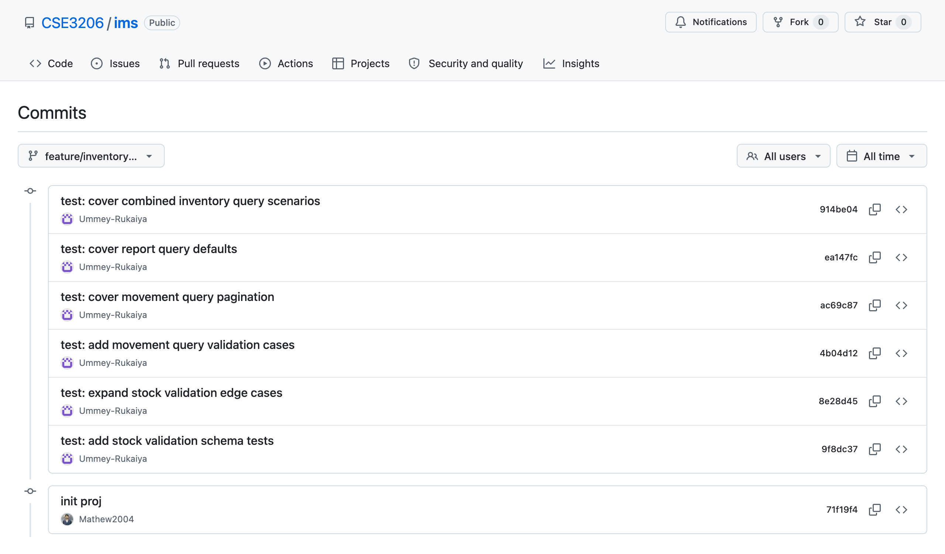
Figure 3: Commit history of feature/inventory-reports.

C. feature/purchasing — Suppliers, Purchase Orders & Goods Receipt (Najmul)
This branch is the “stock in” half of the business. It is the first real user of both the product catalogue (Increment 1) and the stock ledger (Increment 2).
Features
- Suppliers — create, update and delete suppliers with contact person, email, phone and address. The list shows how many products each supplier provides and supports search (name, email or contact person), an active/inactive filter and pagination. A supplier with purchase orders cannot be deleted.
- Multi-line purchase orders — a manager creates a draft order against a supplier with any number of product lines (quantity and unit cost). The order number (PO-2026-0001) and the total are calculated on the server. A draft can be edited — supplier, notes or lines.
- Status flow — draft → ordered → received, or cancelled. Each step is its own endpoint so it can enforce its own rule: only draft or ordered orders can be received or cancelled, and only draft or cancelled orders can be deleted.
- Goods receipt — POST /purchase-orders/:id/receive adds every line to stock in one transaction by calling applyMovement(), and updates each product’s cost price to the unit cost actually paid.
- Guarding illegal transitions — receiving an order that is already received (or cancelled) is rejected with a clear message, so stock can never be added twice.
- Order detail drawer — the Purchase Orders page shows each order’s line items, total, and the buttons for the actions allowed in its current status.
- Documentation — the purchase-order status-transition rules are documented in docs/API.md.
API endpoints
Method | Path | Role | Description
GET | /suppliers, /suppliers/:id | staff | List (search, filter, paginate) and view
POST / PATCH | /suppliers, /suppliers/:id | manager | Create / update a supplier
DELETE | /suppliers/:id | admin | Blocked if the supplier has orders
GET | /purchase-orders, /purchase-orders/:id | staff | List (by status, supplier) and view
POST / PATCH | /purchase-orders, /purchase-orders/:id | manager | Create or edit a draft
POST | /purchase-orders/:id/order | manager | draft → ordered
POST | /purchase-orders/:id/receive | staff | → received — adds stock
POST | /purchase-orders/:id/cancel | manager | → cancelled
DELETE | /purchase-orders/:id | admin | Only draft or cancelled orders

Pages: Suppliers.jsx, PurchaseOrders.jsx. Utility: documentNumber.js (PO/SO numbering).
Commits on this branch
Commit | Message | Files changed
b1ff7a0 | feat(suppliers): supplier CRUD with contact details | 4 files, +90 / −12
e325ee5 | feat(purchasing): create multi-line purchase orders | 5 files, +126 / −8
6a6247a | feat(purchasing): receive goods and update stock transactionally | no file changes
738908c | fix(purchasing): block receiving an already-received order | no file changes
73d885e | docs(api): document purchase order status transitions | 1 file, +32 / −2

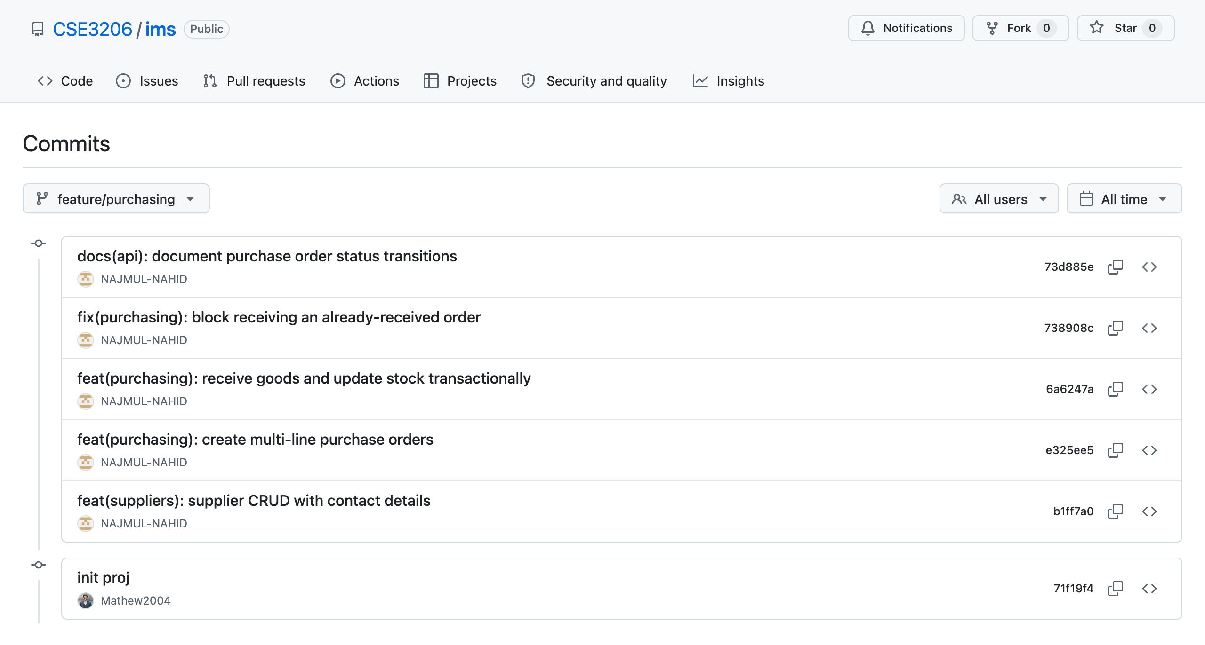
Figure 4: Commit history of feature/purchasing.

D. Supporting branches
- develop — the integration branch. PR #1 (Rukaiya’s work) was merged here and then brought to main with PR #3. Evan started feature/auth-catalog from develop after PR #1, so his branch already contained Rukaiya’s tests when he added his own beside them.
- chore/team-scaffold — Evan’s set-up branch: it adds the members’ GitHub usernames to docs/TEAM.md and trialled a reduced starting scaffold. It was not merged.
- docs/lab-report — holds this report and its screenshots, merged into main.

14.3 Pull Requests
Every feature reached main through a pull request. Each PR used the shared template in .github/PULL_REQUEST_TEMPLATE.md (what it adds, files touched, how it was tested, shared files touched, checklist).
PR | Title | From → To | Author | Merged by | Size
#1 | Add inventory report validation tests | feature/inventory-reports → develop | Ummey-Rukaiya | Mathew2004 | 6 commits, +232
#2 | Feature/purchasing | feature/purchasing → main | NAJMUL-NAHID | Mathew2004 | 5 commits, +248 / −22
#3 | Develop | develop → main | Mathew2004 | Mathew2004 | 7 commits, +232
#4 | Feature/auth catalog | feature/auth-catalog → main | Mathew2004 | Mathew2004 | 7 commits, +502 / −2

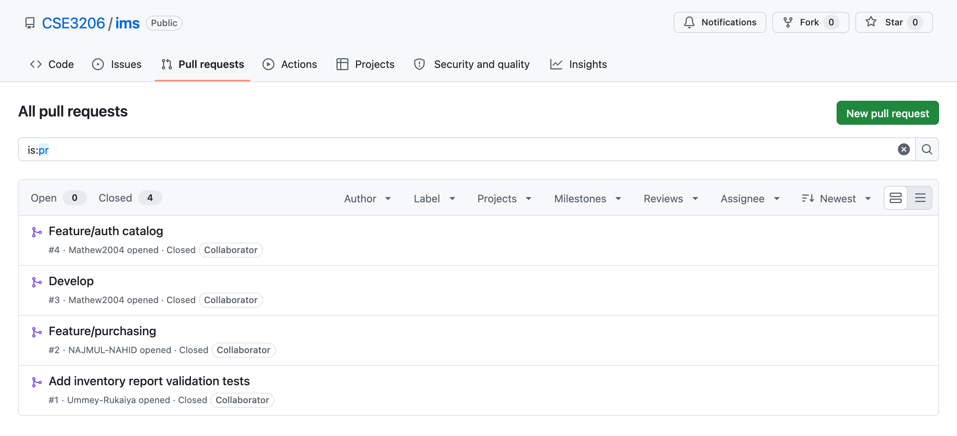
Figure 5: All four pull requests on GitHub, all merged.

14.4 Integration and Merge Conflicts
The four merges produced no merge conflicts. Because of the vertical-slice split, each branch mostly changed its own files. The only shared file edited on two branches was backend/src/validators/schemas.js: Evan changed the product schemas and Najmul changed the supplier and purchase-order schemas. These are separate parts of the file, so Git merged both changes automatically.
To keep it that way, the team agreed on rules for shared files (db/schema.js, routes/index.js, validators/schemas.js, App.jsx, services/api.js, index.css): each member edits only the part that belongs to their feature and announces the change in the group chat before pushing.
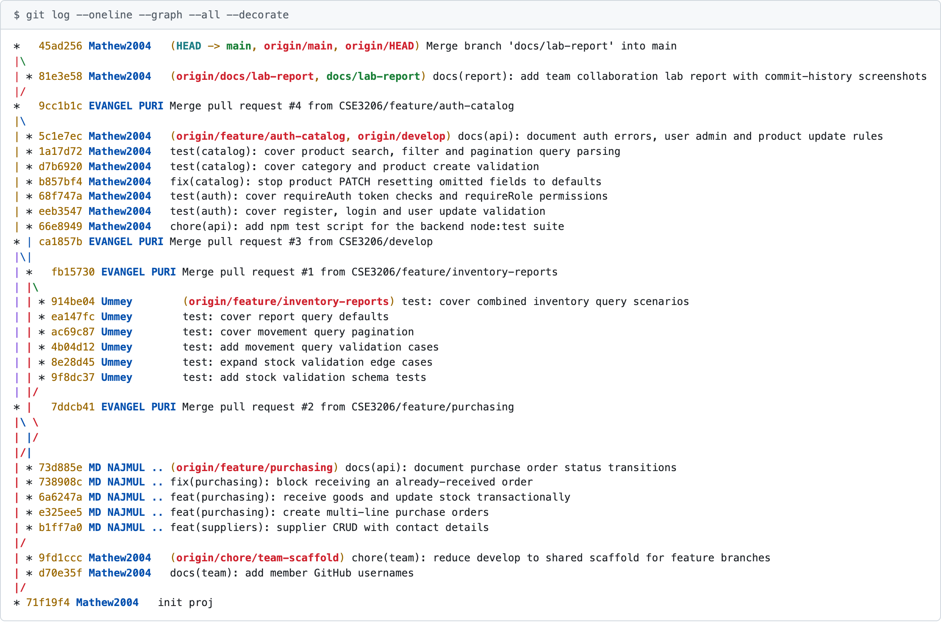
Figure 6: Branch graph (git log --graph --all). The three feature branches start from the initial commit, run in parallel, and are joined back by the merge commits of PRs #1–#4.

14.5 Commit Practice
Commits follow the Conventional Commits format type(scope): description, so the history can be read like a change log:
Type | Used for | Example from our history
feat | New user-visible behaviour | feat(purchasing): create multi-line purchase orders
fix | Bug fix | fix(catalog): stop product PATCH resetting omitted fields to defaults
test | Automated tests | test(auth): cover requireAuth token checks and requireRole permissions
docs | Documentation | docs(api): document purchase order status transitions
chore | Scripts, configuration | chore(api): add npm test script for the backend node:test suite

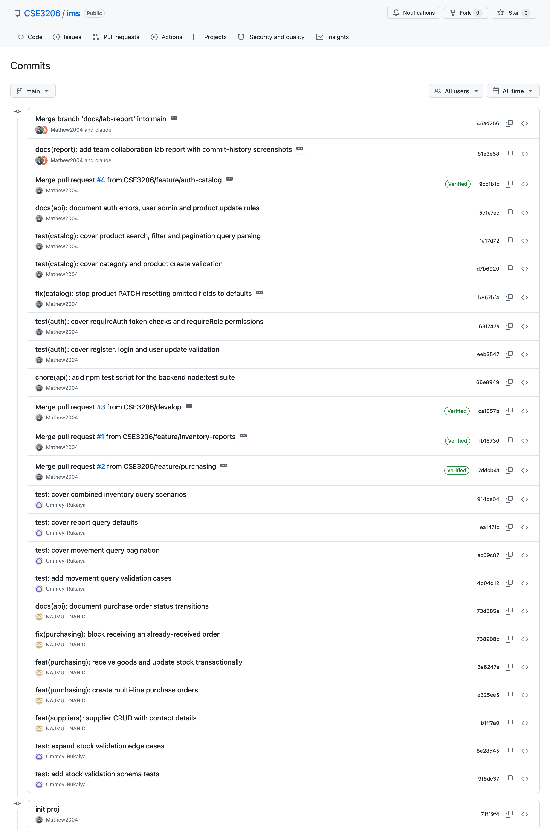
Figure 7: Final commit history of the main branch after all pull requests were merged.

14.6 Contribution Summary
Member | Branch | Commits on feature branch | Lines added / removed | PRs opened
Evan | feature/auth-catalog | 7 (+ initial project, 2 set-up commits) | +502 / −2 | #3, #4
Najmul | feature/purchasing | 5 | +248 / −22 | #2
Rukaiya | feature/inventory-reports | 6 | +232 / −0 | #1

As Integration Lead, Evan also created the initial project skeleton, the documentation, the PR template and the branches, and merged all four pull requests.

14.7 Testing
The backend test suite runs with npm test in the backend/ folder. On the merged main branch, all 71 tests pass:
$ cd backend && npm test
ℹ tests 71
ℹ pass 71
ℹ fail 0

Test file | What it covers | Tests | Author
validators/schemas.test.js | Stock in/out, adjustments, movement filters, report options | 24 | Rukaiya
validators/auth.schemas.test.js | Register, login and user-update validation | 15 | Evan
validators/catalog.schemas.test.js | Category/product validation, search and pagination parsing | 24 | Evan
middleware/auth.test.js | Token checks and role permissions | 8 | Evan

14.8 Repository Structure
Path | Contents
README.md | Project overview, quick start, team, workflow summary
backend/ | Express API — routes, middleware, validators, services, Drizzle schema, tests
frontend/ | React app — pages, components, API client, styles
docs/ | TEAM.md, WORKFLOW.md, ARCHITECTURE.md, API.md, DATABASE.md, SETUP.md
docs/lab-report/ | This report and its screenshots
.github/ | Pull request template
scripts/ | Helper script that creates the develop and feature branches

15. Challenges Encountered
Challenge | How we handled it / what we learned
Keeping the stock quantity and its history consistent when purchasing, sales and manual actions all change stock | Made applyMovement() the single writer of products.quantity, with a row lock and one transaction. Both other members call it instead of writing stock themselves.
Three people editing shared files (schema, router, validators, API client) | Split shared files by feature and agreed to announce every shared-file change. Result: no merge conflicts in four merges.
A hidden validation bug: editing a product reset its prices | Found while writing tests on feature/auth-catalog; fixed the update schema and added a regression test so it cannot return.
Deciding what belongs in the MVP | Mapped every requirement to a branch/increment first and kept the UI simple (plain CSS, no extra libraries).
Following our own PR workflow under deadline pressure | Our plan was feature → develop → main with one approving review and no self-merging. In practice only PR #1 went through develop; PRs #2 and #4 went straight to main, no reviews were recorded on GitHub, and the Integration Lead merged his own PRs. Next time we will turn on GitHub branch protection (require a PR, one approval, no bypass) so the rules are enforced rather than only written down.
Keeping commits meaningful | Most commits are small and follow Conventional Commits, but two purchasing commits contain no file changes and most work was committed close to the deadline. We will commit steadily through the project and make sure each commit contains the change it describes.
Uneven Git experience across the team | Wrote docs/WORKFLOW.md (daily loop, commit format, PR checklist, conflict-resolution steps) and a script that creates the branches, so everyone followed the same steps.

16. Conclusion
In this lab our team analysed the Inventory Management System scenario, identified its stakeholders, and wrote fourteen functional and eleven non-functional requirements. We selected the Incremental process model because the system divides naturally into three modules that build on each other, and we compared it against Waterfall, Prototype, Scrum and Spiral.
The MVP was built as three increments on three feature branches — authentication and catalogue (Evan), stock, sales and reports (Rukaiya), and purchasing (Najmul) — each owned end to end by one member. The branches were integrated through four pull requests without a single merge conflict, the final main branch contains everyone’s work, and all 71 backend tests pass.
The branch-per-feature model and clear file ownership worked well. The weakest part of our process was code review: next time we will enable branch protection so that every pull request needs a teammate’s approval. The next lab will build on the same module boundaries to apply design patterns and testing.

