Alex

The asbestos fiber , crocidolite , is unusually resilient once it enters the lungs , with even brief exposures to it causing symptoms that \*T\*-1 show up decades later , researchers said 0 \*T\*-2 .

((Although) (preliminary findings) (were reported) (\*-2) (more than) (a year ago))(,) （(the latest results) (appear) (in) (today 's)（(New England)（ Journal of Medicine)））（,）（（a forum） （likely） （\*） （to bring）（new attention）（to the problem））（.）

（（We 're） （talking） （about） （years ago）） （before） （anyone） （（heard of） （asbestos） （having） （any） （questionable properties）） （.）

（（Neither） （Lorillard） （nor） （the researchers） （who） （\*T\*-3） （studied） （the workers）） （were aware of） （any research on） （smokers of the （Kent cigarettes））（.）

((Dr. Talcott) led a (team of researchers)) (from the (National Cancer Institute)) and the (medical schools) of ((Harvard University) and (Boston University)) .

(The move) followed ((a round of) (similar increases)) (by other lenders), reflecting (a continuing decline) (in that market)

TIming

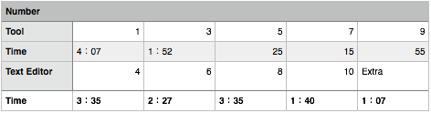

Vincent

A form of asbestos once used \* \* to make Kent cigarette filters has caused a high percentage of cancer deaths among a group of workers exposed \* to it more than 30 years ago , researchers reported 0 \*T\*-1 .

(A form of asbestos) (once used) \*\* (to make) ((Kent cigarette filters) (has caused) (a high percentage)) of (cancer deaths) ((among a group) of (workers)) (exposed \* to it) ((more than) (30 years ago,)) (researched reported) (0 \*T\*-1)

Lorillard Inc. , the unit of New York-based Loews Corp. that \*T\*-2 makes Kent cigarettes , stopped using crocidolite in its Micronite cigarette filters in 1956 .

(Lorillad Inc. ,) ((the unit) of ((New York-based) (Lowes Corp.))) (that ((\*T\*-2) make (Kent Cigarettes))), ((stopped using) (crocidolite) in its (Micronite cigarette filters)) (in 1956.)

A Lorillard spokewoman said , `` This is an old story .

(()A Lorillard spokewoman) (said ,) (``)) ((This) is (an old story))

There is no asbestos in our products now . ''

(There is (no asbestos)) (in (our products) now.")

`` We have no useful information on whether users are at risk , '' said \*T\*-1 James A. Talcott of Boston 's Dana-Farber Cancer Institute .

(``) ((We have) (no useful information) on whether (users are (at risk)),") (said ((\*T\*-1) (James A. Talcott)) of (Boston's (Dana-Farber Cancer Institute.)))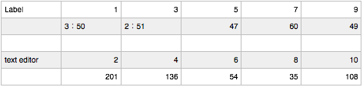

Vincent，

Sentence3:

((Lorillard Inc,) ((the unit) (of) (New York-based (Loews Corp))(. that makes (Kent cigarettes,)))) ((stopped) (using crocidolite) (in) (its Micronite (cigarette filters)) (in 1956.))

Sentece5:

(A (Lorillard spokeswoman) said,) (“This (is an) (old story).)

Sentece 7:

((There is) (no asbestos) )(in (our products) now.”)

Sentence 9:

(“We have (no (useful information) (on whether ((users are) (at risk,”))))) (said ((James A. Talcott) of (Boston’s Dana-Farber Cancer Institute)).)

Sentence 10:

((Dr. Talcott) led ((a team) of researchers)) (from ((the (National Cancer Institute)) and the (medical schools)) (of (Harvard University) and (Boston University.)))