Data Visualization: Assignment 3
Yvonne Chen and Nell O’Rourke
The Dataset
Enlearn is a group that develops adaptive learning solutions. Last fall, they conducted a study assessing student math learning on a tablet based educational platform. Students either completed work on a tablet app or on paper, and also took paper pre- and post- tests across two units of math lessons. The amount of data collected does not lend itself to easy analysis, so we decided to create an interactive visualization that would help with exploring the correlation between student learning gains and factors such as attentiveness, number of example problems completed, version of pre- and post- tests taken, and so on. Since there are many such factors, we chose six as a starting point.
Storyboard
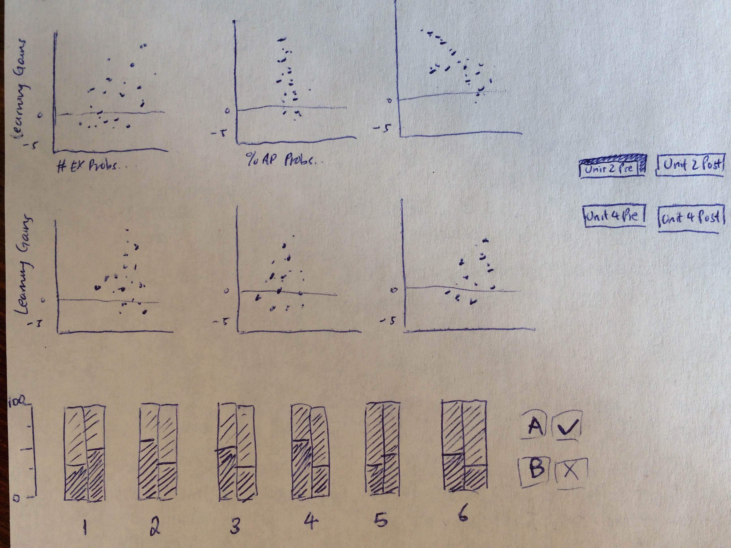
Our chosen interaction techniques centre on our focus of data exploration.
We initially consider a small multiples approach. The scatterplots are split into two rows: the upper row maps 6 important factors versus learning gains for students in the tablet condition and the lower row does the same for students in the paper condition. This allows for direct comparison between the two conditions.
Below the scatterplots is a stacked bar chart. Each pair of bars shows the percentage of students who answered a question correctly and incorrect on the A and B test versions.
To one side of the chart are toggles that select/deselect all students who took a particular test version.
There are 4 test conditions: Unit 2 Pre Test, Unit 2 Post Test, Unit 4 Pre Test and Unit 4 Post Test. With this small number, we decide to create a 2x2 button layout. Clicking on each refreshes the scatterplots and loads the appropriate problem correctness percentage bars for the test condition.
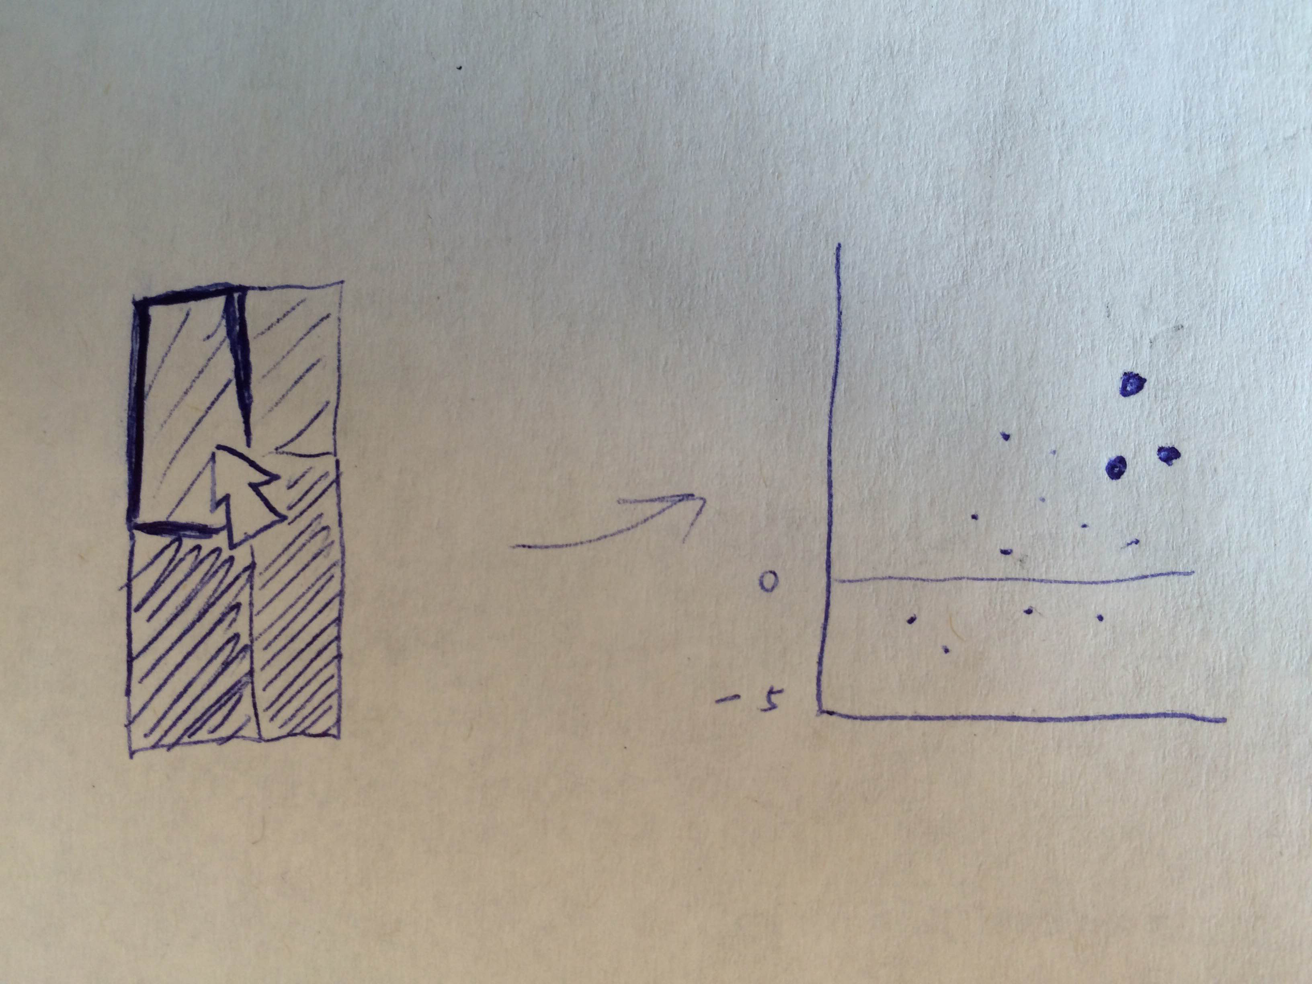
To filter students, we make bars clickable. Click on an individual bar or selection areas between, above and below the bars add or remove filters by which to select students who answered a particular question correctly, or incorrectly, correctly in the A condition only, and so on. Dots that represent students who are not members of the selection are faded to grey.
Since some bars may be small or non existent (such as some questions which no students answered correctly in a pre-test), we increase the interactive footprint of each bar with some padding. Hovering over a bar’s selection area thickens its outline.
Final Design
Brief description here
Development Process
Changes
Leaving space between A and B bars so can click on both at once
Running the Visualization
Please place the visualization web page and csv data files in the same folder. Then, run a local web server in that folder. To view the visualization, simply open the HTML file in a modern web browser.
Part 1
- Start by choosing the data domain and interactive visualization techniques you will implement.
- Think about why the domain and the techniques are a good match for one another.
- Then write a description of the data domain and the interactive visualization application you will build.
- The description should include a storyboard (redraw and take pictures of the sheets I have at work) of the interface/displays you will create.
- Be sure to explain the features of your application.
- Most importantly you should explain why the interaction techniques you will implement will be effective in the context of your data domain.
- The goal of this exercise is to think through the various concerns that go into the software implementation.
Your final submission should include:
- The description with storyboards from part 1.
- A brief description of your final interactive visualization application.
- An explanation of changes between the storyboard and the final implementation.
- The development process. Include a breakdown of how the work was split among the group members. Include a commentary on the development process, including answers to the following questions: Roughly how much time did you spend developing your application (in man-hour)? What aspects took the most time?
- The source code for your application. Please ensure that the software submitted is in working order. If any special instructions are needed for building or running your software, please include them in the writeup too.

