Software Requirements Specification
for
Tourist Assistor System (TAssist)
Version 1.0 approved
Prepared by Naeema Binthe Ashraf & Mahfujur Rahman Afnan
Khulna University
31 July,2018
Table of Contents
Table of Contents ii
Revision History ii
1. Introduction 1
1.1 Purpose 1
1.2 Document Conventions 1
1.3 Intended Audience and Reading Suggestions 1
1.4 Product Scope 1
1.5 References 2
2. Overall Description 2
2.1 Product Perspective 2
2.2 Product Functions 2
2.3 User Classes and Characteristics 3
2.4 Operating Environment 3
2.5 Design and Implementation Constraints 3
2.6 User Documentation 4
2.7 Assumptions and Dependencies 4
3. External Interface Requirements 4
3.1 User Interfaces 4
3.2 Hardware Interfaces 4
3.3 Software Interfaces 4
3.4 Communications Interfaces 5
4. System Features 5
4.1 Search Requested Location 5
4.2 Rating System 6
4.3 Review System 6
4.4 Language 6
4.5 About 6
4.6 Sign In 6
4.7 Sign Out 6
4.8 Use - Case Diagram 6
4.9 Use Case Description 6
5. Other Nonfunctional Requirements 6
5.1 Performance Requirements 6
5.2 Safety Requirements 7
5.3 Security Requirements 7
5.4 Software Quality Attributes 7
5.5 Business Rules 8
6. Other Requirements 8
Appendix A: Glossary 8

Revision History
Name | Date | Reason For Changes | Version
 |  | Change for improvement functionality | 1.0
 | 04/09/18  29/10/18 | Change for improvement use case  Change for class diagram | 1.1  1.2

Introduction

Purpose
Defining and describing the functions and specifications of the Tourist Assistor System (TAS) as “TAssist”. It is an initial approach for making this software so we can assume that version 1.0 and is a subsystem of Smart City Management System (SCMS). In this report we have described the software requirements specifications.

Document Conventions
The document contains 3 types of typographical instance. It includes heading, subheading and description paragraph. Heading has written on the font named ‘Times’ and size is 18 in bold character and subheading has written on the font named ‘Times’ and size is 14 in bold character and paragraph has written on the font named ‘Arial’ and size is 11. We have not given any priority factor.

Intended Audience and Reading Suggestions
This Software Requirements document is intended for:

− Developers who can review project’s capabilities and more easily understand where their efforts should be targeted to improve or add more features to it (design and code the application – it sets the guidelines for future development).

− Project testers can use this document as a base for their testing strategy as some bugs are easier to find using a requirements document. This way testing becomes more methodically organized.

− Users can read this document to know the basic architectural structure and can comment about the features and facilities.

Product Scope
Tourist Assistor System (TAS) is a subsystem of Smart City Management System (SCMS). TAS is a full support system for tourists who visit enormous cities. The facility of searching foods, historical places, tourist spots and restaurants in map with ratings and reviews is included in TAS. It also has the facility of finding tourist guide in a particular area with ratings and reviews.

Our main objective is to ensure the best utilization of time, money and make the tour easy and comfortable for an outsider. The goal we want to achieve is safe and save which means one can safely travel and save the money and time according to their choices. In the web we can find different types of websites that describe the food, restaurant and places and separately, but we have proposed a full module of those facilities and the module is a part of a large system named SCMS.

References

The official website of the project will contain a brief description of the project, screenshots, links, and tutorials and of course it gives users the ability to download and contribute to the project in different ways, since it is an open source project. We are working on it.

Overall Description

Product Perspective
TAS as “Tassist” is completely a new product. It is very useful and timesaving who are like to prefer outing. That project is the component of larger system called smart city management system (SCMS).

Product Functions
TAS provides the following functions according to their perspective user. Each is listed below –

- Tourist can –

- Find out all the tourist spot in map along with their ratings and reviews in a city.
- Find out renowned restaurants of a city with their ratings and reviews.
- Find out the popular and special dish of various restaurant in the basis of ratings and reviews.
- Find out the direction path from the location of tourist to requested specific location by user.
- Hire tourist guides for a wonderful tour and give rating and review.
- Give ratings and reviews about the tourist spot, food item and restaurant.
- Add one or more tourist spot to the list with ratings and reviews.
- Registration and login facility.

- Restaurant can -
- Promote their special offer for tourism season through it.
- Upload their menu and dish items.
- Promote their special offer for tourism season through it.
- Registration and login facility.

- Guide can -
- Upload their resume and area.
- Give their status busy or free.
- Accept the request from a tourist for a guiding tour.
- Registration and login facility

- Admin can -
- Have the control of all kind of activities.
- Delete a rating or review but can’t edit them.

User Classes and Characteristics
Here in the TAS we have several classes -

- Tourist – Tourist has to make an id to use the system. A tourist is the main character in our system.

- Restaurant manager – He can post different types of food menu and special offers to attract the tourists.

- Tourist guide – A tourist guide can guide a tourist in a particular area. For this, he has to register his id.

Operating Environment
TAS should run on Operating Systems: Win2K / WinXP / Vista / Win7 / Win8 / Win10 in any browser that have HTML5, CSS3 and PHP5. It is written in an android-depended language so it will run on a linux-based system or mac and all types of smartphones which includes Android OS with SDK version upper than 15.

Design and Implementation Constraints
TAS is under the GNU General Public License Version 2, June 1991. Everyone, that does or is going to develop or use it, should agree and fully accept the terms of this kind of license. Some are given below:

- The content model for a constrained element must be at least as restrictive as the unconstrained content model for the element
- A domain module can be constrained by only one constraint module.
- Each constraint module can constrain elements from only one vocabulary module.
- When a domain module is integrated into a document-type shell, the base domain element can be omitted from the domain extension group or parameter entity.

User Documentation
User documentation components are available on project’s official website:
http://www.tasssist.com/
Don’t hesitate to ask a question at the project’s forum:
http://www.tassist.com/questions/

Assumptions and Dependencies
One assumption about the product is that it will always be used on mobile phones that have enough performance. If the phone does not have enough hardware resources available for the application, for example the users might have allocated them with other applications, there may be scenarios where the application does not work as intended or even at all.
Another assumption is that the GPS components in all phones work in the same way. If the phones have different interfaces to the GPS, the application need to be specifically adjusted to each interface and that would mean the integration with the GPS would have different requirements than what is stated in this specification.

External Interface Requirements

User Interfaces
User interface of this program is the common windows interface, nothing additional is required. It can be an android application for making it more attractive and easy to use. In android it will have some layout.

Hardware Interfaces
TAS is designed for android platform. Android sdk version 15 is the minimum eligible configuration to run the software and it must have GPS system facility.

Software Interface
As TAS is a location based application in android platform. The specific software components are -

- Android OS
- Mac IOS
- Google Play Services
- Google Maps Locations Api
- Google Maps Directions Api

Communications Interfaces
All the program’s features are available online by an internet connection. By HTTP response from google maps locations api TAS will get the tourist, guide, restaurant and all kinds of locations. TAS use end to end encryption about the location.

System Features
This section describes the functional requirements of the application and the features it provides. System features are described in detail to help the future extension and testing of the system. Features stated here are already parts of the implemented system so no prioritization is needed. Priority is needed for features to be developed that will be added to this document later.

Search Requested Location
4.1.1 Description and Priority
Searching a desired location is one of the most important functionality of this system. By search button user can find all the spots, restaurants, foods available in a particular area. This feature is already done by Google Maps. But they don’t give the rating and review. This is defined as a high priority feature.

4.1.2 Stimulus/Response Sequences
- User has to select the category of the searching options like tourist spot, food, restaurant and guide.
- After that, user click the “Search” button to make a HTTP request to the google locations api.
- System receives the HTTP request and from the FTP server, it will fetch the desired data that contains locations, ratings, reviews etc. By processing the data system will give a HTTP response and user can see it in their display.
4.1.3 Functional Requirements
- Internet connection is compulsory.
- Anyone who wants to use the system needed a valid email id (best Gmail).
- Google Play Services facility is the key to locate the places in the google maps.

Rating System
Tourist can rate tourist spot. They also can rate restaurant, food and tour guide according to their services. The rating system is obviously numerical and the scale is 10.

Review System
Tourist spot, restaurant, tour guide and food would be reviewed by the traveler that helps other traveler who are interested to visit that spot.

Languages
The user interface of TAS is both in Bengali and English that might be helpful for tourist.

About
Easy-to-use, Proper management system, designed to empower independent to the users. The system takes just a minute to get you started.

Sign In
A tourist, restaurant manager, and tourist guide all the entities can sign in with his id and password.

Sign Out
If anyone who uses the TAS want to exit from the system he can easily sign out by clicking on a button.

Use Case Diagram

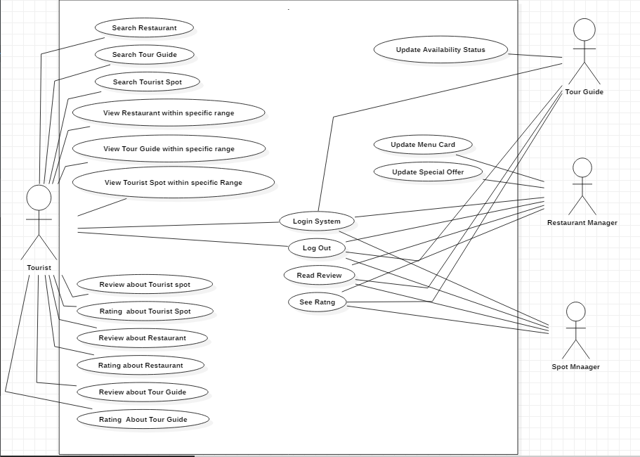
Figure: Use Case Diagram

Use cases Description

Access Tourist Home Page

Use case name: | Access tourist home page
Brief Description: | The web server is waiting on tourist to connect
priority | Essential
Trigger | Tourist select the tourist link on the TAS home page
Precondition | Tourist is connected to the internet on the TAS homepage
Basic path | 1.The smart city management server sends the tourist to the TAS server  2. The TAS server presents the tourist with tourist homepage.
Alternate path | N/A
Post condition | Tourist is on the tourist homepage
Exception path | If there is a connection failure, the  TAS Server returns to the wait state

Find the tourist spot

Use case name: | Find the tourist spot
Brief Description: | The operation permits the tourists to find the tourist spots by the assistance of GPS
priority | Essential
Trigger | Tourist select the tourist spot link on TAS homepage
Precondition | Tourist is connected to the internet on the TAS homepage
Basic path | 1. The TAS server presents the tourist with GPS tracking system
Alternate path | N/A
Post condition | N/A
Exception path | If there is a connection failure, the  TAS Server returns to the wait state

Review & Rating on tourist spot

Use case name: | Review & Rating
Brief Description: | The operation permit tourists to review & rate the tourist spots.
priority | Essential
Trigger | Tourist are in review & rate section
Precondition | Tourist are connected to the internet and on the TAS tourist homepage
Basic path | 1. The TAS Server presents the  tourists with a review & rating section  2. Tourist fill in the section and click submit  3. The TAS Server checks to see if  All required fields are not empty.  4. If the required fields are not empty  5. If any of the required fields are empty,  the TAS Server returns a  message and returns the tourist to the  review & rating section  6. The TAS Server returns the  tourist to the Tourist Home Page
Alternate path | N/A
Post condition | N/A
Exception path | If the connection is terminated before the  Review is submitted, the fields are all  cleared and the TAS Server is  returned to the wait state.

Access restaurant homepage

Use case name: | Access restaurant homepage
Brief Description: | The web server is waiting on representor of any restaurant to connect
priority | Essential
Trigger | Restaurant representor select the tourist link on the TAS home page
Precondition | Restaurant representor is connected to the internet on the TAS homepage
Basic path | 1.The smart city management server sends the tourist to the TAS server  2. The TAS server presents the restaurant representor with restaurant homepage.
Alternate path | N/A
Post condition | Restaurant representor is on the tourist homepage
Exception path | If there is a connection failure, the  TAS Server returns to the wait state

Update menu card and special offer of a restaurant

Use case name | Update menu card and special offer
Brief Description | This operation permits restaurant to update any kind of change  in the restaurant Database.
priority | Essential
Trigger | Alumni choose to update an existing entry in the restaurant Database.
Precondition | Representor must be connected to the Internet and on the  Restaurant homepage
Basic path | 1. The representor click on update the menu and special offer link.  2. The TAS server returns that section where representor would like to update.  3.click the update button replaces the old data with  the new data and returns the representor to the restaurant homepage
Alternate path | N/A
Post condition | The record in the Restaurant Table of the Restaurant Database  has been updated and the Representor is returned to the  Restaurant Home Page.
Exception path | If the connection is terminated before update the database and the  TASl Server is returned to the wait state.

Access tour guide homepage

Use case name: | Access tour guide homepage
Brief Description | The web server is waiting on tour guide of any restaurant to connect
priority | Essential
Trigger | Tour guide select the guide link on the TAS home page
Precondition | Tour guide is connected to the internet on the TAS homepage
Basic path | 1.The smart city management server sends the tourist to the TAS server  2. The TAS server presents the Tour guide with guide homepage.
Alternate path | N/A
Post condition | Tourist Guide is on the tourist homepage
Exception path | If there is a connection failure, the  TAS Server returns to the wait state

Other Nonfunctional Requirements

Performance Requirements
TAS is a web-based application and an android application and it must have to support google map facility. It is designed not to delay the system from other key processes and the response time of the program is direct. Furthermore, the user is able to check for new versions of the program just by clicking a button. In this way TAS will be always up-to-date with all new supported features and bug fixes.

Safety Requirements
TAS does not contain any type of personal data of a user. So there is no possibility for any loss, damage, or harm that could result from the use of the product. TAS only use the current location to locate a user for getting the request response in the map. So it is completely safe to use.

Security Requirements
The program is 100% safe to use. Here, two end encryption is applied for saving the personal information in the FTP server. So there is no chance of leak one’s personal information.

Software Quality Attributes
The requirements in this section specify the required reliability, availability, security and maintainability of the software system.

- Reliability

Tag: System Reliability
Description: The reliability of the system.
Scale: The reliability that the system gives the right result approximately 100%.

- Availability

Tag: System availability
Description: The availability of the system when it is used. It is connected to the internet & GPS device.
Scale: The average system availability (not considering network failing).

- Security

Tag: Communication Security
Description: Security of the communication between system and server. The message should be encrypted for log-in communications. So others cannot get user-name and password from the conversation.

- Maintainability

Tag: Application extendibility.
Description: The application should be easy to extend. The code should be written in a way that it favors implementation of new functions.

- Testability

TITLE: Application testability
Description: Test environments should be built for the application to allow testing of the applications different functions.

- Portability

Title: Application portability
Description: The application should be portable with iOS and android.

Business Rules
We don’t share user information with any third party. We always focus on trust issue and security issue. We will careful about the ratings and reviews about any place, food or restaurant.

Other Requirements
We have discussed all the requirements in the previous segment.
Appendix A: Glossary
- A Software requirements specification (SRS), a requirements specification for a software system, is a complete description of the behavior of a system to be developed and may include a set of use cases that describe interactions the users will have with the software.

Source: http://en.wikipedia.org/wiki/Software_requirements_specification

- The GNU General Public License (GNU GPL or GPL) is the most widely used free software license, which guarantees end users (individuals, organizations, companies) the freedoms to use, study, share (copy), and modify the software.

Source: http://en.wikipedia.org/wiki/GNU_General_Public_License

