Software Requirement Specification
For
Hospital, Doctor, Diagnostic, Ambulance System

Submitted to:
Dr. Kazi Masudul Alam
Associate Professor,
CSE Discipline, Khulna University.

Prepared by
S.M.Mehadi Hasan(160225)
&
MD.Moniruzzaman (150227)

Table of Contents
Table of Contents ii
Revision History ii
1. Introduction 1
1.1 Purpose 1
1.2 Document Conventions 1
1.3 Intended Audience and Reading Suggestions 1
1.4 Product Scope 1
1.5 References 1
2. Overall Description 2
2.1 Product Perspective 2
2.2 Product Functions 2
2.3 User Classes and Characteristics 2
2.4 Operating Environment 2
2.5 Design and Implementation Constraints 2
2.6 User Documentation 2
2.7 Assumptions and Dependencies 3
3. External Interface Requirements 3
3.1 User Interfaces 3
3.2 Hardware Interfaces 3
3.3 Software Interfaces 3
3.4 Communications Interfaces 3
4. System Features 4
4.1 System Feature for Citizen's 4
4.2 System Feature for admin 4
5. Other Nonfunctional Requirements 4
5.1 Performance Requirements 4
5.2 Safety Requirements 5
5.3 Security Requirements 5
5.4 Software Quality Attributes 5

Introduction

Purpose
One of the basic needs of the people is health. But the big problem is the management of the hospital in an area. To build a smart city, hospital management must be emphasized. Therefore, we are building a hospital, Doctor, Diagnostic, Ambulance System for KCC.

Document Conventions
This document uses the following conventions :

DB | Database
ER | Entity Relationship
KCC | Khulna City Corporation

Intended Audience and Reading Suggestions
This product is a prototype for event finder system and it is restricted within Khulna city. This project is useful for KCC and as well as to the citizens. The document is intended for KCC, users and citizens.

Product Scope
The purpose of the a hospital, Doctor, Diagnostic, Ambulance system is to create a useful health
Care system . Where the user of KCC know the location and service of the hospital, doctor and ambulance. The product scope of this project is given bellow:
• KCC will be able to insert the list of hospital, diagnostic center .
• KCC will also be able to list the phone number of the ambulance service.

References
- https://www.tutorialspoint.com/software_engineering/software_requirements.htm
- https://hospital-management-software-system.weebly.com

Overall Description

Product Perspective
The Hospital, Doctor, Diagnostic, Ambulance System stores the following information:

 Hospital, Doctor, Diagnostic, Ambulance System details
 Citizen / User_Descrptions

 KCC / Admin Descriptions

Product Functions
The major features of database system as shown below.

User Classes and Characteristics
KCC Users of the system should be able to retrieve hospital ,diagnostic center,ambulnce information where the hospital will hold from the database. The system will support two types of user privileges. Citizens and Admin. Citizens will have accessed to citizen’s functions, and admin will have accessed to both Citizen and event management functions.

The citizen should do following things

- Know about the hospital and diagnostic center facilities
- can get appointment to the doctor
- can call the Ambulance Service when necessary.
- can see the appointment schedule
- can know the facilities & costs of the hospital and diagnostic center..

The admin should do following things

- Add hospital or diagnostic center
- Update the facilities of the hospital and diagnostic center
- ্delete the hospital or diagnostic center whose facilities is off

Operating Environment
Operating environment for the events finder system is as listed below:

• Database
• Operating system: Windows 10
• Platform: Node.js
• Software: Visual Studio Code

Design and Implementation Constraints

i. SQL commands for queries/applications
ii. Implement the database at least using a centralized database management system

User Documentation
As the system is not completed yet, so user documentation cannot be made.

Assumptions and Dependencies
Let us assume that

✓ During the bad climate, the event may postponed in that case,citizen may get wrong information .

✓ For any reasons, the event may not begin timely .

✓ Database server errors may occur.

External Interface Requirements

User Interfaces

▪ Front-end software : node.js
 
▪ Back-end software: SQL
 

Hardware Interfaces

• Windows 10

• A browser which supports CSS, HTML

Software Interfaces
Following are the software used for the hospital, Doctor, Diagnostic, Ambulance system application:

Software used | Description
Operating system | We have chosen Windows operating system for its best support and user-friendliness
Database | To save the events details we have chosen SQL database
node.js | To implement the project we have chosen .Net language for its more interactive support.

Communications Interfaces
The project will support all types of web browser.

System Features
The Hospital, Doctor, Diagnostic, Ambulance System maintains information on different types of events time date, location etc.

System Feature For Citizen
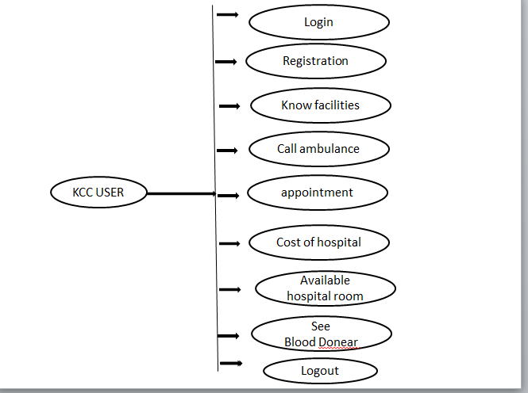

System Feature For Citizen

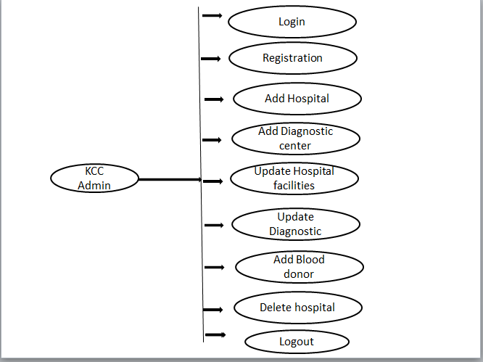

Other Nonfunctional Requirements

Safety Requirements
If there is extensive damage to a wide portion of the database due to a disk crash. Therefore, admin should careful in this case.

Safety Requirements
Security systems need database storage just like many other applications. However, The requirements of the security means that admin must choose their database partner carefully.

Security Requirements
• AVAILABILITY: The event should be available on the specified date and specified time.
• CORRECTNESS: The event should start from correct start time.
• MAINTAINABILITY: The administrators should maintain correct schedules of events.

