Software Requirements Specification

For

Govt. School Management Managed By KCC

Version 1.2 approved

Prepared by

Ryhan Ahmed Tamim (160230) , Avi Deb Raha (160211) & Sumit Kumar Dam (160205).

Software Engineering, Khulna University, Khulna

10 October, 2018

Copyright © 2018 by Sumit Kumar Dam. Permission is granted to use, modify, and distribute this document.
Software Requirements Specification for GSMMKCC Page ii

Table of Contents

Table of Contents ..................................................................................................................... |  |  | ii
Revision History ....................................................................................................................... |  |  | ii
1. | Introduction ......................................................................................................................... |  | 1
 | 1.1 | Purpose ....................................................................................................................................... | 1
 | 1.2 | Document Conventions ................................................................................................................ | 1
 | 1.3 | Intended Audience and Reading Suggestions ................................................................................ | 1
 | 1.4 | Product Scope ............................................................................................................................. | 1
 | 1.5 | References................................................................................................................................... | 1
2. | Overall Description .............................................................................................................. |  | 1
 | 2.1 | Product Perspective ..................................................................................................................... | 1
 | 2.2 | Product Functions ....................................................................................................................... | 2
 | 2.3 | User Classes and Characteristics ................................................................................................. | 3
 | 2.4 | Operating Environment ................................................................................................................ | 3
 | 2.5 | Design and Implementation Constraints ....................................................................................... | 3
 | 2.6 | User Documentation .................................................................................................................... | 3
 | 2.7 | Assumptions and Dependencies ................................................................................................... | 4
3. | External Interface Requirements ........................................................................................ |  | 4
 | 3.1 | User Interfaces ............................................................................................................................ | 4
 | 3.2 | Hardware Interfaces .................................................................................................................... | 4
 | 3.3 | Software Interfaces...................................................................................................................... | 4
 | 3.4 | Communications Interfaces .......................................................................................................... | 4
4. | System Features ................................................................................................................... |  | 5
 | 4.1 | System Feature 1 ......................................................................................................................... | 5
 | 4.2 | System Feature 2 (and so on) ....................................................................................................... | 5
5. | Other Nonfunctional Requirements.................................................................................... |  | 5
 | 5.1 | Performance Requirements .......................................................................................................... | 5
 | 5.2 | Safety Requirements .................................................................................................................... | 6
6. | Questionnaire ..................................................................................................................... |  | 6
7. | Use Case ............................................................................................................................... |  | 8
 | 7.1 | Use Case Descriptions ......................................................................................................... | 9

Revision History

Name | Date | Reason For Changes | Version
SRS | 7/25/2018 | Features should have been more elaborate. | 1.0
SRS | 8/1/2018 | No questionnaire was added. | 1.1

Software Requirements Specification for GSMMKCC Page 1

- Introduction

1.1 Purpose

Since our Government is aiming for making our country digital, A Smart School Management System will pave the way towards success. Purpose of our project is to make the dream come true as far as possible.

1.2 Document Conventions

Here, in this SRS, the requirements that we have described for Software Engineering project, every single requirement has its own priority, whether we talk about the features for teachers or the features for parents.

1.3 Intended Audience and Reading Suggestions

Our project is mainly aimed for the primary school staff, so that they can do their jobs in an easier and organized way. It will also help parents to get notification on various aspects about their children.

1.4 Product Scope

Since we have already said that, our project is mainly aimed for primary school staff & parents as well, it has numerous purposes. For example, it may be used for assigning marks for attendance

- exam, maintaining class schedule for teachers, Scholarship management system, Salary notification etc. Parents will also be able to check their children’s progress, apply for emergency leave & TC etc.

1.5 References

List of documents/Web addresses to which this SRS refers:

  - https://www.tutorialspoint.com/software_engineering/software_requirements.htm
  - https://ocw.cs.pub.ro/courses/

- Overall Description

2.1 Product Perspective

Our project “Govt. School Management Managed by KCC” will mainly focus to help the staff members of the school & parents for various purposes.
Software Requirements Specification for GSMMKCC Page 2

2.2 Product Functions

Our project contains the following functions/features:

Here, we will have three types of users.

- Teachers

- Parents

- Admin Panel

Features for teachers:

    - Login.

    - Change Password.

    - Modify profile.

    - Contact with parents.

    - Approve leave of absence for students.

    - Apply for leave.

    - See student’s profile.

    - Assign Marks in his subjects etc.

    - Modify those marks.

    - Arrange meeting with parents.

    - Cancel meeting with parents.

    - Get salary notification.

    - Apply for advance salary.

    - Can see if the advance salary is provided or not.
    - Can see student’s progress.

    - Can report student’s progress to parents.

    - Log out.

Features for parents:

    - Login.

    - Change Password.

    - Modify profile.

    - Apply for admission.

    - Contact with teacher.

    - Get notification about their children’s progress.

    - Check their children’s marks.

    - Request for reviewing the exam papers.

    - Check term final results.

    - Check their student’s class schedule.

    - Check their student’s exam schedule.

    - Get notification about meeting arranged by the teacher.

    - Apply for scholarship.

    - Get notification about scholarship.

    - Apply for emergency leave.

    - Apply for TC

Features for admin panel:
Software Requirements Specification for GSMMKCC Page 3

- Login.
- Change password.
- Modify profile.
- Create teacher’s account.
- Update teacher’s profile.
- Delete teacher’s profile.
- Approve teacher’s leave of absence.
- Monitor teacher’s attendance.
- Approve for teacher’s advance salary.
- Create parent’s profile.
- Update the profile.
- Delete the profile.
- Approve parent’s request for admission.
- Approve for parent’s request for TC.
- Approve parent’s request for scholarship.

2.3 User Classes and Characteristics

User Friendly:

Our project is very useful & also easy to use so, all users with some basic knowledge with computers are able to use it properly.

Open source software developers and contributors:

- Software Developers: To make any development in source code or to add more features, people need to have good programming knowledge.

- Translators: People of all age groups with very good knowledge of a language not included in the current translation list.

- Anyone who wants to help FOSS (free and open source software) community: The whole project is based on the conception of Free and Open Source software, so all people are welcome to contribute anyway according to their wish & desire.

2.4 Operating Environment

We will use C#.net, for UI we will use METRO UI and BANIFU UI & the database will be made in MySQL. Our project will run on the following operating systems: Win7 / Win8 / Win10. It will also smoothly run on a LINUX-based system or MAC.

2.5 Design and Implementation Constraints

Or project is under the GNU General Public License Version 2, June 1991. Everyone, that does or is going to develop or use our project, should agree and fully accept the terms of this kind of license.

2.6 User Documentation

Regardless the types of users, we will provide a user manual so that they won’t face any problem.
Software Requirements Specification for GSMMKCC Page 4

2.7 Assumptions and Dependencies

- Database server errors may occur.
- ADMIN may have stored wrong information by mistake or for lack of information.
- Updated or new information about users may not have been submitted by the ADMIN PANEL.

- External Interface Requirements

3.1 User Interfaces

For front-end software interfaces, we have used:

- C#.NET
- METRO UI
- BANIFU UI

For front-end software interfaces, we have used:

- MySQL Database.

3.2 Hardware Interfaces

- WINDOWS 7/8/10 or LINUX
- HTML, CSS supported any browser like MAXTHON BROWSER, MOZILLA FIREFOX etc.

3.3 Software Interfaces

Software will be used | Description
Operating System | WINDOWS 7/8/10 because WINDOWS is friendlier than others.
Database | For storing data we have chosen SQL database.
Framework | We have chosen C#.NET framework along with METRO UI & BANIFU UI.

3.4 Communications Interfaces

All types of web browser will support the project.
Software Requirements Specification for GSMMKCC Page 5

- System Features

Here we have discussed about the features of our project. This template illustrates organizing the functional requirements for the product by system features, the major services provided by the product. We have also organized this section by discussing USE CASE in section 7 & 7.1.

4.1 Features for PARENTS

4.1.1 Description and Priority

In the PARENT FORUM, we have provided features to know about the information of the student, to apply for TC, to apply for leave, to know the class schedule, to check result etc. Each feature has equal priority.

4.1.2 Functional Requirements

A parent can’t modify anything like the information or result of his or her student. He or she has to take the permission & help of the associated teacher & admin panel. However he or she can modify his or her personal information.

4.2 Features for TEACHERS

4.2.1 Description and Priority

In the TEACHER FORUM, we have provided features to add members, send message, call a meeting, maintain attendance etc. Each feature has equal priority.

4.2.2 Functional Requirements

A teacher can add new members but to modify their information he has to take the help of the admin panel. However he can modify his or her personal information.

4.3 Features for ADMIN

    - Description and Priority

In the ADMIN FORUM, we have provided features to add members, send message, arrange meeting, maintain attendance etc. Each feature has equal priority.

4.3.2 Functional Requirements

An Admin is able to add & modify all types of data.

- Other Nonfunctional Requirements

5.1 Performance Requirements

Our project will be always up-to-date with all new supported features and bug fixes. It’s a light application that needs very few system resources in order to work.
Software Requirements Specification for GSMMKCC Page 6

5.2 Safety Requirements

Our project is 100% safe to use. Besides, it is an open-source project, so anyone who has doubts can check the source code.

- Questionnaire

For the betterment of our project, we did a Q&A survey from some primary schools. We went from school to school and met the head-teacher. We asked them different questions and got to know about the requirements. Some are the following:

Q1: Sir, how do you do the task of assigning marks?

Head-teacher1: We take approximately 3 exams per year, for making the final result we take 60% from the final exam and 40% from the first two.

Q2: Sir, how are the subjects of different classes taken?

Head-teacher 1: For play/nursery, one specially trained teacher is assigned for the task who takes all the classes & from class 1 to 5, for different subjects, different teachers are assigned.

Q3: Sir, how do you arrange meeting between teachers & parents?

Head-teacher 2: After every term final exam, a meeting is arranged & despite this, we also arrange meetings on different times for different purposes.

Q4: Sir, if we want to make the application system for leave of absence easy, how would you like to get treated?

Head-teacher 2: A generalized format will be helpful that will provide all the necessary information except name, roll, phone number, of the student. When the student will submit the application, he will just put his name, roll & phone number in that form & submit it.

For teachers, we would like to be treated in the same way. A generalized format would be very helpful.

Q5: Sir, if you want to increase the quality of education system in your school, how would you like to get treated?

Head-teacher 3: For increasing the quality of our education system, we would like to maintain a progress report system. In that case the task can be done by sending the report to the parents either by messaging or by sending e-mail. But the fact is that, most of the parents aren’t that much literate. As a result, it is found out that, most of them do not keep e-mail accounts. It is also
Software Requirements Specification for GSMMKCC Page 7

Found out that, they are not good in English. So, a SMS system in Bengali would the best possible way to inform parents about their children’s progress report.

We have also provided an AUDIO FILE that we recorded from different schools.

Software Requirements Specification for GSMMKCC
Page 8

- Use Case

Head Teacher

Teachers

Home page
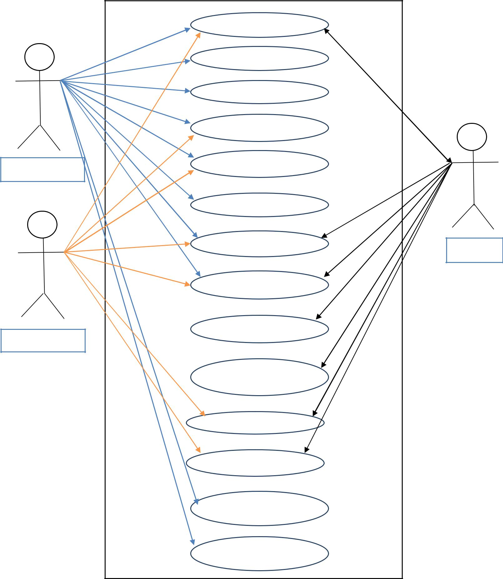

Create teacher entry

Create parent entry

Assign marks

Assign attendance

Arrange meeting

Meeting update

Class Schedule

Apply for T.C.

Apply for leave for
student

Result

Calendar

Approve for leave

Approve for T.C.

Parents

Software Requirements Specification for GSMMKCC | Page 9
7.1 Use Case Descriptions
HOME PAGE
Use Case Name | Home page
Brief Description | The home page provides all necessary page links
 | based on the user accessibility.
Priority | Essential
Trigger | The user can access after log in.
Precondition | The user must be connected to the internet.
Basic Path | 1. The Server presents the users with the user
 | Home Page.
Alternate Path | N/A
Post condition | User is on the User Home Page
Exception Path | If there is a connection failure, the
 | Departmental Server returns to the wait state

CREATE TEACHER ENTRY

Use Case Name | Create teacher entry
Brief Description | This operation creates teacher entity.
Priority | Critical
Trigger | Head teacher chooses to create teacher entity.
Precondition | The user must be connected to the internet.
Basic Path | 1. | The web server presents a form for the
 |  | head teacher.
 | 2. | Head teacher fills in the form and clicks
 |  | submit.
 | 3. | The server checks to see if all the required
 |  | fields are not empty.
 | 4. | If all the required fields are not empty, the
 |  | server creates a new teacher entity to the
 |  | database.
 | 5. | If any required field is empty, the server
 |  | returns an error message.
 | 6. | The server returns the Head teacher to the
 |  | home page.
Alternate Path | N/A
Post condition | The server creates a new teacher entity to the
 | database.
Exception Path | If there is a connection failure, the
 | Departmental Server returns to the wait state

Software Requirements Specification for GSMMKCC Page 10

CREATE PARENT ENTRY

Use Case Name | Create parent entry
Brief Description | This operation creates parent entity.
Priority | Critical
Trigger | Head teacher chooses to create parent entity.
Precondition | The user must be connected to the internet.
Basic Path | 1. | The web server presents a form for the
 |  | head teacher.
 | 2. | Head teacher fills in the form and click
 |  | submit.
 | 3. | The server checks to see if all the required
 |  | fields are not empty.
 | 4. | If all the required fields are not empty, the
 |  | server creates a new teacher entity to the
 |  | database.
 | 5. | If any required field is empty the server
 |  | returns an error message.
 | 6. | The server returns the Head teacher to the
 |  | home page.
Alternate Path | N/A
Post condition | The server creates a new parent entity to the
 | database.
Exception Path | If there is a connection failure, the
 | Departmental Server returns to the wait state
ASSIGN MARKS

Use Case Name | Assign marks
Brief Description | This operation records the subjective marks.
Priority | Critical
Trigger | Head teacher or teacher chooses to Assign marks.
Precondition | The user must be connected to the internet.
Basic Path | 1. | The web server presents a form for the
 |  | Head teacher or teacher.
 | 2. | Head teacher or teacher chooses the class,
 |  | term and select the student.
 | 3. | Teacher fills the subject wise marks and
 |  | clicks submit button.
 | 4. | The server checks to see if all the required
 |  | fields are not empty.
 | 5. | If all the required fields are not empty, the
 |  | server creates a new entity that contains
 |  | subjective marks of a student.
 | 6. | If any required field is empty the server
 |  | returns an error message.
 | 7. | The server returns the teacher to the home
 |  | page.
Alternate Path | N/A
Post condition | The server creates a new entity that contains

Software Requirements Specification for GSMMKCC |  | Page 11
 | subjective marks of a student.
Exception Path | If there is a connection failure, the
 | Departmental Server returns to the wait state
ASSIGN ATTENDANCE
Use Case Name | Assign attendance
Brief Description | This operation records the subjective attendance.
Priority | Critical
Trigger | Head teacher or teacher chooses to Assign
 | attendance.
Precondition | The user must be connected to the internet.
Basic Path | 1. | The web server presents a form for the
 |  | Head teacher or teacher.
 | 2. | Head teacher or teacher chooses the class,
 |  | term.
 | 3. | Teacher fills the roll wise attendance and
 |  | click submit button.
 | 4. | The server checks to see if all the required
 |  | fields are not empty.
 | 5. | If all the required fields are not empty, the
 |  | server creates a new entity that contains
 |  | subjective attendance of students.
 | 6. | If any required field is empty the server
 |  | returns an error message.
 | 7. | The server returns the teacher to the home
 |  | page.
Alternate Path | N/A
Post condition | The server creates a new entity that contains
 | attendance marks of a student.
Exception Path | If there is a connection failure, the
 | Departmental Server returns to the wait state
ARRANGE NEW MEETING
Use Case Name | Arrange new meting
Brief Description | This operation creates a new meeting.
Priority | Critical
Trigger | Head teacher choose to call a meeting.
Precondition | The user must be connected to the internet.
Basic Path | 1. | The web server presents a form for the
 |  | head teacher.
 | 2. | Head teacher fill in the form and click
 |  | submit.
 | 3. | The server checks to see if all the required
 |  | fields are not empty.
 | 4. | If all the required fields are not empty, the
 |  | server creates a new meeting entity to the
 |  | database.
 | 5. | If any required fields are empty the server

Software Requirements Specification for GSMMKCC | Page 12
 | returns an error message.
 | 6. The server returns the Head teacher to the
 | home page.
Alternate Path | N/A
Post condition | The server creates a new meeting entity to the
 | database.
Exception Path | If there is a connection failure, the
 | Departmental Server returns to the wait state.
MEETING UPDATE
Use Case Name | Meeting update
Brief Description | This page contains all the meeting update.
Priority | Essential
Trigger | The user can access after log in.
Precondition | The user must be connected to the internet.
Basic Path | 1. The Server presents the users with the user
 | Meeting update Page.
Alternate Path | N/A
Post condition | User is on the User Meeting update Page.
Exception Path | If there is a connection failure, the
 | Departmental Server returns to the wait state
CLASS SCHEDULE
Use Case Name | Class Schedule
Brief Description | This page contains all the Class Schedule.
Priority | Essential
Trigger | The user can access after log in.
Precondition | The user must be connected to the internet.
Basic Path | 1. The Server presents the users with the user
 | Class Schedule Page.
Alternate Path | N/A
Post condition | User is on the User Class Schedule Page.
Exception Path | If there is a connection failure, the
 | Departmental Server returns to the wait state
APPLY FOR T.C
Use Case Name | Apply for TC
Brief Description | This operation creates a new application for TC.
Priority | Critical
Trigger | Parents choose to Apply for TC.
Precondition | The user must be connected to the internet.
Basic Path | 1. The web server present a form for the
 | patents.
 | 2. Patents fill in the form and click submit.
 | 3. The server checks to see if all the required
 | fields are not empty.
 | 4. If all the required fields are not empty, the
 | server creates a new TC entity to the

Software Requirements Specification for GSMMKCC |  | Page 13
 |  | database.
 | 5. | If any required fields are empty the server
 |  | returns an error message.
 | 6. | The server returns the parents to the home
 |  | page.
Alternate Path | N/A
Post condition | The server creates a new TC entity to the database.
Exception Path | If there is a connection failure, the
 | Departmental Server returns to the wait state.
APPLY FOR LEAVE FOR STUDENT
Use Case Name | Apply for leave for student
Brief Description | This operation creates a new application for leave.
Priority | Critical
Trigger | Parents choose to Apply for leave.
Precondition | The user must be connected to the internet.
Basic Path | 1. | The web server present a form for the
 |  | patents.
 | 2. | Patents fill in the form and click submit.
 | 3. | The server checks to see if all the required
 |  | fields are not empty.
 | 4. | If all the required fields are not empty, the
 |  | server creates a new leave application
 |  | entity to the database.
 | 5. | If any required fields are empty the server
 |  | returns an error message.
 | 6. | The server returns the parents to the home
 |  | page.
Alternate Path | N/A
Post condition | The server creates a new leave application entity to
 | the database.
Exception Path | If there is a connection failure, the
 | Departmental Server returns to the wait state.
APPLY FOR LEAVE FOR TEACHER
Use Case Name | Apply for leave for Teacher
Brief Description | This operation creates a new application for leave.
Priority | Critical
Trigger | Teacher chooses to Apply for leave.
Precondition | The user must be connected to the internet.
Basic Path | 1. | The web server presents a form for the
 |  | teacher.
 | 2. | Teacher fills in the form and click submit.
 | 3. | The server checks to see if all the required
 |  | fields are not empty.
 | 4. | If all the required fields are not empty, the
 |  | server creates a new leave application
 |  | entity to the database.

Software Requirements Specification for GSMMKCC | Page 14
 | 5. If any required field is empty the server
 | returns an error message.
 | 6. The server returns the Teacher to the home
 | page.
Alternate Path | N/A
Post condition | The server creates a new leave application entity to
 | the database.
Exception Path | If there is a connection failure, the
 | Departmental Server returns to the wait state.
RESULT
Use Case Name | Result
Brief Description | This page contains all the Class Schedule.
Priority | Essential
Trigger | The user can access after log in.
Precondition | The user must be connected to the internet.
Basic Path | 1. The Server presents the users with the user
 | Result Page.
Alternate Path | N/A
Post condition | User is on the User Class Result.
Exception Path | If there is a connection failure, the
 | Departmental Server returns to the wait state
CALENDAR
Use Case Name | Calendar
Brief Description | This page contains the Calendar.
Priority | Essential
Trigger | The user can access after log in.
Precondition | The user must be connected to the internet.
Basic Path | 1. The Server presents the users with the user
 | Calendar.
Alternate Path | N/A
Post condition | User is on the User Calendar.
Exception Path | If there is a connection failure, the
 | Departmental Server returns to the wait state
APPROVE FOR LEAVE
Use Case Name | Approve for leave
Brief Description | This page contains the all the leave applications.
Priority | Essential
Trigger | The user can access after log in and choose to the
 | application approve page.
Precondition | The user must be connected to the internet.
Basic Path | 1. The Server presents the head teacher
 | with the users leave applications.
 | 2. The teacher approve the leave
 | application by clicking the approve
 | button.

Software Requirements Specification for GSMMKCC |  | Page 15
Alternate Path | N/A
Post condition | Head teacher is on the leave application approve
 | page.
Exception Path | If there is a connection failure, the
 | Departmental Server returns to the wait state
APPROVE FOR T.C
Use Case Name | Apply for TC
Brief Description | This operation creates a new application for TC.
Priority | Critical
Trigger | Parents choose to Apply for TC.
Precondition | The user must be connected to the internet.
Basic Path | 1. | The web server present a form for the
 |  | patents.
 | 2. | Patents fill in the form and click submit.
 | 3. | The server checks to see if all the required
 |  | fields are not empty.
 | 4. | If all the required fields are not empty, the
 |  | server creates a new TC entity to the
 |  | database.
 | 5. | If any required fields are empty the server
 |  | returns an error message.
 | 6. | The server returns the parents to the home
 |  | page.
Alternate Path | N/A
Post condition | The server creates a new TC entity to the database.
Exception Path | If there is a connection failure, the
 | Departmental Server returns to the wait state.

