Software Requirement Specification
For
Hospital, Doctor, Diagnostic, Ambulance System

Submitted to:
Dr. Kazi Masudul Alam
Associate Professor,
CSE Discipline, Khulna University.

Prepared by
S.M.Mehadi Hasan(160225)
MD.Moniruzzaman (150227)
Israt Jahan (160239)

Table of Contents
Table of Contents ii
Revision History ii
1. Introduction 1
1.1 Purpose 1
1.2 Document Conventions 1
1.3 Intended Audience and Reading Suggestions 1
1.4 Product Scope 1
1.5 References 1
2. Overall Description 2
2.1 Product Perspective 2
2.2 Product Functions 2
2.3 User Classes and Characteristics 2
2.4 Operating Environment 2
2.5 Design and Implementation Constraints 2
2.6 User Documentation 2
2.7 Assumptions and Dependencies 3
3. External Interface Requirements 3
3.1 User Interfaces 3
3.2 Hardware Interfaces 3
3.3 Software Interfaces 3
3.4 Communications Interfaces 3
4. System Features 4
4.1 System Feature for Citizen's 4
4.2 System Feature for admin 4
5. Other Nonfunctional Requirements 4
5.1 Performance Requirements 4
5.2 Safety Requirements 5
5.3 Security Requirements 5
5.4 Software Quality Attributes 5

Introduction

Purpose
One of the basic needs of the people is health. But the big problem is the management of the hospital in an area. To build a smart city, hospital management must be emphasized. Therefore, we are building a hospital, Doctor, Diagnostic, Ambulance System for KCC.

Document Conventions
This document uses the following conventions :

DB | Database
ER | Entity Relationship
KCC | Khulna City Corporation

Intended Audience and Reading Suggestions
This product is a prototype for event finder system and it is restricted within Khulna city. This project is useful for KCC and as well as to the citizens. The document is intended for KCC, users and citizens.

Product Scope
The purpose of the a hospital, Doctor, Diagnostic, Ambulance system is to create a useful health
Care system . Where the user of KCC know the location and service of the hospital, doctor and ambulance. The product scope of this project is given bellow:
• KCC will be able to insert the list of hospital, diagnostic center .
• KCC will also be able to list the phone number of the ambulance service.

References
- https://www.tutorialspoint.com/software_engineering/software_requirements.htm
- https://hospital-management-software-system.weebly.com

Overall Description

Product Perspective
The Hospital, Doctor, Diagnostic, Ambulance System stores the following information:

 Hospital, Doctor, Diagnostic, Ambulance System details
 Citizen / User_Descrptions

 KCC / Admin Descriptions

Product Functions
The major features of database system as shown below.

User Classes and Characteristics
KCC Users of the system should be able to retrieve hospital ,diagnostic center,ambulnce information where the hospital will hold from the database. The system will support two types of user privileges. Citizens and Admin. Citizens will have accessed to citizen’s functions, and admin will have accessed to both Citizen and event management functions.

The citizen should do following things

- Know about the hospital and diagnostic center facilities
- can get appointment to the doctor
- can call the Ambulance Service when necessary.
- can see the appointment schedule
- can know the facilities & costs of the hospital and diagnostic center..

The admin should do following things

- Add hospital or diagnostic center
- Update the facilities of the hospital and diagnostic center
- ্delete the hospital or diagnostic center whose facilities is off

Operating Environment
Operating environment for the events finder system is as listed below:

• Database
• Operating system: Windows 10
• Platform: Node.js
• Software: Visual Studio Code

Design and Implementation Constraints

i. SQL commands for queries/applications
ii. Implement the database at least using a centralized database management system

User Documentation
As the system is not completed yet, so user documentation cannot be made.

Assumptions and Dependencies
Let us assume that

✓ During the bad climate, the event may postponed in that case,citizen may get wrong information .

✓ For any reasons, the event may not begin timely .

✓ Database server errors may occur.

External Interface Requirements

User Interfaces

▪ Front-end software : node.js
 
▪ Back-end software: SQL
 

Hardware Interfaces

• Windows 10

• A browser which supports CSS, HTML

Software Interfaces
Following are the software used for the hospital, Doctor, Diagnostic, Ambulance system application:

Software used | Description
Operating system | We have chosen Windows operating system for its best support and user-friendliness
Database | To save the events details we have chosen SQL database
node.js | To implement the project we have chosen .Net language for its more interactive support.

Communications Interfaces
The project will support all types of web browser.

System Features
The Hospital, Doctor, Diagnostic, Ambulance System maintains information on different types of events time date, location etc.

4.1 System Feature For User/ Citizen

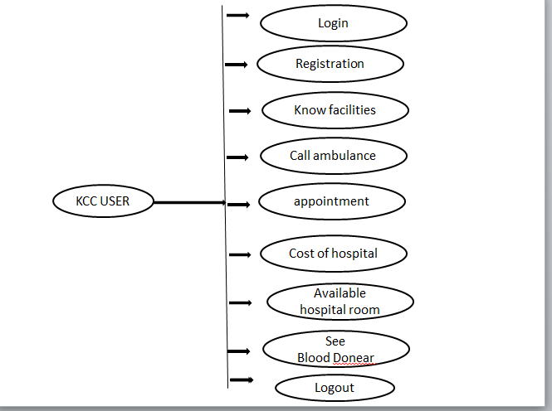

System Feature For Admin

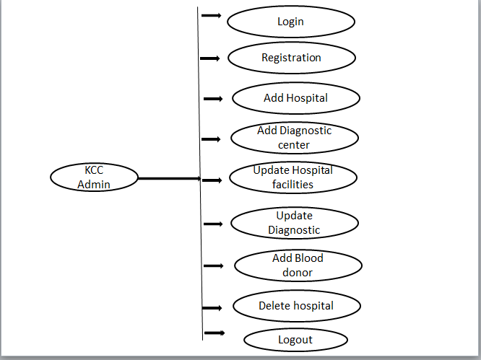

4.3. Use cases description

4.3.1. User/citizen and admin access homepage

Use Case Name: | User/citizen and admin access homepage
Brief Description: | The Web Server is waiting on  User and admin to connect.
Priority | Essential
Trigger | User and admin select their activity in the home page.
Precondition | User and admin is connected to the Internet.
Basic Path | 1.For user they can go to their own page  From the home page.  1.For Admin they can go to their own page  From the home page.
Alternate Path | N/A
Post condition | User is on the user Home Page and admin on the admin home page
Exception Path | If there is a connection failure, the  Server returns to the wait state

4.3.2.Admin Create Hospital and Diagnostic center

Use Case Name: | Admin Can Create Hospital and Diagnostic
Brief Description: | This operation permits Admin to create a  new hospital and diagnostic center on the Entries page.
Priority | Essential
Trigger | Admin choose to create a new entry on the  Entries page.
Precondition | Admin must be connected to the Internet  and on the Entries page.
Basic Path | 1. Admin click on add a new entry.  2. The Departmental Server returns a form.  3.Admin fill in the form and click submit.  4. The Server checks to see if  any required field is empty.  5. If any required field is empty, the  Server will send a message
Alternate Path | N/A
Post condition | A record is created in the Admin Table of  the Admin Database
Exception Path | 1. If the connection is terminated before the  form is submitted, the fields are cleared  and the Server is returned  to the wait state.

4.3.3.Admin Update Hospital and Diagnostic center facilities

Use Case Name: | Admin Update Hospital and Diagnostic center facilities
Brief Description: | This operation permits admin to update hospital and diagnostic  Center facilities on the update page.
Priority | Essential
Trigger | admin choose to update hospital and diagnostic center on the  update page.
Basic Path | 1. admin click on update hospital  facilities  2. Server returns a form.  3. Admin fill in the form and click submit.  4. If no required field is empty, the  Departmental Server will create a new  record in the Admin Table in the Admin  Database, and return Admin to the hospital Home Page.  5. Admin may select Cancel.  .
Alternate Path | N/A
Post condition | A record is created in the Alumni Table of the Admin Database

Exception Path | If the connection is terminated before the form is submitted, the fields are cleared and the Server is returned to the wait state.

4.3.4.Search Hospital and Diagnostic center

Use Case Name: | Search Hospital and Diagnostic center
Brief Description: | This operation permits the user to search of  The hospital and diagnostic center.  .
Priority | If time permits.
Trigger | User search the hospital and diagnostic center and their facilities
Basic Path | 1. User search hospital and diagnostic center  2. user find the facilities of the hospital and diagnostic center..
Alternate Path | N/A
Exception Path | If the connection is terminated before the form is  submitted, the fields are cleared and the  Departmental Server is returned to the wait state.

4.3.5 User appointment system

Use Case Name: | User appointment system
Brief Description: | The Web Server is waiting for the  Patients to connect
Priority | Essential
Precondition | user can appointment for the doctor
Basic Path | The user clicks on appointment an entry link.  2. The Server returns a form.  3. user appointment on the doctor
Alternate Path | There is no alternate path for the user
Post condition | The record in the user Table of the user appointment Database  has been updated.  .
Exception Path | If the connection is terminated before the form is  submitted, the fields are cleared and the  Departmental Server is returned to the wait state.

4.3.6 User search for available cabin room

Use Case Name: | User search for available cabin room
Brief description: | user search available room in the hospital
Priority | Essential
Precondition | The user is connected to the Internet and on the acess the search cabin.
Basic Path | 1. The Departmental Server returns a form.  2. In the form user search the cabin  3.after search he find different types visit different type of cabin room,
Alternate Path | N/A
Exception Path | There is dialog box for the exception path

4.3.7 User search for available cabin room

Use Case Name: |  | User search for available cabin room
Brief Description: |  | This operation permits user to search a available cabin room.
Priority |  | Essential
Trigger |  | User choose to search a new cabin on this page.
Precondition |  | user must be connected to the Internet  and on the ACC Entries page.
Basic Path |  | Alumni click on add a search a cabin  2. The Departmental Server returns a search box.  3. user search for the available cabin room  4. The Departmental Server checks to see if  any required field is empty. Or there is free cabin  5. user may select Cancel.
Alternate Path |  | N/A
Post condition |  | A record is search in the cabin Table of  the user Database.
Exception Path | 1. If the connection is terminated before the  form is submitted, the fields are cleared  and the Departmental Server is returned  to the wait state.

Other Nonfunctional Requirements

Safety Requirements
If there is extensive damage to a wide portion of the database due to a disk crash. Therefore, admin should careful in this case.

Safety Requirements
Security systems need database storage just like many other applications. However, The requirements of the security means that admin must choose their database partner carefully.

Security Requirements
• AVAILABILITY: The event should be available on the specified date and specified time.
• CORRECTNESS: The event should start from correct start time.
• MAINTAINABILITY: The administrators should maintain correct schedules of events.

