**USER MANUAL OF**

**SHOP MANAGEMENT**

Step 01: Welcome Layout

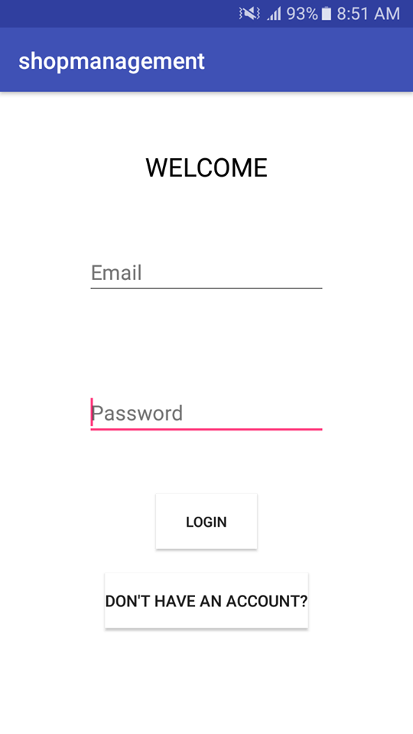

In this Layout there are two buttons a) LOGIN and b) Don’t Have an Account?

a) LOGIN: If the user already has an account, then he has to type his email and password in the specified field and press the login button.

b) ) Don’t Have an Account?: If there is a new user then he has to click this button to register. This button will take him to the Registration Page.

Step 02: Registration Layout

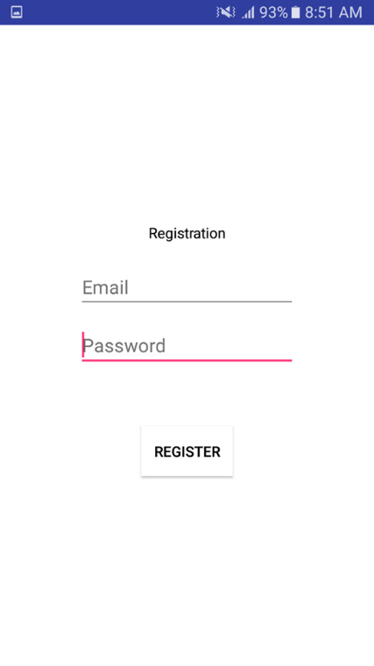

The new user have to type his email and password in those specified fields and click the Register Button. The button will save his email and password into the database for future use. This will also take the user to the Create Shop Layout.

Step 03: Create Shop Layout

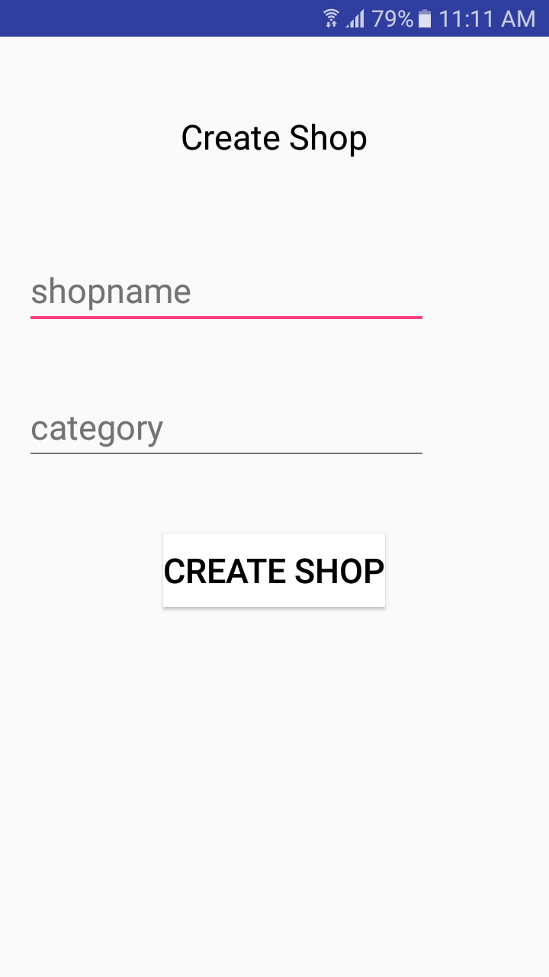

In this layout there are two fields to register the shop’s name and it’s category. After full filling the fields with data, the user has to click the CREATE SHOP button to Complete his Registration. Now the user has to go back to the Welcome Layout to Login.

Step 04: Admin Layout

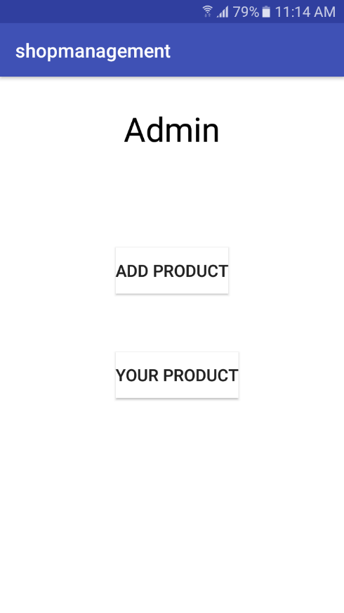

After Login, the user will see the Admin Layout. In this Layout, there are two buttons a) Add Product and b) Your Product.

a) Add Product: If the user wants to add products, then he has to click the “ADD PRODUCT” button; this will take him to the “Add Product” layout where he can insert the description of the product. (Step 05)

b) Your Product: If the user wants to see his products (which are already inserted into the database) , then he has to click this button to show the products list (Step 06).

Step 05: Add Product

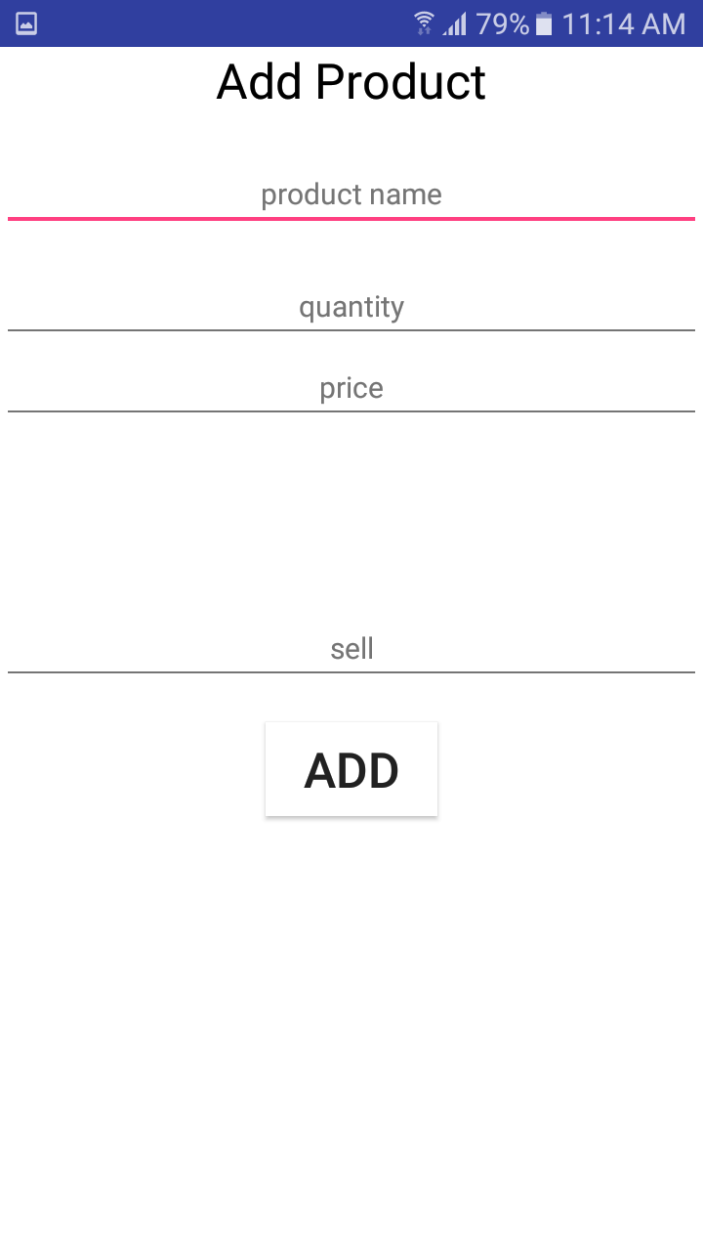

In this layout, there are 4 fields a) Product Name, b) Quantity, c) Price and d) Sell. The user has to fill those fields and Press “ADD” button to insert the product and details in the database.

Step 06: Show Products

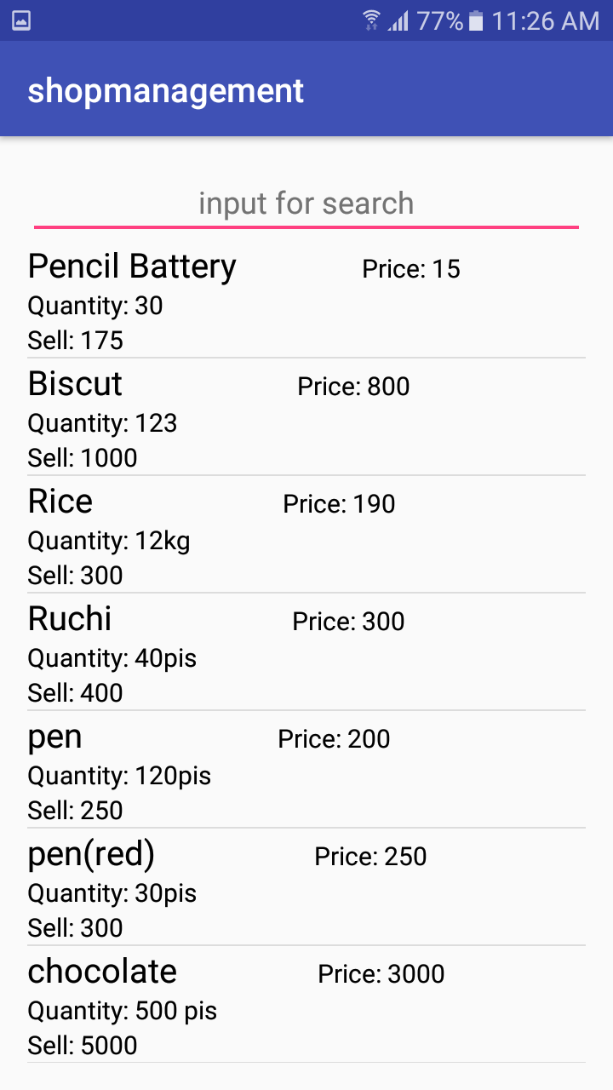

If the user, click "YOUR PRODUCT” in the ADMIN layout, then he will come to this layout and can see the products which are already inserted. Like the screenshot above.

Step 07: Profit or Loss

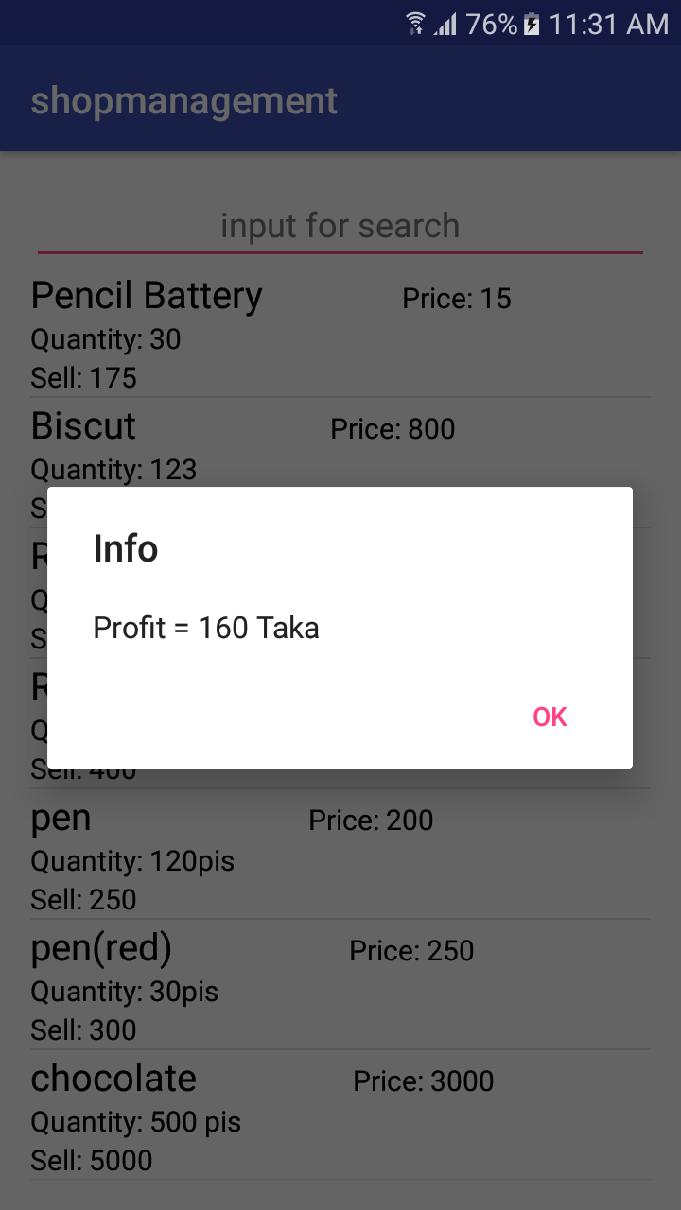

The user can easily see the profit or loss from a product just by clicking the the product name.

Step 08: Search Product

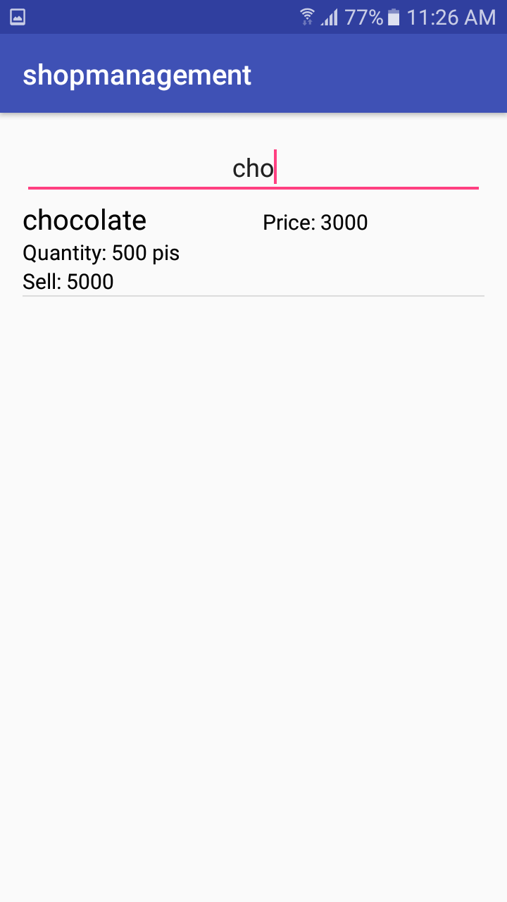

If the user wants to search one specific product from the product list, then he has to type the name of the product in the “input for search” field and the product will appear.

Step 09: Edit & Data Update

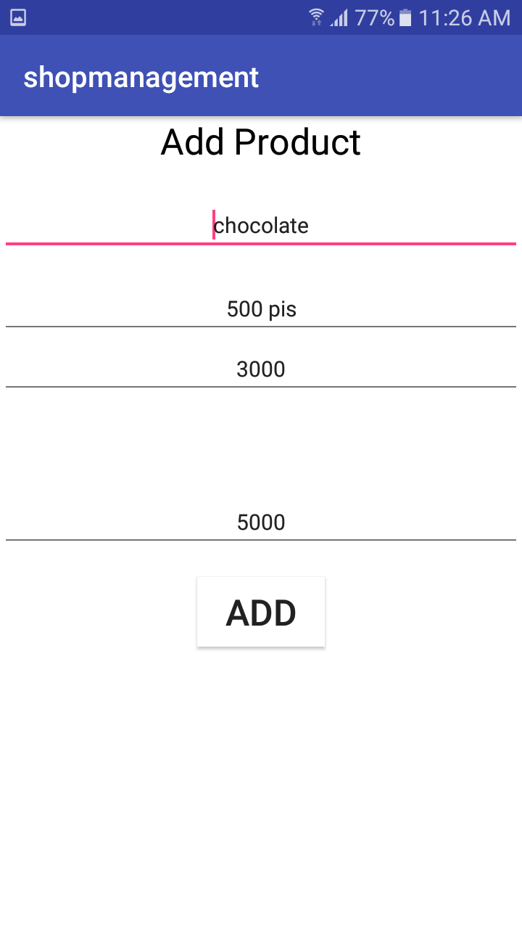

To edit a product, the user has to long press the product name from the product list. Then a new layout will appear where the user can update the datas.

THANK YOU!!!