# WORKSHEET #4

## Assumes: Ch1, Ch2, Ch3

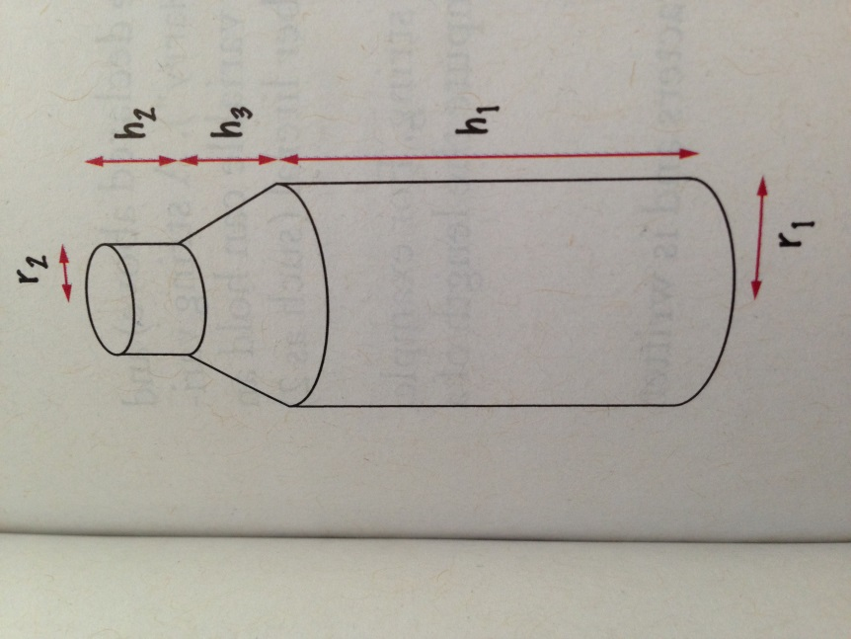

The shape of a bottle is approximated by two cylinders of radius *r1* and *r2* and heights *h1* and *h2*, joined by a cone section oh height *h3*. Using the formulas for the volume of a cylinder and a cone section shown below, develop a pseudocode to compute the volume of the bottle. Using an actual bottle with known volume as a sample, start by my making a hand calculation of your pseudocode. Next, implement the pseudocode in java.

Volume of a cylinder: **V = πr2h**

Volume of a cone section: $V=π\frac{\left({r_{1}}^{2}+ r_{1} r_{2 }+ {r_{2}}^{2}\right) h}{3}$

1. Write a program that ask a user for an integer, and computes and prints the first and the last digit of the given number. For example, if the input is 23456789, the program should print 2 and 9. *Hint*: utilize % for the last digit; utilize Math.log10 and casting for the first digit
2. Easter Sunday is the first Sunday after the first full moon of spring. To compute the date, one can use the following algorithm, invented by the mathematician Carl Friedrich Gauss in 1800:
   1. Let ***y*** be the year (such as 1800 or 2014)
   2. Divide ***y*** by *19* and call the reminder ***a***. Ignore the quotient
   3. Divide ***y*** by *100* to get a quotient ***b*** and a reminder ***c***
   4. Divide ***b*** by *4* to get a quotient ***d*** and a reminder ***e***
   5. Divide ***8*b+13*** by *25* to get a quotient ***g***. Ignore the remainder
   6. Divide ***19*a+b-d-g+15*** by *30* to get a reminder ***h***. Ignore the quotient
   7. Divide ***c*** by *4* to get a quotient ***j*** and reminder ***k***
   8. Divide ***a+11*h*** by *319* to get a quotient ***m***. Ignore the reminder
   9. Divide ***2*e+2*j-k-h+m+32*** by *7* to get a reminder ***r***. Ignore the quotient
   10. Divide ***h-m+r+90*** by *25* to get a quotient ***n***. Ignore the remainder
   11. Divide ***h-m+r+n+19*** by *32* to get the remainder ***p***. Ignore the quotient

The Easter falls on day ***p*** of month ***n***. For example, if y is 2001: n is 4 and p is 15, so Easter Sunday fell on April 15. Write a program that prompts the user for a year and prints out the month and day of Easter Sunday for that year.

1. The following pseudocode describes how a bookstore computes the price of an order from the total price and the number of the books that were ordered. Implement this algorithm in java:
   1. *read the total book price and the number of books*
   2. *compute the tax (7.5 percent of the total book price)*
   3. *compute the shipping charge ($2 per book)*
   4. *the price of the order is the sum of the total book price, the tax, and the shipping charge*
   5. *print the price of the order*
2. ☺