# WORKSHEET #5

## Assumes: Ch1, Ch2, Ch3, Ch5-1

1. Write a program that computes taxes for the following schedule. Utilize cascading if statement(s) and nested if statement(s):

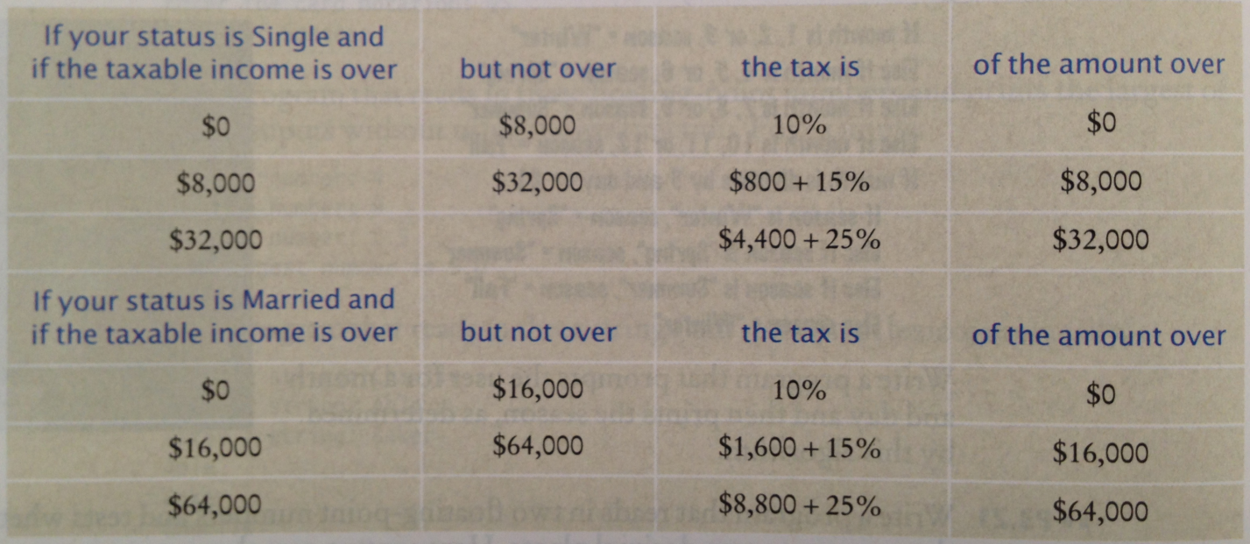

1. French country names are feminine when they end with a letter ***e***, masculine otherwise, except for the following which are masculine even though they end with ***e***:
   * le Belize
   * le Cambodge
   * le Mexique
   * le Mozambique
   * le Zaire
   * le Zimbabwe

Write a program that reads the French name of a country and adds the article: ***le*** for masculine or ***la*** for feminine, such as le Canada or la Belgique. However, if the country name starts with a vowel, use ***l’*** (for example l’Afghanistan). For the following plural country names, use ***les***:

* + Les Etats-Unis
  + Les Pays-Bas

1. ☺