**MATH448 - Final Project preliminary Results – Cameron Embree**

**Basic Sound Identification Project**

**GOAL**

Take recordings of me saying “zero one, two, three, four, five” and do some measurement of these recordings that could be used to classify later recordings of those words.

**METHODS**

Made 6 recordings of be saying zero,…,five and then take the Discrete Fourier Cosine Transform of each and average each word’s Fourier Transform to get a rough average for that word. This array of 6 Fourier transforms are used to find a polynomial of degree six for a best fit function. These best-fit functions for the Fourier’s of the words are compared to later recordings by integrating between the classifying polynomial and a polynomial of best fit for the audio clip being analyzed.

**RESULTS**

Still using a polynomial of degree 6 seems to work the best for finding an average classifying Fourier Transform equation. I did try using some periodic functions with various periods to create a best fit and the results of these two options can be seen bellow (Left is polynomial of degree 6, Right is periodic functions)

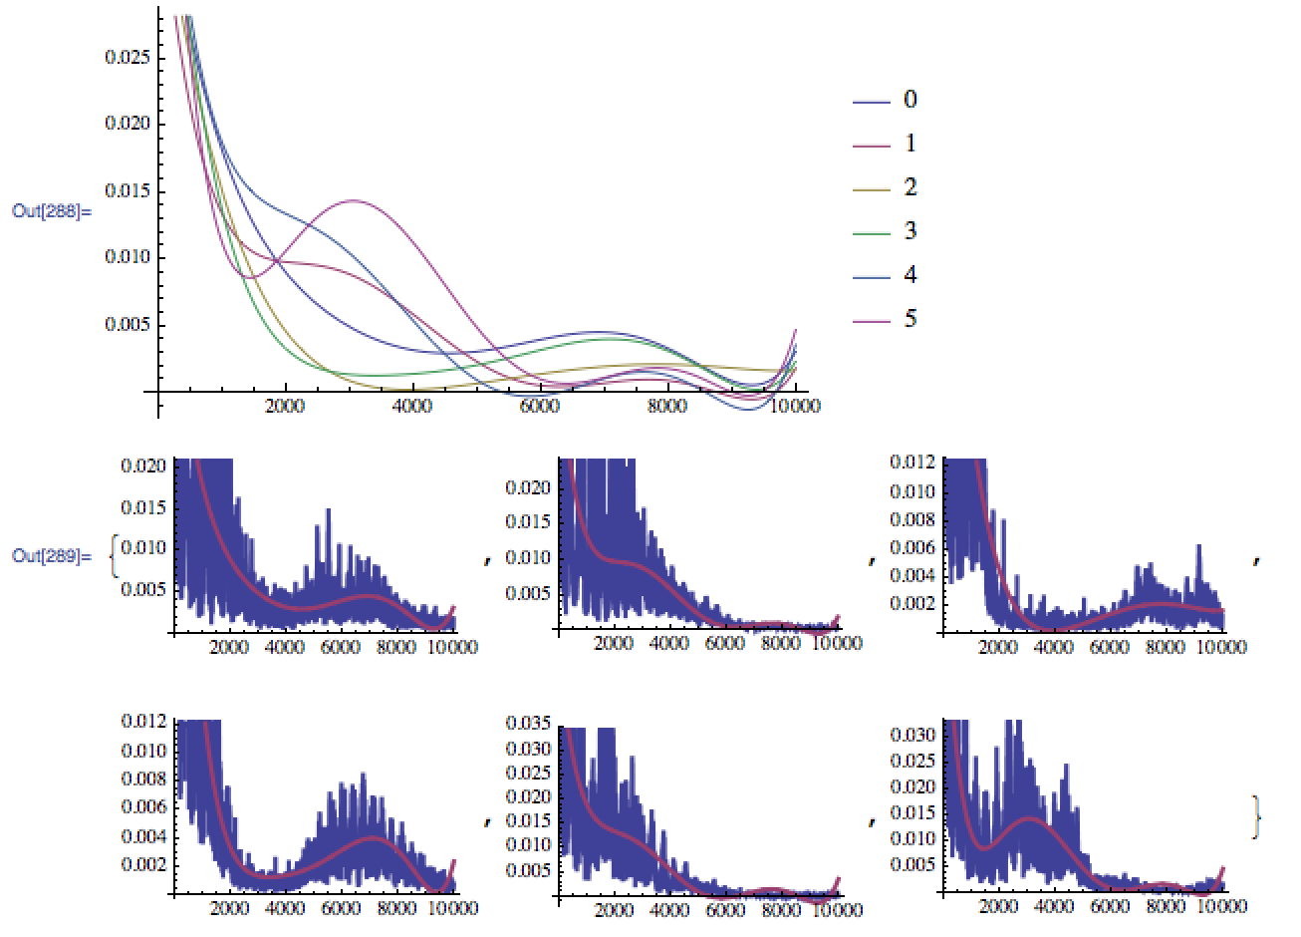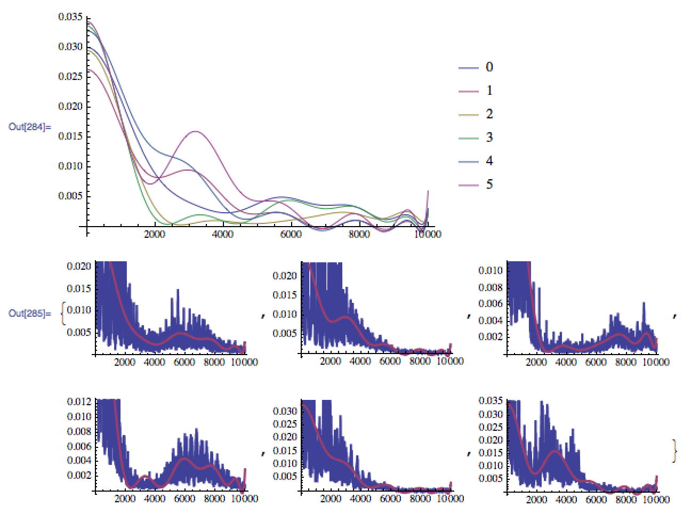

Results of the 6th degree polynomial are decent at up to 6 recordings. The second element at each index is what that position was classified as. Each row is 1 word. For example, row 1 is me saying “zero”, row 2 is me saying “one.” The first element at each element is the time it took to perform all integration and decide which of the classifying polynomials was most similar to each test recording. This is just for interest of showing how fast the computation is, although the measurement metric may not be great.

**Initial test**: 4 words, 20 recordings.

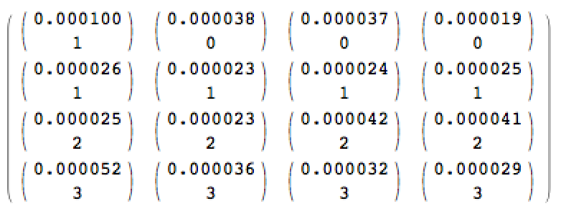

**Recent test**: 6 words, 36 recordings.

