Project Gray Zone
Project Gray Zone is an initiative launched by Kalyna OSINT on 12 February 2026. The concept of the “grey zone” has shifted alongside changes in the nature of warfare, and our objective is to update the public conceptual framework through which grey zone spaces are understood, while encouraging the OSINT community to revise how the term is defined in open-source analysis. This page will continuously compile definitions, terminology, case studies, and sources.
This analysis will be updated as research progresses and additional data becomes available. What you see here is not a final version. You can re-enter this page at any time through the “Projects” section of the Kalyna OSINT website.

New Mapping Reference Standard
As our definition of the grey zone evolves, the front line depicted on the Kalyna Battle Map will also be adjusted to reflect this framework. We will initially apply this standard in the Dnipropetrovsk and Zaporizhzhia regions.
Under the new model, the front line no longer contains a grey zone. It consists solely of red and blue control areas and the zones in which they overlap. Positions of opposing forces are interwoven; within the bi-colored areas, both friendly and enemy positions exist simultaneously. The implications of this approach are explained below.
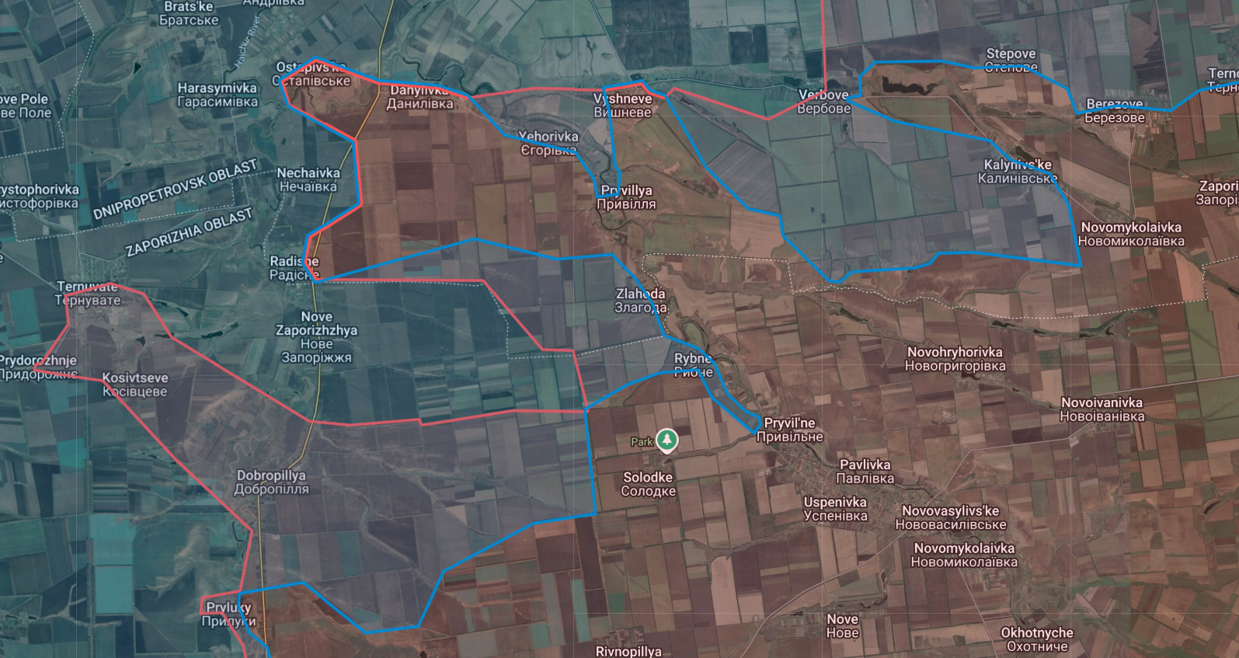

The Grey Zone in Its Previous Definition
In earlier analyses, particularly during 2023–2024, war-research institutions and the OSINT community generally defined the grey zone as either overlapping with, or identical to, a combat zone. The grey zone referred to an area in which neither side maintained permanent positions, while the combat zone described an area both sides could temporarily enter and contest but were unable to hold.
Conversely, both sides were understood to maintain stable control lines. Within these lines, friendly forces occupied all positions and controlled all reinforcement routes, establishing stable territorial control with minimal concern for enemy infiltration. Under those conditions, geolocation was a reliable indicator of front-line change: positions struck by the enemy implied friendly control, positions struck by friendly forces implied enemy control, and areas with frequent mutual strikes were classified as contested.

The “Grey Zone” Today
Since 2025, the spatial structure of the Ukrainian front has undergone a fundamental transformation that renders the traditional concept of the grey zone analytically obsolete. In earlier military frameworks, the grey zone was understood as the area between two stable control lines—an area lacking permanent garrisons but accessible to both sides for temporary entry and combat. This concept depended on a key assumption: that the front itself was continuous and linear, with opposing positions facing one another and shifting through advance or withdrawal. Once this linear structure collapses, the grey zone—defined as the space between two lines—loses its conceptual foundation.
The contemporary front no longer appears as an empty band between two continuous lines. Instead, it is a network of dispersed positions. There are neither clear separations between positions nor stable unoccupied areas. Opposing positions coexist within the same geographic space and interpenetrate in depth. Consequently, under present battlefield conditions, no stable, continuous area devoid of both sides’ positions can be meaningfully described as a grey zone. The spatial structure implied by the traditional concept has been fundamentally reconfigured under drone-dominated attritional warfare.

Infiltration Warfare and Presence-Based Occupation
The prolonged attrition of the full-scale war—especially the sustained depletion of Russian armored forces, mechanized assault capability, and training quality—has forced a fundamental shift in Russian offensive methods. Traditional armored breakthroughs and systematic clearance operations have become difficult to sustain under high-loss conditions. Russian forces have increasingly turned to dismounted infantry infiltration.
The core of this approach is not the immediate destruction of defending forces and stabilization of territory, but the ability to penetrate deeper positions covertly and survive there. The primary task of small infantry groups is not combat but arrival, concealment, emplacement, and persistence.
This logic of presence-based occupation transforms positions from combat nodes into existence nodes. If personnel can reach a location and establish a sustainable shelter or foothold, a forward presence is created even without immediate tactical superiority. Over time, these dispersed presence points can evolve into more stable positions through resupply, rotation, and manpower accumulation. Once sufficient density is achieved, adjacent defensive positions may be forced to withdraw under pressure and attrition, resulting in territorial gain. Occupation thus emerges through survival and accumulation rather than decisive assault.
This shift is closely tied to current Russian force structure. Limited training and reduced effectiveness in close-range engagements incentivize infiltrating infantry to avoid contact. Firefights increase casualties and risk exposure to drones. The optimal state for infiltrating groups is long-term concealment without detection. This logic produces large numbers of opposing positions coexisting in close proximity without direct combat, fundamentally altering front-line contact dynamics.

Position Survival Logic Under Drone Dominance
Persistent surveillance and precision strike by drones have made exposure itself the primary lethal factor on the battlefield. Infantry detected in open terrain are typically struck within minutes by FPV drones, loitering munitions, or indirect fire. The spaces between positions are therefore no longer maneuver corridors but highly lethal exposure zones. Soldiers caught between positions rarely survive for long; they must either reach a defensive structure quickly or be destroyed in transit.
Under these conditions, the core function of a position shifts from fighting to survival. The primary purpose of positions becomes concealment and protection rather than firing capability. Many positions deliberately minimize activity or fire to avoid drone detection (Martin, 2026). As a result, opposing positions increasingly coexist at extremely short distances without direct engagement. Within the same building complex, street block, or even adjacent basements, hostile positions may exist simultaneously, with drones and indirect fire—not infantry—conducting the actual combat. As described by front-line personnel, one basement may hold Ukrainian troops, the next Russian troops, and then Ukrainian troops again, and these positions may never exchange fire (Martin, 2026), because the entities that fight are drones, not the positions themselves.
This spatial structure directly negates the traditional meaning of the grey zone. What was once conceptualized as unoccupied space between positions no longer exists as habitable tactical terrain. The gaps between positions are lethal exposure zones, not maneuver space. The “unoccupied area” implied by the grey zone has therefore disappeared in practice.

Depth Interpenetration and Positional Interweaving
Infiltration warfare has also produced extensive depth interpenetration along the front. Because both sides rely on small infiltrating elements to establish presence points, positions are no longer arranged linearly but in a network pattern. Ukrainian small positions can sometimes be found several to more than ten kilometers behind Russian lines, while Russian infiltration groups may pass through Ukrainian positions and remain concealed for extended periods (Martin, 2026). Positions thus form island-like distributions rather than lines.
Such positions cannot be considered grey zone. They possess clear affiliation, tasking, and supply logic, and their objective is sustained presence. Their roles may include simulating forward presence, maintaining territorial narratives, observing, or awaiting further action. Even if these positions cannot expand, their existence still constitutes effective forward presence. The front line concept therefore shifts from a continuous contact line to a set of outermost presence points. Control is determined not by line continuity but by positional reach.
This depth interweaving renders traditional front-line mapping inadequate. The coexistence of hostile positions within the same area has become normal rather than exceptional. The front is no longer the boundary between two colors but the overlap of both.

Tactical Structure in the Drone Age
Drone-saturated conditions have also altered tactical-scale combat. Classical concepts such as encirclement, flanking maneuver, and tactical isolation—central to traditional doctrine—are increasingly difficult to achieve at positional scale. Positions lack safe maneuver corridors; exposed movement invites drone strikes. Encirclement therefore tends to occur only at operational or strategic scale, not between adjacent positions. Mutual support between nearby positions is also limited because any exposed reinforcement movement is highly vulnerable.
Assault dynamics are consequently shaped by positional dispersion. Once an assault group reaches a target position, defenders often cannot receive support from neighboring positions. Combat rapidly devolves into close-range explosive clearance within bunkers and buildings. This environment produces highly stochastic outcomes and heavy casualties. Russian forces may attempt assaults frequently but cannot reliably control losses or results. A successful assault often requires prolonged preparation, including drone activity pattern analysis, weather window selection, route and vehicle matching, and personnel accumulation and rotation. The cycle of a successful operation may last weeks, fundamentally different from classical rapid assault doctrine.

The End of the Grey Zone Concept
Taken together, these changes lead to a clear conclusion: the traditional grey zone no longer exists on the contemporary front. The previously assumed area devoid of both sides’ positions has disappeared under drone surveillance and infiltration warfare. It has been replaced by a spatial structure of positional interweaving, in which opposing positions coexist within the same geographic area without forming continuous control lines. The front is no longer composed of an empty band between red and blue but of red and blue control areas and their overlap.
The overlap zone is not a transitional or contested band but a coexistence zone. Both friendly and enemy positions exist simultaneously within it; control is non-continuous, and contact is primarily conducted by unmanned systems. The outermost position defines forward presence rather than linear contact. Under this structure, the grey zone loses both spatial and tactical meaning and should be removed from mapping and analytical frameworks.

New Mapping Representation and Assessment Standard
In response to these battlefield realities, Kalyna Battle Map will eliminate the traditional grey zone and instead depict front lines as red and blue control areas and their overlap. Red and blue areas represent the outermost sustained positions of each side, while overlap represents spatial interweaving of opposing positions. This representation no longer assumes continuous control lines or stable empty space between them.
Position assessment will be based on presence and survivability rather than linear contact. Regardless of whether a position is reached through infiltration, concealment, post-assault occupation, or other lawful means, if it can sustain itself and function as a position, it is considered valid forward presence. Connectivity or expansion is not required. Even positions located deep within enemy rear areas are included if they persist. This standard reflects the true spatial structure of the drone-era battlefield and updates the OSINT community’s conceptual framework for understanding the grey zone.

References
Martin. (2026.). Post on X (Twitter). https://x.com/TuiteroMartin/status/2021980963253756136?s=20

