Lesson 1: Intro to SQL

## Learning Check

1. What does SQL stand for?
   1. Simple Query Language
   2. Structured Query Language
   3. System Quality Logic
   4. Standard Query Layout

* ***Correct Answer: B***

1. What is SQL usually used for? *(Select all that apply)*
   1. Creating and managing databases
   2. Writing code for mobile apps
   3. Querying and analyzing data
   4. Connecting relational database tables

* ***Correct answers: A, C, D***

1. In a relational database, data is typically organized into one large table to make querying faster. *(TRUE/FALSE)*

* ***Correct Answer: False***. Relational databases use multiple related tables to store data efficiently and minimize duplication.

1. In a relational database, a foreign key is a unique identifier for each row in a table. *(TRUE/FALSE)*

* ***Correct answer: False***. A primary key is a unique identifier for each row. A foreign key is a reference to a primary key in another table, used to link tables together.

1. What SQL keyword is used to retrieve data from a table?
   1. GET
   2. FETCH
   3. SELECT
   4. OUTPUT

* ***Correct answer: C***

## Exercise

1. Using the ERD provided in this course, identify the primary key and foreign key(s) in the following tables:

* residents
* intakes

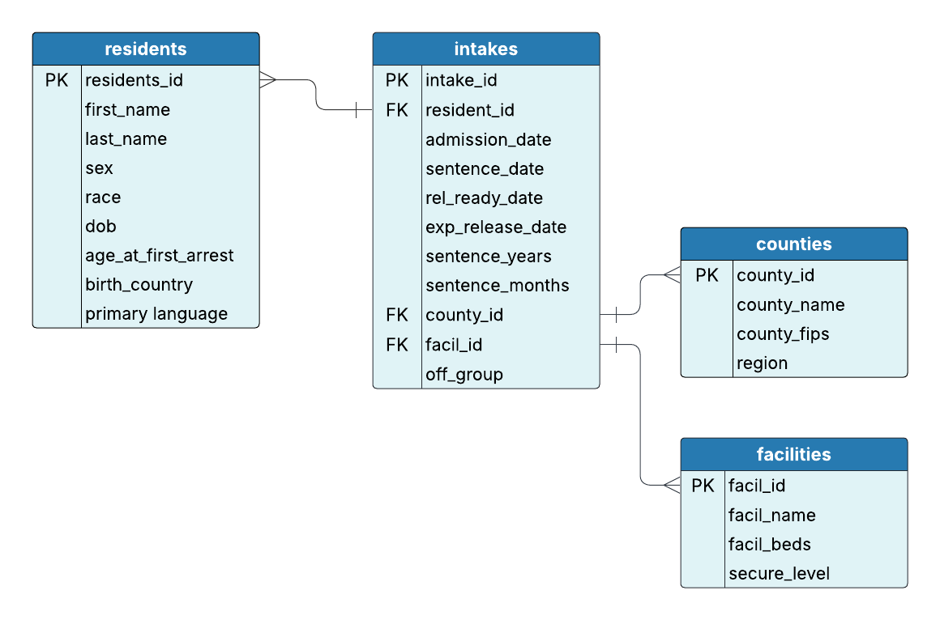

Show the answer

residents

* Primary key: resident_id

intakes

* Primary key: intake_id
* Foreign key(s):
  + resident_id (which references residents)
  + facil_id (which references facilities)
  + county_id (which references counties)

1. Write a query to retrieve all resident ids and their age at first arrest.

Show the answer

Query:

SELECT resident_id,   
 age_at_first_arrest  
FROM residents;