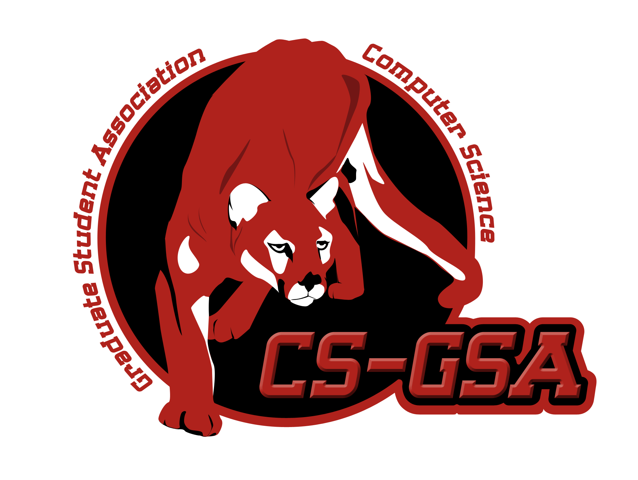

CSGSA hangout for Spring 2015

Do you feel like grabbing beer one day after class? Do you want to meet up with colleagues from CS department? Here is the event for you! CSGSA would like to invite you to have this great opportunity to meet other graduate students.

Feel free to come with your friends. Go Coogs!

When: 6:00pm – 9:00pm Thursday April 16, 2015

Where: Calhoun Rooftop at University of Houston (On Campus Bar)

Who: All students, faculty and staff are welcome.

\* Bring your Photo ID

