Group 7: LLMotive
Project Title: Summarization of a Stack of Papers using LLMs (SSPL) – Stage 3

Arianna Matienzo
Website Designer

Atharva Dalvi
System Architect

Khushi Nankani
Data Reporting Analyst

Olu Ogunnirian

Marketing Designer

Abstract — As academic literature continues to expand, keeping up with key insights becomes increasingly challenging. Traditional summarization methods are often time-consuming and labor-intensive. This project explores how Large Language Models (LLMs) can automate the process in a three-step approach: first, summarizing individual papers, then categorizing them by topic, and finally combining the summaries into a cohesive document. By leveraging LLMs’ natural language processing capabilities, the system aims to improve literature review efficiency, allowing researchers and professionals to quickly grasp essential insights without sacrificing accuracy or detail. Early-stage prototypes have demonstrated a functional system that processes papers at scale, and ongoing improvements focus on enhancing summarization speed and handling domain-specific technical language.
Keywords: Summarization, Automated Literature Review, Research Synthesis, Prototype, LLM

DESCRIPTION
As the volume of academic literature grows, efficiently synthesizing insights from multiple sources remains a challenge. Building on our Stage 2 framework, we now have a fully functional front end and back end that processes and summarizes collections of research papers. The system not only generates individual paper summaries but also produces a higher-level meta-summary that condenses these into a single, cohesive overview.
In our current demo, the system successfully processes 8 test papers and generates the final summary in approximately 325 seconds. This three-stage workflow—topic recognition, summarization, and collation—has been extended to include summary-of-summaries, enabling users to quickly understand the key insights of entire literature sets through an intuitive interface.

MOTIVATION
Our goal in Stage 3 is to move from concept to application by delivering a practical and interactive summarization tool using some AI tools and LLM's. The exponential growth of research continues to overwhelm researchers, and our solution addresses this by enabling fast, structured knowledge extraction at scale.
By summarizing both individual documents and their collective insights, we aim to:
- Improve the speed and depth of literature synthesis.
- Reduce cognitive load through layered summarization.
- Enhance cross-paper connections and topic understanding.
- Support researchers with an accessible, ready-to-use interface.
This stage brings us closer to a scalable solution for accelerating research workflows and making academic insights more actionable.

- DESIGN DETAILS
Class Diagram: This diagram outlines the system’s class structure across the Web and Processing layers. It shows how the FlaskApp interacts with components like Summarizer, PDFProcessor, and TopicModeler to handle PDF summarization and topic visualization.
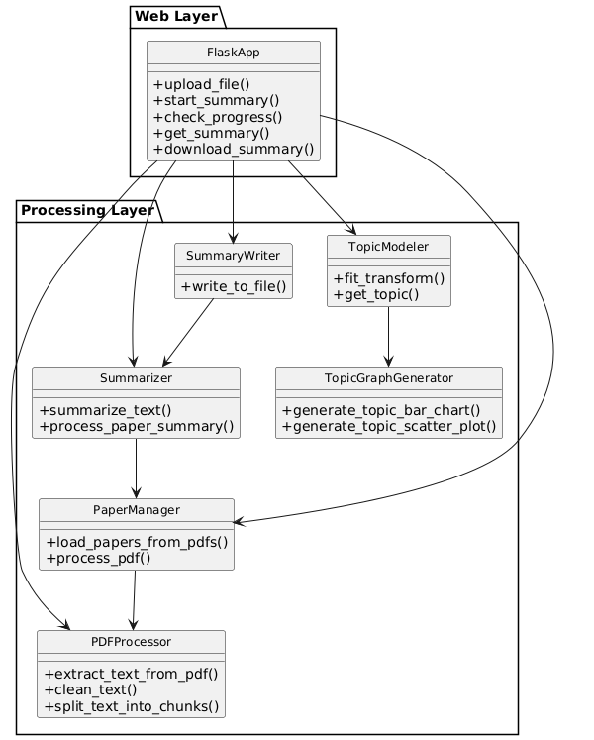
Use Case Diagram: This use case diagram shows how a user interacts with the summarization system. Key actions include uploading PDFs, starting summarization, checking progress, downloading summaries, and visualizing topic data.
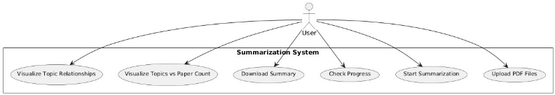
Sequence Diagram: This diagram illustrates the step-by-step interactions between the user and backend components during the process of PDF summarization and topic modeling. It shows the method calls and data flow between modules like FlaskApp, PDFProcessor, Summarizer, and TopicModeler.

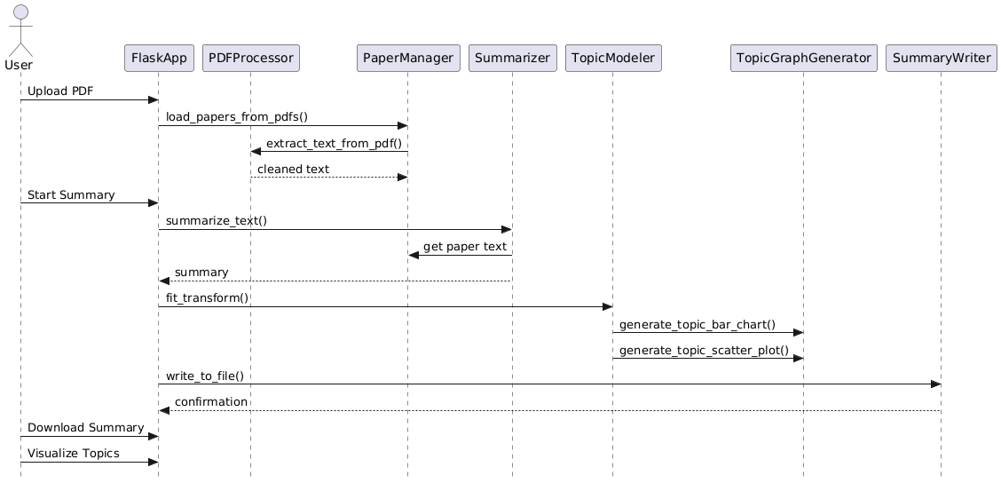
System Architecture: This diagram presents the overall architecture of the summarization system using LLMs. It shows how the client, Flask server, backend processing pipeline, and file system work together to extract, summarize, and visualize PDF content.
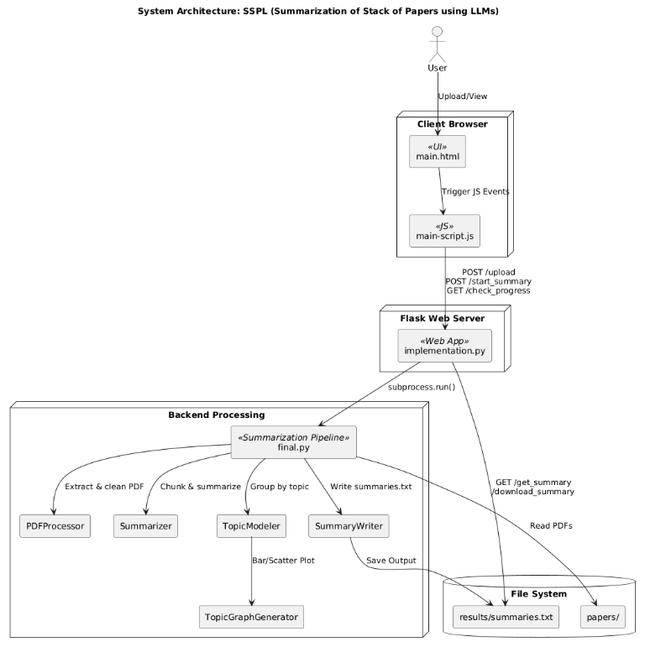
Flowchart: This flowchart outlines the overall workflow of a PDF summarization system, from uploading a PDF to generating summaries and visualizations. It highlights key stages like validation, text extraction, summarization using LLM, topic grouping with BERTopic, and output generation.
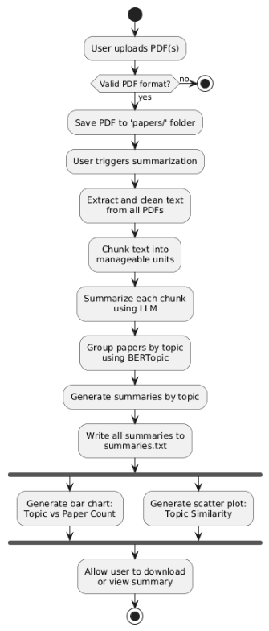
- IMPLEMENTATION DETAILS
Implementation overview: The Paper Summarization and Knowledge Graph Generation project is a tool that lets users upload PDF research papers. It reads the content, picks out the main ideas, and creates a visual map (knowledge graph) to show how key concepts are connected. The system is built using Flask for the website, and uses spaCy and Transformers for understanding and summarizing the text. It's packed into Docker containers, making it easy to run and expand when needed. The main features are: reading PDFs, summarizing the content, and creating knowledge graphs
How to implement your project? Any related key technique(s):
- Flask: Handles API requests (file uploads, summarization start, progress tracking).
- spaCy/Transformers: Used for text extraction and summarization.
- Docker: Containers the app for easy deployment.
What functionalities have been done?:
- PDF file upload and parsing.
- Text summarization using NLP models.
- Knowledge graph generation.
- Real-time progress tracking via API.
What functionalities remain to be done?:
- Optimize PDF processing speed.
- Improve error handling and logging.
- Implement user interface enhancements.
- Optimize model performance and memory usage.
Any implementation/technical issue?:
- High Memory Usage: NLP models consume significant memory.
- Slow PDF Processing: Parsing large PDFs can be slow.
- Timeouts: Large files may cause timeouts on cloud platforms.
- Scaling: Needs better task management and scaling for large loads.
Any experimental results:
- For the test run, we ran the code using 8 test files. The run time of the code is around 900 sec.
- For a full run, we ran the file on 52 papers and had a run time of around 10 hours.
- We then applied some steps to reduce the runtime significantly but it resulted in depreciating the quality of the summary.
Analysis of experimental results:
- The test case execution time is optimal, and although the full processing run takes around 10 hours, this is significantly more efficient compared to manually reading and summarizing the papers. Given the nature of the task, the code offers a better alternative in terms of scalability and speed.
- The current setup strikes a balance between runtime and summary quality, ensuring the best possible summary generation within a reasonable timeframe. User feedback has been favorable, highlighting the efficiency and accuracy of the application in producing high-quality summaries.
- LOCAL/GLOBAL IMPACTS
The local and global impacts of our project on individuals, organizations, and society are to meet the needs for efficient and effective ways to handle the vast amounts of academic literature produced every year.
- Impact on Individuals:
Time Efficiency: Students and researchers can use this system to effectively summarize and save hours on reading materials. It will allow them to instead focus more on analysis, hypothesis generation, and advancing their own research.
Accessibility for Non-Experts: The system can make complex academic literature more accessible to individuals without deep domain specific knowledge.
- Impact on Organizations:
Enhanced Research Productivity: Academic institutions, research organizations, and companies can improve their research productivity. Researchers can process large volumes of papers more quickly and identify valuable insights, helping organizations keep up with the rapid race of research development.
Increased Competitive Edge: For businesses, especially in fields like pharmaceuticals, tech, or engineering, the ability to efficiently process and synthesize research can give them a competitive edge. Staying ahead in research can lead to innovations that differentiate them in the market.
- Impact on Society
Accelerated Innovation: By streamlining the literature review process, the project can speed up the discovery and application of new knowledge. This can drive advancements in critical areas such as medicine, climate change, engineering, and technology, benefiting society.
Improved Policy Making and Social Change: Governments and policymakers can use the system to synthesize research findings quickly and accurately, enabling them to make evidence-based decisions. This could be especially impactful in areas like healthcare policy, education reform, and environmental policy.
The local and global impacts of our project are significant, both in terms of improving individual research practices and contributing to larger societal benefits. By improving efficiency, accessibility, and knowledge sharing, the system has the potential to drive innovation, foster collaboration, and support informed decision-making across various sectors.

TEAM MEMBERS CONTRIBUTIONS

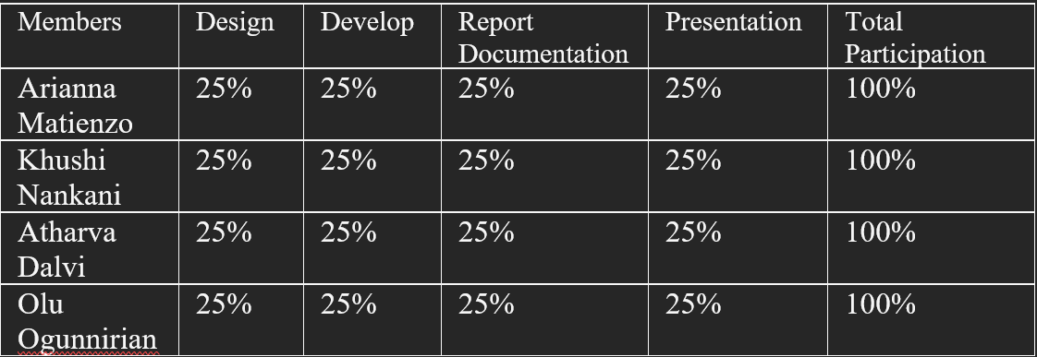

Application Details
https://youtu.be/smVq01zN1ok

1. Application to upload files, check the files uploaded are correct, and get the completed summaries are ready to use.
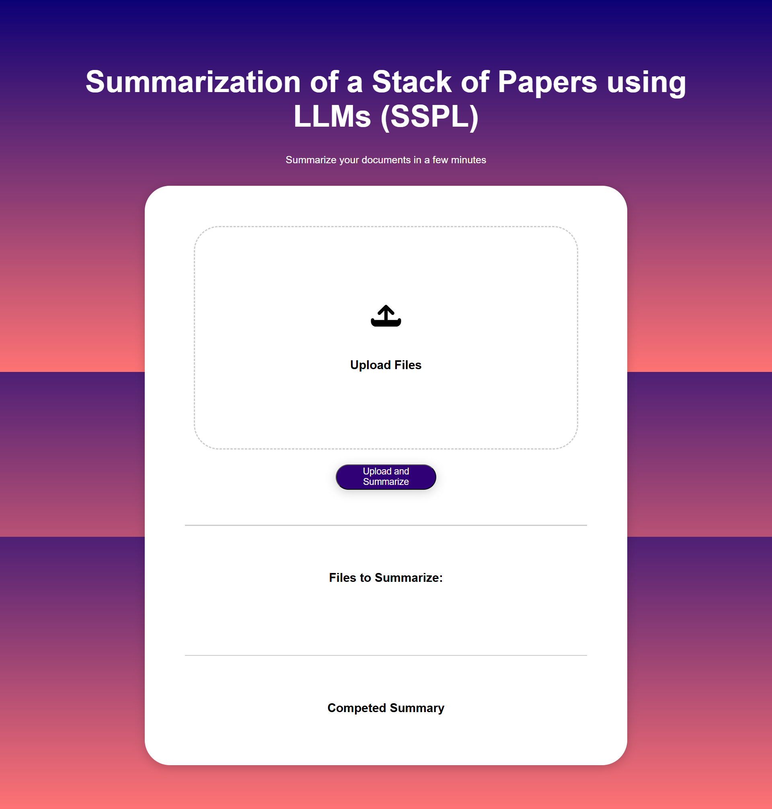
2. Uploaded files are being summarized
3. Backend showing the progress of summary
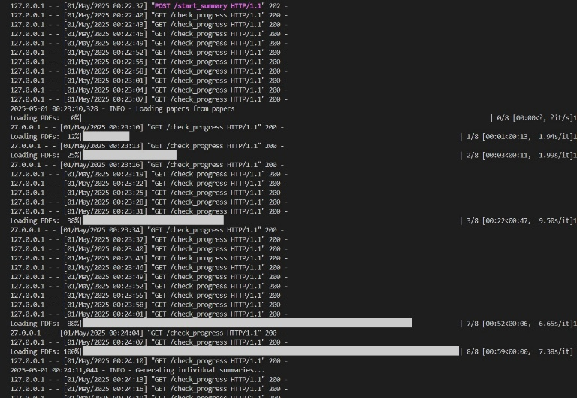

4. Summaries and Knowledge Graph has been generated
5. Results being generated on the backend

6. Knowledge Graph
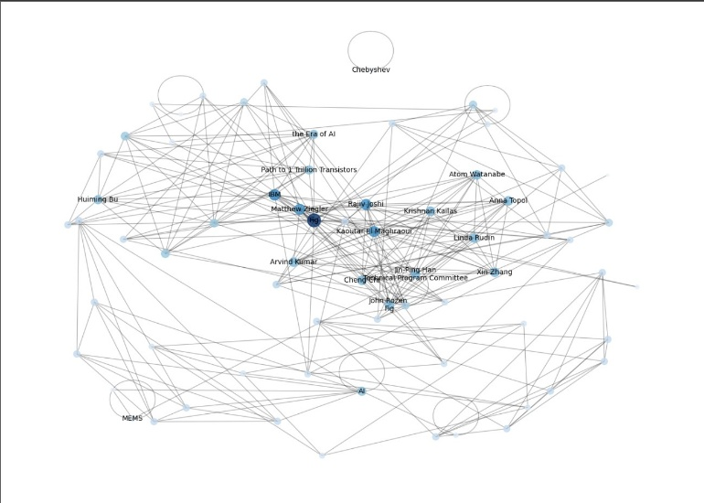

VALIDATION OF THE APPLICATION
To get user feedback for our application, we asked the following prospective users about their opinions.
- Dr. Amrika Deonatine, Assistant Professor, TTU
- Dr. Kishor Mehta, Horn Professor, TTU
- Dr. Evan Gray, Assistant Professor, TTU
- Hossein Ebadi, Research Assistant, TTU

Below are the results:

https://forms.office.com/Pages/AnalysisPage.aspx?AnalyzerToken=mlBxkfkI5LlwiAQdNjSghqtnmiubx6GY&id=v1GKFyCL_0m2VVYkXVwXPFXXoGyA9vZNlgB4LUd5M4FUNlg1QlQzM0xSOUQ2Q0NYREVIMDhaN1pLOS4u

