**User’s**

**MANUAL**

*IoT device management and control service using RPA*

**Team Generator**

December 2020

**Revision Sheet**

|  |  |  |
| --- | --- | --- |
| **Release No.** | **Date** | **Revision Description** |
| Rev. 0 | 12/14/2020 | User’s Manual Template and Checklist |
| Rev. 1 | 12/15/2020 | Initial Work |
| Rev. 2 | 12/19/2020 | Revision 1: To Reflect Prototype 1.0 |
|  |  |  |
|  |  |  |
|  |  |  |
|  |  |  |

**USER'S MANUAL**

**TABLE OF CONTENTS**

Page #

A. **INTRODUCTION** **4**

1.1 Package Contents 4

1.1.1 Software 4

1.2 Specification 4

1.2.1 Product Specification 4

1.2.2 Requirement Specification 4

B. **SYSTEM Install Guide** **6**

2.1 System Summary 6

2.2 System Configuration 6

2.3 Install 6

C. **HOW TO USE** **14**

3.1 Log in and Sign up page 14

3.1.1 Login page 15

3.1.2 Sign up page 15

3.2 Main Page 16

3.2.1 Side Menu 16

3.2.2 Top Menu 17

3.2.3 IoT Device 18

3.3 Monitoring Page 19

3.3.1 Sub menu 19

3.4 Building-floor Status Page 22

3.4.1 Minimap Tab 22

3.4.2 Logtable Tab 23

3.5 RPA Solution Program 23

D. **NOTICE** **25**

4.1 Caution 25

4.2 Solution 25

4.3 Caveats and Exceptions 25

E. **REFERENCE** **27**

**1.0 INTRODUCTION**

# INTRODUCTION

## 1.1 Package Contents

#### 1.1.1 Software

This software is divided into 2 parts, one is a web application that keeps monitoring the status of IoT devices’ in the system and alerts when the report documents are ready by the administrator. And the other is an RPA program automating devices’ management. You need a valid key to authenticate for using the RPA program.

## 1.2 Specification

#### 1.2.1 Product Specification

DIMS, A web application for managing IoT devices keeps getting values of IoT devices by a specified url and stores them into the database. It determines each status of devices by 3-Sigma rule. If DIMS detects a non-active status of some devices, The error logs are displayed in the monitoring table. The administrator of these devices can export the current state of devices or error history to write a report document.

CheckMATE RPA, developed by Symation Inc. is a work automation solution for domestic IT environments optimized for diverse user IT environments, helping automate all tasks. It can automate tasks by scheduled method, triggered method, and executed directly by users.

#### 1.2.2 Requirement Specification

System Requirement for CheckMATE RPA

* Processor: Intel Core i5 or higher
* Memory: 8GB or higher
* OS: Windows 7 or higher

Dependencies

* .NET Framework 4.7.2 or higher
* Microsoft VC Redist Package
* Microsoft Office suites
* A Chrome-based web browser

**2.0 SYSTEM INSTALL GUIDE**

# SYSTEM Install Guide

## 2.1 System Summary

Install the CheckMate RPA solution program to run the CheckMate RPA solution program and the exec file created by the CheckMate RPA solution program.

## 2.2 System Configuration

- The RPA solution program must be preinstalled

- Display settings  
 : Change the size of text, apps, and other items as ‘100%’

- Settings > Personalization > Colors

Choose your color : ‘Dark’, Transparency effect : ‘On’

- Background Color of Computer : ‘Black’

- Theme of Excel.exe and Word.exe : ‘Gray’

- Browser : ‘Chrome’, Theme : ‘Black’

- DailyReport_Src.docx file should be in the ‘C:\RPA_Generator\Report\Report Format’ path

- EmergReport_Src.docx file should be in the ‘C:\RPA_Generator\Report\Report Format’ path

- Scale of a word document : ‘80%’

- Close all open windows to run Generator_RPA.exe

## 2.3 Install

Run the provided CheckMate RPA solution program exe file.

When a window such as <Figure 1> appears, click Yes.

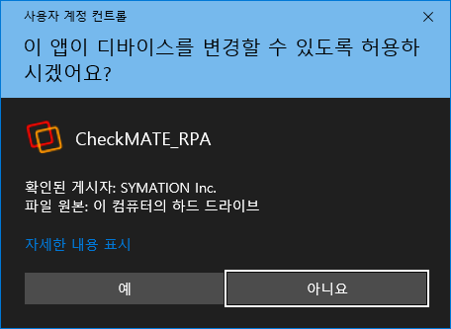

<Figure 1>

When a window such as <Figure 2> appears, check the bottom "I accept the agreement" item as shown in <Figure 2> and click the "Next" button.

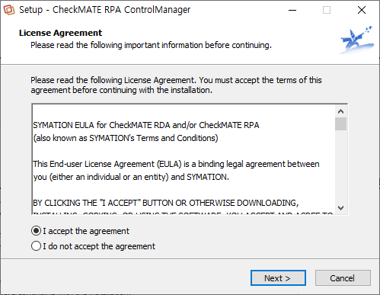

<Figure 2>

<Figure 3> is a window for saving folder paths. The default path is "C:\CheckMATE\RPA\ControlManager" and can be changed. It can be changed after installation. Click the "Next" button when setup is complete.

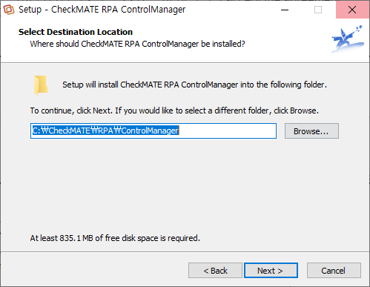

<Figure 3>

<Figure 4> asks if you want to create a shortcut shortcut on the desktop. Checking the "Create a desktop shortcut" checkbox produces a shortcut. Click the "Next" button when setup is complete.

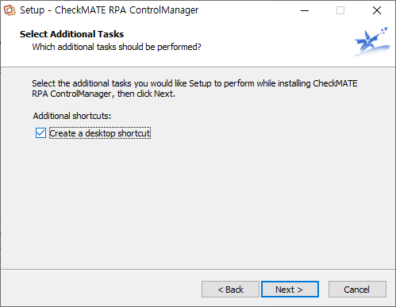

<Figure 4>

<Figure 5> is a window to reconfirm the previous settings. If there is no problem, click the "Install" button.

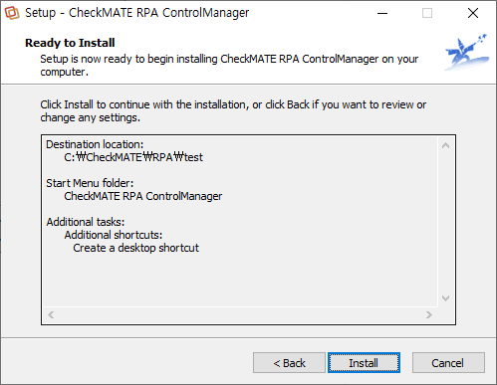

<Figure 5>

When the installation completes successfully, a window such as <Figure 6> appears. When the "Launch CheckMATE RPA Control Manager" checkbox is checked, the program runs after clicking the "Finish" button.

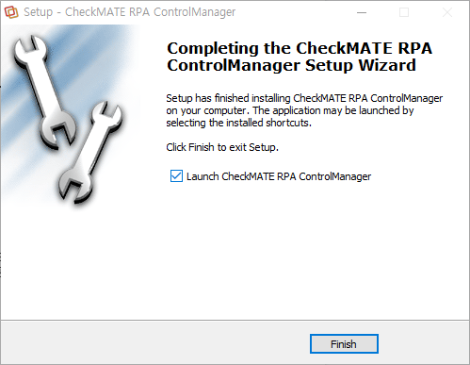

<Figure 6>

<Figure 7> is the window that appears after the program is installed for the first time. Click the "Office License" tab at the top of the window to become like <Figure 8>.

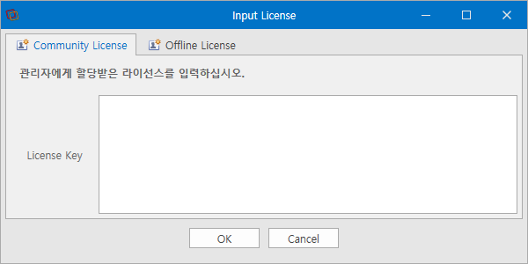

<Figure 7>

In the License Key column of <Figure 8>, enter the license key that you received from Symation and click the "OK" button.

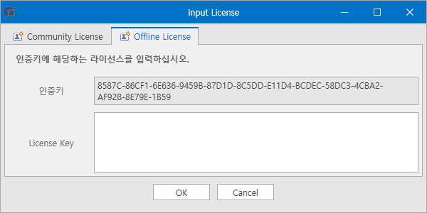

<Figure 8>

**3.0 HOW TO USE**

# HOW TO USE

This service is divided into two parts: web application and RPA solution program.

## 3.1 Log in and Sign up page

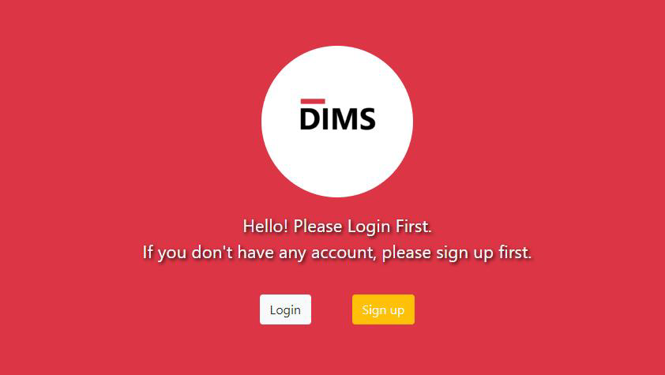

<Figure 9>

This is the screen that is displayed when you first access the web application. This screen has a Login button and a Sign-up button. Here, pressing the Login button switches to the screen that the user can log in, and pressing the Sign up button switches to the screen that the user can sign up.

#### 3.1.1 Login page

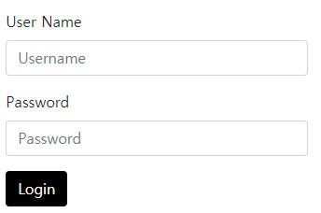

<Figure 10>

In Figure 10, enter the user ID and password and press the Login button to complete the login and go to the Main page

#### 3.1.2 Sign up page

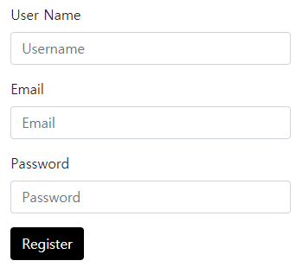

<Figure 11>

In Figure 11, users can sign up by typing User Name, Email address, and Password. Email address is later used to receive information from IoT devices.

## 3.2 Main Page

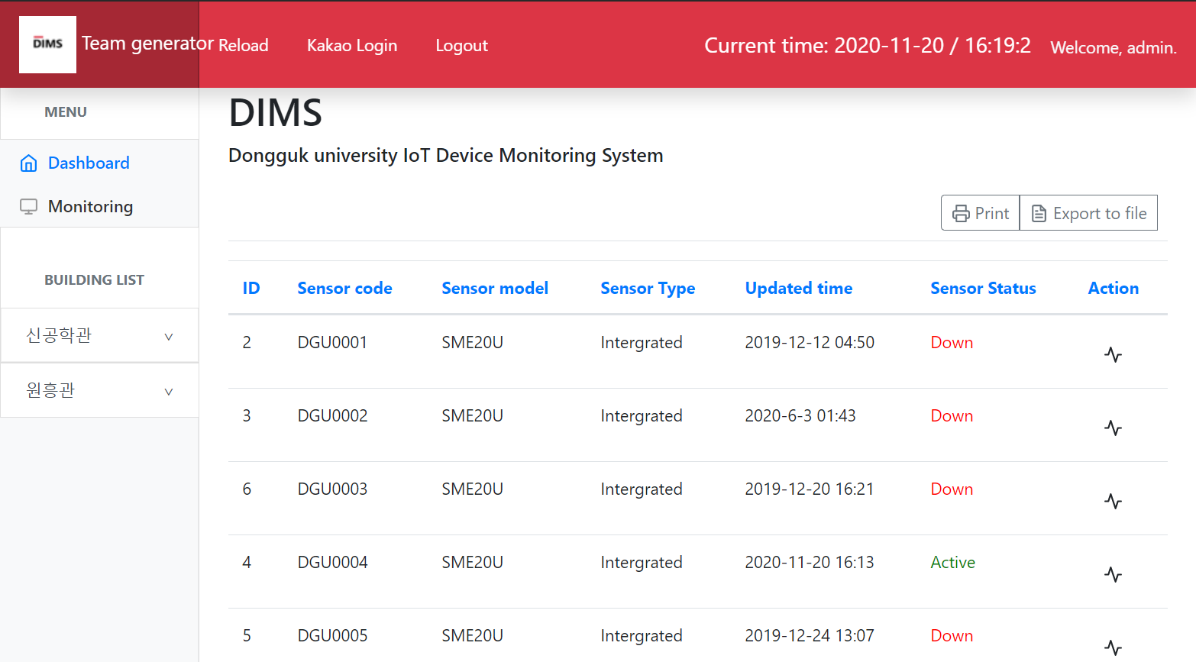

<Figure 12>

Main page provides a Dashboard containing information about all IoT devices in Dongguk University.

#### 3.2.1 Side Menu

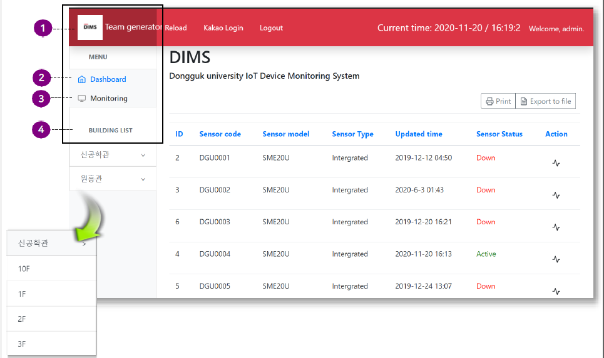

<Figure 13>

① Home Button : Click to return to Main page.

② Dashboard : The menu corresponds to the main page. this screen shows the status and information of all IoT devices in Dongguk University

③ Monitoring :This menu goes to the page that RPA solution program monitors to manage IoT devices.

④ Building List : It lists buildings where IoT devices are located in university.

#### 3.2.2 Top Menu

* + - 1. 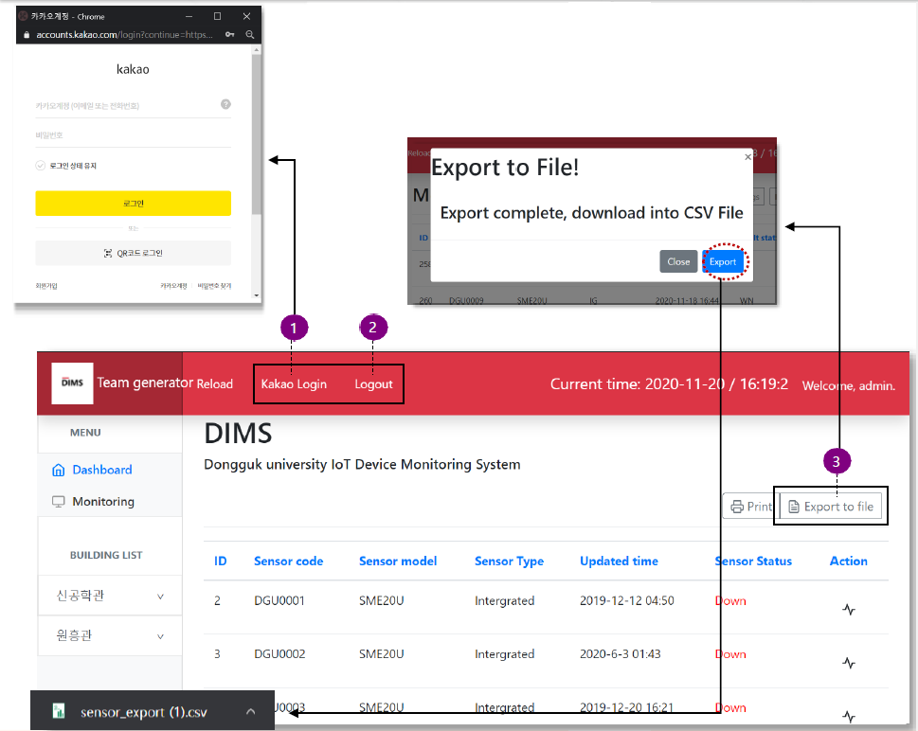
      2. <Figure 14>

① Kakaotalk Login : Click to pop up the Kakaotalk login screen.

② Logout Button : Click to log out the logged-in user account.

③ Download IoT device data : Click to download the csv file containing the status information of current IoT devices

#### 3.2.3 IoT Device

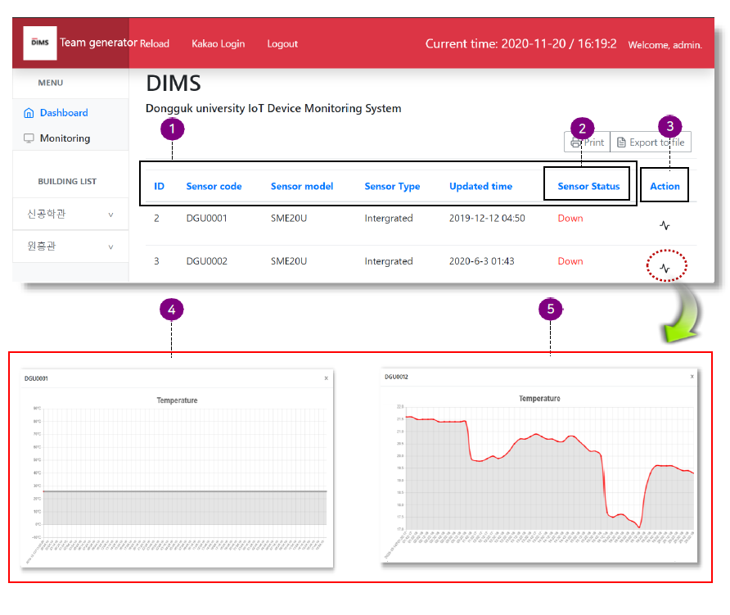

<Figure 15>

① IoT device information : Showing ID, Code, Model, Type, Time that the value has updated, and status of IoT device.

② IoT device Status : The status of IoT device is defined by Down, Active, Warning, Unknown, Error. Down is inoperative, Active is in working condition, Warning is in abnormal state, Unknown is in undefined state, And Error is in error state.

③ Action button : Click to display graphs showing the values of IoT device

④ Graph showing ‘down’ device’s value : The last updated value is displayed as a straight line.

⑤ Graph showing ‘Active’ device’s value

## 3.3 Monitoring Page

This page updates information on IoT devices that are not functioning normally, and the RPA solution program performs the task of monitoring this page.

#### 3.3.1 Sub menu

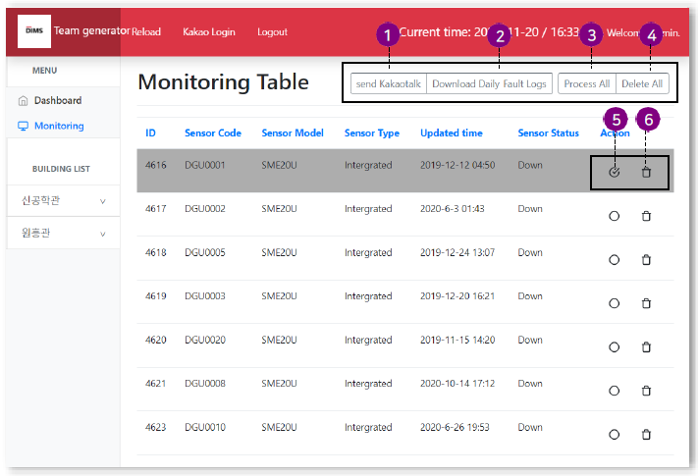

<Figure 16>

① Send KakaoTalk Message button : When a new non-normal Iot device is added to the list, it sends a Kakaotalk message to the specified administrator. THe message sent is shown in Figure 17.

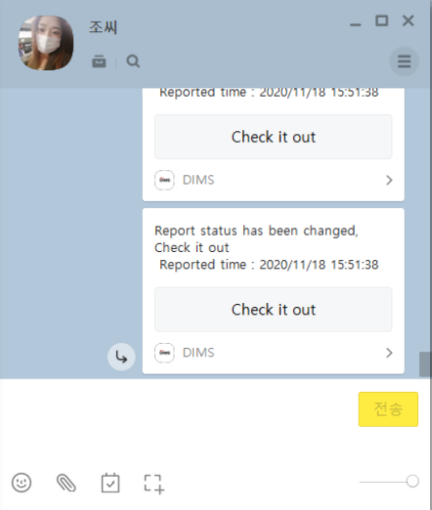

<Figure 17>

② Download Daily Fault Log button : Download the csv file containing the reported fault logs for one day. The RPA solution creates a report through this file. Figure 18 shows the pop-up window that appears when this button is pressed. The download starts when the Export button is pressed.

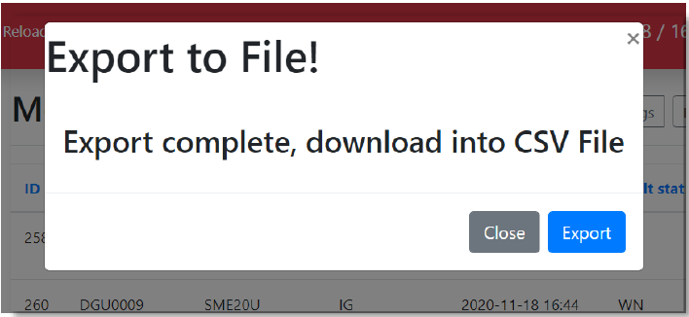

<Figure 18>

③ Process All button : After performing actions 1 and 2 on the updated IoT device fault log list, pressing this button opens a pop-up window in Figure 19. If you select and save the Reported checkbox in this pop-up window, change the report completion option to Reported for all logs

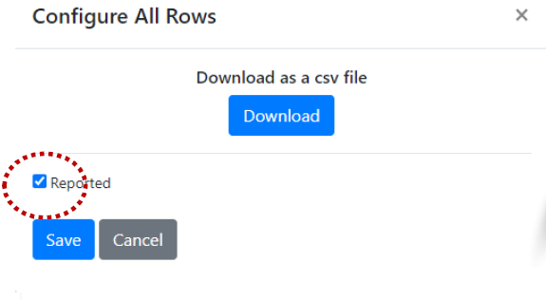

<Figure 19>

The changed logs change background color to gray at the table as shown in Figure 20.

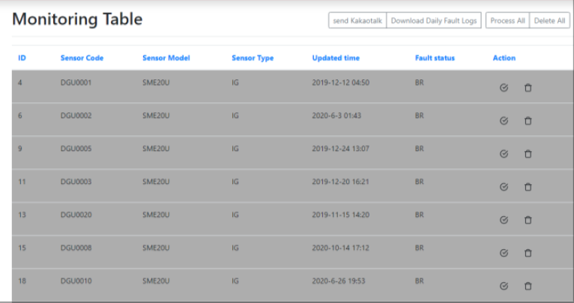

<Figure 20>

④ Delete All button : All IoT device fault logs are treated as processed and deleted from the list

⑤ Process button : A checkmark in the circle of the icon and a gray background indicates that the RPA solution program has completed processing for the corresponding fault log. Click this button to indicate that fault log has been processed.

⑥ trash can icon : Delete the corresponding IoT device fault log.

## 3.4 Building-floor Status Page

This page shows the current status and information of IoT devices that exist on each floor of the building that exist in Dongguk university.

#### 3.4.1 Minimap Tab

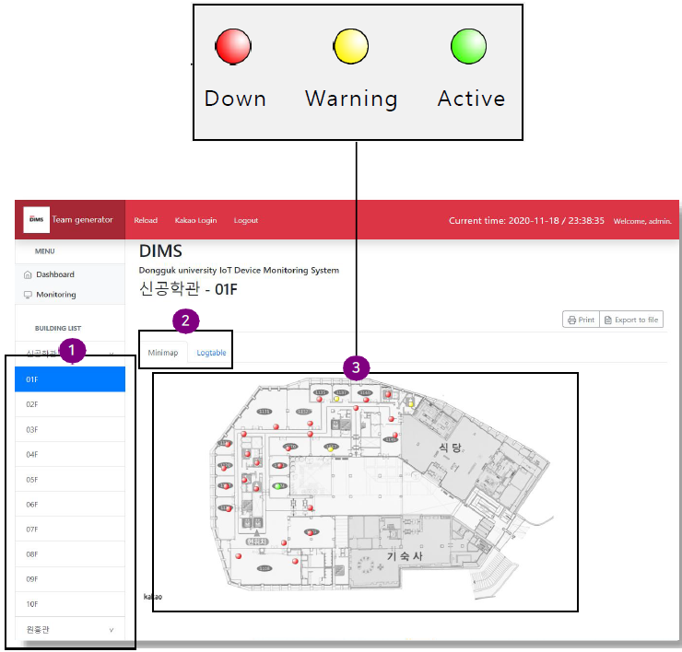

<Figure 21>

①Floor List : This is a list of floors in each building. Click on a specific layer to check the information and status of IoT devices that exist on that layer.

②Select tab : It is a button that selects a tab so that it can check the current status of IoT devices in the form of Minimap or Table.

③Minimap : The current layer’s map is displayed, and the location and state of each IoT device can be visually verified. The Down status is red, Warning status is yellow, ans Active status is green. Clicking on a specific device displays an Info Window for the device.

#### 3.4.2 Logtable Tab

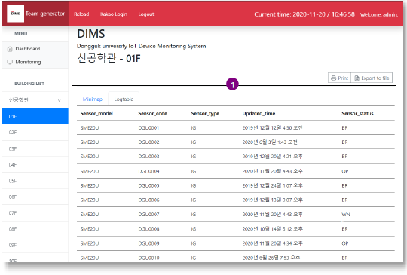

<Figure 22>

① Log table : A table containing the status and information of IoT devices in the current layer, displaying a list of devices and their status in text.

## 3.5 RPA Solution Program

The RPA solution program works by converting existing scripts into executable files to execute them. The environment for executing the RPA solution program can be set up with reference to 1.2.2. When the configuration is complete, the RPA robot will operate when you run Genenrator_RPA.exe.

**4.0 NOTICE**

# NOTICE

## 4.1 Caution

1. the screen on the web page does not appear.

2. Information from IoT devices may be missing if the Internet connection is lost.

3. The Generator_RPA.exe file does not function normally. (4.2 Solution > 3)

## 4.2 Solution

**1. check the Internet connection status**

**2. Maintain A Steady Internet Connection**

**3. The Generator_RPA.exe file does not function normally**

: Check again ‘2.2 System Configuration’ to see if the setting for RPA solution operation is set correctly. If the setting is correct, check the 4.2 Solution for 3_1, 3_2 if any errors occur.

**3_1. When a Web page has been modified**

: CheckMATE RPA provides image recognition. Therefore, if visual changes occur through web page modifications and UI changes, the RPA script must also be modified accordingly.

**3_2. When the notification window appears**

: While RPA is running, please turn off advertising or popup (e.g. messenger pop-up) notifications.

## 4.3 Caveats and Exceptions

If authentication expires when using the RPA program, you must contact SYMATION to resolve it.

**5.0 REFERENCE**

# REFERENCE

CheckMATE RPA Solution User Manual

RPA Script Creation Manual