# Version control of IMOS processing template

Now onwards IMOS processing will be using only two templates as below.

1. IMOS_BASOOP_template_Ex60: for processing Ex60 data i.e. EK60, ES60, and ES70
2. IMOS_BASOOP_template_Ex80: for processing Ex80 data i.e. EK80 and ES80.

Templates are not frequency specific, can be used for processing both single and multi-frequency data with any channel order (currently for 18, 38, 70, 120, 200 kHz). This avoids maintaining a separate template for 38 kHz. Echoview now figure out channel order in the raw files, no need to be strictly in ascending order, avoiding the usage of ekshuffle.jar and ek80shuffle.jar for shuffling the channels.

The precondition with this change is the SourceCal numbering in the ECS file. For example: in the ECS file, SourceCal T1 should be defined for 18 kHz and SourceCal T2 for 38 kHz etc.

'check_ecs' function (implemented in the processing GUI) will check for this and re-number SourceCal field if there is any mismatch between ECS file and template. This function assumes that for IMOS processing old versions of template will not be used. If you are using old 38 kHz template, there will be a problem because check_ecs function will re-number SourceCal field in the ECS file as a result calibration values will not be applied!

At this stage we have to maintain only two template versions for processing IMOS data. The table below captures the changes made to the template.

Backup files are in the archive locations- all old\deprecated versions are there.

\\oa-archive-hba.it.csiro.au\OA-BA-SOOP-ARCHIVE

# What are the export variables from Echoview?

The figure (Figure 1) below shows the export variables in Echoview and corresponding echo integration CSV files (green for fast processing and red for slow processing). Shown only for 38 kHz channel. Some of the variables are grouped for simplifying the template view. Expanded here for demonstration purpose.

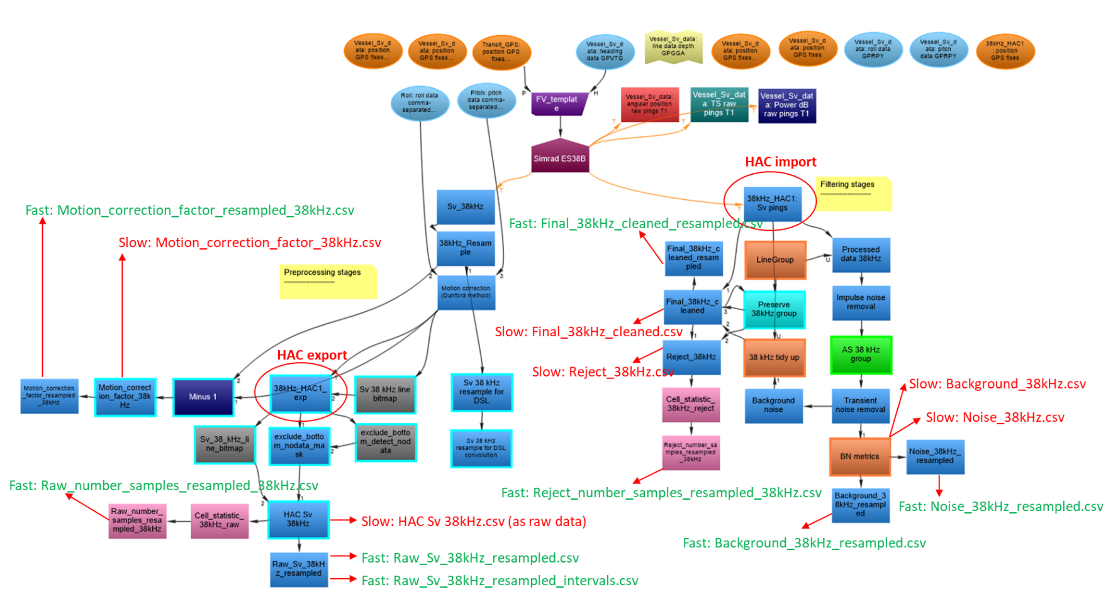

Figure 1. Export variables in Echoview and corresponding echo integration CSV files (green for fast processing and red for slow processing).

|  |  |  |
| --- | --- | --- |
| **Date** | **Template version** | **Reason for modification** |
| 2019-11-26 | IMOS_BASOOP_template_Ex60_V1.26  IMOS_BASOOP_template_Ex80_V1.26 | For implementing fast processing routine and standardising the templates. Note that fast processing results are matching with historical processing. For more information see Q:\Analysis\Check_fast_processing_method |
| 2019-11-27 | IMOS_BASOOP_template_Ex60_V1.27  IMOS_BASOOP_template_Ex80_V1.27 | Delete unused legacy lines ‘Sv_xx_kHz - Picked Line’ and ‘UpperLine_xx kHz’ to keep ‘Line and Surface (2)’ tab simple. No variable uses these lines. The template now has frequency specific lines and removal of unused lines will simplify this view for easy selection\edit while reviewing EV files. Echoview may implement a sort option here in future release.  The frequency specific lines used in template are given below.  acoustic bottom_xxkHz: frequency specific acoustic bottom  exclude firepulse_xx kHz: frequency specific exclude fire pulse line  Lower Line_xx kHz: frequency specific line for preserving schools from transient noise removal filter  upper DSL line_xx kHz: frequency specific line for attenuated signal removal operator  Lower DSL Line_xx kHz: frequency specific line for attenuated signal removal operator |
| 2019-11-27 | IMOS_BASOOP_template_Ex60_V1.28  IMOS_BASOOP_template_Ex80_V1.28 | Delete unused legacy regions ‘Set all good’, ‘impulse_noise_preserve’, and ‘Background_noise_preserve’. No variable uses these regions.  The frequency specific regions used in template are given below.  xx kHz bad: frequency specific bad data region  all channels bad: to set all channel bad  Preserve xx kHz: frequency specific ‘Analysis’ region to preserve frequency specific data from filtering stages  Preserve all freq: to preserve all channels from filtering stages  These regions are grouped under ‘Regions_all_channel’. |
| 2020-01-02 | Ex60_V1.28  Ex80_V1.28 | Shortening EV file name to avoid windows directory path length error while exporting NetCDF. Note that template name is used to create processed data folder. |
| 2020-08-24 | Ex60_V1.29  Ex80_V1.29 | The operator xxkHz_HAC1:Sv pings copy controls the behaviour of data subject to filtering stages. This copy operator is followed by a ‘Processed data’ operator, and any settings defined in the copy operator will flow through the filtering chain. Earlier in the ‘Analysis’ domain, ‘Exclude below’ and ‘Apply bad data regions’ were enabled for this copy operator. This means that filters were working on the data retained after applying regions (for example bad data region and acoustic bottom).  Now unselecting those options with an intention that filters should work on the original data before applying any bad data regions. Note that this change only affects filtering operators where calibrated raw data before applying any bad data regions will be used.  This change was also needed to export ‘background noise’ and ‘SNR’ values from the bad data regions as well.  Bad data regions are correctly applied to the final cleaned operator so that quality-controlled data (after applying relevant regions) will be exported. |
| 2020-08-24  2020-09-15  2020-09-16 | Ex60_V1.30  Ex80_V1.30 | Apply line exclusion (i.e. exclude above and below) and bad data regions in the ‘Analysis’ domain of the operators: Cell_statistic_xxkHz_reject and Reject_number_samples_resampled_xxkHz. Applied for all channels.  Apply line exclusion (i.e. exclude below ‘acoustic bottom’) in the ‘Analysis’ domain of the operators: Noise_xxkHz and Noise_xxkHz_resampled. Applied for all channels. This is needed so that SNR values of seafloor and below are not included in the NetCDF.  For Ex80_V1.30: under raw data echogram ‘Grid’ unselect ‘Start interval numbering from the first ping in the echogram’ so that interval numbering on echogram is continuous across multiple EV files – done for all channels. |