Community context and incentives for adoption of standards

Presentation by: Simon J D COX
CSIRO Australia
Email:simon.cox@csiro.au
ORCID: orcid.org/0000-0002-3884-3420

Abstract- Development and adoption of information standards is strongly influenced by the community context, and incentives offered.

Column 1 | Column 2 | Column 3
Table 1: example table

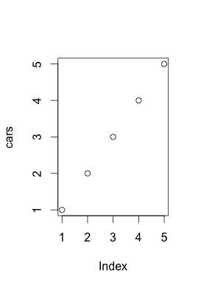
Figure 1: example Figure

Acknowledgement
Acknowledge other collaborators, insitution, funding body etc.

References
- S. J. D. Cox, B. A. Simons, G. Walker, “Adoption of earth science informatics standards : key factors,” Geophysical Research Abstracts. vol. 13, EGU2011-5407, 2011

